Pollard Rho Factorization Handout Example

Example: Factor 31861 using the Pollard Rho method with polynomial 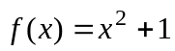 and initial guess 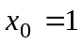.

Solution: For this problem, m = 31861. Our goal is to find two iterates i, j where
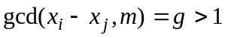 and 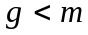. We generate iterates using the formula

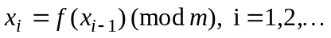

and compute the greatest common divisor with m of each result (the Maple gcd command will be helpful) of the following absolute value sequence

.

Starting with the initial guess , we have

Now 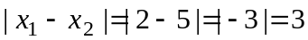 and

(not larger than 1 proceed to next iterates)

We next compute

Now 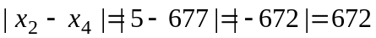 and

(not larger than 1 proceed to next iterates)

We next compute

Now and

(not larger than 1 proceed to next iterates)

We next compute

Now and

(not larger than 1 proceed to next iterates)

We next compute

Now and

(larger than 1 and less than 31861)

Hence, we have found a prime divisor 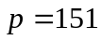 of 31861. The other divisor is 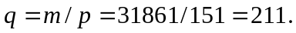 Thus, the prime factorization of 31861 is

