9/8/2019
Assignment 1
DDL COMMANDS:
- Create
- Drop
- Truncate
- Rename
- Alter

DML COMMANDS:
- Insert
- Delete
- Update

TYPES OF CONSTRAINTS:
1) Primary key
2) Foreign key/references
3) Unique
4) Not null
5) Null
6) Default
7) On delete
- Cascade
- No Action
- SET NULL
- SET Default
8) On update
- Cascade
- No Action
- SET NULL
- SET Default
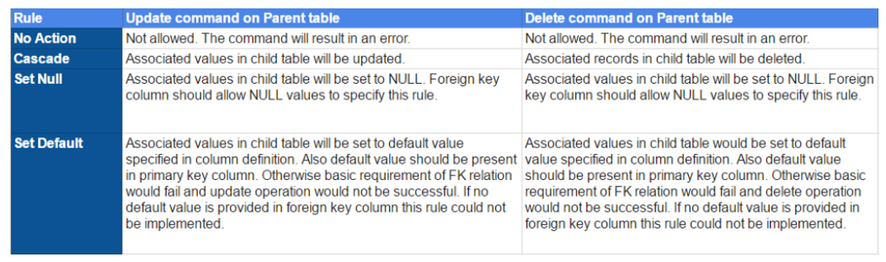

COMPANY DATABASE:
Minimum 6 tuples information for each table is required.
Example:
