What is RDBMS(Relational Database Management System)?

RDBMS is the basis for SQL, and for all modern database systems like MS SQL Server, IBM DB2, Oracle, MySQL, and Microsoft Access. A Relational database management system (RDBMS) is a database management system (DBMS) that is based on the relational model as introduced by E. F. Codd.

What is table?
The data in RDBMS is stored in database objects called tables. The table is a collection of related data entries and it consists of columns and rows.
Remember, a table is the most common and simplest form of data storage in a relational database.

What is field, or column?
Every table is broken up into smaller entities called fields. The fields in the CUSTOMERS table consist of ID, NAME, AGE, ADDRESS and SALARY.
A field is a column in a table that is designed to maintain specific information about every record in the table.

What is record, or row?
A record, also called a row of data, is each individual entry that exists in a table. For example there are 7 records in the above CUSTOMERS table.
A record is a horizontal entity in a table.

What is NULL value?
A NULL value in a table is a value in a field that appears to be blank which means A field with a NULL value is a field with no value.
It is very important to understand that a NULL value is different than a zero value or a field that contains spaces. A field with a NULL value is one that has been left blank during record creation.
Pictorial representation of a Table?
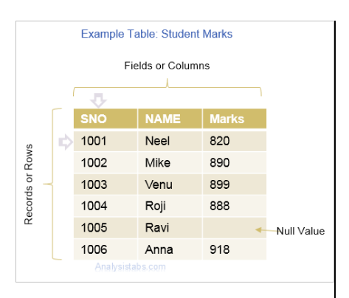

Terminologies & Integrity types associated with RDBMS
PRIMARY KEY | Column used to uniquely identify a Tuple.
FOREIGN KEY | Column of a table used to establish relationship with other tables and present itself in all the relation tables.
ALTERNATE KEY | Column or combination of columns which has unique values but not selected as primary key and is not part of the primary
COMPOSITE KEY | A combination of columns used to identify a unique row. Combination of customer name and address can consider to be the
Domain Integrity | Integrity of information allowed in column.
Referential Integrity | Rule states that every foreign key in the first table must either match a primary key value in the second table or must
Entity Integrity | Rule states that no column that is part of a primary key can have a null value

SQL Data Definition Language – DDL commands
The Data Definition Language (DDL) is used to create and destroy databases and database objects.
These commands are:
–CREATE: to create a new data structure.
–ALTER: to change an existing data structure.
–DROP: to remove an entire data structure.
–TRUNCATE : to remove all rows from table.
–RENAME : to rename existing table.

CREATE
SQL command that adds a new table or View to an SQL database. Tables are a basic unit of organization and storage of data in SQL.
Syntax:
CREATE TABLE <table_name> (
<column_name1> <datatype1> <constraint1>
<column_name2> <datatype2> <constraint2>
<constraint-list>
) ;
Example:
CREATE TABLE Product
(
ProductId INT PRIMARY KEY NOT NULL AUTO_INCREMENT,
OrderId INT NOT NULL,
ProductPrice decimal, ProductName varchar(255));

ALTER
SQL command can be used to add, modify, or drop a column from the existing table or to rename a table.
Syntax:
Alter table <table name> add <column name><data type>;
Example:
ALTER TABLE Product
ADD CreateDate datetime;

DROP command
DROP command completely removes a table from the database. This command will also destroy the table structure and the data stored in it. Following is its syntax,
DROP TABLE table_name
Here is an example explaining it,
DROP TABLE Product;
The above query will delete the Product table completely. It can also be used on Databases, to delete the complete database. For example, to drop a database,
DROP DATABASE Test;
The above query will drop the database with name Test from the system.
Note: Before table drop must remove the dependent constraints

TRUNCATE command
TRUNCATE command removes all the records from a table. But this command will not destroy the table's structure. When we use TRUNCATE command on a table its (auto-increment) primary key is also initialized. Following is its syntax,
TRUNCATE TABLE table_name
Here is an example explaining it,
TRUNCATE TABLE Product;
The above query will delete all the records from the table Product.
In DML commands, we will study about the DELETE command which is also more or less same as the TRUNCATE command.

RENAME
The SQL command that removes the entire table.
Syntax:

ALTER TABLE table_name RENAME TO new_table_name;

Or
RENAME command is used to set a new name for any existing table. Following is the syntax,
RENAME TABLE old_table_name to new_table_name
Here is an example explaining it.
RENAME TABLE Product to Product_info;
The above query will rename the table Product to Product_info.

Examples : In this example we creates a table and insert the values.
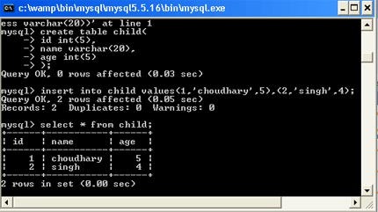
Example : In the following figure shows the alter a table .
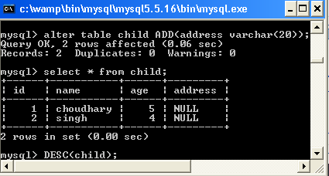
For Example : In this figure shows the describe command.
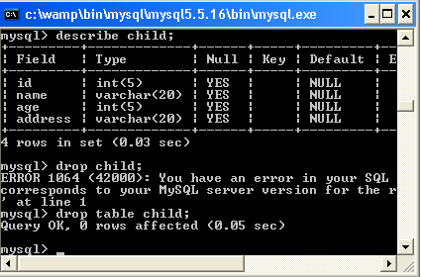

SQL Data Manipulation Language – DML Commands
The Data Manipulation Language (DML) is used to insert and modify database information.
Different DML statements includes:
–INSERT: to add records into the table
–UPDATE: to change column value in the table
–DELETE: to remove rows from the table

DML -INSERT Query
SQL INSERT statement allows to insert single or multiple records into the tale.

Syntax
INSERT INTO table_name
(column-1,column-2,…column-n) VALUES
(value-1, value-2, … value-n);

Example
The following example insert a new record into Employee table,
INSERT INTO Employee(EID, Department, Name, Salary) VALUES( 11,’HR’, ‘MICHAEL’,35000);

DML -UPDATE Query
UPDATE QUERY is used to update existing records in the table.

Syntax
UPDATE table SET column1=value1,column2=value2… WHERE condition;

Example
The following example update the Mike’s salary to 35000 in the Employee table,
UPDATE Employee SET Salary= 35000 WHERE Name = ‘Mike’;

DML -DELETE Query
DELETE QUERY is used to delete selected rows,or all rows from the table.

Syntax
DELETE from table WHERE condition;

Example
The following example dlete the record where EID equals to 10 from the Employee table,
DELETE from Employee WHERE EID=10;

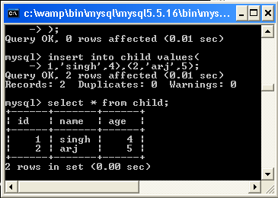
Example : In the below figure shows the update and delete command on the given table.
