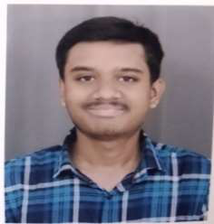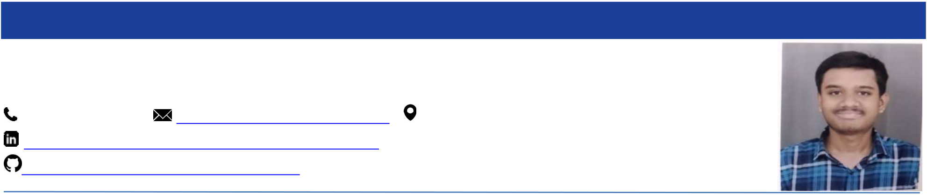

**ADITYA KASHIKAR**

+919975798353| adityakashikar02@gmail.com|Wardha, Maharashtra - 442001

www.linkedin.com/in/aditya-kashikar-7b5962270

https://github.com/adityakashikar2002

**EDUCATION**   
**Bajaj Institute of Technology, Wardha2021-Present** Bachelor of Technology, Computer Engineering CGPA: 8.30 **Bhavan’s Lloyds Vidya Niketan, Wardha 2019-2021** XII CBSE 85.60% **Agragami Convent School, Mhasala, Wardha 2019** X CBSE 93.20%



**SKILLS**  
 • Java • C Programming • SQL • Machine Learning • JavaScript• Teamwork • Analysis • Observation



**PROJECTS**   
**LIDA - Language Independent Data Augmentation for Text Classification Feb - June 2024 Skills:** Python | Machine Learning   
**Team Size: 3**   
 • Developed a high-performance text classification model for low-resource languages using datasets from English, Chinese, and Indonesian.

Optimized model performance on dataset fractions (5%, 10%, 25%, 50%, 80%, 100%), achieving consistent •  
improvements, with the model sustaining over 75% accuracy even with just 25% of the data.

• Pioneered Language-independent Data Augmentation (LiDA) with a pretrained multilingual model, significantly enhancing data diversity and model robustness across 50+ languages.

• Surpassed traditional backtranslation methods in synthetic data generation with LiDA, achieving a 75% improvement for English, 78% for Chinese, and 81% for Indonesian, leading to superior classification results.

**PetCare Website Aug - Nov 2023 Skills:** HTML | CSS | JavaScript | MySQL   
**Team Size: 3**   
 • Developed a responsive website enabling users to register and schedule pet appointments, boosting user engagement by 35%.

• Integrated an admin login feature, ensuring secure access to appointment data and enhancing data management efficiency by 45%.

• Streamlined the appointment scheduling process, cutting booking time by 50% through an intuitive user interface.



**INTERNSHIP**   
**IBM SkillsBuild Artificial Intelligence Internship Oct - Nov 2023**  • Completed a 6-week Virtual Internship in collaboration with AICTE and Edunet Foundation, gaining hands-on experience in Python application development and machine learning.

• Developed a sentiment analysis application using ML models, increasing the accuracy of categorizing hotel reviews by 65%, streamlining the rating process for hotels based on customer feedback.



**CERTIFICATIONS**  
 • Introduction to Java and Object-Oriented Programming (View) 98.25/100 • C for Everyone: Programming Fundamentals (View) 94.06/100 • PCAP: Programming Essentials in Python

**EXTRACURRICULAR**   
 • Competed in National Level Smart India Hackathon 2023 organized by Ministry of Education and AICTE. • Participated in National Level KAVACH Hackathon 2023.

• Won the Kabaddi School Annual Sports Meet.



**WEB LINKS**  
• **Naukri Code360:**https://www.naukri.com/code360/profile/adityakashikar • **Leetcode:**https://leetcode.com/u/viper2002/