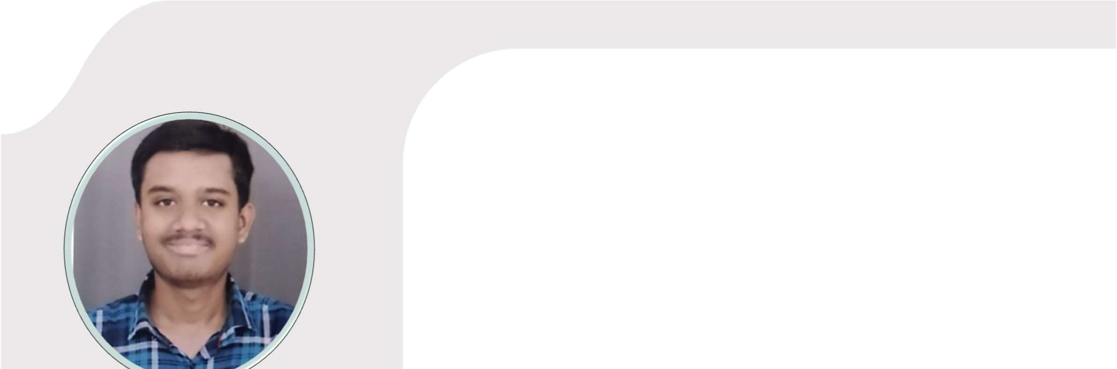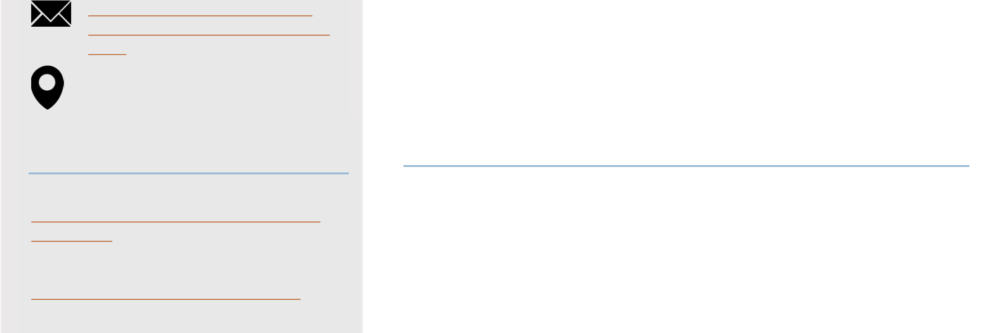

|  |  |  |  |
| --- | --- | --- | --- |
| **TECHNICAL SKILLS** | | |  |
| **Java** | |  | | --- | | **C Programming** | | | **SQL** |
| **Python** | **Machine Learning** | |
|  |
| **Team Work** | |  |
| **Analysis** |  |
|  | | | |

|  |
| --- |
| **CONTACT** |

|  |
| --- |
| +91 9975798353 |

+91 9096987253

adityakashikar02@gmail.com co.2021.akkashikar@bitwardha.

ac.in

|  |
| --- |
| Wardha, Maharashtra - 442001 |

|  |
| --- |
| **WEB LINKS** |

|  |
| --- |
| ***Linked In:*** |

www.linkedin.com/in/aditya-kashikar-7b5962270

***Leetcode:***   
https://leetcode.com/u/viper2002/

***Naukri Code360:***   
https://www.naukri.com/code360/profile /adityakashikar

***Github:***   
https://github.com/adityakashikar2002

ADITYA KASHIKAR

**EDUCATION**

**Bajaj Institute of Technology, Wardha2021 - Present** Bachelor of Technology, Computer Engineering CGPA: 8.30

**Bhavan’s Lloyds Vidya Niketan, Wardha 2019- 2021** XII CBSE 85.6%

**Agragami Convent School, Mhasala, Wardha 2019**   
X CBSE 93.2%

**PROJECTS**

**LIDA - Language Independent Data Augmentation for Text Classification Skills:** Python | Machine Learning   
**Team Size: 3 Feb - June 2024** • Developed a high-performance text classification model for low-resource languages using datasets from English, Chinese, and   
Indonesian, achieving consistent improvements, with the model   
sustaining over 75% accuracy even with just 25% of the data.

• Pioneered Language-independent Data Augmentation (LiDA) with a pretrained multilingual model, significantly enhancing data diversity and model robustness across 50+ languages.

• Surpassed traditional backtranslation methods in synthetic data   
generation with LiDA, achieving a 75% improvement for English, 78% for Chinese, and 81% for Indonesian, leading to superior classification results.

**PetCare Website**   
**Skills:** HTML | CSS | JavaScript | MySQL   
**Team Size: 3 Aug - Nov 2023** • Developed a responsive website enabling users to register and schedule pet appointments, boosting user engagement by 35%.

• Integrated an admin login feature, ensuring secure access to appointment data and enhancing data management efficiency by 45%.

• Streamlined the appointment scheduling process, cutting booking time by 50% through an intuitive user interface.

**INTERNSHIP**

**IBM SkillsBuild Artificial Intelligence InternshipOct - Nov 2023** • Completed a 6-week Virtual Internship in collaboration with AICTE and Edunet Foundation, gaining hands-on experience in Python application development and machine learning.

• Developed a sentiment analysis application using ML models,   
increasing the accuracy of categorizing hotel reviews by 65%,   
streamlining the rating process for hotels based on customer feedback.

**ACHIEVEMENTS**

• Competed in National Level Smart India Hackathon 2023 organized by Ministry of Education and AICTE.

• Participated in National Level KAVACH Hackathon 2023. • Won the Kabaddi School Annual Sports Meet.