Weakly-supervised Deep Embedding for Product Review Sentiment Analysis

In Ecommerce world product reviews are very important for the purchaser to purchase good quality product. All existing systems were using data mining classifier based on product rating which was not giving correct classification. All reviews accompanied with text and rating values and just considering rating will drive users to make wrong decision.

Example from paper

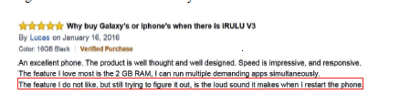

From above image we can see review content negative words but given 5 start ratings. To overcome from this issue author has introduce two algorithms which will process review text (review text mining also called as Deep Learning) and rating information to get correct label such as Positive or Negative.

Algorithm1: Convolutional Neural Network-Weakly-supervised Deep Embedding (CNN-WDE): This algorithm generate features vector using neural network technique and then identify label for review.

Algorithm2: Long Short-Term Memory-Weakly-supervised Deep Embedding (LSTM-WDE) this algorithm is similar to first one but it will process reviews in window size instead of processing all and due to this window size performance will drop down. CNN-WDE is better compare to LSTM-WDE.

CNN-WDE builds feature vector along with rating value and algorithm will give value weather review is positive or not. CNN-WDE all reviews will be train and later test review will apply on train review to predict label.

Weakly-supervised deep refers to mining on text data.

To implement this project I have downloaded some reviews from internet and saved inside dataset folder

Screen shots

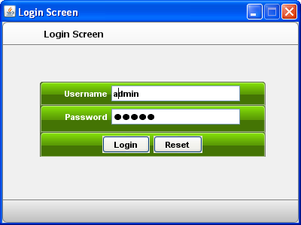

After login will get below screen

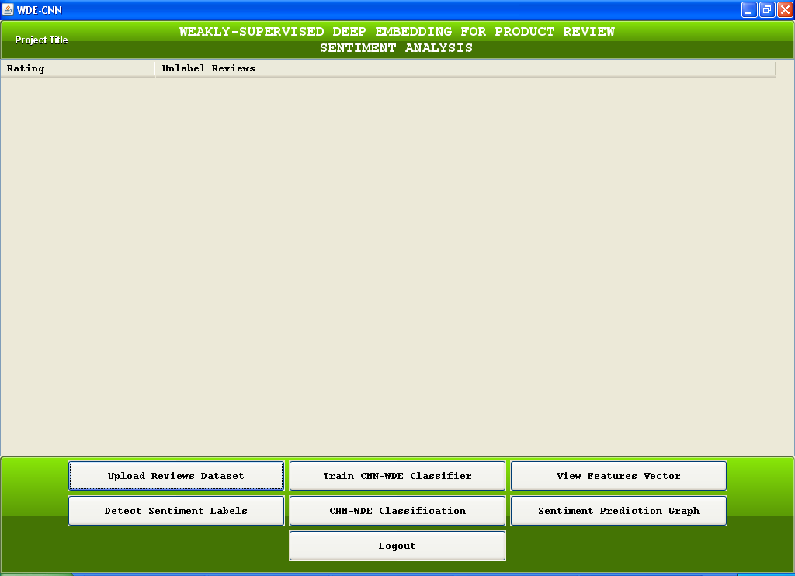

Now click on ‘Upload Reviews Dataset’ button to upload dataset

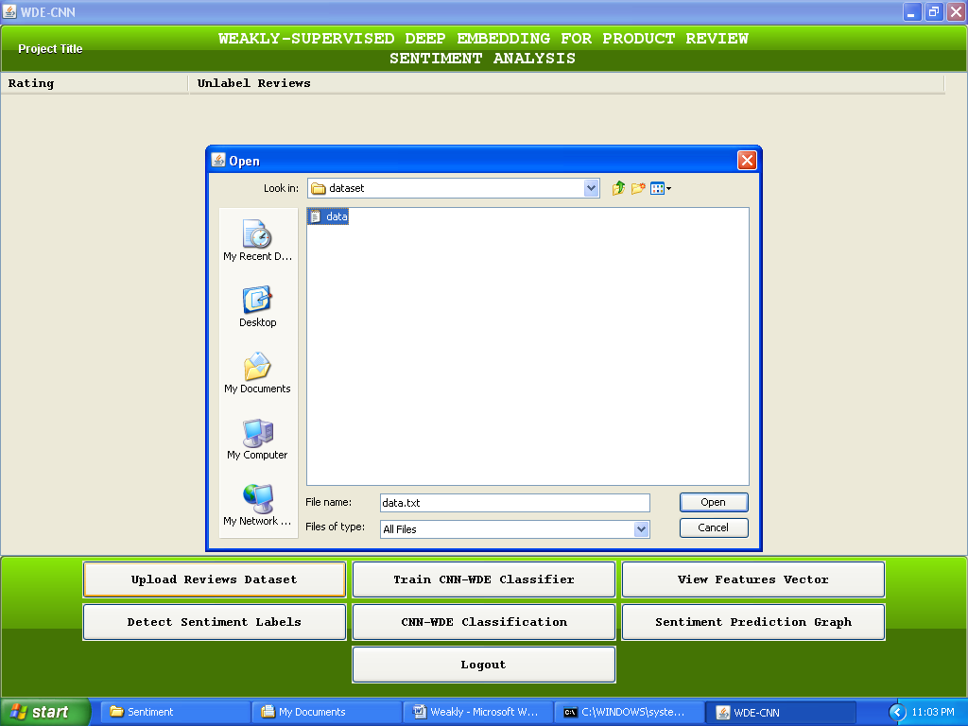

Will get below screen after dataset upload

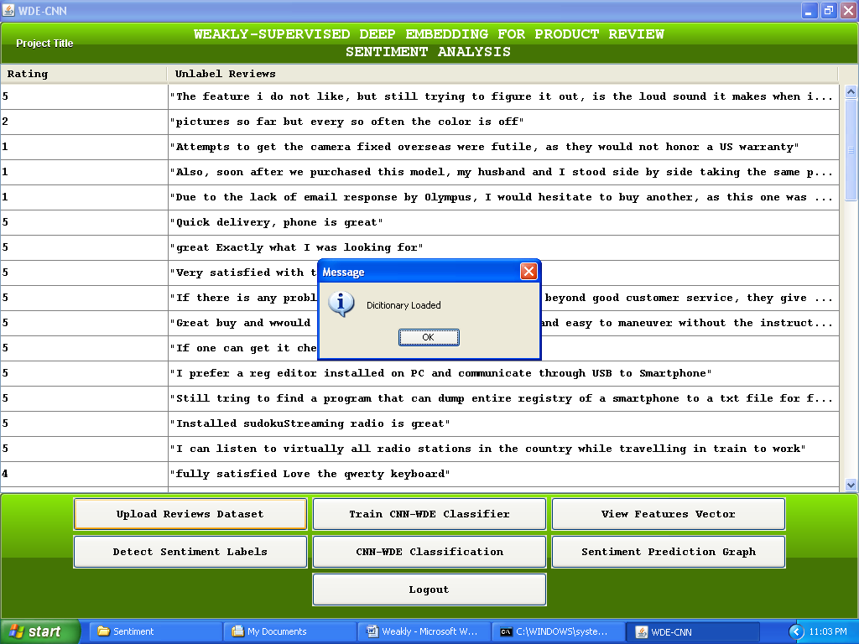

In first column review rating and in second column review text is there. Now click on ‘Train CNN-WDE Classifier’ to train dataset USING CNN-WDE algorithm

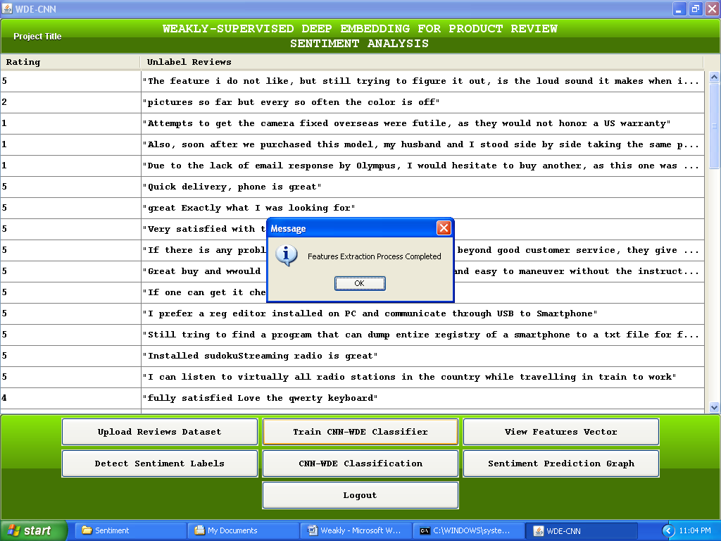

Now click on ‘View Features Button’ to view extracted features

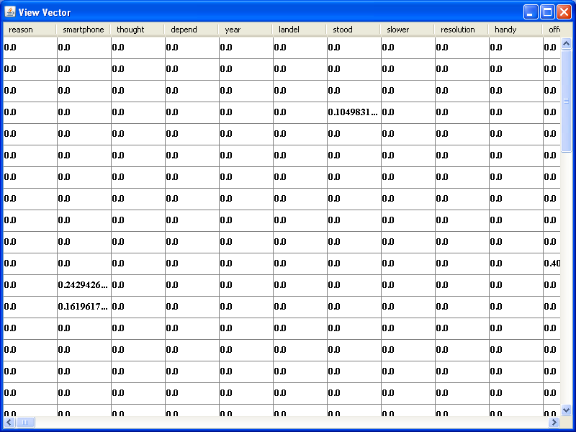

Now click on ‘Detect Sentiment Labels’ to detect either review is positive or negative

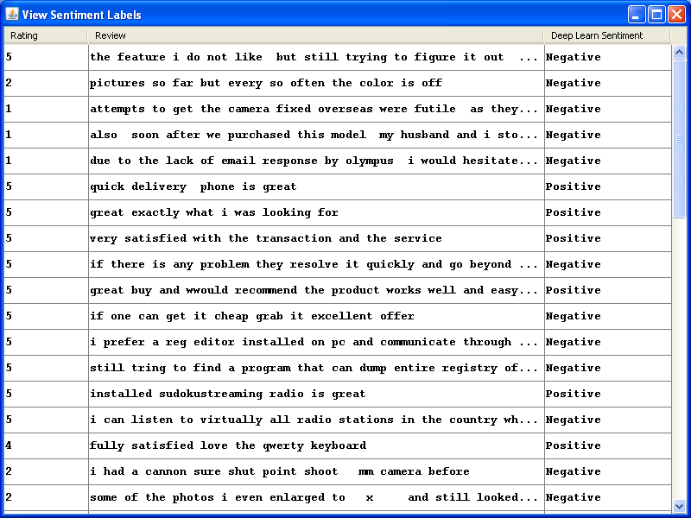

From above screen in first row rating is 5 but review text contains negative words and later by using this paper algorithm we found out that review is negative. Now click on ‘Sentiment Prediction Graph’ button to give input as review and then this input will test again train model to detect weather input is positive or negative

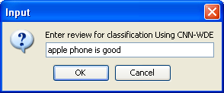

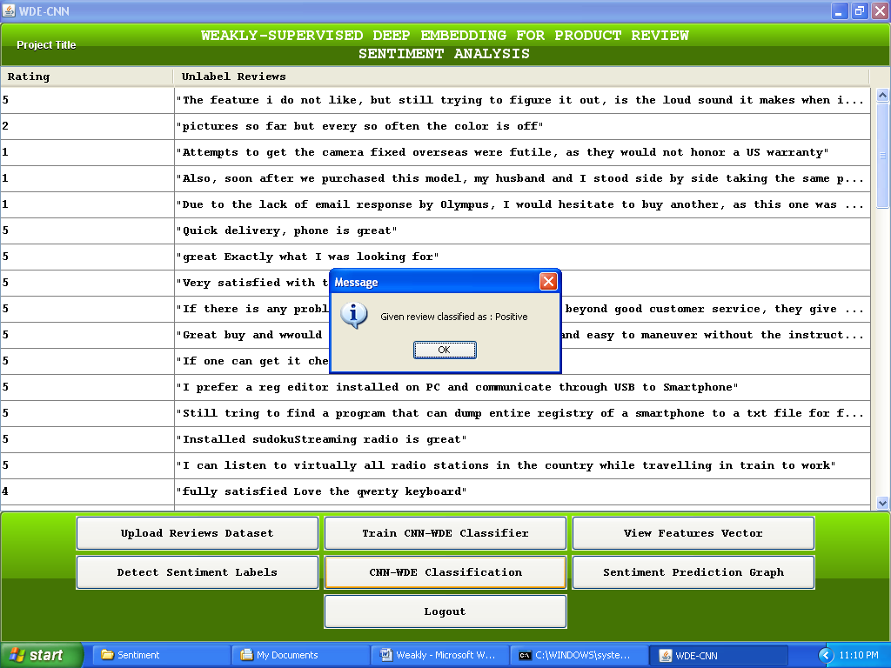

Now in above screen we can see input is identified as positive

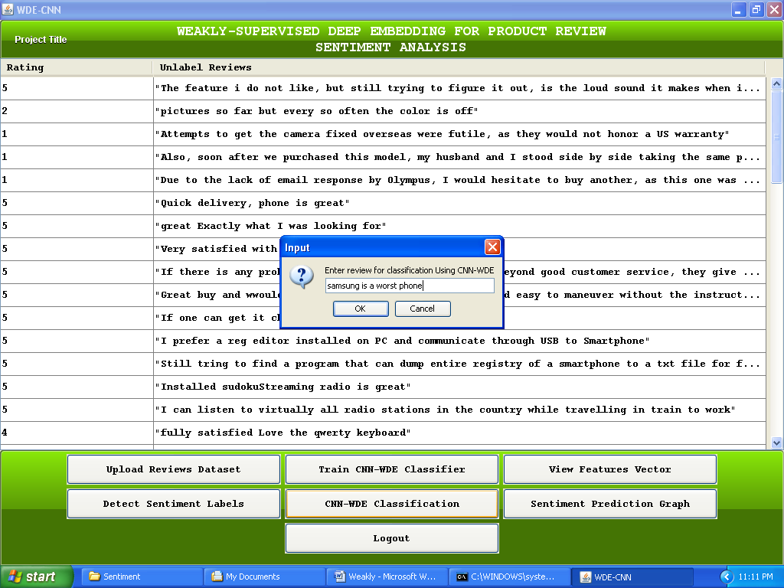

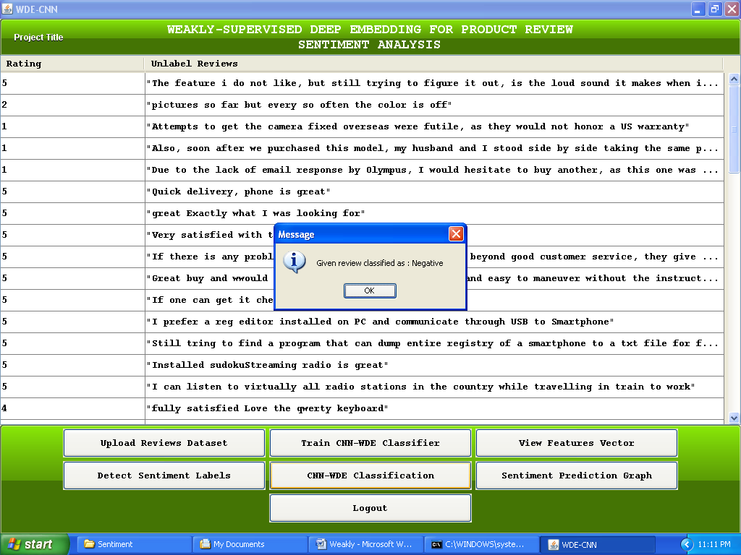

Now click on ‘Sentiment Prediction Graph’ button to identify total positive and negative reviews in graph

