- Title: Power BI Video Educational Course
Link: https://www.upwork.com/nx/search/jobs/details/~022023103068991647428?nbs=1&q=power%20bi&sort=recency&page=1&per_page=50&pageTitle=Job%20Details&_modalInfo=%5B%7B%22navType%22%3A%22slider%22,%22title%22%3A%22Job%20Details%22,%22modalId%22%3A%221771373342610%22%7D%5D
Spent: $257K total spent
Hook ( the very first two lines ):
Most Power BI courses teach buttons and charts — and learners still feel lost.
I build courses that teach how to think with data, not just where to click.
Key points:
• Structuring
• Teaching
• Demonstrating
• Practicing
• Scaling
Reason for choosing : the client is having good spent and hire rate. Although I don’t know if the company can provide video editor.

Final Message:
Most Power BI courses teach buttons and charts — and learners still feel lost.
I build courses that teach how to think with data, not just where to click.
Structuring.
Teaching.
Demonstrating.
Practicing.
Scaling.
I design clear course roadmaps, explain concepts simply, show real-world use cases, reinforce learning with hands-on exercises, and build content that’s ready to grow into future courses.

- Title: Power BI Developer
Link: https://www.upwork.com/nx/search/jobs/details/~022023499303077724702?nbs=1&q=power%20bi&sort=recency&page=1&per_page=50&pageTitle=Job%20Details&_modalInfo=%5B%7B%22navType%22%3A%22slider%22,%22title%22%3A%22Job%20Details%22,%22modalId%22%3A%221771374802641%22%7D%5D
Spent: $474K total spent
Final Message:
Most Power BI developers add work before they remove it.
I step into existing BI teams and take ownership of reports without hand-holding.
I handle overflow work end-to-end: building new Power BI reports, extending existing ones, fixing performance issues, and keeping refresh logic reliable in production.
Power BI Desktop & Service.
Advanced DAX.
Power Query (M).
SQL.
Data modeling.
I’m used to working inside someone else’s reporting ecosystem — understanding current models quickly, translating business requirements accurately, and documenting everything so nothing becomes fragile.
Remote, flexible, deadline-driven, and comfortable with regular check-ins — you get progress without needing to manage me.

Reason for choosing: good spent but the time (years) is very long, but the description fits the requirements and our work line, so I thought y not go for it

- Title: PowerBI - Infor Visual Data visualization.
Link: https://www.upwork.com/nx/search/jobs/details/~022023474631122552835?nbs=1&q=power%20bi&sort=recency&page=1&per_page=50&pageTitle=Job%20Details&_modalInfo=%5B%7B%22navType%22%3A%22slider%22,%22title%22%3A%22Job%20Details%22,%22modalId%22%3A%221771376370863%22%7D%5D
Spent: na
Final message:
Most Power BI developers can build dashboards.
Very few understand Infor VISUAL data well enough to make those dashboards trustworthy.
I help teams integrate Infor VISUAL 10.0.0 data into Power BI and turn complex manufacturing datasets into clear, decision-ready dashboards.
Power BI Desktop & Service.
Infor VISUAL (v10.0.0).
Data modeling & relationships.
Performance-optimized visuals.
My focus is on accuracy, clarity, and usability — so stakeholders don’t just see data, they trust it and act on it.
I work independently, move fast, and deliver dashboards that hold up in real business use, not just demos.

Reason for choosing: the client is fairly new to the market and he might be scouting for trusted devs and also it aligns with work we do

- Title: Power BI Specialist for KPI Reporting Enhancement

Link: https://www.upwork.com/nx/search/jobs/details/~022022412328622617257?nbs=1&q=power%20bi&sort=recency&page=2&per_page=50&pageTitle=Job%20Details&_modalInfo=%5B%7B%22navType%22%3A%22slider%22,%22title%22%3A%22Job%20Details%22,%22modalId%22%3A%221771379600932%22%7D%5D

$59K total spent (really good spent for someone this new)

Final Message:
KPI dashboards only deliver value when they are accurate, performant, and easy to maintain.
I help teams refine, consolidate, and stabilize Power BI reporting so it continues to support decision-making over time.
I can improve and finalize existing Power BI dashboards, optimize data models for performance, and provide clear documentation so your team can confidently maintain and extend the reports.
Strong experience with Power BI, Excel-based KPI reporting, data modeling, and integration, with a collaborative and structured working approach.

Reason for choosing: aligns with the work we do, really good spent, potential client

- Title: NO AGENCIES | Looker Studio Visualization and Analytics Guru (EST Time-zone)

Link: https://www.upwork.com/nx/search/jobs/details/~022022391534279801438?nbs=1&q=power%20bi&sort=recency&page=2&per_page=50&pageTitle=Job%20Details&_modalInfo=%5B%7B%22navType%22%3A%22slider%22,%22title%22%3A%22Job%20Details%22,%22modalId%22%3A%221771380038848%22%7D%5D

$245K total spent

Final message:
I build Looker Studio dashboards that stakeholders trust, by validating data end-to-end.
- Advanced Looker Studio dashboard development
- BigQuery → Looker Studio data validation & QA
- Source-to-dashboard discrepancy checks
- BigQuery test tables for logic verification
- Clear communication and documentation
- EST-time availability for real-time collaboration

Reason for choosing: Good spent and doable

AI CHATBOTS:

- Title: Senior Python/FastAPI Developer: Vertex AI Migration & Stripe Integration

Link : https://www.upwork.com/nx/search/jobs/details/~022023942937660213670?nbs=1&q=Ai%20chatbot&sort=recency&pageTitle=Job%20Details&_modalInfo=%5B%7B%22navType%22%3A%22slider%22,%22title%22%3A%22Job%20Details%22,%22modalId%22%3A%221771380737555%22%7D%5D

$6.3K total spent (the client is very new to the platform)

Final message:
Large AI backends only migrate cleanly when region control, retrieval logic, and billing are treated as first-class concerns.
That’s the level I work at.
- Vertex AI migration with enforced Montreal residency (northamerica-northeast1)
- Refactor all LLM inference to the Vertex AI SDK
- Parent–Child retrieval implementation (≈500-token child, ≈3k-token parent) with cache-trigger validation
- FastAPI Stripe webhook with signature verification and idempotency handling
- Stripe Product → Supabase tier mapping with access_expiry lifecycle updates
- Deployment-ready documentation and simple verification scripts
I work directly in existing FastAPI codebases, push clean commits to private repositories, and validate delivery against explicit acceptance criteria through logs and test runs.

Reason for choosing: I thought it was a good opportunity

- Title: Voice AI Systems Architect

Link: https://www.upwork.com/nx/search/jobs/details/~022023869551315807283?nbs=1&q=Ai%20chatbot&sort=recency&page=1&per_page=50&pageTitle=Job%20Details&_modalInfo=%5B%7B%22navType%22%3A%22slider%22,%22title%22%3A%22Job%20Details%22,%22modalId%22%3A%221771381248518%22%7D%5D

$241K total spent

Final message:
I help teams make deliberate, auditable architectural decisions so systems behave predictably under real-world constraints.
- Architecture review and risk assessment (before issues surface in production)
- Dialogflow → in-house multi-agent migration guidance
- LangGraph-based orchestration and agent handoff design
- Telephony-aware system design (latency, barge-in, retries, fallbacks)
- Tool-calling agents and MCP backend integration patterns
- Deterministic vs probabilistic flow boundaries
- Conversation state persistence and observability strategy
I work as a senior architectural partner, not a prompt engineer — focused on reducing uncertainty, avoiding fragile patterns, and helping teams ship systems they can confidently operate and audit.

Reason to choose: good hire rate and spent

Act like a really experienced frelancerr on upwork who does all sort of jobs related to data analytics
Hey gpt I wnt you to understand the pain points and urgencies, the industry they are in , the job title, problems the are facing , what outcome they are expecting or looking for, the budget for solving the problem. So this thing should have a really AND I MEAN A REALLY EYE CATCHING HOOK, A Body, this body it has, keep it very concise and to the point which highlights the solution to the pain points, relevant skills and a closure. Also make sure to address the problem and how I can solve it and how I have done it before. All this just keep in mind that I use upwork to get the job done. So I want you to work with the perspective of that platform
NOTE: THROUGHLY ANALYSE THE INPUT
Now the hook should be eother in this way “Most Power BI developers can build dashboards. Very few understand Infor VISUAL data well enough to make those dashboards trustworthy.” OR “hey…your job posting caught my attention” keep it in uk or us style of communication. Now these are just the examples I am giving ,u are free to THINK and add your own hook that suit the summaries and titles of the job. The closure must be like “I hope to connect wth you soon ” OR “When can I accet a reply or a call back”
Lets do one thheing I will paste the entie thing read where the client is from and accordingly use the hooks the style of it, in the sense there thought process . I want you to think from their perspective while reading the summary
*I use a plt upwork to get prj *
*Proposal ke niche dalo req jaise ki hook and other stuff*

Prompt 2
Subject: Build {{tool}} dashboard for {{team}} in {{time_estimate}}
You need visibility on {{metrics}} across {{sources}}.
• Model: clean {{tables}}; define dims/measures and grain.
• Visualize: {{charts}} with filters/segments; permissions by role.
• Handoff: docs + Loom walkthrough.
Proof: Cut reporting time {{percent}} for {{company}} (sample: {{link}}).
Phase 1: MVP ({{metrics}}) by {{date}} — {{price}}.

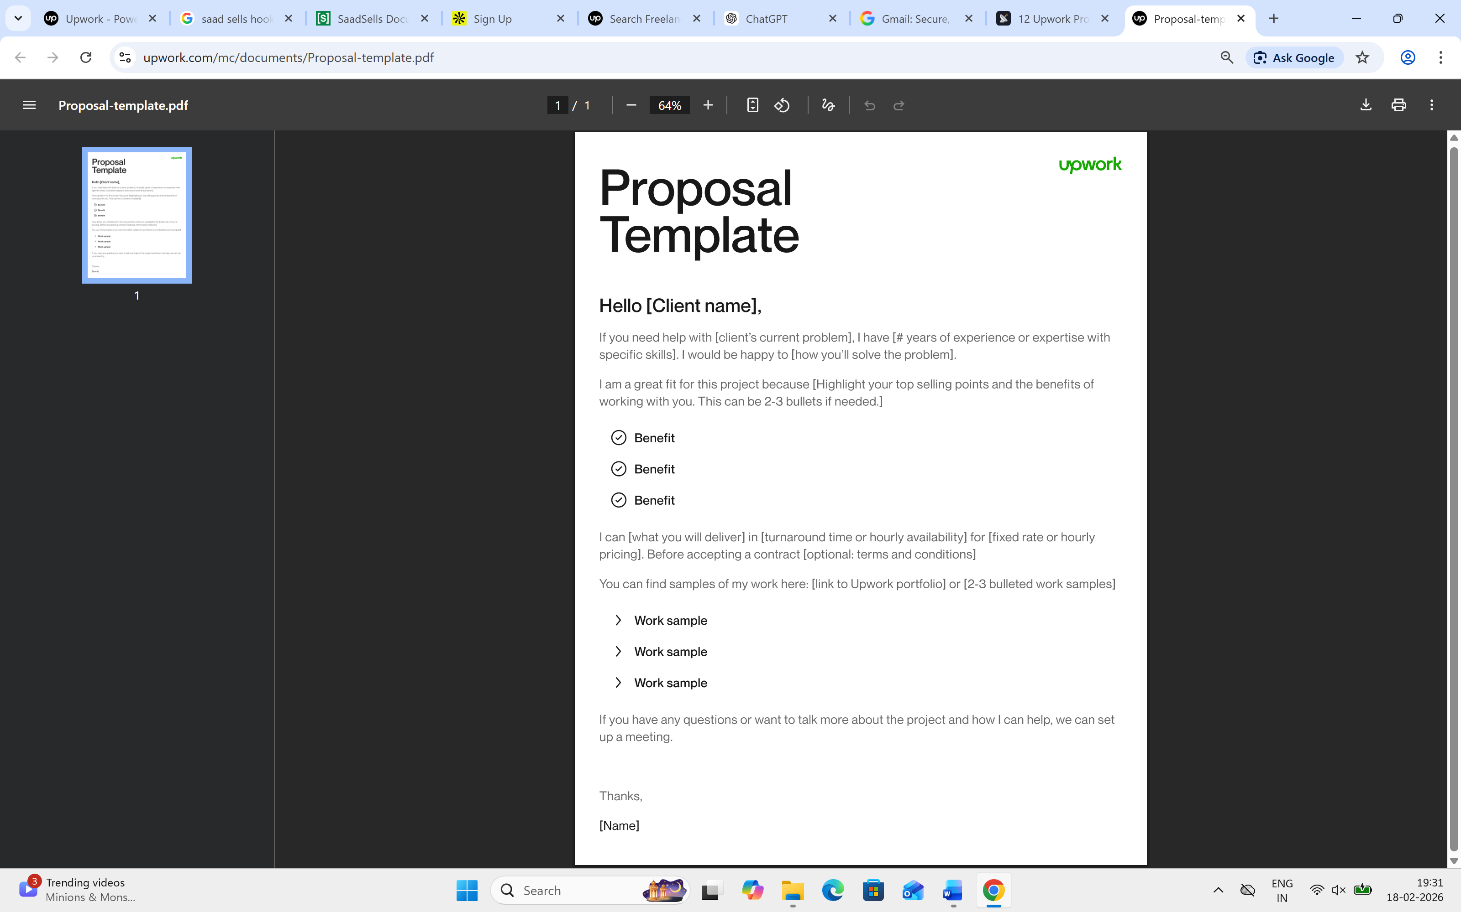

Link: https://www.upwork.com/nx/search/jobs/details/~022023493720624474838?nbs=1&q=power%20bi&sort=recency&page=2&per_page=50&nav_dir=pop&pageTitle=Job%20Details&_modalInfo=%5B%7B%22navType%22%3A%22slider%22,%22title%22%3A%22Job%20Details%22,%22modalId%22%3A%221771410492834%22%7D%5D
Final Message:
Most Power BI reports break down when they’re automated against Business Central.
I specialize in building Power BI dashboards that stay accurate, performant, and hands-off after deployment.

You’re not just asking for dashboards — you’re asking for 12 automated management reports that leadership can rely on across Sales, Finance, Warehouse, Buying, and Operations.
I’ve worked with Power BI + Microsoft Dynamics 365 Business Central integrations where the real challenges are:
- clean data modeling across BC tables
- reliable scheduled refreshes
- performance at scale
- and reports that don’t need constant fixing
I can design and deliver:
- Fully automated Power BI reports integrated directly with Business Central
- Optimized data models using Power Query and DAX
- Scheduled refreshes (hourly / daily / monthly as needed)
- Role-based views where required
- Validated, management-ready dashboards with clean documentation
I’m used to working independently on structured projects like this — clarifying assumptions early, flagging dependencies, and delivering reports that are stable long after handover.
If you’re looking for someone who can own this end-to-end and deliver reports you won’t need to babysit, I’d be glad to connect.
When would be a good time to discuss timelines and assumptions?

Link: https://www.upwork.com/nx/search/jobs/details/~022023471818632005635?nbs=1&q=power%20bi&sort=recency&page=2&per_page=50&nav_dir=pop&pageTitle=Job%20Details&_modalInfo=%5B%7B%22navType%22%3A%22slider%22,%22title%22%3A%22Job%20Details%22,%22modalId%22%3A%221771411101993%22%7D%5D
Final Message:
Your posting caught my attention because you’re looking to replace AgencyAnalytics with a clean, automated, client-ready reporting setup in Google Sheets.
I help agencies build centralized Google Sheets dashboards that pull data from multiple marketing platforms, automate updates, and present metrics in a way clients actually understand. I’ve worked with LinkedIn, Meta, Google Analytics, PR/SEO tools, and API-based connectors, and I focus on reliability, clarity, and low-maintenance reporting.
I can review your current approach, recommend where automation will help most, and build a dashboard structure that scales across clients.
I’d be happy to connect — when would be a good time to discuss your current setup?

New prompt

Your job posting caught my attention because you’re not looking for another dashboard — you’re trying to replace a tool that’s no longer serving you.

You’re an agency that needs clean, automated, client-facing marketing reports without manual work or rigid tools like AgencyAnalytics.
I’ve built Google Sheets–based reporting dashboards that:
- Pull data automatically from LinkedIn, Meta, Google Analytics, PR/SEO tools, and APIs
- Centralize multiple sources into a single, structured reporting view
- Leave room for insights, summaries, visuals, and context (not just raw numbers)
- Reduce reporting time while improving clarity for clients
I don’t just connect data — I review the existing reporting flow, identify what can be simplified or automated, and design dashboards that scale across clients without breaking.
Strong experience with Google Sheets, APIs, data connectors, and Looker Studio, with a focus on reliability and presentation quality for client delivery.

I hope to connect with you soon and learn more about your current reporting setup.
When can I expect a reply or a quick call back?

http://upwork.com/nx/search/jobs/details/~022023493720624474838?nbs=1&q=power%20bi&sort=recency&page=2&per_page=50&nav_dir=pop&pageTitle=Job%20Details&_modalInfo=%5B%7B%22navType%22%3A%22slider%22,%22title%22%3A%22Job%20Details%22,%22modalId%22%3A%221771420966871%22%7D%5D

Your project stood out because it’s not about visuals — it’s about reliable, automated reporting from Microsoft Business Central that management can trust.
You need 12–15 automated Power BI reports across Sales, Finance, Warehouse, Buying, and Operations, all refreshing reliably from Dynamics 365 Business Central.
I’ve delivered Power BI + Business Central reporting where the focus is:
- Clean data modeling across BC tables
- Stable scheduled refreshes (hourly / daily / monthly)
- Performance tuning for growing datasets
- Clear, role-based views for different teams
I handle the full flow — integration, modeling, DAX, validation, and documentation — so reports remain accurate and low-maintenance after handover. I also flag assumptions and dependencies early to avoid rework.
I hope to connect with you soon and understand your reporting priorities in more detail.
When can I expect a reply or a quick call back?

