SOLUTION DESIGN PROPOSAL
Agentic AI-Powered Audit Assistant
Enterprise Product Requirements & Technical Architecture

CONFIDENTIAL — DRAFT FOR INTERNAL REVIEW

Prepared by: GenAI Solutions Architecture Practice
Version 1.0 | June 2025 | For Senior Architect & Engineering Manager Review

Document Type | Solution Design Proposal / PRD
Project Name | Agentic AI-Powered Audit Assistant
Version | 1.0 — Initial Release
Classification | Confidential — Internal Use Only
Prepared By | GenAI Solutions Architecture Practice
Target Audience | Engineering Manager, GenAI Architect, Enterprise Architect, Audit Stakeholders
Review Date | June 2025
Status | Draft — Pending Architecture Review Board Approval

Table of Contents

1. Executive Summary
This document presents the Solution Design Proposal for an Agentic AI-Powered Audit Assistant — an enterprise-grade intelligent system that enables internal auditors and compliance professionals to investigate complex audit questions using natural language, receiving accurate, evidence-backed, and fully traceable responses.

Modern enterprise audit functions operate under significant data complexity. Financial transactions, vendor records, compliance documentation, approval workflows, internal policies, and operational logs are distributed across disparate systems and formats. Auditors expend disproportionate time on information gathering and correlation activities rather than higher-value analytical work.
This solution addresses the core challenge through a purpose-built, multi-agent AI architecture that orchestrates intelligent retrieval across both structured relational data and unstructured document repositories. Unlike generic chatbot implementations, this system is designed with audit-specific requirements at its foundation: every response must be accurate, grounded in verifiable evidence, explainable, and traceable to authoritative sources.
The proposed system incorporates ten specialised AI agents working in concert, a hybrid retrieval framework combining SQL, vector search, BM25 full-text search, and knowledge graph traversal, together with a rigorous validation and hallucination prevention layer. The architecture is designed for enterprise deployment on cloud-native infrastructure with full security, governance, and observability controls.

Dimension | Current State | Target State
Query Resolution | Hours to days of manual research | Minutes with AI-assisted investigation
Evidence Quality | Inconsistent, manually compiled | Verified, cited, evidence-backed responses
Audit Coverage | Sample-based, limited scope | Full population analysis capability
Traceability | Analyst-dependent documentation | Automated evidence chain with citations
Scalability | Linear with headcount | Scalable AI infrastructure

2. Problem Statement

2.1 The Enterprise Audit Data Challenge
Enterprise organisations generate vast volumes of audit-relevant information across multiple systems, formats, and organisational domains. This data landscape is characterised by structural heterogeneity — financial transaction databases coexist with policy documents in SharePoint, approval workflows in ERP systems, compliance records in GRC platforms, and operational logs in monitoring tools.
Auditors tasked with investigating anomalies, verifying compliance, or preparing audit reports must manually navigate this fragmented landscape. The consequence is significant: audit teams dedicate a disproportionate share of their capacity to information gathering rather than analytical judgment.

2.2 Core Problem Areas
- Information Fragmentation: Relevant audit evidence is dispersed across structured databases (ERP, finance systems), unstructured documents (policies, SOPs, audit reports), and semi-structured logs, with no unified access interface.
- Evidence Correlation Complexity: Answering a single audit question frequently requires correlating data from multiple sources — for example, matching a flagged transaction against its approval record, the applicable policy, and the vendor's compliance status.
- Verification Burden: Without systematic tooling, auditors cannot efficiently verify that findings are supported by sufficient evidence or that conclusions are consistent with policy requirements.
- Knowledge Capture: Institutional audit knowledge embedded in past reports, investigation notes, and policy interpretations is largely inaccessible for future investigations.
- Scalability Constraints: The volume of transactions and documents requiring review exceeds the practical capacity of manual audit workflows.

2.3 Business Impact
Impact Area | Description
Audit Cycle Time | Extended investigation timelines due to manual information retrieval and correlation
Risk Exposure | Potential for missed findings when audit scope is constrained by capacity limitations
Evidence Quality | Inconsistent documentation standards across investigation teams
Regulatory Risk | Delayed or incomplete responses to regulatory requests requiring comprehensive evidence
Cost Efficiency | Disproportionate audit budget allocated to lower-value data gathering activities

3. Current Challenges

3.1 Data Access Challenges
- No unified query interface across structured (SQL) and unstructured (document) data sources
- Manual extraction from multiple ERP modules, finance systems, and document repositories
- Lack of semantic search capability over policy and procedure documents
- Inability to efficiently traverse entity relationships (e.g., vendor → contract → compliance → transaction)

3.2 Analysis Challenges
- Policy cross-referencing is a manual, error-prone process requiring knowledge of multiple regulatory frameworks
- Threshold and limit violation analysis requires joining data across approval workflow and transaction systems
- Historical pattern analysis across large transaction volumes is not operationally feasible manually
- Vendor risk profiling requires aggregating data from procurement, compliance, and payment systems

3.3 Response Quality Challenges
- Findings produced without systematic evidence validation are subject to challenge during audit review
- Inconsistent citation standards make it difficult to verify the basis for audit conclusions
- No mechanism to assess confidence levels or quantify uncertainty in audit findings
- Generic AI chatbots without audit-specific validation are unsuitable for high-assurance audit environments

3.4 Technology Gaps
Capability Gap | Current Limitation
Natural Language Query over Structured Data | No NL-to-SQL capability; requires SQL expertise
Semantic Document Search | Basic keyword search only; no semantic understanding
Entity Relationship Analysis | No graph-based investigation capability
Evidence Validation | Manual review process; no automated evidence verification
Multi-Source Correlation | No automated cross-source evidence fusion
Response Explainability | No citation or evidence chain generation

4. Business Objectives

4.1 Primary Objectives
- Enable auditors to query enterprise audit data using natural language without requiring technical expertise in SQL or information systems.
- Deliver accurate, evidence-backed responses to audit queries with explicit citation of supporting source materials.
- Reduce audit investigation cycle time through automated information retrieval and evidence correlation.
- Ensure every system response is explainable, traceable, and verifiable to support audit defensibility.
- Implement a validation framework that prevents hallucinated or unsupported findings from reaching auditors.

4.2 Strategic Objectives
- Position the organisation with a scalable AI audit capability that supports both routine investigations and complex multi-domain inquiries.
- Establish a reusable AI architecture pattern for enterprise-grade, evidence-backed AI systems.
- Improve audit coverage by enabling analysis across complete data populations rather than samples.
- Create an institutional knowledge repository that makes past audit findings and policy interpretations accessible for future investigations.

4.3 Success Criteria
KPI | Baseline | Target | Measurement
Query Resolution Time | 4–8 hours | < 15 minutes | Average time-to-insight (p95)
Evidence Citation Rate | Inconsistent | 100% of responses | Citation coverage per response
Retrieval Precision@5 | N/A | > 85% | RAGAS evaluation framework
Response Faithfulness | N/A | > 90% | Groundedness score
Auditor Adoption | 0% | > 80% active users | 30-day active user rate
Validated Finding Rate | N/A | > 95% | Validation pass rate

5. Functional Requirements

5.1 Query Processing
FR-ID | Requirement Description
FR-QP-01 | System shall accept natural language queries from authenticated auditors via a conversational interface.
FR-QP-02 | System shall classify query intent into predefined audit investigation categories (transaction analysis, compliance review, vendor assessment, policy lookup, anomaly detection).
FR-QP-03 | System shall extract named entities, date ranges, thresholds, and domain constraints from natural language queries.
FR-QP-04 | System shall decompose complex multi-part queries into atomic investigation sub-tasks.
FR-QP-05 | System shall maintain conversational context across multi-turn investigation sessions.

5.2 Data Retrieval
FR-ID | Requirement Description
FR-DR-01 | System shall retrieve structured financial data (transactions, approvals, expenses, vendor records) via natural language to SQL translation.
FR-DR-02 | System shall perform semantic similarity search over unstructured document repositories.
FR-DR-03 | System shall support BM25 full-text keyword search as a complementary retrieval mechanism.
FR-DR-04 | System shall apply metadata filters (date range, document type, department, jurisdiction) to retrieval operations.
FR-DR-05 | System shall traverse knowledge graph relationships to identify entity-level connections relevant to audit investigations.
FR-DR-06 | System shall fuse and rank evidence from multiple retrieval sources using reciprocal rank fusion.

5.3 Analysis & Validation
FR-ID | Requirement Description
FR-AV-01 | System shall identify policy violations by comparing retrieved evidence against applicable policy documents.
FR-AV-02 | System shall verify that every claim in a generated response is supported by at least one evidence item.
FR-AV-03 | System shall perform cross-source consistency validation to detect contradictions across evidence items.
FR-AV-04 | System shall apply a critic agent to challenge finding quality and identify weak or unsupported conclusions.
FR-AV-05 | System shall calculate and expose confidence scores for each finding and overall response.
FR-AV-06 | System shall prevent hallucinated findings from reaching the user through NLI-based claim verification.

5.4 Response Generation & Explainability
FR-ID | Requirement Description
FR-RG-01 | System shall generate audit responses with inline citations referencing specific source documents and database records.
FR-RG-02 | System shall expose the full evidence chain supporting each finding.
FR-RG-03 | System shall provide visibility into agent actions taken during investigation.
FR-RG-04 | System shall display validation status and confidence scores alongside responses.
FR-RG-05 | System shall support export of investigation results and evidence packages in structured formats.

6. Non-Functional Requirements
NFR-ID | Category | Requirement | Target Metric
NFR-P-01 | Performance | Simple query response time | < 10 seconds (p95)
NFR-P-02 | Performance | Complex multi-source query | < 60 seconds (p95)
NFR-P-03 | Performance | Concurrent user sessions | ≥ 200 concurrent sessions
NFR-S-01 | Security | Authentication | SSO via SAML 2.0 / OIDC
NFR-S-02 | Security | Authorisation | RBAC with field-level access control
NFR-S-03 | Security | Data encryption | AES-256 at rest, TLS 1.3 in transit
NFR-S-04 | Security | Audit logging | 100% of queries and agent actions logged
NFR-A-01 | Availability | System uptime SLA | 99.9% monthly availability
NFR-A-02 | Availability | RTO / RPO | RTO < 4 hours, RPO < 1 hour
NFR-SC-01 | Scalability | Horizontal pod autoscaling | Auto-scale 2× to 10× baseline
NFR-Q-01 | Quality | Retrieval faithfulness | > 90% RAGAS faithfulness score
NFR-Q-02 | Quality | Hallucination rate | < 2% unsupported claims
NFR-C-01 | Compliance | Data residency | Configurable per regulatory jurisdiction
NFR-C-02 | Compliance | Data lineage | Full lineage tracking to source system

7. Solution Overview

7.1 Architectural Philosophy
The Agentic AI-Powered Audit Assistant is architected as a multi-agent, evidence-first system. The core design principle is that no response reaches an auditor without passing through a structured evidence retrieval, validation, and explainability pipeline. This is a deliberate departure from generative AI chatbots, which produce responses based on model parameters alone.
The system implements three architectural pillars:
- Evidence-First Retrieval: All responses are grounded in explicitly retrieved evidence from authoritative sources — not model-generated assumptions.
- Validation Before Generation: A dedicated validation and critic pipeline challenges every finding before response generation.
- Full Explainability: Every response exposes its evidence chain, agent actions, validation status, and confidence scores.

7.2 System Capability Overview
- Natural language querying over structured financial databases (SQL) and unstructured document repositories (RAG).
- Ten specialised AI agents orchestrated by a planning layer to handle complex multi-step audit investigations.
- Hybrid retrieval combining SQL, vector semantic search, BM25 keyword search, metadata filtering, and knowledge graph traversal.
- Knowledge graph model representing audit entity relationships (Employee, Vendor, Transaction, Approval, Policy, Compliance Record).
- Multi-layer validation framework including evidence verification, policy validation, cross-source consistency checking, and hallucination prevention.
- Comprehensive explainability layer exposing retrieved sources, agent action traces, evidence chains, confidence scores, and inline citations.
- Enterprise security with RBAC, SSO, end-to-end encryption, comprehensive audit logging, and data lineage tracking.
- Cloud-native Kubernetes deployment with horizontal autoscaling, service mesh, blue-green deployments, and full observability stack.

8. Enterprise Architecture

8.1 Architecture Overview
The enterprise architecture is organised into eight horizontal layers, each providing a distinct set of capabilities. The architecture follows a defence-in-depth pattern where security, validation, and observability controls are embedded at every layer rather than applied as a perimeter overlay.
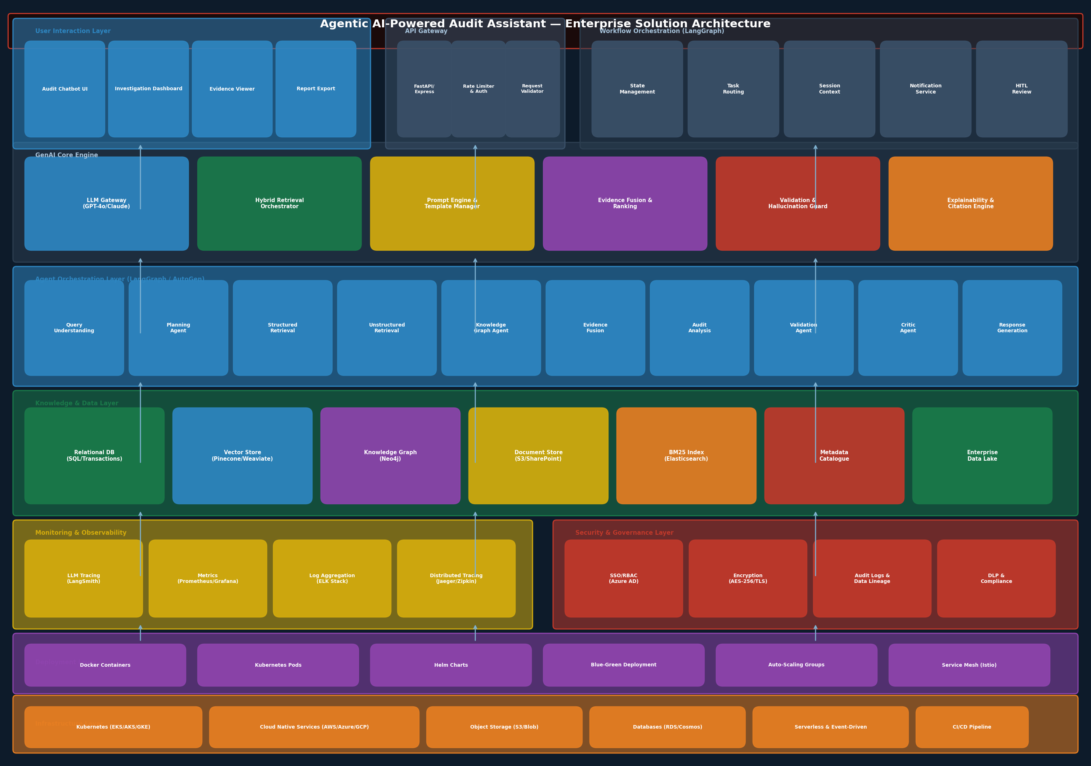
Figure 1: Enterprise Solution Architecture — Full System Layer Overview

8.2 Architecture Layers

Layer 1: User Interaction Layer
The user-facing layer provides the Audit Chatbot UI (React-based conversational interface), an Investigation Dashboard with evidence visualisation, an Evidence Viewer for drilling into source citations, and a Report Export module for generating audit deliverables. All user interactions are authenticated via SSO before reaching the API gateway.

Layer 2: API Gateway
A FastAPI/Express backend-for-frontend (BFF) pattern routes user requests through rate limiting, WAF controls, request validation, and authentication middleware before dispatching to the GenAI core. The API gateway is the single entry point for all client interactions.

Layer 3: GenAI Core Engine
The GenAI Core Engine contains the LLM Gateway (routing to GPT-4o / Claude 3.5 / Gemini 2.5), the Hybrid Retrieval Orchestrator, the Prompt Engine and Template Manager, the Evidence Fusion and Ranking module, the Validation and Hallucination Guard, and the Explainability and Citation Engine.

Layer 4: Agent Orchestration Layer
Implemented using LangGraph, this layer hosts the ten specialised audit agents. LangGraph's stateful graph execution model is well-suited to the conditional branching, parallel execution, and feedback loops required by complex audit investigations.

Layer 5: Knowledge & Data Layer
A polyglot data layer comprising: PostgreSQL/SQL Server for structured financial data, Pinecone/Weaviate vector store for semantic search, Neo4j for the knowledge graph, Elasticsearch for BM25 full-text search, S3/SharePoint for raw document storage, and a metadata catalogue for document management.

Layer 6: Security & Governance Layer
SSO/RBAC via Azure AD or Okta, AES-256 encryption at rest, TLS 1.3 in transit, comprehensive audit logging, DLP controls, and compliance policy enforcement.

Layer 7: Monitoring & Observability Layer
Prometheus/Grafana for system metrics, ELK Stack for log aggregation, Jaeger/Zipkin for distributed tracing, LangSmith for LLM-specific tracing and evaluation, and usage analytics for business intelligence.

Layer 8: Infrastructure Layer
Kubernetes (EKS/AKS/GKE) for container orchestration, cloud-managed services (AWS/Azure/GCP), CI/CD pipeline (GitHub Actions + ArgoCD), and multi-region deployment capability.

9. Agent Architecture

9.1 Agent Workflow Overview
The multi-agent architecture orchestrates ten specialised agents through a LangGraph-managed state machine. Each agent has precisely defined inputs, outputs, and responsibilities. Agents communicate through a shared state object that maintains the investigation context throughout the session.
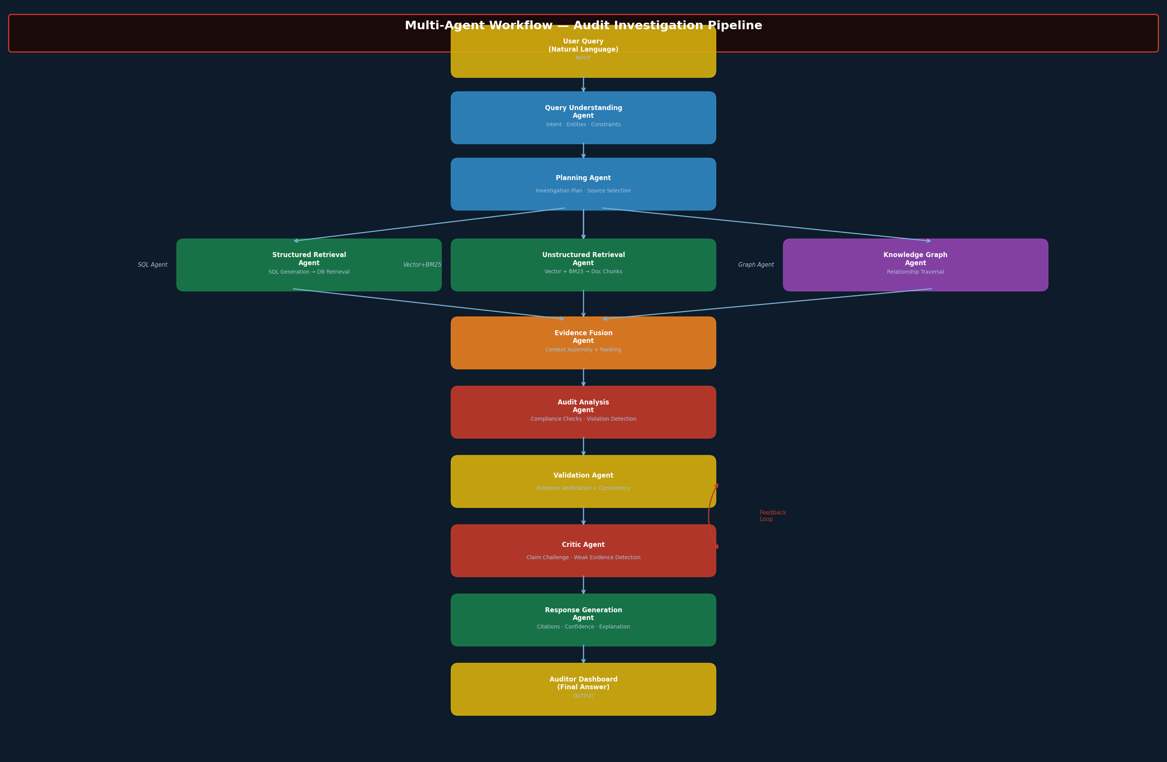
Figure 2: Multi-Agent Investigation Workflow — Agent Collaboration Pipeline

9.2 Agent Roles & Responsibilities

9.2.1 Query Understanding Agent
The entry point for all user queries. Applies intent classification, named entity recognition, constraint extraction, and query disambiguation. Produces a structured query object consumed by the Planning Agent.

9.2.2 Planning Agent
Receives the structured query and produces a detailed investigation plan — a directed acyclic graph (DAG) of retrieval tasks. Determines which data sources to query, in what sequence, and with what parameters. Selects appropriate retrieval agents based on the query intent and entity types identified.

9.2.3 Structured Retrieval Agent
Responsible for all structured data access. Translates the retrieval plan into parameterised SQL queries, validates them for safety and schema compliance, executes against the relational database, and returns typed result sets with row-level evidence metadata.

9.2.4 Unstructured Retrieval Agent
Manages document retrieval across the vector store and document repositories. Performs semantic similarity search using embedding-based cosine similarity, applies metadata pre-filters, and returns ranked document chunks with source attribution.

9.2.5 Knowledge Graph Agent
Traverses the Neo4j knowledge graph to identify entity relationships relevant to the investigation. Executes Cypher traversal queries to uncover connections between employees, vendors, transactions, approvals, and compliance records that would not be visible through tabular queries alone.

9.2.6 Evidence Fusion Agent
Aggregates retrieval outputs from all three retrieval agents (structured, unstructured, graph). Applies reciprocal rank fusion, de-duplication, relevance re-ranking, and token budget management to produce a unified evidence package optimised for the LLM context window.

9.2.7 Audit Analysis Agent
Applies audit-domain reasoning to the evidence package. Performs compliance checking against retrieved policy documents, identifies threshold violations, flags missing documentation, and generates candidate findings with supporting evidence references.

9.2.8 Validation Agent
Systematically verifies each candidate finding: confirms every claim has supporting evidence, checks claim-evidence semantic alignment (similarity threshold > 0.82), validates against the active policy version, and performs cross-source consistency checks.

9.2.9 Critic Agent
Acts as an independent challenger. Reviews validated findings for weak evidence, unsupported inferences, and logical inconsistencies. Returns findings for revision if they do not meet evidence quality standards. This agent implements a "red team" pattern to improve output quality.

9.2.10 Response Generation Agent
Produces the final auditor-facing response. Generates natural language explanations with inline citations, constructs the evidence chain, assigns confidence scores, and formats the explainability package for the UI layer.

10. Agent Input / Output Specification
Agent | Primary Input | Primary Output | Key Responsibilities
Query Understanding Agent | Raw natural language query string | Structured query: intent, entities, constraints, date ranges | Intent classification, NER, constraint extraction, query disambiguation
Planning Agent | Structured query object + data source catalogue | Investigation DAG: ordered retrieval tasks with source assignments | Task decomposition, source selection, execution planning, parallelism
Structured Retrieval Agent | SQL retrieval task + schema metadata | Typed result set with row IDs and threshold analysis | NL-to-SQL, SQL validation, DB execution, result post-processing
Unstructured Retrieval Agent | Semantic search task + metadata filters | Ranked document chunks with source attribution and similarity scores | Embedding search, BM25 search, metadata filtering, result ranking
Knowledge Graph Agent | Entity relationship traversal task | Graph paths, entity relationships, risk findings via traversal | Cypher query generation, graph traversal, relationship scoring
Evidence Fusion Agent | All retrieval agent outputs (structured, unstructured, graph) | Unified evidence package: ranked, de-duplicated, token-budgeted | RRF fusion, re-ranking, de-duplication, context window management
Audit Analysis Agent | Evidence package + applicable policies | Candidate findings with evidence references and violation flags | Policy comparison, threshold analysis, compliance checking
Validation Agent | Candidate findings + evidence package | Validation report: evidence check, alignment score, policy match, confidence | Evidence verification, NLI alignment, cross-source consistency
Critic Agent | Validated findings + validation report | Approved findings or revision requests with specific objections | Independent challenge, weak evidence detection, logical consistency
Response Generation Agent | Approved findings + evidence chain + citations | Final response with citations, confidence, evidence chain, agent trace | Explanation generation, citation formatting, confidence reporting

11. Structured Data Architecture

11.1 Overview
Structured financial and operational data is the primary evidentiary source for transaction-level audit questions. Unlike unstructured documents, structured data provides precise, quantitative evidence about financial events, approval decisions, and compliance statuses. The system is designed to query this data through a sophisticated SQL generation pipeline rather than embedding-based retrieval, which would lose the precision required for financial analysis.
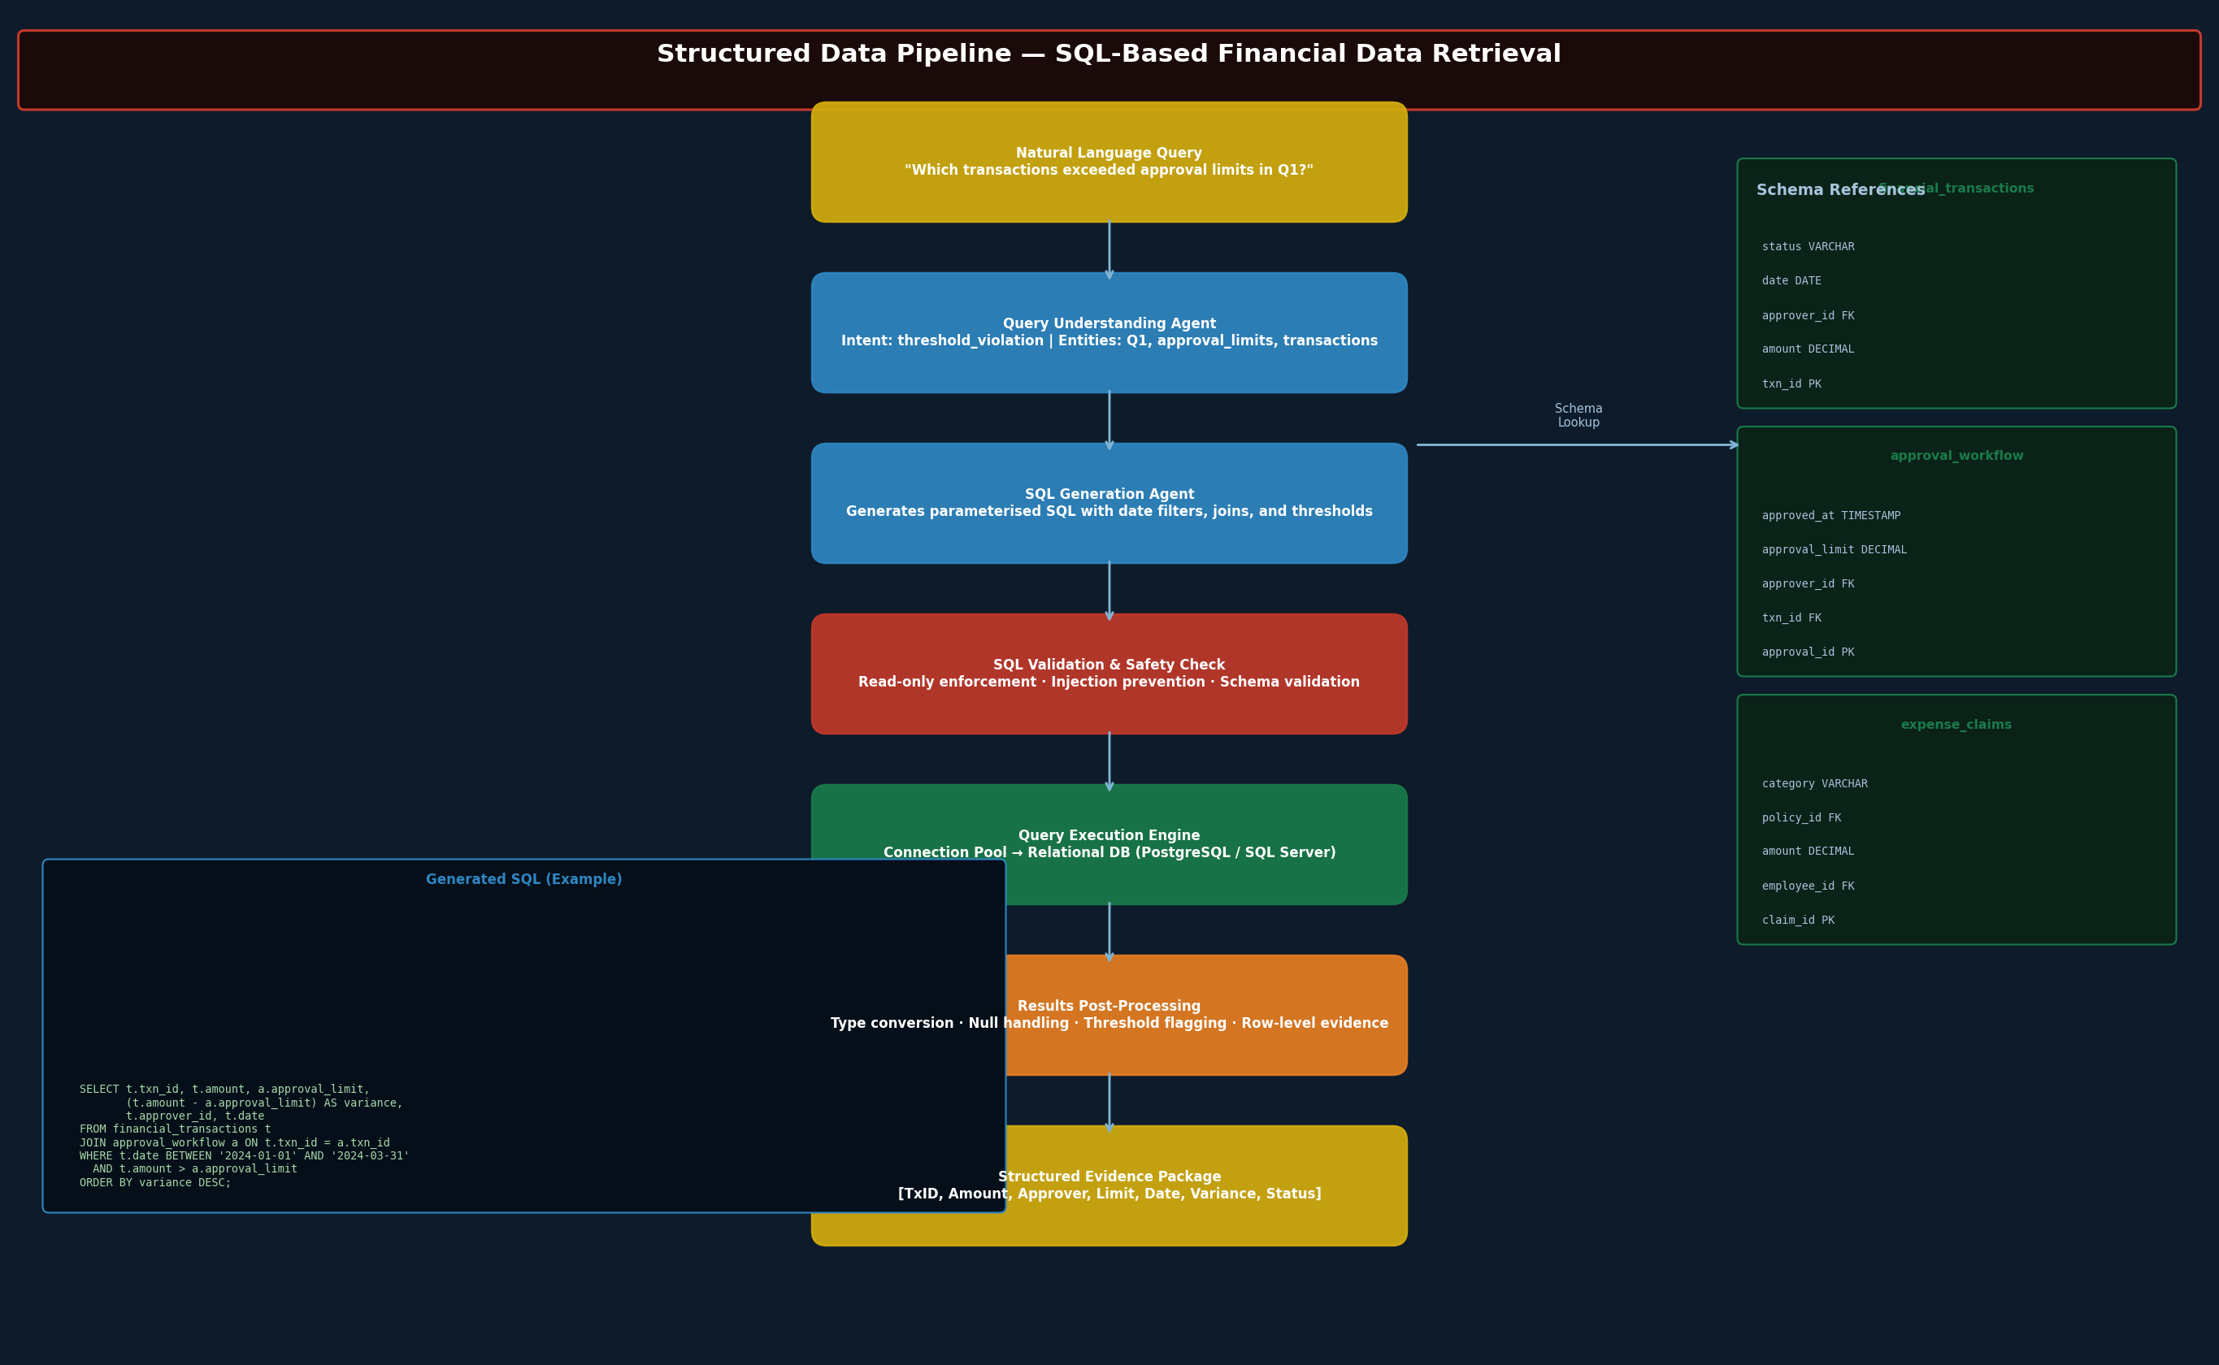
Figure 3: Structured Data Pipeline — NL-to-SQL Financial Data Retrieval

11.2 Core Data Domains
Data Domain | Key Tables / Entities
Financial Transactions | financial_transactions (txn_id, amount, date, category, approver_id, status, supporting_doc_id)
Approval Workflows | approval_workflow (approval_id, txn_id, approver_id, approval_limit, approved_at, delegation_chain)
Expense Claims | expense_claims (claim_id, employee_id, amount, category, policy_id, receipt_id, travel_policy_ref)
Vendor Records | vendors (vendor_id, name, registration, tier, active_status, compliance_expiry, contract_ref)
Compliance Records | compliance_records (record_id, entity_id, entity_type, framework, status, assessed_date, expiry_date)
Purchase Orders | purchase_orders (po_id, vendor_id, amount, approval_chain, delivery_status, contract_id)

11.3 SQL Generation Pipeline
The SQL Generation Agent implements a schema-aware few-shot prompting approach. It maintains a read-only view of the database schema and uses structured output (JSON function calling) to produce parameterised SQL queries. All generated SQL undergoes safety validation before execution:
- Read-only enforcement: All generated queries are SELECT statements; write operations are blocked at the connection level.
- SQL injection prevention: Parameters are extracted as typed values and bound via prepared statement patterns.
- Schema validation: Table and column references are validated against the actual schema before execution.
- Execution limits: Maximum row return limits and query timeout controls prevent runaway queries.

11.4 Example Investigation Flow
Query: "Which transactions exceeded approval limits during Q1?"
SQL Generated:
SELECT t.txn_id, t.amount, a.approval_limit, (t.amount - a.approval_limit) AS variance,
t.approver_id, t.date, t.status
FROM financial_transactions t
JOIN approval_workflow a ON t.txn_id = a.txn_id
WHERE t.date BETWEEN '2024-01-01' AND '2024-03-31'
AND t.amount > a.approval_limit
ORDER BY variance DESC;
Evidence Output: 23 transactions returned with txn_id, amount, limit, variance, and approver chain.

12. Unstructured Data Architecture

12.1 Overview
Unstructured document data provides the policy context, procedural guidance, and historical audit evidence that structured data cannot. Policies define what constitutes a violation; SOPs specify required procedures; past audit reports establish precedent. The unstructured data pipeline is responsible for ingesting, processing, indexing, and retrieving this corpus.
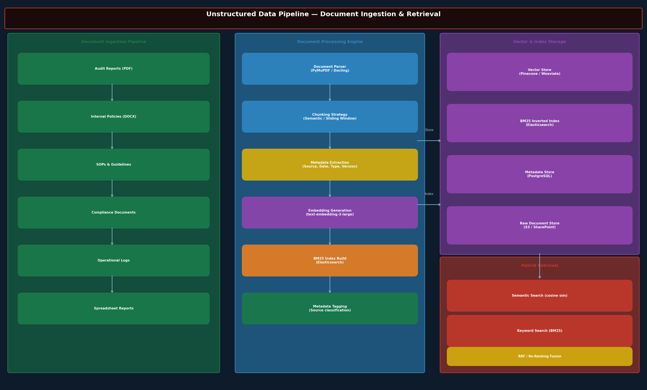
Figure 4: Unstructured Data Pipeline — Document Ingestion, Indexing & Retrieval

12.2 Document Ingestion Pipeline

Document Parsing
Ingested documents pass through a multi-format parser (PyMuPDF for PDFs, python-docx for Word, Apache Tika for other formats) that extracts clean text, tables, and structural metadata. OCR (Tesseract) is applied to scanned documents.

Chunking Strategy
A semantic chunking approach is used over fixed-size windows, preserving natural paragraph and section boundaries. Chunk size is configured per document type: 512 tokens for policies (precise policy clause retrieval), 1024 tokens for reports (broader context), with 10% overlap to prevent context loss at chunk boundaries.

Embedding Generation
Document chunks are embedded using OpenAI text-embedding-3-large (3072 dimensions) for high-precision semantic search. Embeddings are stored in the vector store alongside the chunk text and source metadata.

Metadata Tagging
Each chunk is tagged with: source document ID, document type (policy/SOP/audit report/compliance doc), effective date, version, jurisdiction, and owning department. Metadata tags enable pre-filtering before similarity search, dramatically improving retrieval precision.

13. Hybrid Retrieval Architecture

13.1 Design Rationale
No single retrieval method is optimal across all audit query types. Vector search excels at semantic similarity but can miss precise keyword matches. BM25 excels at keyword retrieval but lacks semantic understanding. SQL retrieval is essential for structured data but cannot process unstructured documents. Knowledge graph retrieval uncovers entity relationships invisible to text-based methods. The hybrid architecture combines all four to maximise evidence recall and precision.
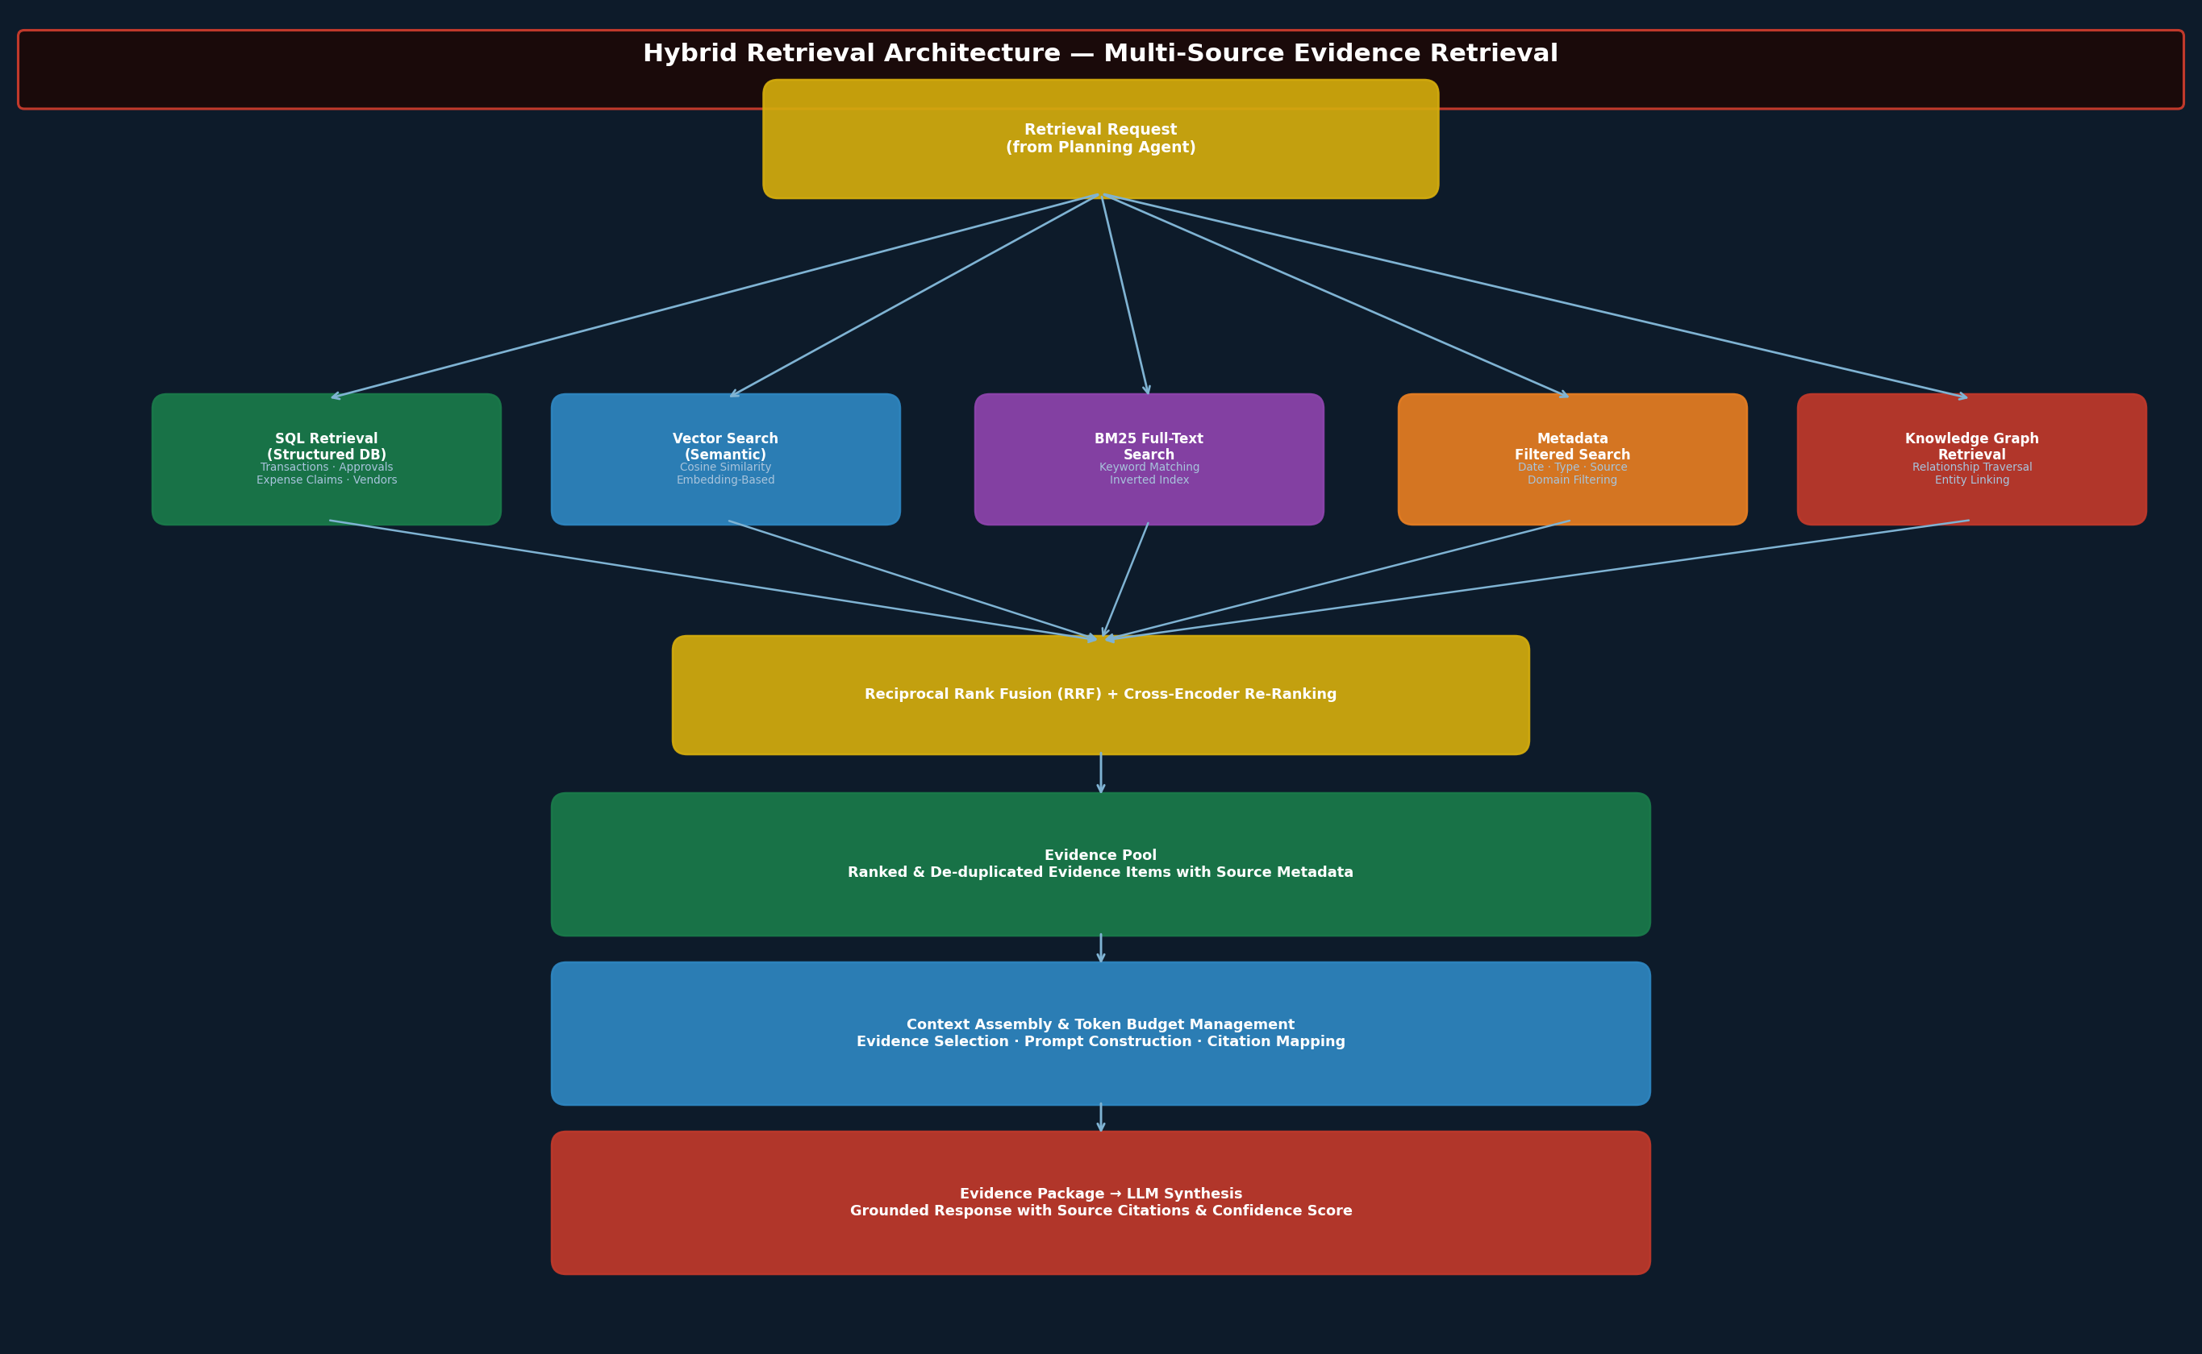
Figure 5: Hybrid Retrieval Architecture — Multi-Source Evidence Fusion

13.2 Retrieval Components
Retrieval Method | Description & Use Cases
SQL Retrieval | NL-to-SQL generation for structured financial databases. Optimal for precise quantitative queries: threshold violations, approval limit checks, date-range transaction analysis.
Vector Search | Embedding-based cosine similarity search in the vector store. Optimal for semantic policy lookups, document similarity, and concept-level queries where exact keywords are not known.
BM25 Full-Text Search | Elasticsearch inverted index keyword search. Optimal for specific regulation references, policy clause lookups, and queries where exact terminology is important.
Metadata Filtering | Pre-retrieval filter applied to both vector and BM25 searches. Uses document type, date, jurisdiction, and department tags to restrict the retrieval space before similarity scoring.
Knowledge Graph Retrieval | Cypher-based traversal of Neo4j entity graph. Optimal for relationship-based queries: vendor risk profiling, approval chain analysis, entity-level compliance status.

13.3 Evidence Fusion: Reciprocal Rank Fusion (RRF)
Results from all retrieval methods are fused using Reciprocal Rank Fusion (RRF), a parameter-free rank aggregation algorithm that has been shown to outperform individual ranking methods without requiring score normalisation across heterogeneous sources.
The RRF score for evidence item d is computed as: RRF(d) = Σ 1 / (k + rank_i(d)) where k=60 (a constant that reduces the impact of high-ranked results) and rank_i(d) is the rank of item d in retrieval method i. Items not retrieved by a method receive a rank penalty.
Following RRF fusion, a cross-encoder re-ranking model (ms-marco-MiniLM-L-6-v2) is applied to the top-50 candidates to produce the final ranked evidence list.

14. Knowledge Graph Architecture

14.1 Graph Model
The audit knowledge graph models the entity relationships that are most relevant to audit investigations. The graph is implemented in Neo4j and updated via CDC (Change Data Capture) events from the relational database.
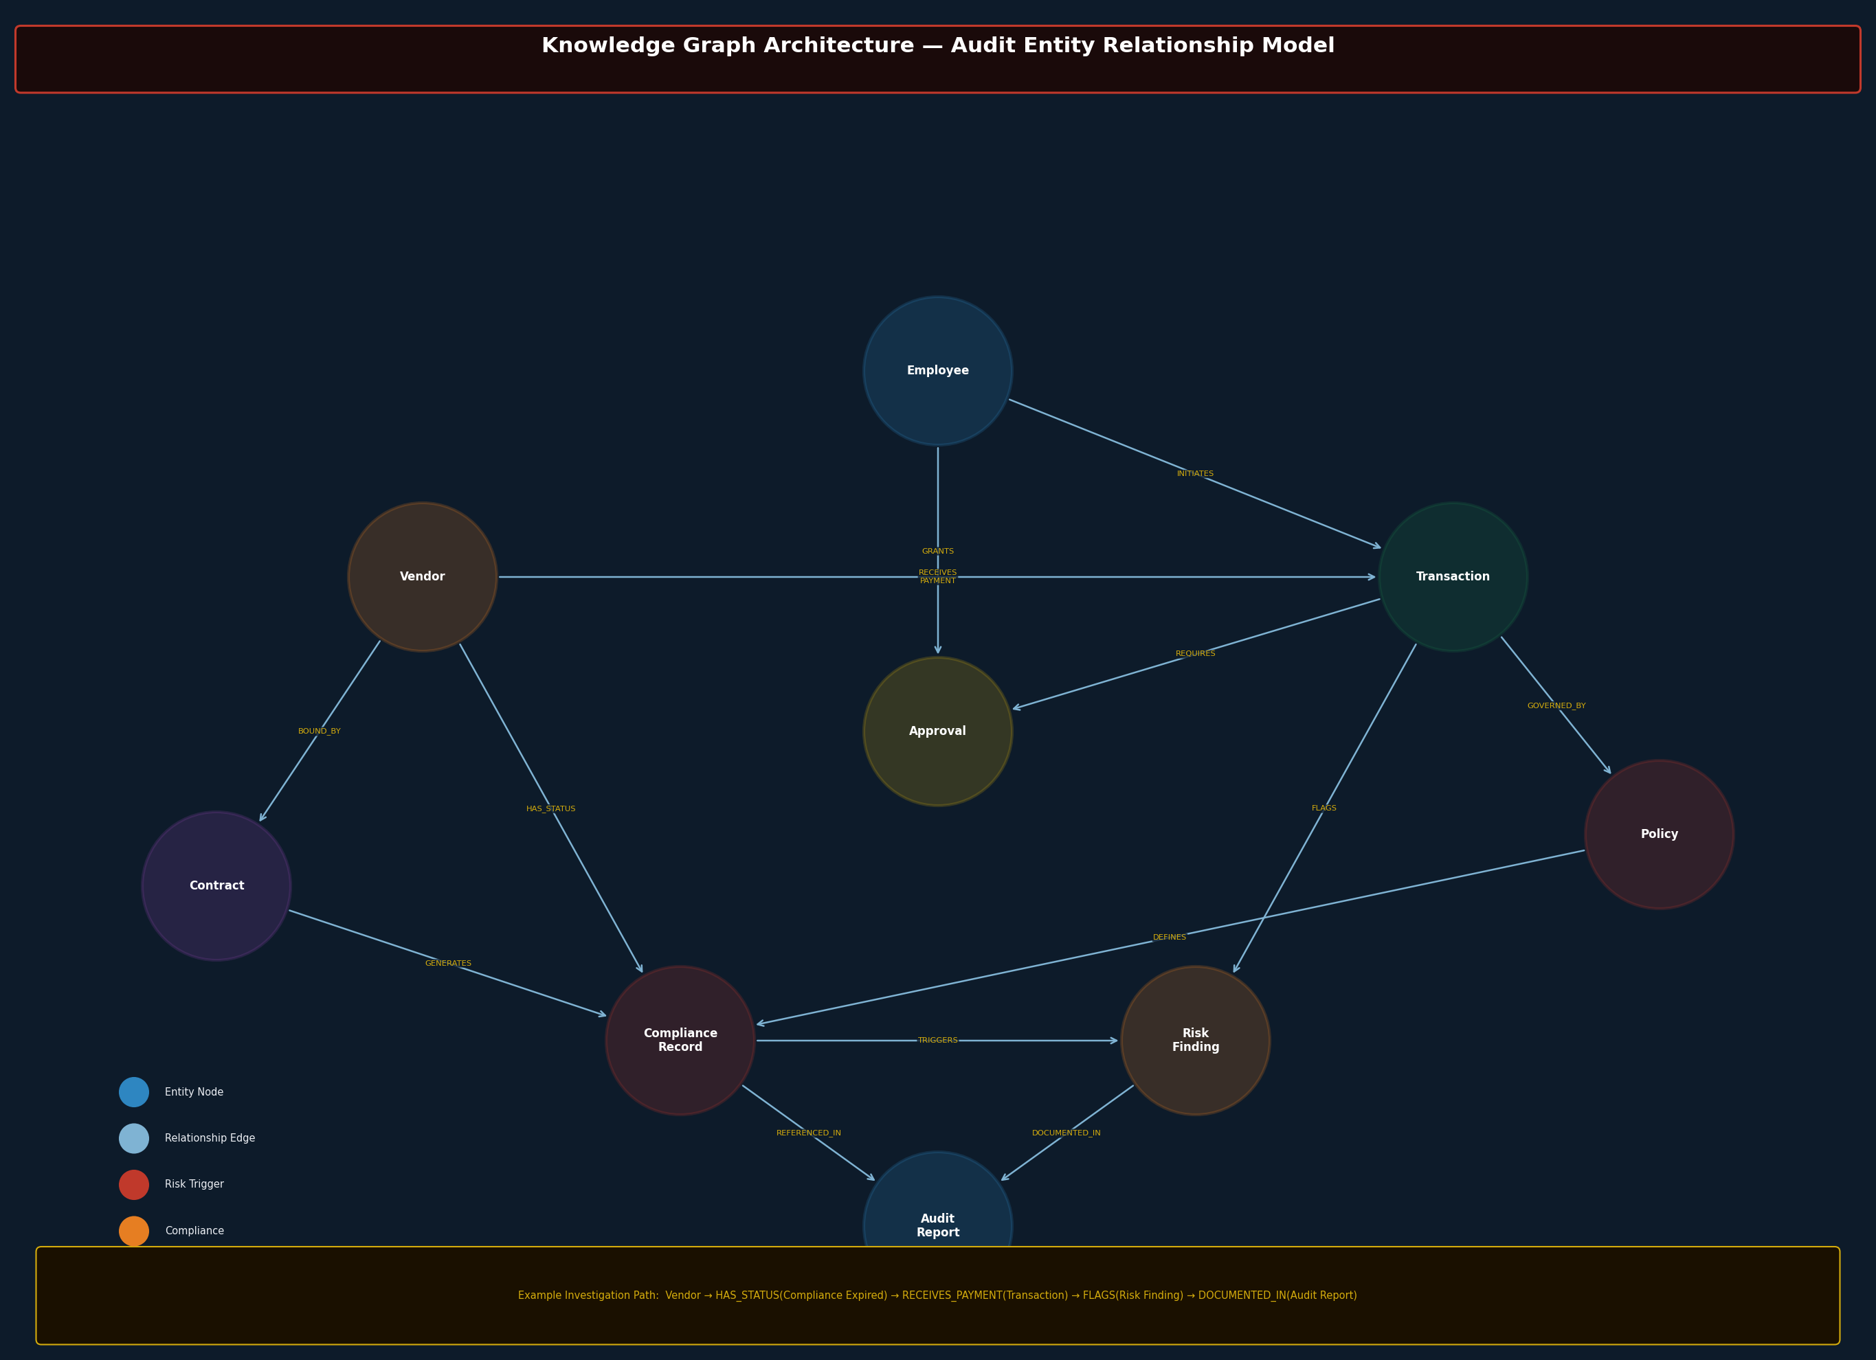
Figure 6: Knowledge Graph Architecture — Audit Entity Relationship Model

14.2 Node Types & Properties
Node Type | Key Properties
Employee | employee_id, name, department, role, approval_authority_level, active_status
Vendor | vendor_id, name, registration_no, country, tier, risk_rating, active_status
Transaction | txn_id, amount, date, category, status, supporting_doc_ref
Approval | approval_id, approval_limit, approved_by, approved_at, delegation_ref
Contract | contract_id, vendor_id, value, start_date, end_date, scope
Compliance Record | record_id, framework, status, assessed_date, expiry_date, findings
Policy | policy_id, name, version, effective_date, jurisdiction, owner
Risk Finding | finding_id, severity, category, description, evidence_refs, status

14.3 Relationship Types
Relationship | Description
(Employee)-[INITIATES]->(Transaction) | Employee initiates or creates a transaction
(Employee)-[GRANTS]->(Approval) | Employee provides approval for a transaction
(Vendor)-[RECEIVES_PAYMENT]->(Transaction) | Vendor is the beneficiary of a transaction
(Vendor)-[BOUND_BY]->(Contract) | Vendor is subject to a specific contract
(Vendor)-[HAS_STATUS]->(Compliance Record) | Current compliance assessment for vendor
(Transaction)-[REQUIRES]->(Approval) | Transaction requires an approval record
(Transaction)-[GOVERNED_BY]->(Policy) | Transaction falls under a specific policy
(Compliance Record)-[TRIGGERS]->(Risk Finding) | Expired or failed compliance triggers a risk finding
(Transaction)-[FLAGS]->(Risk Finding) | Transaction is associated with a risk finding

14.4 Graph Investigation Patterns
The knowledge graph enables investigation patterns that are impractical with relational queries alone:
- Vendor Risk Path: Vendor → HAS_STATUS(Compliance Expired) → Vendor: identify all vendors with expired compliance, then → RECEIVES_PAYMENT → Transaction: identify all transactions with these vendors.
- Approval Chain Analysis: Transaction → REQUIRES → Approval → GRANTS ← Employee: traverse the full approval delegation chain for a transaction to identify inappropriate approval authority.
- Policy Breach Path: Transaction → GOVERNED_BY → Policy → DEFINES ← Compliance Record: identify transactions governed by a policy that has associated failed compliance records.

15. Validation Architecture

15.1 Overview
The validation architecture is the quality assurance backbone of the system. It implements a sequential multi-layer validation pipeline that every candidate finding must pass before reaching the response generation stage. This pipeline is the primary mechanism for preventing hallucinated, unsupported, or policy-inconsistent findings from reaching auditors.
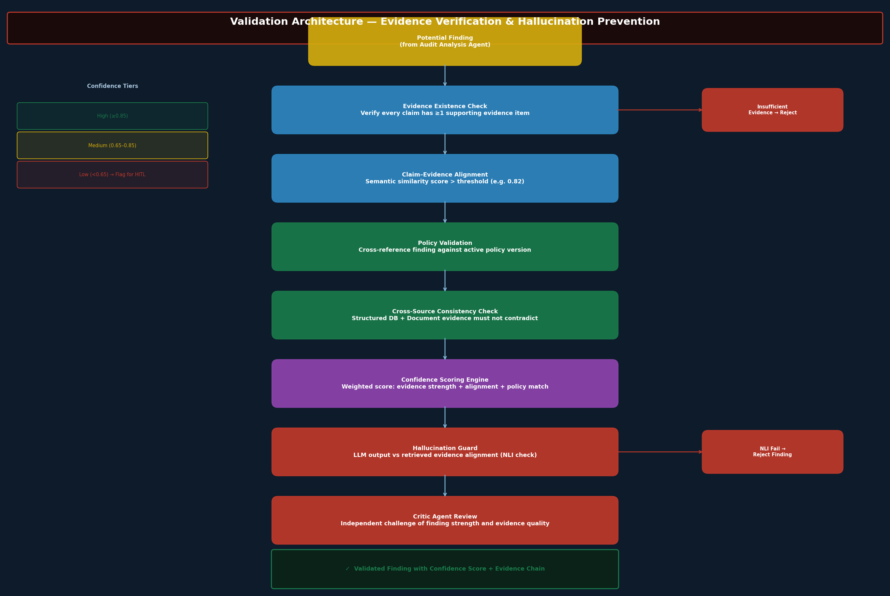
Figure 7: Validation Architecture — Multi-Layer Evidence Verification Pipeline

15.2 Validation Layers
Validation Layer | Description & Failure Handling
Evidence Existence Check | Verifies that every claim in a candidate finding is supported by at least one retrieved evidence item. Findings with unsupported claims are rejected back to the Evidence Fusion Agent for additional retrieval.
Claim-Evidence Alignment | Computes semantic similarity between each claim and its supporting evidence using a cross-encoder model. Claims with alignment score < 0.82 are flagged. Persistent failures trigger rejection.
Policy Validation | Cross-references each finding against the current active version of the applicable policy. Policy references are retrieved from the unstructured data pipeline and version-checked against the metadata catalogue.
Cross-Source Consistency | Checks for contradictions between structured database evidence and unstructured document evidence for the same finding. Contradictions are flagged for human-in-the-loop (HITL) review.
Confidence Scoring Engine | Calculates a weighted confidence score: Evidence Strength (40%) + Claim-Evidence Alignment (30%) + Policy Match (30%). Findings below 0.65 threshold are escalated to HITL review.
Hallucination Guard | Applies Natural Language Inference (NLI) to classify each claim as Entailed, Neutral, or Contradicted by the evidence. Contradicted claims are rejected; Neutral claims trigger additional retrieval before re-evaluation.
Critic Agent Review | Final independent challenge by the Critic Agent. Reviews validated findings for logical consistency, evidence sufficiency, and alternative interpretations. May return findings for revision with specific objections.

15.3 Confidence Score Interpretation
Score Range | Tier | Action
0.85 – 1.00 | High Confidence | Present to auditor with confidence indicator; no HITL required
0.65 – 0.84 | Medium Confidence | Present to auditor with uncertainty flag; recommend verification
< 0.65 | Low Confidence | Escalate to HITL review; do not present as finding without human validation

16. Explainability Architecture

16.1 Design Principle
Explainability is not an optional feature in audit AI systems — it is a core architectural requirement. Auditors must be able to understand and defend every conclusion produced by the system. The explainability architecture ensures that all six dimensions of response transparency are exposed to the auditor for every query response.
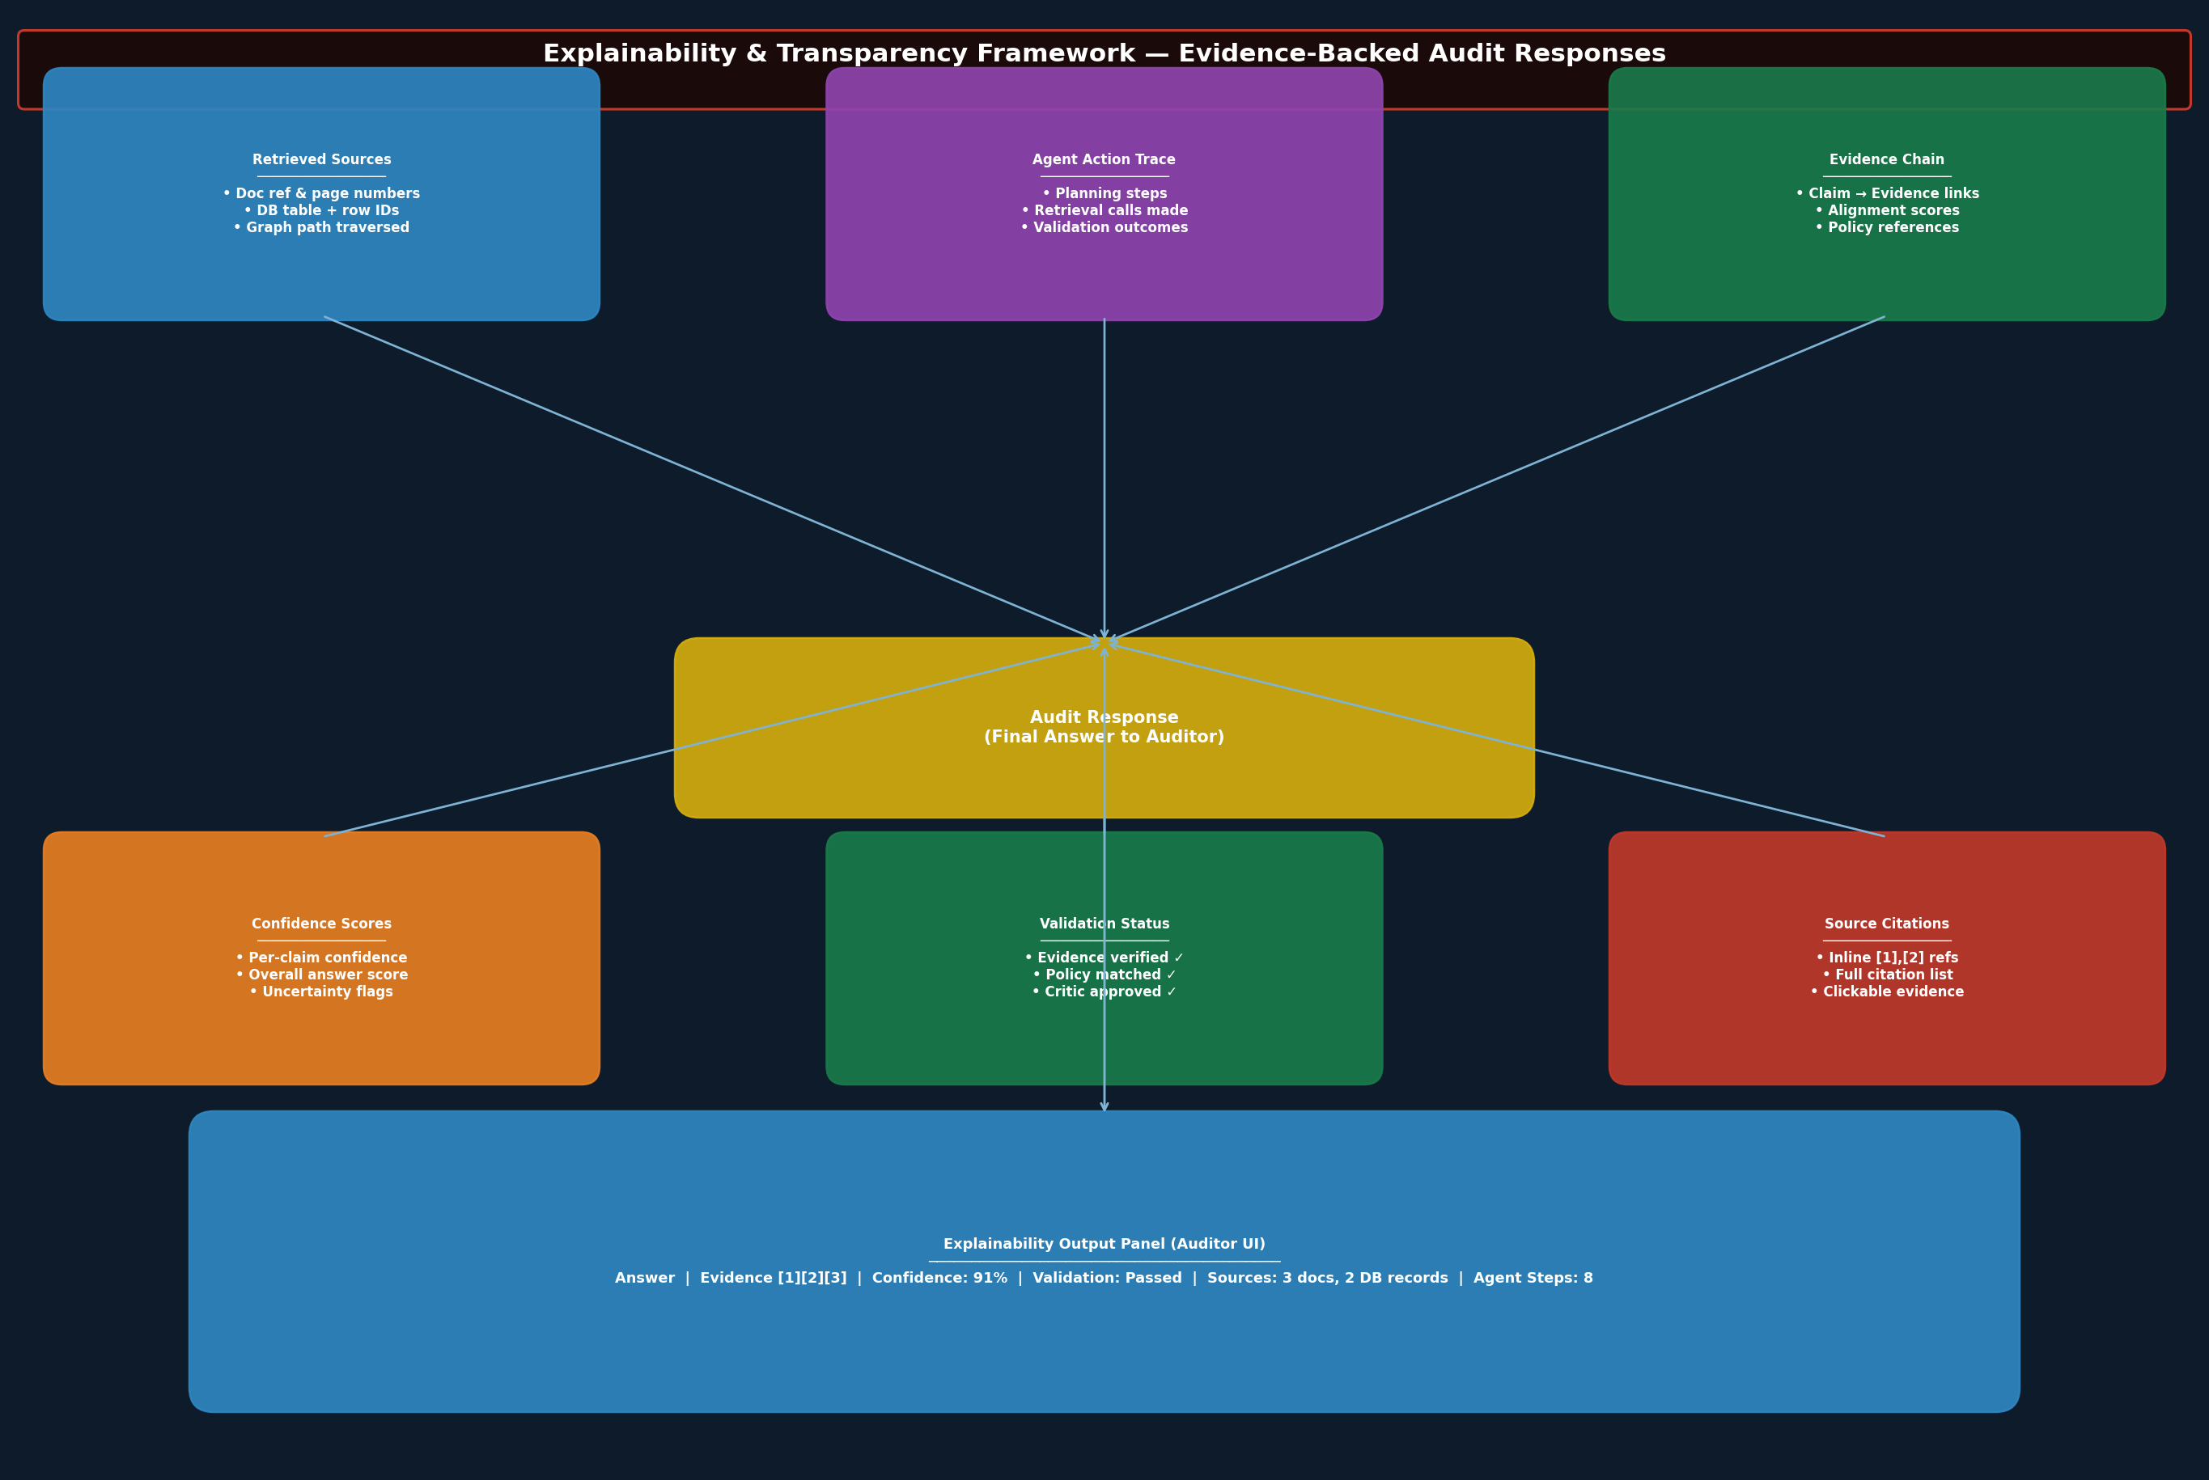
Figure 8: Explainability Framework — Six-Dimension Response Transparency Model

16.2 Explainability Dimensions
Dimension | What is Exposed
Retrieved Sources | All documents, DB records, and graph paths retrieved during the investigation, with document IDs, page numbers, table/row references, and source system identifiers.
Agent Action Trace | Complete log of agent invocations, tools called, sub-queries executed, and retrieval operations performed — the full "reasoning path" of the investigation.
Evidence Chain | Explicit mapping from each claim in the response to the specific evidence items that support it, including semantic alignment scores.
Validation Status | Per-finding validation outcomes: evidence existence check result, policy match status, cross-source consistency result, NLI classification, and critic review outcome.
Confidence Score | Weighted confidence score for each finding (0–100%) and overall response confidence, with component score breakdown (evidence strength, alignment, policy match).
Source Citations | Inline numbered citations [1][2][3] within the response text, linked to a full citation list with document title, version, date, and access URL/record reference.

16.3 UI Explainability Panel
The auditor UI exposes a collapsible explainability panel alongside every response. The panel presents: the answer with inline citations; a confidence score badge (High/Medium/Low); a validation status summary; expandable evidence items with source attribution; the agent action trace timeline; and an export-to-PDF option for the full evidence package.

17. Security Architecture

17.1 Authentication & Authorisation
- Single Sign-On (SSO) via SAML 2.0 / OIDC integration with enterprise identity providers (Azure Active Directory, Okta, PingFederate).
- Role-Based Access Control (RBAC) enforced at the API gateway and data access layers. Roles: Read-Only Auditor, Audit Manager, System Administrator, Data Owner.
- Field-level access control on structured data queries — auditors can only retrieve data within their authorised scope (department, entity, geographic region).
- Document-level access control in the vector store — document metadata includes access permission tags enforced at retrieval time.

17.2 Data Security
- AES-256 encryption at rest for all stored data (vector embeddings, database records, document files, audit logs).
- TLS 1.3 for all data in transit between system components and between clients and the API gateway.
- Data Loss Prevention (DLP) controls to prevent sensitive financial data from being transmitted outside authorised channels.
- Data residency controls to enforce regulatory jurisdiction requirements (e.g., GDPR EU data residency).

17.3 Audit Logging & Data Lineage
- 100% query logging: every user query, agent action, retrieval call, and response generated is logged to an immutable audit log store (append-only).
- Data lineage tracking: every piece of evidence in a response is traceable to its source system record with a lineage chain from the original data source through ingestion, processing, and retrieval.
- Audit log integrity: logs are cryptographically signed and stored in tamper-evident storage.
- Retention policy: audit logs retained for minimum 7 years in compliance with standard audit record retention requirements.

17.4 Security Controls Summary
Security Domain | Controls Implemented
Identity & Access | SSO (SAML 2.0/OIDC), MFA enforcement, RBAC, field-level access control, least privilege principle
Encryption | AES-256 at rest, TLS 1.3 in transit, key rotation (90-day cycle), HSM-managed keys
Network Security | VPC isolation, private endpoints, WAF (OWASP ruleset), DDoS protection, network segmentation
Application Security | SQL injection prevention, prompt injection detection, input validation, dependency scanning
Audit & Compliance | Immutable audit logs, data lineage, 7-year retention, GDPR/SOX/ISO27001 controls
Incident Response | SIEM integration, automated threat detection, incident runbooks, 4-hour RTO

18. Deployment Architecture

18.1 Overview
The system is deployed on a cloud-native Kubernetes architecture designed for high availability, horizontal scalability, and zero-downtime deployments. The architecture supports multi-cloud deployment (AWS EKS, Azure AKS, or GCP GKE) through cloud-agnostic Helm charts and Terraform IaC.
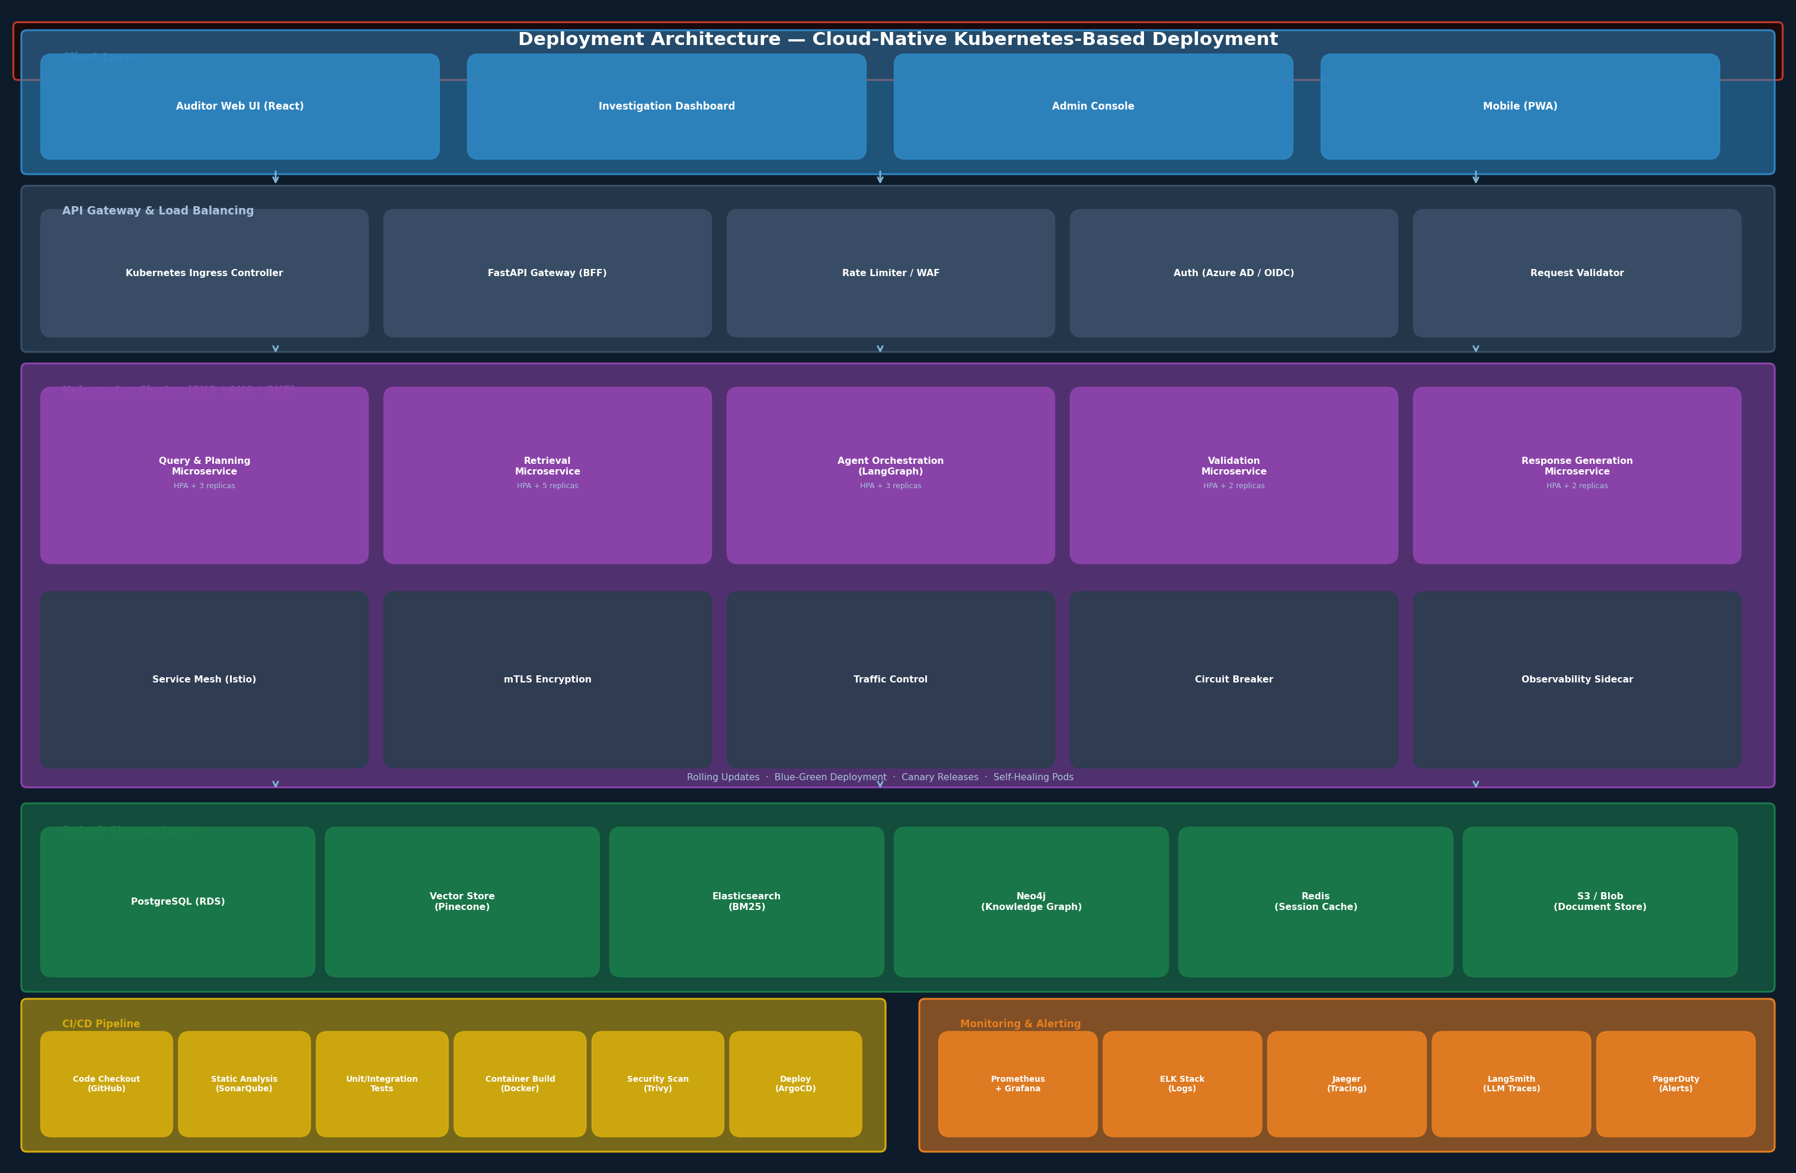
Figure 9: Deployment Architecture — Cloud-Native Kubernetes Infrastructure

18.2 Kubernetes Configuration
Microservice | Replicas (Baseline)
Query & Planning Service | 3 replicas, HPA configured (2× – 10×)
Retrieval Service (Structured + Unstructured) | 5 replicas, HPA (3× – 15×)
Agent Orchestration Service (LangGraph) | 3 replicas, HPA (2× – 10×)
Validation Service | 2 replicas, HPA (2× – 8×)
Response Generation Service | 2 replicas, HPA (2× – 8×)

18.3 Deployment Strategies
- Blue-Green Deployment: Production traffic switches between blue and green environments via the ingress controller. Enables zero-downtime major releases and instant rollback.
- Canary Releases: New versions receive 5% of traffic initially, with automated promotion based on error rate and latency SLOs.
- Rolling Updates: Minor updates use rolling deployment with a 25% max unavailable policy.
- Self-Healing: Kubernetes liveness and readiness probes restart failed pods automatically. Pod disruption budgets ensure minimum availability during updates.

18.4 Service Mesh
Istio service mesh provides mTLS encryption for all inter-service communication, traffic control (weighted routing for canary deployments), circuit breaker patterns to prevent cascade failures, and distributed tracing integration with Jaeger.

18.5 CI/CD Pipeline
GitHub Actions pipeline triggers on pull request merge: code checkout → static analysis (SonarQube) → unit/integration tests → container build (Docker) → security scan (Trivy container scanning + Snyk dependency scan) → ArgoCD GitOps deployment → smoke tests → automated rollback on failure.

19. Evaluation Framework

19.1 Overview
Given the high-assurance nature of audit environments, the evaluation framework is a first-class component of the system architecture. Evaluation operates at two cadences: online evaluation (continuous per-query scoring) and offline evaluation (periodic batch assessment against curated benchmarks). The RAGAS framework provides the foundation for retrieval and response quality metrics.
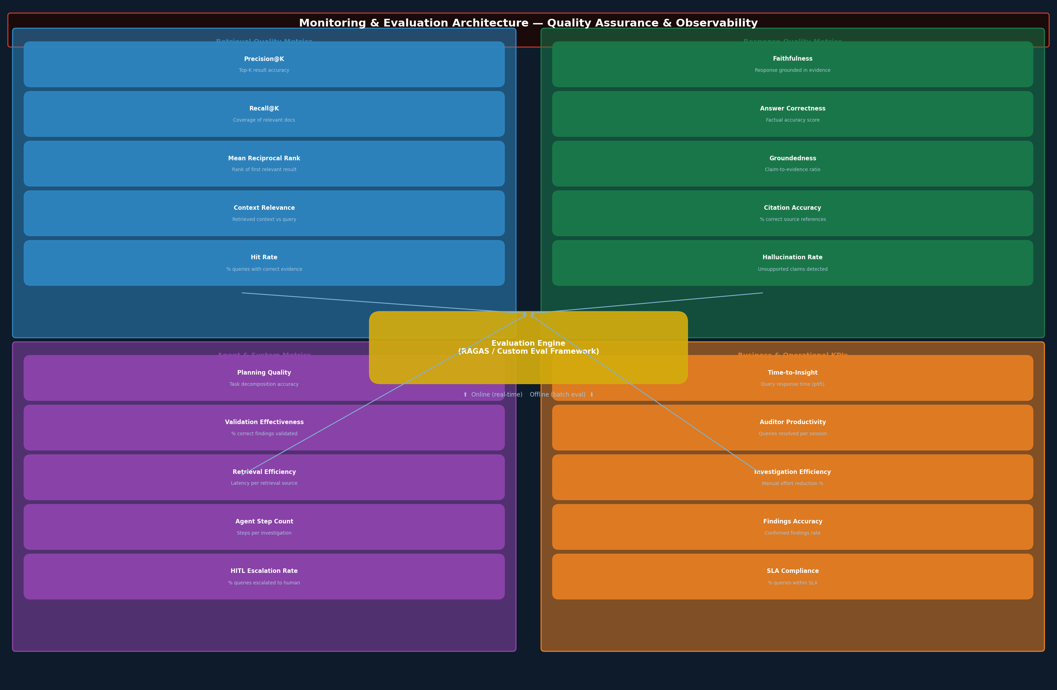
Figure 10: Monitoring & Evaluation Architecture — Quality Assurance & Observability

19.2 Retrieval Quality Metrics
Metric | Definition | Target | Tool
Precision@K | Proportion of top-K retrieved items that are relevant | > 0.85 at K=5 | RAGAS
Recall@K | Proportion of all relevant items retrieved in top K | > 0.80 at K=10 | RAGAS
Mean Reciprocal Rank | Average of reciprocal rank of first relevant result | > 0.75 | Custom
Context Relevance | Relevance of retrieved context to the query | > 0.82 | RAGAS
Hit Rate | Proportion of queries with correct evidence in top K | > 0.90 | RAGAS

19.3 Response Quality Metrics
Metric | Definition | Target | Tool
Faithfulness | Proportion of claims supported by retrieved context | > 0.90 | RAGAS
Answer Correctness | Factual accuracy vs ground truth answers | > 0.85 | RAGAS + LLM Judge
Groundedness | Degree to which response is grounded in evidence | > 0.88 | RAGAS
Citation Accuracy | Proportion of citations that correctly reference the claim | > 0.92 | Custom
Hallucination Rate | Proportion of claims not supported by any evidence | < 0.02 | NLI Model

19.4 Agent & System Metrics
Metric | Definition | Target | Monitoring
Planning Quality | Accuracy of retrieval source selection vs expert-labelled queries | > 0.88 | LangSmith
Validation Effectiveness | Proportion of incorrect findings correctly rejected | > 0.95 | Audit log analysis
Agent Step Count (p95) | Number of agent invocations per query (efficiency) | < 12 steps | LangSmith
Query Latency (p95) | End-to-end response time | < 60 seconds | Prometheus
HITL Escalation Rate | Proportion of queries escalated to human review | < 5% | Custom dashboard

20. Future Enhancements

20.1 Phase 2 Enhancements (6–12 Months)
- Continuous Learning Loop: Implement feedback capture from auditors on response quality. Use accepted/rejected findings to fine-tune the validation and analysis agents.
- Proactive Anomaly Detection: Extend from reactive (query-driven) to proactive (scheduled) investigations. The system automatically surfaces high-risk transactions, expiring compliance records, and approval limit trends without requiring explicit queries.
- Multi-Modal Evidence: Extend document ingestion to support image-based evidence (scanned invoices, signed documents) using vision-capable models for OCR and content extraction.
- Regulatory Framework Integration: Pre-built policy libraries for major audit frameworks (SOX, GDPR, ISO 27001, IFRS) with automated policy version management and change impact analysis.

20.2 Phase 3 Enhancements (12–24 Months)
- Agentic Audit Report Generation: Full-cycle automated draft audit report generation based on investigation findings, structured according to standard audit report templates.
- Cross-Entity Investigation: Extend knowledge graph to support multi-entity (multi-subsidiary) investigations for group-level audit functions.
- Predictive Risk Scoring: Machine learning models that score transaction risk in real-time based on historical audit findings patterns, enabling pre-emptive flagging of high-risk items.
- Integration with GRC Platforms: Native connectors to ServiceNow GRC, SAP GRC, and Archer for seamless finding export and issue management workflow integration.
- Federated Query Architecture: Extend structured retrieval to support federated SQL queries across multiple ERP instances and subsidiary databases without centralising sensitive data.

20.3 Technology Roadmap
Enhancement | Rationale
Model fine-tuning on audit corpus | Improve domain-specific accuracy for audit terminology and investigation patterns
Streaming responses | Improve perceived performance for complex queries with real-time agent status updates
Voice interface | Enable hands-free query entry for field auditors during site visits
Offline mode (edge deployment) | Support investigations in low-connectivity environments with local model inference
Blockchain evidence attestation | Immutable timestamping of evidence packages for regulatory defensibility

21. Conclusion
The Agentic AI-Powered Audit Assistant represents a materially different approach to AI-assisted audit than generic chatbot or RAG-only implementations. By grounding every response in verified, cited evidence retrieved through a multi-method hybrid retrieval architecture, and subjecting every finding to a rigorous multi-layer validation pipeline before it reaches an auditor, the system addresses the fundamental trust and reliability requirements of enterprise audit environments.
The ten-agent architecture provides both the specialisation required for complex audit investigations and the modularity necessary for independent testing, monitoring, and future enhancement. The separation of retrieval (structured SQL, unstructured vector/BM25, knowledge graph), analysis (audit logic, policy checking), and validation (evidence verification, hallucination prevention, critic challenge) ensures that each system capability can be independently measured and improved.
The hybrid retrieval architecture — combining SQL precision, vector semantic search, BM25 keyword matching, metadata filtering, and knowledge graph traversal — ensures that no relevant evidence is systematically missed due to the limitations of any single retrieval method. This is particularly critical in audit contexts where completeness of evidence coverage directly affects the validity of findings.
The comprehensive explainability framework, exposing retrieved sources, agent action traces, evidence chains, validation statuses, confidence scores, and inline citations, ensures that auditors are never asked to trust a black-box response. Every conclusion can be verified, challenged, and defended.

The proposed architecture is designed for enterprise-grade deployment with the security, governance, scalability, and observability controls required for regulated financial environments. It provides a robust foundation for the current use case while establishing a reusable AI architecture pattern applicable to adjacent use cases including procurement audit, IT audit, and regulatory compliance monitoring.

— END OF DOCUMENT —
Version 1.0 | Confidential | GenAI Solutions Architecture Practice

