INTERNAL WORKING DOCUMENT
Audit Assistant — Logical Data Model
Entity Relationships · Schema Definitions · Audit Linkage Design

Field | Value
Document Status | Draft — Pending Manager Approval
Version | 1.0
Prepared By | Aditya — GenAI Solutions Team
For Review By | Engineering Manager / Data Architect
Date | June 2025
Next Step | Schema approval → Synthetic data generation

1. Purpose & Scope
This document defines the logical data model for the Agentic AI-Powered Audit Assistant. It covers entity definitions, column-level schemas, primary/foreign key relationships, and the business rationale for every linkage. Synthetic data generation will begin only after this model is approved.

The data model is designed around audit investigation workflows — not around source system convenience. Every relationship answers a concrete audit question: who approved this transaction? is this vendor compliant? what evidence supports this finding?

12 core entities are defined across three layers:
- Organisational Layer: Department, Employee
- Operational Layer: Vendor, Contract, Transaction, Approval Workflow, Expense Claim, Purchase Order, Compliance Record
- Audit Layer: Audit Investigation, Audit Finding, Evidence

2. Entity Relationship Diagram
The diagram below illustrates all 12 entities and their relationships. Solid lines represent foreign key relationships; arrow direction points from child → parent (FK → PK).

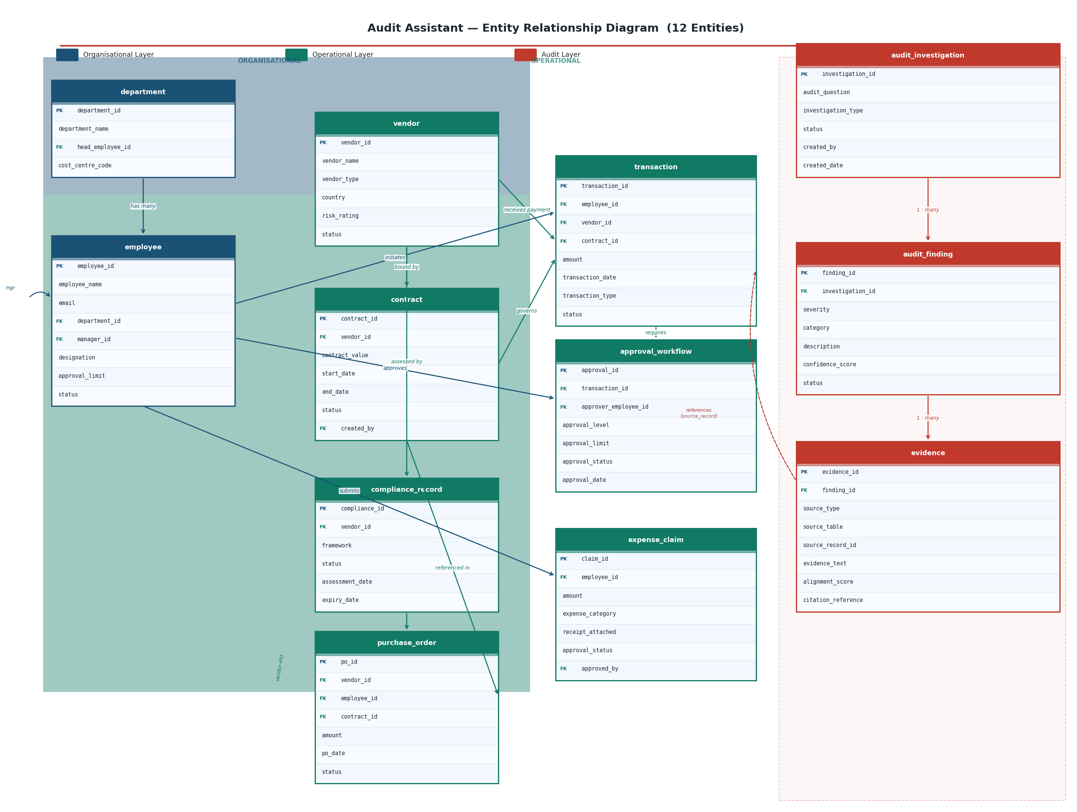
Figure 1: Audit Assistant — Full Entity Relationship Diagram (12 Entities)

Key Design Principle: Every audit investigation path is fully traversable through FK chains. Example: Audit Finding → Evidence → Transaction → Approval Workflow → Employee provides a complete chain from finding to the approving employee in a single JOIN path.

3. Key Relationship Design
This section explains the four critical audit linkages the manager raised, with the exact FK chain that answers each question.

3.1 How is a Transaction linked to an Employee?
Chain | Table | Column | Role
Initiator | transaction | employee_id → employee.employee_id | The employee who raised / submitted the transaction
Approver | approval_workflow | approver_employee_id → employee.employee_id | The employee who approved (or rejected) the transaction
Department | employee | department_id → department.department_id | Cost centre / business unit owning the transaction

Audit query enabled: "Show all transactions initiated by employees whose approval limit was exceeded by their own manager."

3.2 How is an Approval Record linked to a Transaction?
Column | Direction | Business Meaning
approval_workflow.transaction_id | FK → transaction.transaction_id | Every approval record belongs to exactly one transaction
approval_workflow.approval_limit | (stored value) | The limit at the time of approval — enables historical threshold checks
approval_workflow.approval_level | (stored value) | Level 1/2/3 — supports multi-tier approval chain analysis

Audit query enabled: "Which transactions in Q1 had an amount exceeding the approver's approval_limit at the time of approval?"

3.3 How are Compliance Records linked to Vendors?
Column | Direction | Business Meaning
compliance_record.vendor_id | FK → vendor.vendor_id | Links each compliance assessment to its vendor
compliance_record.framework | (stored value) | ISO 27001, SOC 2, GDPR, etc. — multiple records per vendor per framework
compliance_record.expiry_date | (stored value) | Enables "vendors with expired compliance" queries

Audit query enabled: "Show all vendors who received payments in the last 90 days but have at least one expired compliance record."

3.4 How are Findings linked back to Evidence?
Entity | Column | Direction | Purpose
audit_finding | investigation_id | FK → audit_investigation | Groups findings under an investigation
evidence | finding_id | FK → audit_finding | Each evidence item supports a specific finding
evidence | source_type | (ENUM) | TRANSACTION / POLICY / AUDIT_REPORT / COMPLIANCE / PO
evidence | source_table + source_record_id | (stored values) | Points to the exact row in the source table

Full audit trail: Audit Investigation → Audit Finding → Evidence → source_table[source_record_id]
Example: Investigation #42 → Finding #7 (High severity) → Evidence #19 → Transaction TXN-2024-0891

4. Schema Definitions
Complete column-level schema for all 12 entities. PK = Primary Key, FK = Foreign Key.

4.1 Department
department
Column | Data Type | Key | Description
department_id | SERIAL | PK | Auto-incrementing surrogate key
department_name | VARCHAR(100) |  | Human-readable name (Finance, Procurement, IT…)
head_employee_id | INTEGER | FK | FK → employee.employee_id (department head)
cost_centre_code | VARCHAR(20) |  | GL cost centre reference for financial allocation
created_at | TIMESTAMP |  | Record creation timestamp

4.2 Employee
employee
Column | Data Type | Key | Description
employee_id | SERIAL | PK | Auto-incrementing surrogate key
employee_name | VARCHAR(150) |  | Full legal name
email | VARCHAR(150) |  | Corporate email (unique)
department_id | INTEGER | FK | FK → department.department_id
manager_id | INTEGER | FK | FK → employee.employee_id (self-referential hierarchy)
designation | VARCHAR(100) |  | Job title / grade
approval_limit | DECIMAL(15,2) |  | Maximum transaction value this employee can approve (USD)
status | VARCHAR(20) |  | ACTIVE / INACTIVE / SUSPENDED
hire_date | DATE |  | Employment start date

4.3 Vendor
vendor
Column | Data Type | Key | Description
vendor_id | SERIAL | PK | Auto-incrementing surrogate key
vendor_name | VARCHAR(200) |  | Legal entity name
vendor_type | VARCHAR(50) |  | SUPPLIER / CONTRACTOR / CONSULTANT / SERVICE_PROVIDER
country | CHAR(2) |  | ISO 3166-1 alpha-2 country code
registration_no | VARCHAR(80) |  | Company registration / tax identification number
risk_rating | VARCHAR(10) |  | LOW / MEDIUM / HIGH / CRITICAL
onboarding_date | DATE |  | Date vendor was approved and onboarded
status | VARCHAR(20) |  | ACTIVE / INACTIVE / BLACKLISTED

4.4 Contract
contract
Column | Data Type | Key | Description
contract_id | SERIAL | PK | Auto-incrementing surrogate key
vendor_id | INTEGER | FK | FK → vendor.vendor_id
contract_value | DECIMAL(15,2) |  | Total contracted value (USD)
currency | CHAR(3) |  | ISO 4217 currency code
start_date | DATE |  | Contract effective date
end_date | DATE |  | Contract expiry date
contract_type | VARCHAR(50) |  | FIXED_PRICE / TIME_MATERIAL / FRAMEWORK
status | VARCHAR(20) |  | ACTIVE / EXPIRED / TERMINATED / DRAFT
created_by | INTEGER | FK | FK → employee.employee_id (procurement officer)

4.5 Compliance Record
compliance_record
Column | Data Type | Key | Description
compliance_id | SERIAL | PK | Auto-incrementing surrogate key
vendor_id | INTEGER | FK | FK → vendor.vendor_id
framework | VARCHAR(80) |  | ISO_27001 / SOC2 / GDPR / PCI_DSS / SOX / AML
status | VARCHAR(20) |  | COMPLIANT / NON_COMPLIANT / EXPIRED / PENDING
assessment_date | DATE |  | Date assessment was conducted
expiry_date | DATE |  | Date compliance status expires
assessed_by | VARCHAR(150) |  | Name of assessing body / auditor
findings_summary | TEXT |  | Free-text summary of assessment findings
document_ref | VARCHAR(200) |  | Reference to assessment report document

4.6 Transaction
Most critical operational table. Links employee (initiator), vendor (payee), and contract (governing instrument) in a single record.

transaction
Column | Data Type | Key | Description
transaction_id | SERIAL | PK | Auto-incrementing surrogate key
employee_id | INTEGER | FK | FK → employee.employee_id (initiating employee)
vendor_id | INTEGER | FK | FK → vendor.vendor_id (payee)
contract_id | INTEGER | FK | FK → contract.contract_id (governing contract, nullable)
amount | DECIMAL(15,2) |  | Transaction value in USD
currency | CHAR(3) |  | ISO 4217 currency code
transaction_date | DATE |  | Date transaction was initiated
transaction_type | VARCHAR(50) |  | PAYMENT / REIMBURSEMENT / ADVANCE / INTER_COMPANY
description | VARCHAR(500) |  | Narrative description of the transaction
status | VARCHAR(20) |  | PENDING / APPROVED / REJECTED / CANCELLED
supporting_doc_id | VARCHAR(200) |  | Reference to supporting document (invoice, receipt)

4.7 Approval Workflow
approval_workflow
Column | Data Type | Key | Description
approval_id | SERIAL | PK | Auto-incrementing surrogate key
transaction_id | INTEGER | FK | FK → transaction.transaction_id
approver_employee_id | INTEGER | FK | FK → employee.employee_id (approving employee)
approval_level | INTEGER |  | 1 = Line manager, 2 = Finance, 3 = CFO / Board
approval_limit | DECIMAL(15,2) |  | Approver's authorised limit at time of approval (snapshot)
approval_status | VARCHAR(20) |  | APPROVED / REJECTED / PENDING / ESCALATED
approval_date | TIMESTAMP |  | Timestamp of approval / rejection action
rejection_reason | TEXT |  | Free-text reason if status = REJECTED
delegation_ref | VARCHAR(100) |  | Reference if authority was delegated (e.g. leave cover)

4.8 Expense Claim
expense_claim
Column | Data Type | Key | Description
claim_id | SERIAL | PK | Auto-incrementing surrogate key
employee_id | INTEGER | FK | FK → employee.employee_id (claimant)
amount | DECIMAL(10,2) |  | Claimed amount in USD
expense_category | VARCHAR(80) |  | TRAVEL / ACCOMMODATION / MEALS / EQUIPMENT / OTHER
claim_date | DATE |  | Date expense was incurred
submission_date | DATE |  | Date claim was submitted
receipt_attached | BOOLEAN |  | TRUE = receipt uploaded; FALSE = missing receipt (audit flag)
policy_id | VARCHAR(50) |  | Reference to applicable expense policy version
approval_status | VARCHAR(20) |  | PENDING / APPROVED / REJECTED / QUERIED
approved_by | INTEGER | FK | FK → employee.employee_id (approving manager)

4.9 Purchase Order
purchase_order
Column | Data Type | Key | Description
po_id | SERIAL | PK | Auto-incrementing surrogate key
vendor_id | INTEGER | FK | FK → vendor.vendor_id
employee_id | INTEGER | FK | FK → employee.employee_id (raised by)
contract_id | INTEGER | FK | FK → contract.contract_id (underlying contract)
amount | DECIMAL(15,2) |  | PO value in USD
po_date | DATE |  | Date PO was issued
delivery_due_date | DATE |  | Expected delivery / completion date
status | VARCHAR(20) |  | DRAFT / ISSUED / RECEIVED / CANCELLED / DISPUTED
line_items | JSONB |  | Structured line-item breakdown (item, qty, unit price)

Audit-Specific Tables
The following three tables are purpose-built for the AI Audit Assistant. They do not exist in operational source systems — they are created and owned by the audit platform.

4.10 Audit Investigation
audit_investigation
Column | Data Type | Key | Description
investigation_id | SERIAL | PK | Auto-incrementing surrogate key
audit_question | TEXT |  | The natural language query that triggered this investigation
investigation_type | VARCHAR(80) |  | TRANSACTION_REVIEW / VENDOR_COMPLIANCE / EXPENSE_AUDIT / POLICY_BREACH
status | VARCHAR(20) |  | OPEN / IN_PROGRESS / COMPLETED / ESCALATED
created_by | VARCHAR(100) |  | Auditor username / email
created_date | TIMESTAMP |  | Investigation creation timestamp
completed_date | TIMESTAMP |  | Timestamp when investigation was closed
scope_period_start | DATE |  | Start of the data period under review
scope_period_end | DATE |  | End of the data period under review

4.11 Audit Finding
audit_finding
Column | Data Type | Key | Description
finding_id | SERIAL | PK | Auto-incrementing surrogate key
investigation_id | INTEGER | FK | FK → audit_investigation.investigation_id
severity | VARCHAR(20) |  | CRITICAL / HIGH / MEDIUM / LOW / INFORMATIONAL
category | VARCHAR(80) |  | APPROVAL_LIMIT / MISSING_DOCS / POLICY_BREACH / VENDOR_RISK / EXPENSE_VIOLATION
description | TEXT |  | Human-readable finding description generated by the AI agent
confidence_score | DECIMAL(4,3) |  | AI validation confidence (0.000–1.000)
status | VARCHAR(20) |  | DRAFT / VALIDATED / APPROVED / REJECTED / ESCALATED
created_at | TIMESTAMP |  | Timestamp when finding was generated
validated_at | TIMESTAMP |  | Timestamp when finding passed validation pipeline

4.12 Evidence
Most important audit table. Every claim in every finding must have at least one evidence record. This is the primary hallucination-prevention mechanism.

evidence
Column | Data Type | Key | Description
evidence_id | SERIAL | PK | Auto-incrementing surrogate key
finding_id | INTEGER | FK | FK → audit_finding.finding_id
source_type | VARCHAR(40) |  | TRANSACTION / POLICY / AUDIT_REPORT / COMPLIANCE / PO / EXPENSE_CLAIM
source_table | VARCHAR(100) |  | Exact PostgreSQL table name (e.g. "transaction")
source_record_id | VARCHAR(100) |  | PK value of the source record (e.g. "TXN-2024-0891")
evidence_text | TEXT |  | Extracted text snippet or structured data summary used as evidence
alignment_score | DECIMAL(4,3) |  | Semantic alignment between claim and this evidence (0–1)
citation_reference | VARCHAR(200) |  | Human-readable citation: "Transaction TXN-2024-0891, Table: transaction"
retrieved_at | TIMESTAMP |  | Timestamp when this evidence was retrieved by the agent

5. Relationship Summary
Relationship | Type | FK Column | Audit Query Enabled
employee → department | 1 Dept : Many Employees | employee.department_id | Which department has the most policy violations?
employee → employee (manager) | Self-referential hierarchy | employee.manager_id | Approval chain traversal up the org hierarchy
transaction → employee | 1 Employee : Many Txns | transaction.employee_id | All transactions initiated by a specific employee
transaction → vendor | 1 Vendor : Many Txns | transaction.vendor_id | All payments made to a specific vendor
transaction → contract | 1 Contract : Many Txns | transaction.contract_id | Transactions exceeding contracted scope/value
approval_workflow → transaction | 1 Txn : Many Approvals | approval_workflow.transaction_id | Full approval chain for any transaction
approval_workflow → employee (approver) | 1 Employee : Many Approvals | approval_workflow.approver_employee_id | Approvals where limit was exceeded
compliance_record → vendor | 1 Vendor : Many Records | compliance_record.vendor_id | Vendors with expired or failed compliance
contract → vendor | 1 Vendor : Many Contracts | contract.vendor_id | Active/expired contract status per vendor
purchase_order → vendor | 1 Vendor : Many POs | purchase_order.vendor_id | POs raised against vendors with compliance issues
purchase_order → contract | 1 Contract : Many POs | purchase_order.contract_id | POs outside contracted scope
expense_claim → employee | 1 Employee : Many Claims | expense_claim.employee_id | Expense claims without receipts per employee
audit_finding → audit_investigation | 1 Investigation : Many Findings | audit_finding.investigation_id | All findings raised in an investigation
evidence → audit_finding | 1 Finding : Many Evidence | evidence.finding_id | All evidence items supporting a finding

6. Audit Query Traceability Examples
Illustrative JOIN paths that demonstrate how the schema answers real audit questions without ambiguity.

Query A — "Transactions exceeding approval limits in Q1"
Step | Table | Join Condition | Filter / Output
1 | transaction t | Base table | WHERE t.transaction_date BETWEEN Jan 1 AND Mar 31
2 | approval_workflow a | a.transaction_id = t.transaction_id | Retrieve approval_limit at time of approval
3 | employee e | e.employee_id = t.employee_id | Initiating employee name + department
4 | Compute | — | WHERE t.amount > a.approval_limit → OUTPUT variance

Query B — "Vendors with expired compliance receiving payments"
Step | Table | Join Condition | Filter / Output
1 | compliance_record cr | Base table | WHERE cr.expiry_date < TODAY AND cr.status = EXPIRED
2 | vendor v | v.vendor_id = cr.vendor_id | Get vendor name, risk_rating
3 | transaction t | t.vendor_id = v.vendor_id | WHERE t.transaction_date in last 90 days
4 | Output | — | vendor_name, framework, expiry_date, payment_amount, txn_date

Query C — "Expense claims missing receipts > policy threshold"
Step | Table | Join Condition | Filter / Output
1 | expense_claim ec | Base table | WHERE ec.receipt_attached = FALSE AND ec.amount > 50
2 | employee e | e.employee_id = ec.employee_id | Claimant name, department, manager
3 | Output | — | employee_name, amount, category, claim_date, policy_id

Query D — "Full audit trail for a finding"
Step | Table | Join Condition | Output
1 | audit_investigation ai | Base | investigation_id, audit_question
2 | audit_finding af | af.investigation_id = ai.investigation_id | finding description, severity, confidence_score
3 | evidence ev | ev.finding_id = af.finding_id | source_type, source_record_id, evidence_text, citation
4 | transaction t | t.transaction_id = ev.source_record_id | Original transaction record (if source_type = TRANSACTION)

7. Next Steps
This schema is ready for review. Approval of this document unlocks the synthetic data generation phase, where realistic operational and audit data will be generated to populate all 12 tables.

Step | Action | Owner | Dependency
1 | Manager / Architect review and approval of this data model | Manager | This document
2 | PostgreSQL DDL script generation (CREATE TABLE with constraints) | Aditya | Step 1 approval
3 | Synthetic data generation — operational tables (Vendors, Employees, Transactions, POs, Expense Claims, Compliance Records) | Aditya | Step 2
4 | Synthetic data generation — audit tables (Investigations, Findings, Evidence) | Aditya | Step 3
5 | Data ingestion into PostgreSQL + validation of FK integrity | Aditya | Step 4
6 | Connect Structured Retrieval Agent to DB | Aditya | Step 5

— END OF DOCUMENT —
Audit Assistant Logical Data Model v1.0 | Internal Working Document

