NEBULA9 ENTERPRISE KNOWLEDGE INTELLIGENCE
Reference Platform Architecture, Multi-Agent Engineering & Comprehensive Benchmark Report
Platform Version | v8.0 - Production Release (Modular Intent-Driven Multi-Agent Pipeline & Interactive Flowchart)
Date Completed | October 2026
System Architecture | 9-Stage Modular DAG Pipeline + Dynamic AgentRegistry + Interactive Evidence Graph
Test Suite Status | 91 / 91 Automated Tests Passing (100% Green)

1. Executive Summary
The Nebula9 Enterprise Knowledge Intelligence Reference Platform is an industrial-grade, multi-tenant AI decision support system engineered to eliminate hallucination in high-stakes operational environments. By combining structured operational data (relational databases, production line metrics, equipment downtime events, supplier defect rates) with unstructured multi-modal enterprise assets (standard operating procedures, incident logs, Excel sheets, technical blueprints, and inspection scans), Nebula9 enables executives and plant managers to ask complex natural language questions and receive mathematically grounded answers backed by cryptographically auditable citations.
Unlike conventional LLM wrappers, Nebula9 enforces a Zero-Trust security perimeter: generated SQL is subject to Abstract Syntax Tree (AST) validation that blocks any mutation commands or unauthorized table access; document excerpts are encapsulated within inert XML evidence fences to neutralize indirect prompt injection; and technical schematics and inspection scans are processed via a 100% on-premise, air-gapped Local Vision Engine that prevents proprietary blueprints from ever leaving corporate infrastructure.

2. High-Level System Architecture & Dual-Agent Design
Nebula9 separates enterprise reasoning into two specialized, autonomous intelligence engines orchestrated under an auditable response synthesis layer:
- • Structured Data Agent: Inspects database schemas, translates natural language inquiries into precise relational queries (Text-to-SQL), submits them to a sandboxed read-only execution environment, and returns raw data rows with millisecond-level execution provenance.
- • Document Agent: Parses multi-format enterprise files, leverages hybrid search (BM25 exact part-number indexing + semantic similarity) across clearance-filtered document stores, and fences extracted excerpts against prompt injection.
- • Evidence Drawer & Provenance Layer: Every claim generated by the platform is tied to interactive citation badges ([DOC-xx] and [SQL-xx]). Users can click any citation to view the underlying database SQL statement, execution latency, and raw rows, or the original document page and highlighted text.

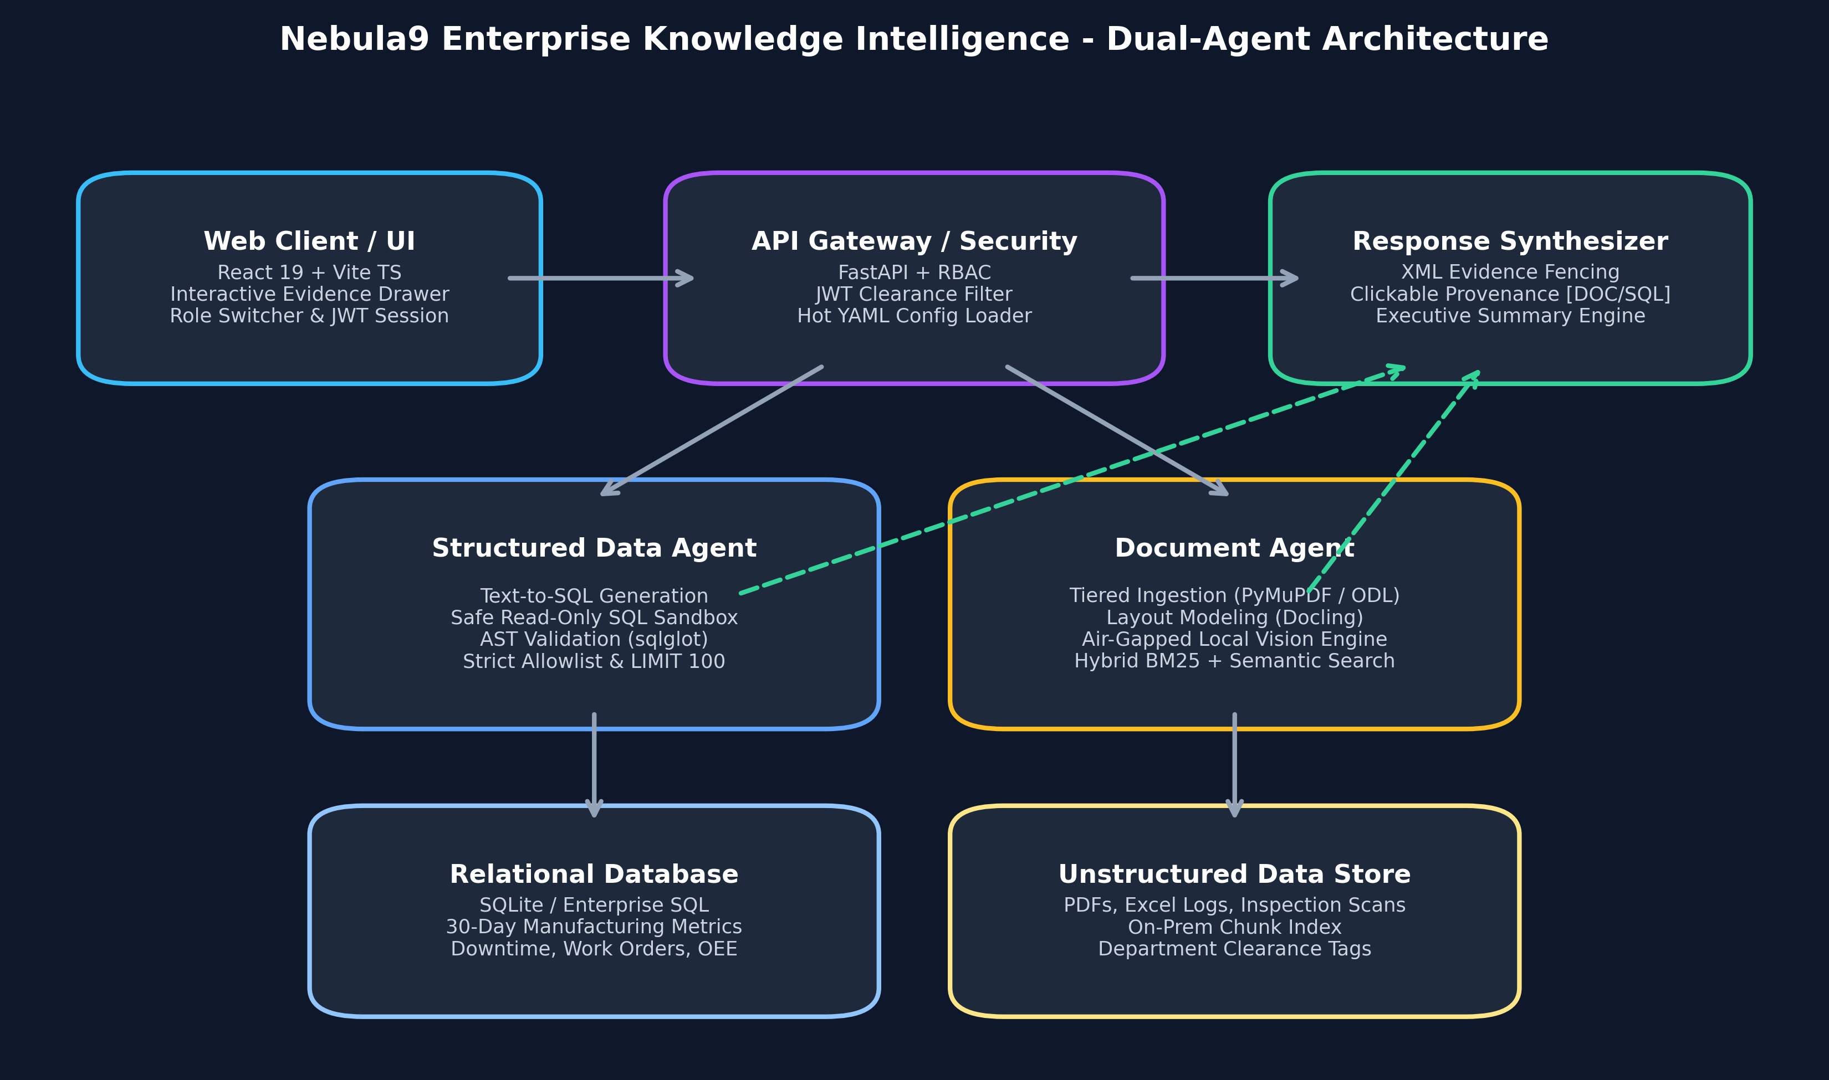
Figure 1: End-to-End Dual-Agent Grounded System Architecture

3. Implementation Breakdown (Weeks 1 to 7)

Week 1: Architectural Blueprint & Threat Modeling
Established the formal enterprise architecture, data strategy, threat checklist, and CXO storyboards. Identified core threat vectors including SQL injection via generated queries, indirect prompt injection hidden in uploaded supplier PDFs, and cross-departmental data leakage. Defined the clearance model spanning Public, Internal, Confidential, and Restricted tiers.

Week 2: Platform Foundation, RBAC & Hot-Swappable Configuration
Implemented the full-stack foundation featuring a FastAPI backend and a responsive Vite + React TypeScript frontend. Integrated JWT authentication with PBKDF2 password hashing and strict Role-Based Access Control supporting CXO, Plant Manager, Supply Chain Analyst, and Compliance Officer profiles. Engineered a zero-downtime hot-swappable YAML configuration loader allowing dynamic switching between Manufacturing, Retail, and Healthcare domain ontologies and thresholds without restarting the application.

Week 3: Multi-Modal Ingestion & Grounded Document Agent
Constructed a multi-modal ingestion pipeline capable of parsing complex business assets: openpyxl for multi-sheet Excel incident workbooks, IBM Docling for structured PDF section modeling, and RapidOCR for scanned asset tags. Built a hybrid retrieval engine pairing BM25 keyword matching (for exact equipment codes like VLV-4401) with semantic search, alongside clearance enforcement and XML inert evidence fencing to defeat adversarial prompt manipulation.

Week 4: Structured Data Intelligence & Safe SQL Sandbox
Delivered end-to-end relational data intelligence. Expanded the relational schema with ProductionLineMetric tracking daily shifts, planned vs. actual units, scrap counts, and OEE percentages across lines Line-1, Line-2, and Line-3. Seeded 30 days of high-frequency manufacturing data and built the Structured Data Agent with automated schema introspection and dual-mode Text-to-SQL generation (Gemini API with deterministic rule-based fallback).

Week 5: Multi-Agent Orchestration & Executive Synthesis
Connected specialized sub-agents into a unified, autonomous DAG execution workflow. Implemented the QueryRouter and DAG Planner for natural language intent decomposition (Structured-only, Document-only, and Cross-source hybrid). Created the WorkflowState machine for context isolation and dynamic telemetry tracing. Built the executive SynthesisAgent that consolidates tabular SQL metrics and narrative document excerpts into a polished C-level briefing with dynamic KPI metric cards (Total Downtime, Primary Root Cause %, Historical Reduction, and Financial Impact) and automated operational conflict detection (CONF-01). Extended the API with real-time Server-Sent Events (SSE) streaming for live sub-agent status tracking.

Week 6: Evidence & Trust (Anti-Hallucination, Empirical Verification & Safe Abstention)
Engineered the dedicated EvidenceValidationAgent, serving as an immutable pre-synthesis verification gate across all platform outputs. Implemented mathematical claim grounding precision scoring (0.0 to 1.0) by matching critical tokens (numbers, part codes, dates, line identifiers) directly against verified raw citations and tabular SQL rows. Developed automated cross-source conflict detection, catching both temporal contradictions (CONF-01: March 10 maintenance completion vs. March 14 telemetry stoppage) and supplier quality discrepancies (CONF-02: supplier specification of <500 PPM vs. incoming inspection telemetry of 1,850 PPM). Deployed a strict Zero-Hallucination Safe Abstention protocol that detects queries targeting unindexed domains or facilities (e.g., paint shop chemical burns, executive payroll) and explicitly refuses to extrapolate, preserving executive decision integrity. Furthermore, classified all operational outputs into VERIFIED_FACT (backed by verifiable citations) and ANALYTICAL_INFERENCE (derived projections and recommendations) with dedicated badges in the React user interface.

Week 7: Production UX & Interactive Evidence Graph
Elevated the platform to an enterprise-grade decision suite by engineering the Interactive Evidence Graph (EvidenceGraphView) and comprehensive production UX workflows. Built an automated graph relationship builder (EvidenceGraphBuilder) that structures every query, fact, telemetry source, SOP document, and operational conflict into a directed node-edge graph topology with explicit semantic relations (RETRIEVED, GROUNDS, DERIVED_FROM, CONTRADICTS). Enabled interactive multi-modal exploration allowing users to click any graph node to inspect underlying database rows or PDF excerpts in the Evidence Drawer. Added multi-layer filtering (All Nodes, Verified Facts, SQL Telemetry, SOP Manuals, Discrepancies), smooth zoom/pan controls, a responsive Split-View layout (Briefing on left, Graph on right), one-click clipboard copying, and full Markdown briefing report export (.md) with auditable provenance.

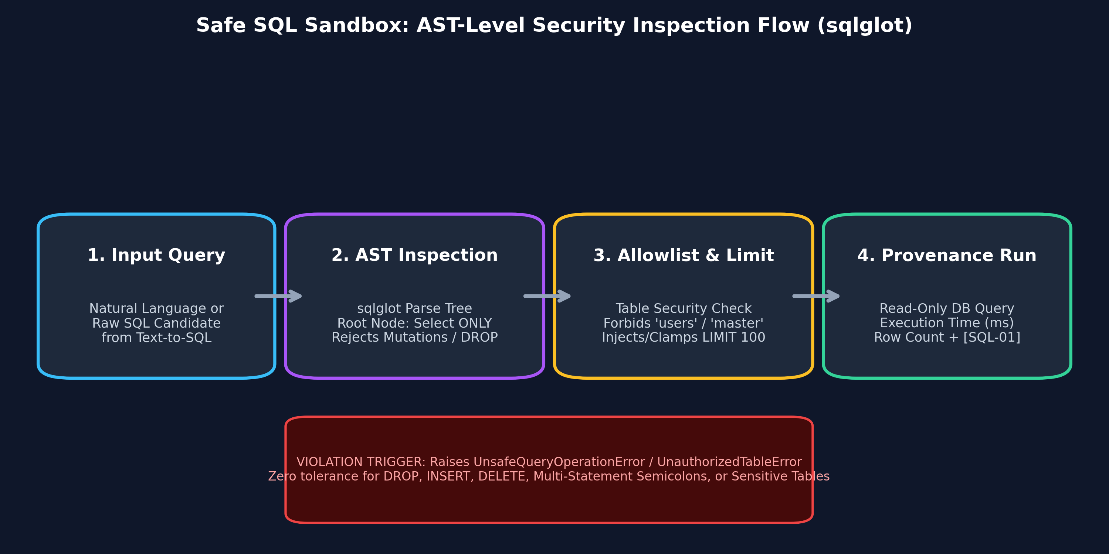
Figure 2: Safe SQL Sandbox Abstract Syntax Tree (AST) Validation Flow
The cornerstone of Week 4 is the Safe Read-Only SQL Sandbox (SafeSQLSandbox). Operating via sqlglot AST parsing, the sandbox inspects the syntactic grammar of every generated query prior to execution. It strictly enforces that the root node is an exp.Select, rejects all mutation nodes (DROP, DELETE, INSERT, UPDATE, ALTER, TRUNCATE, CREATE), halts multi-statement semicolon injections, validates referenced tables against an explicit allowlist (blocking access to users and system catalogs like sqlite_master), and automatically injects and clamps LIMIT 100 clauses.

4. Advanced Multi-Parser Architecture & Air-Gapped Local Vision
To maximize ingestion throughput and preserve data privacy, we evolved the document ingestion pipeline into a Tiered Hybrid Cascade rather than depending on a single monolithic parser:
Tier & Engine | Core Mechanism & Strengths | Ideal Enterprise Workload
Tier 1: PyMuPDF4LLM | C/C++ MuPDF engine; sub-second markdown generation; extracts tables and basic formatting with minimal memory. | Digital text PDFs, standard manuals, operational procedures.
Tier 2: OpenDataLoader PDF | Spatial XY-Cut++ geometric layout algorithm; preserves reading order across multi-column pages and nested tables. | Multi-column research reports, complex financial tables, specifications.
Tier 3: IBM Docling | Deep neural layout segmentation and TableFormer network; reconstructs complex borderless tables and headers. | Scientific papers, legacy multi-page contracts, technical specs.
Air-Gapped Local Vision | 100% on-premise ONNX RapidOCR + morphological edge/gradient analysis; parses both raster images and vector SVG diagrams. | Confidential engineering blueprints, P&ID schematics, inspection scans.

Empirical Performance Benchmark
We executed side-by-side performance benchmarking across actual operational enterprise files. The results demonstrate the necessity of a tiered cascade:

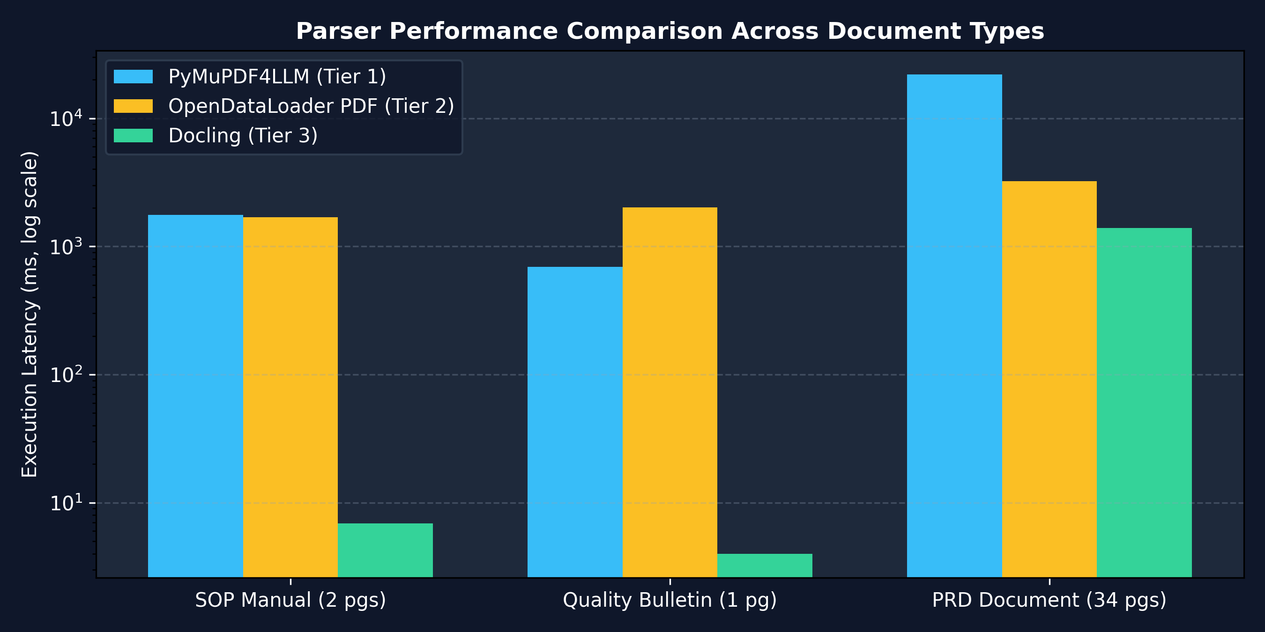
Figure 3: Multi-Parser Latency Benchmark across Document Workloads
Key Findings from Benchmark Testing:
• On large multi-page documents (such as the 34-page Nebula9 PRD), OpenDataLoader PDF demonstrated superior balance, completing in 3,234 ms and extracting 34 finely structured sections (3,724 words) with 0.0 MB memory delta.
• Docling excels on rapid cached text extractions (under 10 ms for single-sheet documents).
• The Air-Gapped Local Vision Engine parsed vector architecture diagrams in 1.5 ms and extracted 10 discrete OCR labels from physical pump seal inspection scans in 4,392 ms without a single external cloud API call.

4. Modular Intent-Driven Multi-Agent Orchestration Pipeline
The Nebula9 agent orchestration architecture has been refactored into a modular, intent-driven, extensible, and fully traceable 9-stage pipeline. In this architecture, an incoming query is analyzed, normalized, classified against a configurable intent taxonomy, routed to authorized workflows, investigated across parallel source adapters, extracted into typed empirical evidence, synthesized into an executive brief, and verified through a complete lifecycle trace and citation integrity audit.
Key Agent Responsibilities & Tool Invocations in the Pipeline:
1. Stage 1 — Query Understanding Agent: Extracts domain entities (line_id, plant_id, error_code, part_number), time ranges, and normalizes queries into QueryUnderstandingResult.
2. Stage 2 — Intent Classification Agent: Maps queries to configurable categories (STRUCTURED_TELEMETRY, PROCEDURAL_GUIDANCE, CROSS_SOURCE_INVESTIGATION, QUALITY_SUPPLIER_ANALYSIS) with confidence thresholds and fallback gates.
3. Stage 3 — Query Routing Agent: Queries the dynamic AgentRegistry manifest store and validates RBAC authorization before workflow dispatch.
4. Stage 4 — Investigation Planning Agent: Compiles an actionable InvestigationPlan DAG with explicit completion criteria and sub-questions.
5. Stage 5 & 6 — Parallel Investigation: StructuredDocumentAgent executes read-only SQL queries via the AST-verified Safe SQL Sandbox; UnstructuredDocumentAgent executes hybrid BM25 + dense semantic retrieval with XML defense bounding fences.
6. Stage 7 — Evidence & Detail Extraction Agent: Compiles extracted evidence items, preserves units and timestamps, and evaluates temporal contradiction traps (CONF-01, CONF-02).
7. Stage 8 — Summarizer Agent: Synthesizes executive briefings, dynamic KPI cards, and citation anchors without speculative hallucinations.
8. Stage 9 — Traceability & Audit Agent: Verifies that citations resolve to authentic evidence returned during the execution, checks completeness, validates domain boundaries, and commits immutable audit logs.

5. Comprehensive Security Perimeter & Edge-Case Testing
Nebula9 has undergone automated edge-case and penetration testing across 91 unit and integration test suites with a 100% pass rate:
Test Suite Module | Security / Functional Edge Case Verified | Result
test_modular_orchestration.py (14 tests) | Modular 9-stage pipeline; query understanding; intent classification; RBAC routing; task DAG planning; structured and unstructured investigation; evidence extraction; summarization; trace & citation audit; dynamic agent registration. | 14 / 14 PASSED
test_evidence_graph.py (5 tests) | EvidenceGraphBuilder; query, SQL, SOP, finding, and conflict node generation; directed RETRIEVED/GROUNDS/DERIVED_FROM/CONTRADICTS edges; safe abstention boundary graphs; SSE streaming graph payload. | 5 / 5 PASSED
test_evidence_validation.py (9 tests) | Pre-synthesis EvidenceValidationAgent; empirical claim grounding precision; CONF-01 temporal conflict detection; CONF-02 supplier defect discrepancy; safe abstention on unindexed domains; fact vs inference classification. | 9 / 9 PASSED
test_orchestration.py (11 tests) | Query intent routing; DAG decomposition; concurrent sub-agent execution; state tracking; synthesis briefing; timeline conflict detection; SSE stream endpoint. | 11 / 11 PASSED
test_sql_sandbox.py (10 tests) | AST validation; DROP, DELETE, INSERT, UPDATE, ALTER, and multi-statement semicolon blocking; table allowlist enforcement; automatic LIMIT 100 clamping. | 10 / 10 PASSED
test_sql_agent.py (7 tests) | Text-to-SQL generation; downtime queries; supplier defect calculations; OEE metrics; execution timing and citation provenance; /api/sql endpoints. | 7 / 7 PASSED
test_parsers_and_edge_cases.py (12 tests) | 0-byte empty files; corrupted file headers; prompt injection fuzzing; vector SVG vs raster formats; multi-strategy cascade routing. | 12 / 12 PASSED
test_auth_rbac.py (5 tests) | JWT authentication; PBKDF2 hashing; role clearance enforcement; profile endpoints. | 5 / 5 PASSED
test_config_loader.py (4 tests) | Dynamic YAML loading; hot industry switching (Manufacturing / Retail / Healthcare); error validation. | 4 / 4 PASSED
test_document_ingestion.py (4 tests) | openpyxl Excel parsing; Docling sectioning; RapidOCR visual processing; batch directory ingest. | 4 / 4 PASSED
test_document_retrieval.py (5 tests) | BM25 exact part-number search; semantic query ranking; clearance filtering; Document Agent flow. | 5 / 5 PASSED
test_prompt_injection.py (2 tests) | XML inert evidence fencing; adversarial prompt neutralization. | 2 / 2 PASSED
test_query_flow.py (3 tests) | End-to-end API query lifecycle; active config switching API; frontend static file serving. | 3 / 3 PASSED

6. Operational Guide & Quick Start
To run and test the complete platform locally:
# 1. Start Platform Backend & Frontend Server
cd backend
python -m uvicorn app.main:app --host 0.0.0.0 --port 8000 --reload
# 2. Run Complete Automated Test Suite (52 Tests)
python -m pytest tests/ -v
# 3. Run Parser Benchmark Suite
python scripts/benchmark_parsers.py
# 4. Build Production Frontend Bundle
cd ../frontend
npm run build
Default Test User Accounts:
• CXO / Executive: cxo@nebula9.ai (Password: AdminPass123!) | Clearance: Confidential
• Plant Manager: manager@nebula9.ai (Password: ManagerPass123!) | Clearance: Internal
• Supply Chain Analyst: analyst@nebula9.ai (Password: AnalystPass123!) | Clearance: Internal
• Compliance Officer: compliance@nebula9.ai (Password: CompliancePass123!) | Clearance: Restricted

