NIT JALANDHAR

ACS ASSIGNMENT

OFDM

NAME:ADITYA KHANNA **Submitted to:-**

ROLL:16104008 Dr Sukwinder Singh

BRANCH:ECE

**What is OFDM?**

Orthogonal Frequency Division Multiplexing (OFDM) is a digital multi-carrier modulation scheme that extends the concept of single subcarrier modulation by using multiple subcarriers within the same single channel. Rather than transmit a high-rate stream of data with a single subcarrier, OFDM makes use of a large number of closely spaced orthogonal subcarriers that are transmitted in parallel. Each subcarrier is modulated with a conventional digital modulation scheme (such as QPSK, 16QAM, etc.) at low symbol rate. However, the combination of many subcarriers enables data rates similar to conventional single-carrier modulation schemes within equivalent bandwidths.

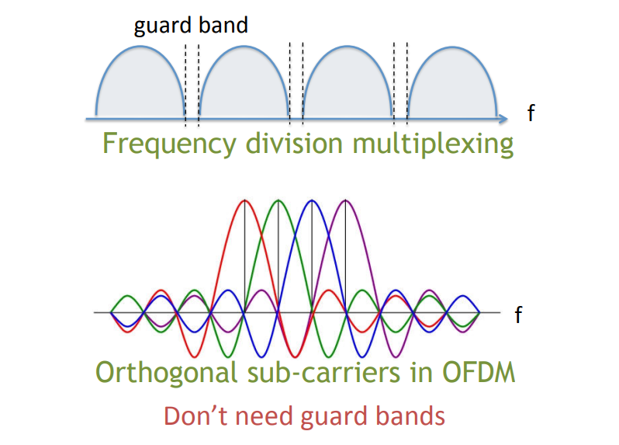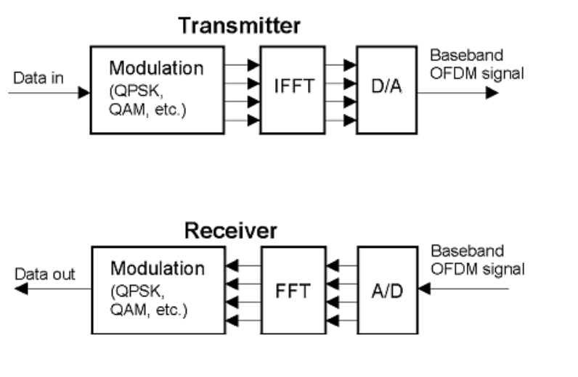

**WORKING**

To see how OFDM works, it is necessary to look at the receiver. This acts as a bank of demodulators, translating each carrier down to DC. The resulting signal is integrated over the symbol period to regenerate the data from that carrier. The same demodulator also demodulates the other carriers. As the carrier spacing equal to the reciprocal of the symbol period means that they will have a whole number of cycles in the symbol period and their contribution will sum to zero - in other words there is no interference contribution.

One requirement of the OFDM transmitting and receiving systems is that they must be linear. Any non-linearity will cause interference between the carriers as a result of inter-modulation distortion. This will introduce unwanted signals that would cause interference and impair the orthogonality of the transmission.

**Key features of OFDM**

The OFDM scheme differs from traditional FDM in the following interrelated ways:

* Multiple carriers (called subcarriers) carry the information stream
* The subcarriers are orthogonal to each other.
* A guard interval is added to each symbol to minimize the channel delay spread and intersymbol interference.

**OFDM advantages**

OFDM has been used in many high data rate wireless systems because of the many advantages it provides.

* ***Immunity to selective fading:***   One of the main advantages of OFDM is that is more resistant to frequency selective fading than single carrier systems because it divides the overall channel into multiple narrowband signals that are affected individually as flat fading sub-channels.
* ***Resilience to interference:***   Interference appearing on a channel may be bandwidth limited and in this way will not affect all the sub-channels. This means that not all the data is lost.
* ***Spectrum efficiency:***   Using close-spaced overlapping sub-carriers, a significant OFDM advantage is that it makes efficient use of the available spectrum.
* ***Resilient to ISI:***   Another advantage of OFDM is that it is very resilient to inter-symbol and inter-frame interference. This results from the low data rate on each of the sub-channels.
* ***Resilient to narrow-band effects:***   Using adequate channel coding and interleaving it is possible to recover symbols lost due to the frequency selectivity of the channel and narrow band interference. Not all the data is lost.
* ***Simpler channel equalisation:***   One of the issues with CDMA systems was the complexity of the channel equalisation which had to be applied across the whole channel. An advantage of OFDM is that using multiple sub-channels, the channel equalization becomes much simpler.

**OFDM disadvantages**

Whilst OFDM has been widely used, there are still a few disadvantages to its use which need to be addressed when considering its use.

* ***High peak to average power ratio:***   An OFDM signal has a noise like amplitude variation and has a relatively high large dynamic range, or peak to average power ratio. This impacts the RF amplifier efficiency as the amplifiers need to be linear and accommodate the large amplitude variations and these factors mean the amplifier cannot operate with a high efficiency level.
* ***Sensitive to carrier offset and drift:***   Another disadvantage of OFDM is that is sensitive to carrier frequency offset and drift. Single carrier systems are less sensitive.