PREDICTIVE AND ADAPTIVE
VIRTUAL MEMORY MANAGEMENT
with Intelligent Thrashing Prevention
OPERATING SYSTEMS LAB PROJECT REPORT
Submitted by
Aditya Kiran Upadhye
Aman Singh Sachan
Aditya Jain
A reproducible simulation of address translation,
page replacement, thrashing detection, and adaptive control.

1. Executive Summary
This project implements an educational virtual-memory simulator. It models address translation through a translation lookaside buffer (TLB) and a two-level page table, simulates page faults and replacement, estimates working-set pressure, detects thrashing using rule-based thresholds, and demonstrates adaptive frame redistribution and temporary process suspension.
The committed experiment has 1000 rows across five synthetic workload patterns, ten seeds, four replacement policies, four adaptive-control modes, and matched TLB checks. Under LRU, combined adaptation reduced pooled mean faults from 1,193.1 to 963.6 (19.2% by ratio of means). The mean paired reduction is 22.3%. These are simulator results, not measurements from a real operating system.

Objectives
- Demonstrate a full virtual-address translation path with TLB and hierarchical page tables.
- Compare FIFO, LRU, Clock, and Optimal page replacement on repeatable reference streams.
- Estimate working-set pressure and detect simulated thrashing.
- Evaluate frame redistribution and process suspension independently and together.
- Publish run-level CSV output, summaries, figures, tests, and a reproducible report.

Scope
The simulator does not inspect or modify host OS memory, kernel page tables, live CPU usage, or real running processes. CPU utilization, pressure, and process suspension shown in the dashboard are simulated proxies.

2. System Architecture
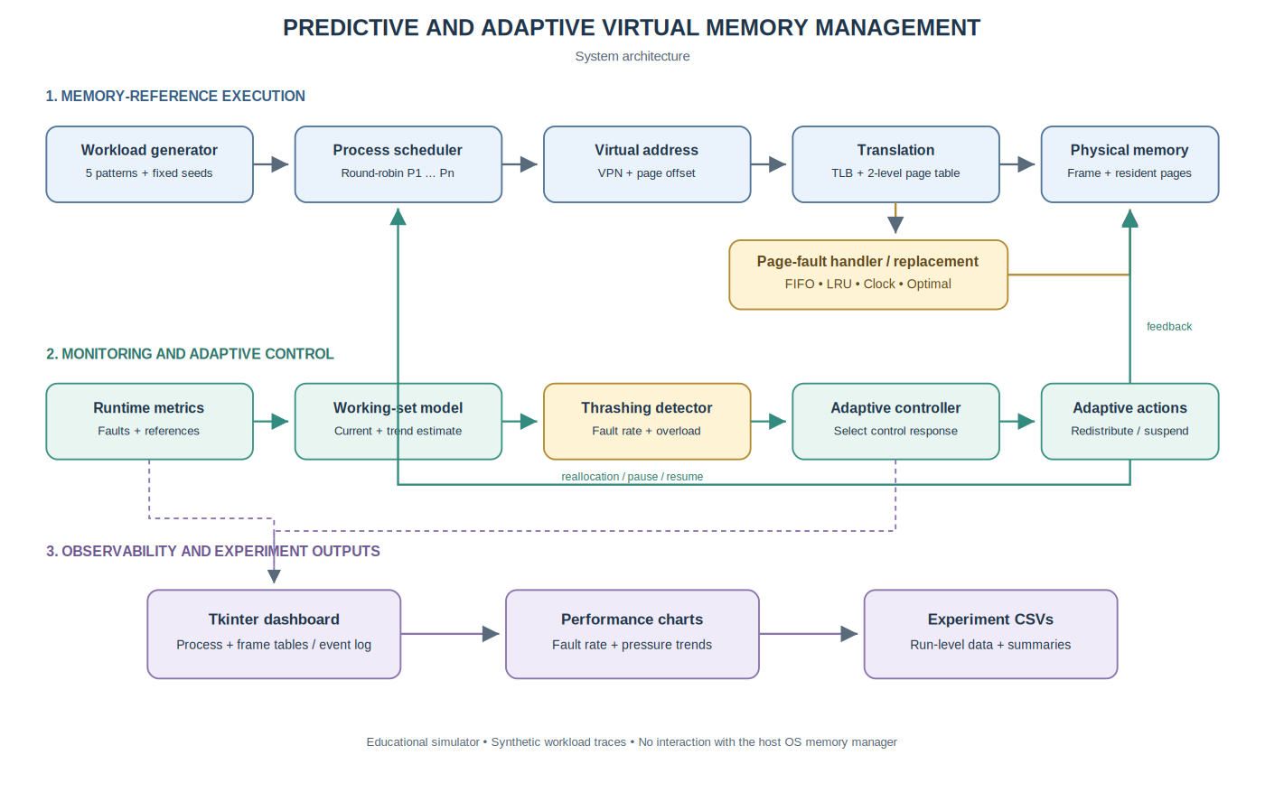
Figure 1. Workload execution, feedback control, and experiment outputs.
A workload generator supplies synthetic references to a round-robin scheduler. Address translation checks the TLB before walking the two-level page table. A non-resident page invokes a fault handler and the selected replacement algorithm. Runtime metrics feed a working-set estimator and thrashing detector; the adaptive controller can change frame ownership and temporarily suspend a process.
Module | Responsibility
vm_simulator/core.py | TLB, page tables, physical frames, replacement, workloads, monitoring, and adaptive controls.
vm_simulator/gui.py | Tkinter dashboard, charts, process/frame tables, event log, address inspector, CSV export.
benchmark.py | Multi-seed experiment, ablations, confidence-interval summaries, paired effect analysis, TLB comparisons.
docs/generate_figures.py | Rebuild figures from the experiment CSVs and render the architecture diagram.

3. Virtual-Memory Model

Address format and translation
The modeled page size is 256 bytes; the offset is the low eight bits. The 64 virtual pages use two 3-bit page-table indices, with eight entries at each level, giving a virtual address range of 0 through 16,383.
Stage | Action | Metric
TLB lookup | Lookup cached translation by (process, VPN). | TLB hits and misses.
Page-table walk | Check first- and second-level entries. | Page-table accesses.
Page fault | Select a frame allocated to process; evict if occupied; map VPN. | Faults and replacements.
Physical address | Combine frame number and page offset. | Address shown in event log.

Replacement policies
Policy | Summary
FIFO | Evict the page loaded earliest.
LRU | Evict the least recently used resident page.
Clock | Use reference bits to implement a second-chance scan.
Optimal* | Evict the resident page whose next use is farthest away.

*Optimal uses knowledge of future generated references and is only a theoretical oracle comparison, not an implementable online policy.

4. Thrashing Detection and Adaptive Control
A recent-reference window estimates each process's working set. A trend heuristic estimates possible near-term growth in demand. Pressure compares active working-set demand to frame capacity. Thrashing detection combines a rolling page-fault ratio and an overload condition. These are hand-set rules, not a trained machine-learning model.
Mode | Redistribution | Suspension | Interpretation
none | Off | Off | Baseline.
redistribution_only | On | Off | Isolates effects of frame allocation changes.
suspension_only | Off | On | Suspended process retains its allocation, allowing suspension effect to be isolated.
combined | On | On | Suspension and reallocation can coordinate.

Suspension-only page-fault counts therefore remain equal to baseline in this implementation. In combined mode, frame redistribution can transfer the suspended process's frames to active processes. The outcome is workload-dependent.

Dashboard
The dashboard shows process state/faults, frame ownership/resident pages, recent fault rate, TLB hit rate, pressure estimate, simulated CPU-use proxy, and an event log. The address inspector is read-only and does not advance simulation time or increment counters.

5. Dashboard Layout Illustrations
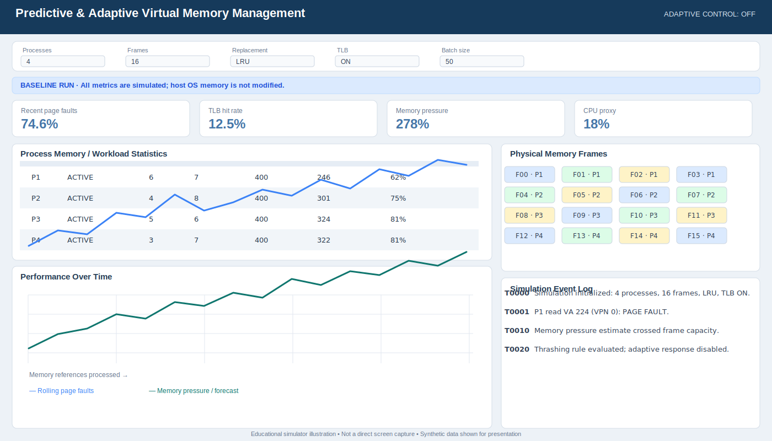
Figure 2. Redrawn baseline dashboard layout; illustrative, not a direct capture.
This dashboard illustration reflects the baseline layout and labels; displayed metrics are illustrative values, not a recorded experiment.

5. Dashboard Layout Illustrations (continued)
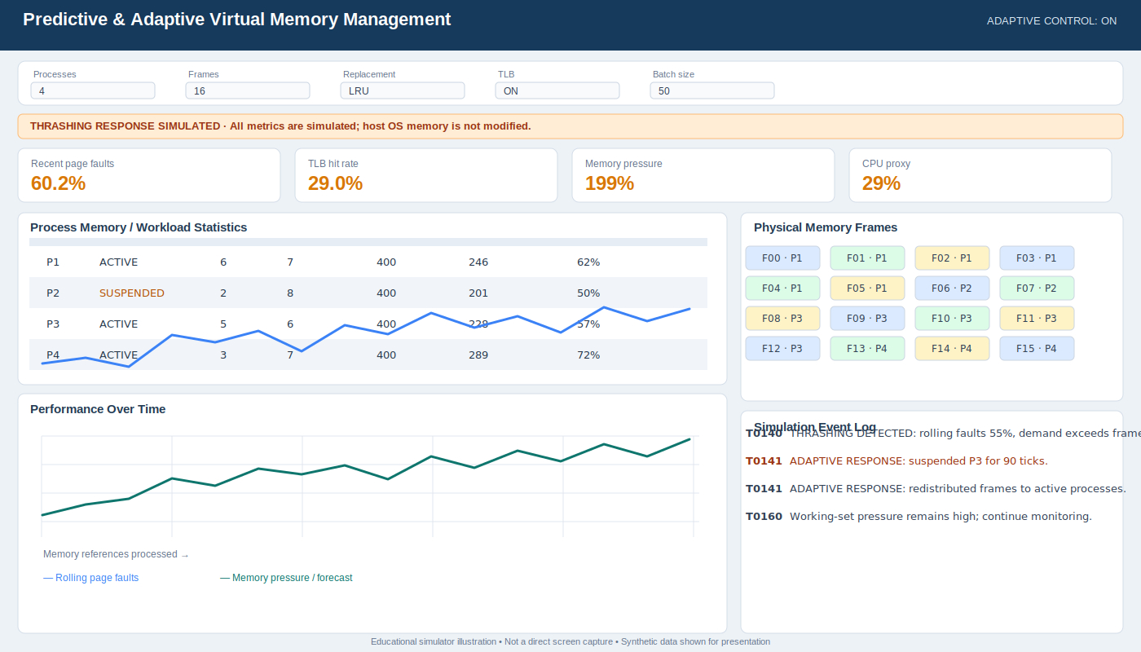
Figure 3. Redrawn adaptive dashboard layout; illustrative, not a direct capture.
This dashboard illustration shows the adaptive-control presentation; values are illustrative and no real host process is suspended.

6. Experimental Methodology
Parameter | Setting
Processes | 4
Physical frames | 16
References per process | 400
References per completed main run | 1,600
Seeds | 42–51 (10 seeds)
Workload patterns | 5
Replacement policies | FIFO, LRU, Clock, Optimal
Adaptive modes | 4
Main TLB-on runs | 800
Matched TLB-off runs | 200
Total raw records | 1000

Workload | Trace structure
phase locality | Mostly accesses a small region, then shifts by phase.
uniform random | Random accesses across 64 pages.
sequential scan | Sequentially scans all 64 pages.
bursty hot set | Small hot-set bursts interspersed with broad random phases.
alternating hot sets | Alternates between two disjoint eight-page regions.

The main design varies pattern, seed, replacement policy and adaptive mode. The TLB validation repeats no-adaptation cases with TLB disabled. Summary intervals use a normal approximation and should be treated as descriptive.

7. Aggregate Ablation Results
Policy | None | Redistribution | Suspension | Combined | Reduction*
FIFO | 1199.8 | 1206.7 | 1061.2 | 965.8 | 19.5%
LRU | 1193.1 | 1201.9 | 1050.5 | 963.6 | 19.2%
Clock | 1197.5 | 1205.5 | 1051.6 | 964.2 | 19.5%
Optimal | 953.4 | 974.2 | 869.5 | 843.6 | 11.5%

Table 1. Mean page faults pooled over seeds and patterns; all runs complete 1,600 references.
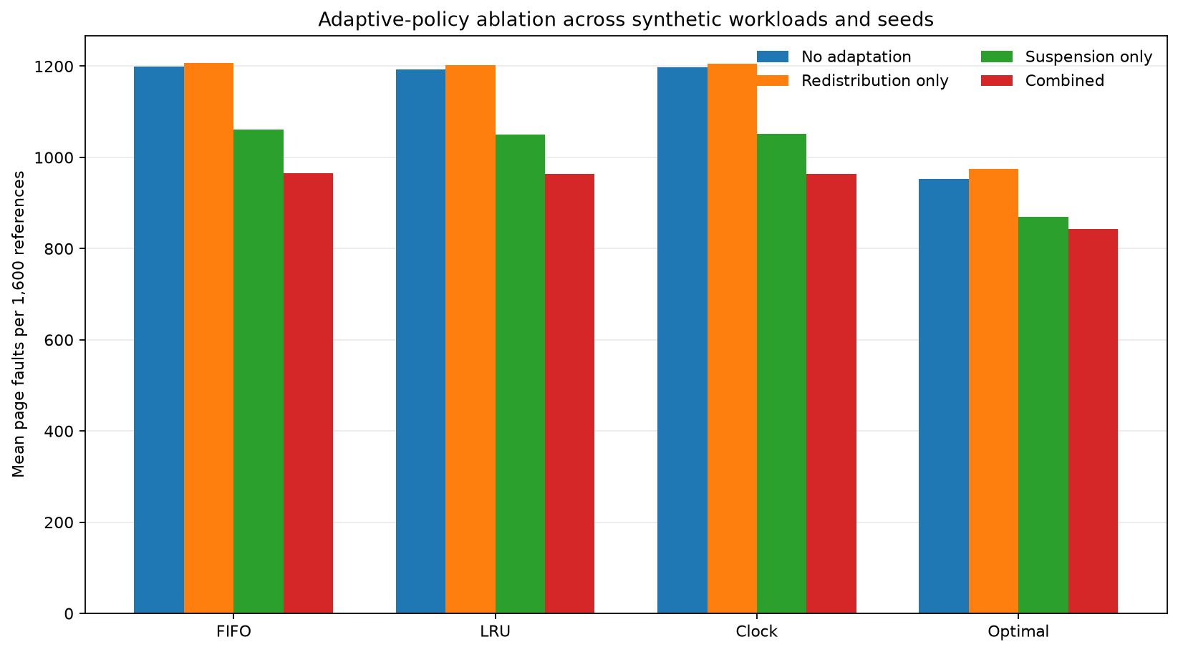
Figure 4. Adaptive-policy ablation.
Redistribution alone slightly increased mean faults, partly because changing frame ownership can invalidate useful resident pages. Suspension alone kept page-fault totals unchanged because it did not transfer frames. The combined mode reduced pooled faults for all four replacement algorithms in this synthetic experiment.

8. Workload-Specific Findings and TLB
Workload | Baseline LRU | Combined LRU | Reduction
phase locality | 1026.1 | 676.3 | 34.1%
uniform random | 1498.3 | 1272.7 | 15.1%
sequential scan | 1600.0 | 1600.0 | 0.0%
bursty hotset | 966.5 | 680.0 | 29.6%
alternating hotsets | 874.5 | 589.2 | 32.6%

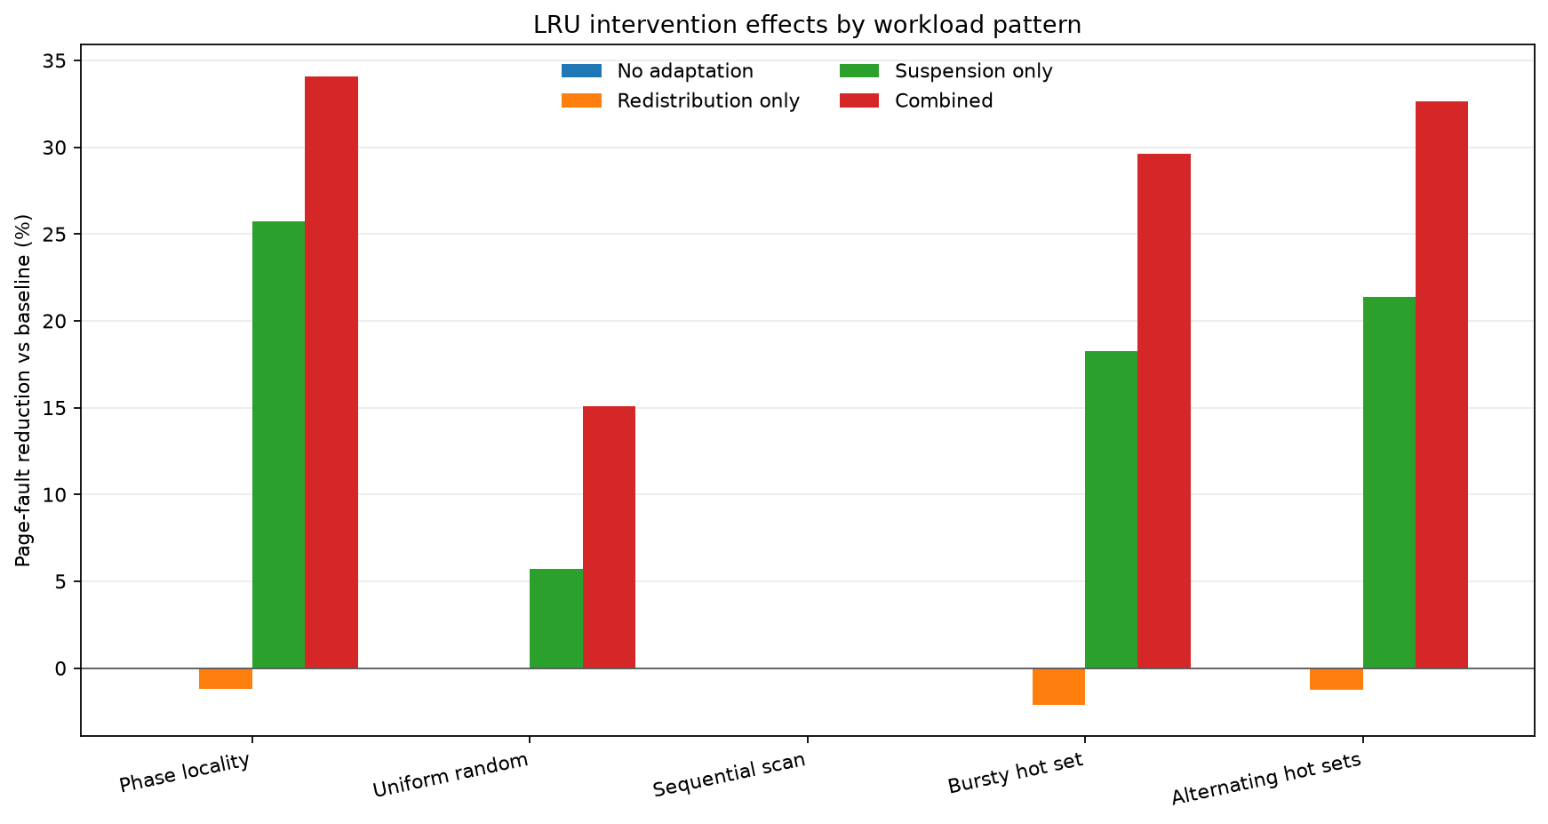
Figure 5. LRU intervention effect by workload; negative values indicate more faults.
TLB measure | Result
Mean table accesses, TLB on | 2,450.2
Mean table accesses, TLB off | 2,856.6
Reduction in table accesses | 14.2%
Page-fault mismatches in matched pairs | 0 / 200

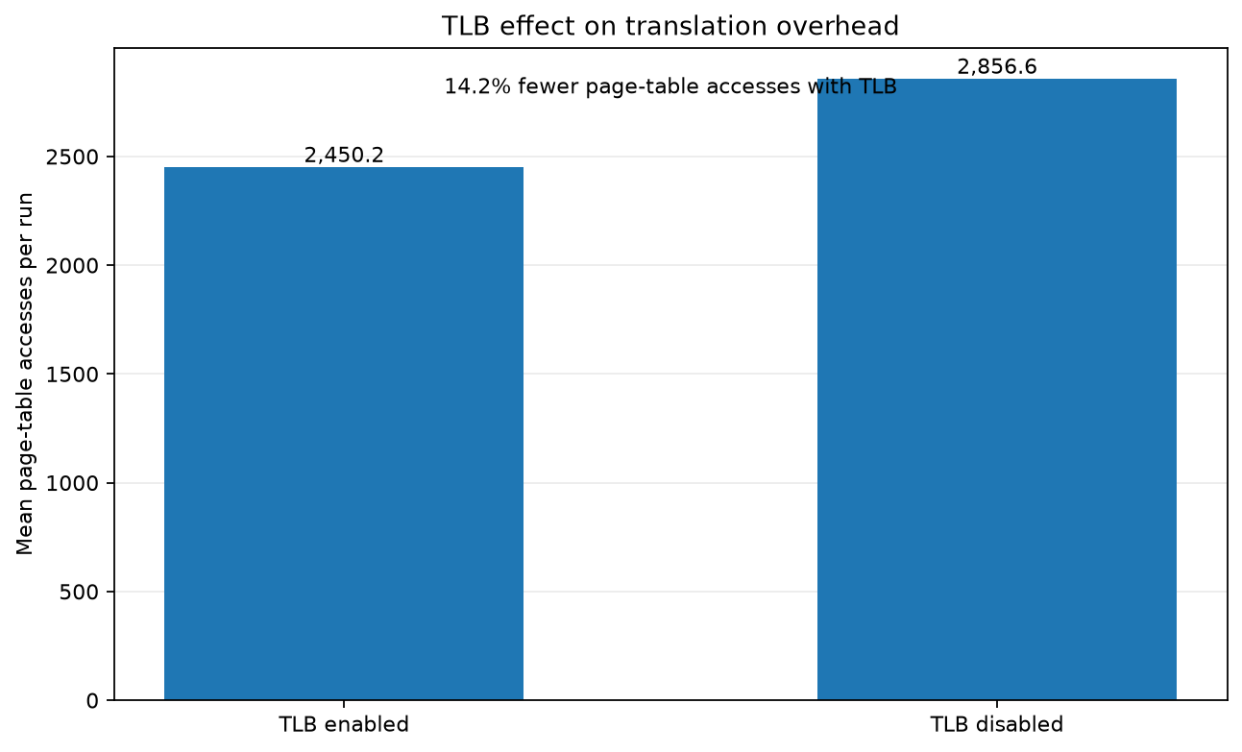
Figure 6. Translation-table access overhead, TLB enabled vs disabled.
The TLB caches translations rather than page contents. Accordingly, it reduces page-table accesses but should not change whether a page is resident. The paired dataset is checked for page-fault mismatches.

9. Reproducibility and Testing
- Install dependencies from requirements.txt in a Python virtual environment.
- Run python -m unittest discover -s tests -v to execute automated tests.
- Run python benchmark.py to regenerate the raw data, grouped summary, and paired analysis.
- Run python docs/generate_figures.py to regenerate chart images and the architecture PNG.
- Run python docs/build_report.py to rebuild the Word report; the GitHub Actions workflow exports it to PDF.

Validation coverage
The test suite covers two-level mapping and unmapping, TLB behavior, all replacement algorithms, allocation invariants, address-inspector validation, all workload generators, and independent adaptive switches. Run-level and grouped CSVs expose intermediate data for review.

10. Limitations and Conclusion
- Workloads are synthetic, not collected from real applications or operating systems.
- Pressure and CPU utilization are simulated proxies, not host telemetry.
- Prediction and thrashing thresholds are rule-based heuristics.
- Suspension-only retains frame ownership and therefore does not model OS reclamation.
- Redistribution can increase faults, and sequential scans may not benefit from the selected policy.
- Optimal uses future references and is only an oracle baseline.
- Further work should test threshold sensitivity, more seeds, real traces, reclamation-aware suspension, and additional outcomes such as completion time.

Conclusion
The project combines memory translation, replacement algorithms, working-set reasoning, and a visible simulation of feedback control. Its main strength is reproducibility: the same workloads can be used for paired comparisons, individual adaptive mechanisms can be isolated, and results are retained as CSV. The experiment shows that coordinated controls can reduce faults for some synthetic workload patterns but not all; the sequential-scan result illustrates why adaptive policies require workload-aware evaluation.

Reference basis
Policy terminology follows standard operating-systems concepts for paging, TLBs, FIFO/LRU/Clock replacement, working sets, and thrashing. Quantitative claims in this report are computed from the accompanying CSV files.

