Git and GitHub Flask Workflow
Submission report | Prepared 21 October 2026 | Repository: Git_and_GitHub_Adity

Overview
This project demonstrates the requested Git workflow using a Flask to-do application, a JSON API, and a MongoDB-backed submission route. Local branches, merges, a JSON conflict resolution, three separate field commits, a soft reset, and a rebase are present in the repository history. GitHub publication and portal upload remain pending because this browser session is signed out of GitHub and the submission portal address was not provided.
Each PNG command capture presents corresponding captured Git CLI output. The exact commands and full output are also retained in evidence/commands.txt.
GitHub repository link | PENDING — no repository has been created or pushed
Local branch | main
Working tree | Report and evidence are included as submission files
Remote | Not configured

Task 1 — Repository setup and first branch
Initialized a local main branch, created the Adity branch, committed the Flask source, and merged the branch into main. The source includes app.py, templates/index.html, static assets, requirements.txt, api_data.json, and .gitignore. No SSH key was present in the inspected user SSH folder. The repository has no GitHub remote, so SSH key registration and remote clone/push still require the signed-in GitHub account.
Evidence: local branch and commit graph are in evidence/commands.txt and the first command capture below.
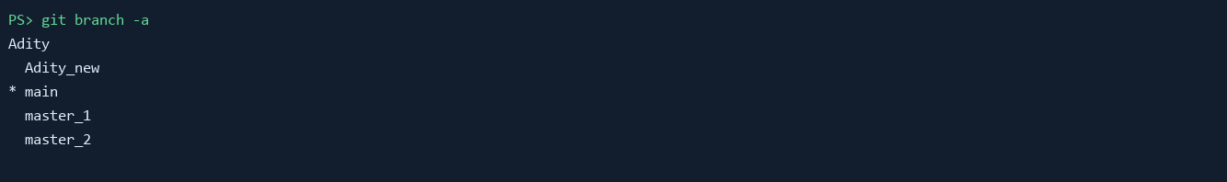

Task 2 — JSON update and conflict resolution
Created Adity_new and changed api_data.json there. A conflicting edit was committed on main to create a real merge conflict. The merge was resolved by checking out the Adity_new version, staging it, and committing the resolution as 0dcfdfb. The /api route reads and returns the committed JSON file.
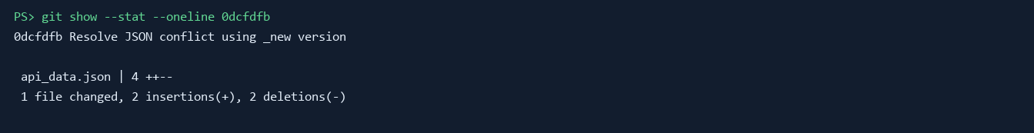

Task 3 — Parallel feature branches
Created master_1 and master_2 from main. master_1 contains the to-do page with Item Name and Item Description. master_2 contains the MongoDB-backed POST implementation at /submittodoitem, accepting JSON or form data, validating both required fields, and storing the item in MongoDB. Both branches were merged into main. MongoDB must be running locally or MONGODB_URI must point to a reachable database for successful writes.
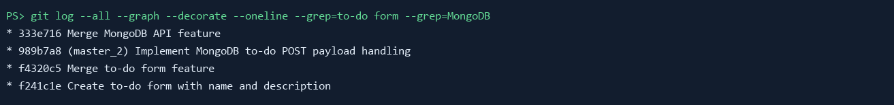

Task 4 — Separate commits, reset, and rebase
On master_1, Item ID, Item UUID, and Item Hash were each introduced in their own commit. The branch was merged into main. Main was then reset --soft to the Item ID commit and the resulting state was recommitted. The command git rebase main master_1 was run; Git reported a conflict while replaying the UUID commit, which was resolved and the rebase continued. The rebased master_1 branch was merged into main. The final graph preserves the separate field commits.
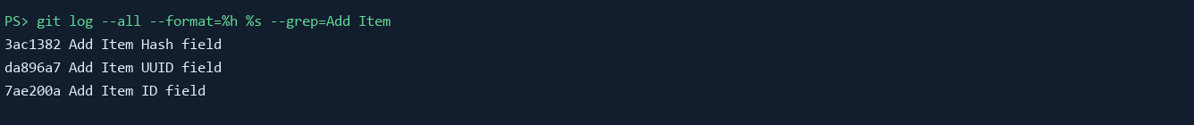

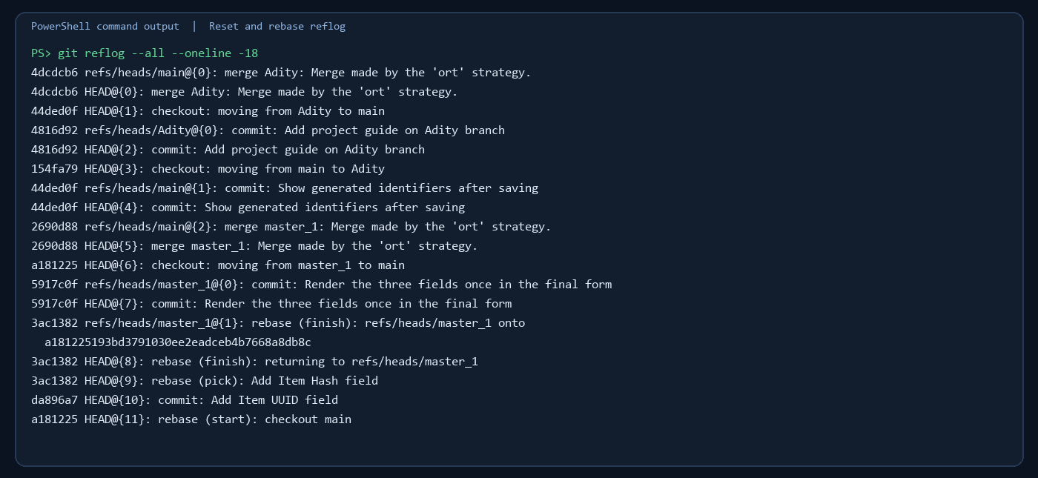

Key commands
The following commands summarize the local branch, merge, conflict, reset, and rebase operations shown in the repository history. Commit hashes and full captured command output are recorded in evidence/commands.txt.
git init -b main
git switch -c Adity
git add README.md
git commit -m "Add project guide on Adity branch"
git switch main
git merge --no-ff Adity -m "Merge Adity project branch"
git switch -c Adity_new
git add api_data.json
git commit -m "Update JSON payload on _new branch"
git switch main
git merge --no-ff Adity_new
git checkout --theirs api_data.json
git add api_data.json
git commit -m "Resolve JSON conflict using _new version"
git switch -c master_1
git commit -m "Create to-do form with name and description"
git switch -c master_2
git commit -m "Implement MongoDB to-do POST payload handling"
git switch main
git merge --no-ff master_1
git merge --no-ff master_2
git switch master_1
git commit -m "Add Item ID field"
git commit -m "Add Item UUID field"
git commit -m "Add Item Hash field"
git switch main
git merge --no-ff master_1
git reset --soft 7ae200a
git commit -m "Recommit main at Item ID reset state"
git rebase main master_1
git switch main
git merge --no-ff master_1
Remote setup and push commands are in WORKFLOW_COMMANDS.md. Those commands are pending because the current GitHub session is signed out; do not treat them as completed output.

Project run instructions
Install dependencies with pip install -r requirements.txt, start MongoDB, then run python app.py. Open http://127.0.0.1:5000. GET /api returns api_data.json. POST /submittodoitem accepts itemName and itemDescription as JSON or form fields. It returns HTTP 400 for missing values, HTTP 201 when stored, and HTTP 503 when MongoDB is unavailable. The form also displays Item ID, Item UUID, and Item Hash fields.

