DOCKERIZED
FULL-STACK APPLICATION
Express frontend / Flask backend / Docker Compose

Student name | Aditya Kittad
Course / section | YOUR COURSE
Submission date | YOUR DATE
Project folder | Docker_Adityakittad
  - Assignment implementation and deployment guide

1. Objective and overview
This project containerizes a full-stack greeting form. The browser loads an interface served by Node.js and Express. On submit, the interface sends JSON to a Flask API, which validates the name and returns a greeting.

Reference behavior
The supplied reference repository exposes a Flask page and a POST /process route that returns “Hello {name}! Data received successfully.” This project keeps that API contract and separates the user interface into its own Express service.

2. Architecture
- Frontend: Node.js 20 with Express on port 3000; serves static HTML, CSS, and browser JavaScript.
- Backend: Python 3.12, Flask, Flask-CORS, and Gunicorn on port 5000.
- Docker Compose builds both images and connects both services to the assignment-net bridge network.
- The browser calls the published backend endpoint at localhost:5000; both ports are published for local access.
- Health checks are exposed at /health for both services.

3. Folder structure
Docker_Adityakittad/
├── backend/
│ ├── app.py
│ ├── requirements.txt
│ └── Dockerfile
├── frontend/
│ ├── public/ (HTML, CSS, browser JavaScript)
│ ├── server.js
│ ├── package.json
│ └── Dockerfile
├── documentation/
│ ├── Assignment_Report.docx
│ └── SCREENSHOT_CHECKLIST.md
├── docker-compose.yml
├── .dockerignore
└── .gitignore

4. API and form behavior
POST /process accepts JSON with a non-empty name up to 80 characters. A valid request returns HTTP 200 with a greeting; malformed or invalid requests return HTTP 400 with a readable error. GET /health returns a service status.
POST http://localhost:5000/process
Content-Type: application/json
{"name":"Alex"}
200 OK
{"message":"Hello Alex! Data received successfully."}

5. Build and run
Start Docker Desktop. In PowerShell, change to the Docker_Adityakittad project folder and run:
docker compose config
docker compose up --build -d
docker compose ps
Open http://localhost:3000, enter a name, and submit. The success message confirms the browser-to-Flask request completed.
SCREENSHOT REQUIRED • Compose build and running containers (docker compose ps)
Insert a genuine screenshot from your own run here.

SCREENSHOT REQUIRED • Application loaded in browser and successful greeting response
Insert a genuine screenshot from your own run here.

6. Verification commands
Invoke-RestMethod http://localhost:5000/health
Invoke-RestMethod -Method Post -Uri http://localhost:5000/process -ContentType 'application/json' -Body '{"name":"Alex"}'
docker compose images
Expected API response: “Hello Alex! Data received successfully.” Stop the services with docker compose down.
SCREENSHOT REQUIRED • API response and local Docker image tags
Insert a genuine screenshot from your own run here.

7. Publish images to Docker Hub
The Compose image tags already use adityakittad. Authenticate to Docker Hub and publish both service images:
docker login
docker compose build
docker compose push
Capture the Docker Hub repository page after both pushes finish. Uploading requires the student’s own Docker Hub credentials.
SCREENSHOT REQUIRED • Docker Hub page showing frontend and backend repositories
Insert a genuine screenshot from your own run here.

8. Publish source to GitHub
Create an empty repository under your own GitHub account, then run these commands from the project folder. Replace the sample URL:
git init
git add .
git commit -m "Build Dockerized Express and Flask assignment"
git branch -M main
git remote add origin https://github.com/YOUR_GITHUB_USERNAME/YOUR_REPOSITORY.git
git push -u origin main
SCREENSHOT REQUIRED • GitHub repository page showing uploaded source files
Insert a genuine screenshot from your own run here.

9. Submission checklist
- Confirm the folder and zip are named Docker_Adityakittad.
- Replace Docker Hub username placeholders and push both images.
- Push the source code to GitHub and add the repository link to the submission portal.
- Keep the genuine terminal build screenshot in the report and add the service status and successful browser response screenshots.
- Keep the full source, Dockerfiles, Compose file, report, and screenshots in the project folder.
- Compress the project folder as Docker_Adityakittad.zip and submit that archive.

Evidence status
The Express and Flask containers built and started successfully. The report contains a genuine terminal screenshot of the Compose build, network creation, backend health, and frontend startup. A sample browser form submission returned the expected Flask greeting. The student supplied successful Docker Hub push output for both image tags and a successful Git push. The public GitHub repository is live at https://github.com/adityakittad1/dockerized-flask-assignment. Screenshots of docker compose ps, the browser success response, Docker Hub, and GitHub should still be added for a complete visual evidence record.
Reference: https://github.com/Toto3107/flaskp

10. Work completed and remaining submission steps
The project source has been committed locally in Git. Commit: 6c04a93 — “Build Dockerized Express and Flask assignment.” The source is organized under separate frontend and backend folders, and both Dockerfiles, the Compose network, ignore files, report, and README are included.
Docker Desktop is running in the student’s PowerShell. The student ran docker compose up --build -d successfully: both tagged images were built, the Compose network was created, the backend container became healthy, and the frontend container started. A genuine terminal screenshot of this result is included below. The Docker engine remains inaccessible to the project workspace command environment, so further container commands must be run in the student’s PowerShell. The code has a local Git commit, but no GitHub remote was created or pushed and no Docker Hub images were uploaded.
Before portal submission: capture docker compose ps, the successful browser form response, Docker Hub repository pages, and the GitHub repository page; add those screenshots to this report and rebuild the ZIP.

Docker Compose build evidence
The screenshot below shows the successful Compose build and startup. Both image tags were built; Docker created the bridge network; the backend reached Healthy; and the frontend started.
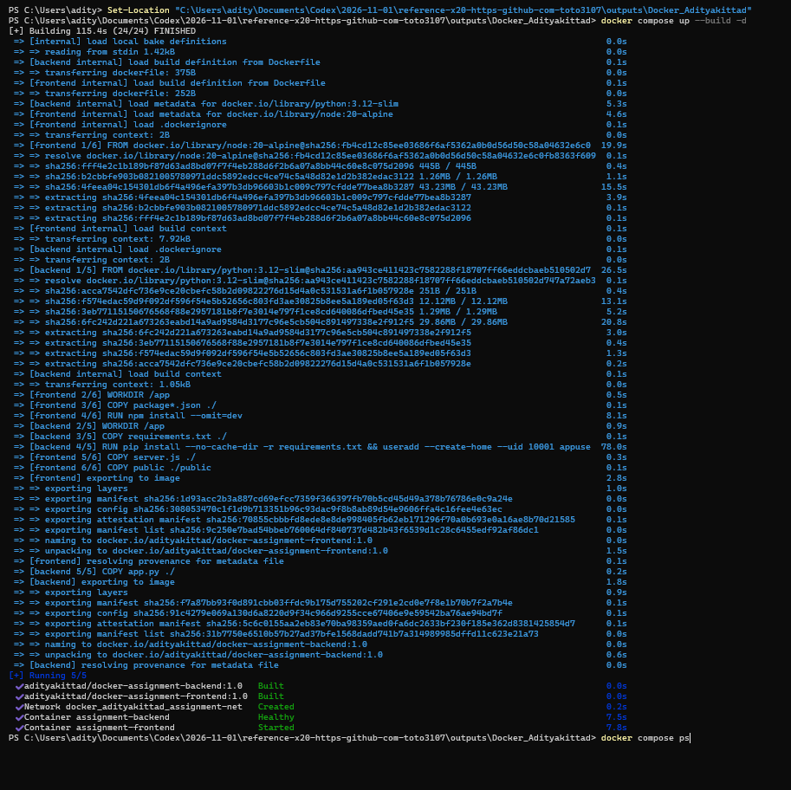
Figure 1. PowerShell output from docker compose up --build -d.

Docker Hub upload status
The student supplied successful docker compose push output for both images. The output marks the backend and frontend image layers as Pushed (with one shared layer mounted from library/postgres). Image tags: adityakittad/docker-assignment-backend:1.0 and adityakittad/docker-assignment-frontend:1.0.
Docker Hub repositories: https://hub.docker.com/r/adityakittad/docker-assignment-backend and https://hub.docker.com/r/adityakittad/docker-assignment-frontend
A screenshot of the push output or both Docker Hub repository pages is still needed for the report evidence.

GitHub repository status
The source was pushed to the public main branch. Repository: https://github.com/adityakittad1/dockerized-flask-assignment. The public repository page was opened and confirmed to show the project files.

