Linux Basics
TuteDude DevOps Assignment
Name: Aditya Kittad
Course: DevOps
Assignment: Linux Basics
Document Purpose: Commands, explanations, and screenshot evidence for Tasks 1-12

Objective
The objective of this assignment is to demonstrate basic Linux command-line skills, including creating and managing files and directories, viewing file contents, searching text, compressing and extracting files, downloading files, changing permissions, and setting environment variables.

Submission Details
Student Name: Aditya Kittad
Course: DevOps
Assignment: Linux Basics
Screenshot Requirement: Attach the matching terminal screenshot under each task placeholder.
GitHub Repository: Add the final public GitHub repository URL in the GitHub Repository section.
This document does not include fabricated command output. All terminal screenshots should be inserted by the student after completing the tasks in the Linux environment.

Tasks 1-12

Task 1: Create a Directory
Question: Create a new directory named test_dir.
Command(s):
mkdir test_dir
ls
Explanation: The mkdir command creates a new directory. The ls command is used to verify that test_dir was created.
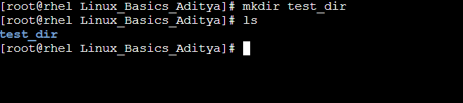

Task 2: Create a File
Question: Create a file named example.txt inside test_dir.
Command(s):
touch test_dir/example.txt
ls test_dir
Explanation: The touch command creates an empty file if it does not already exist. The ls command confirms that example.txt is present inside test_dir.
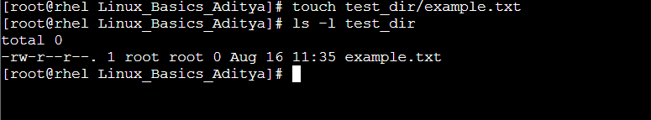

Task 3: Rename a File
Question: Rename example.txt to renamed_example.txt.
Command(s):
mv test_dir/example.txt test_dir/renamed_example.txt
ls test_dir
Explanation: The mv command can move or rename files. Here, it renames example.txt to renamed_example.txt while keeping it inside test_dir.
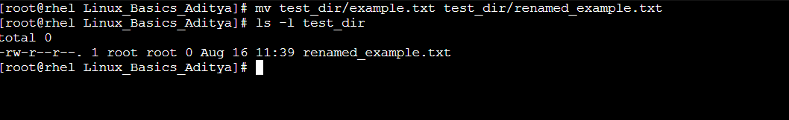

Task 4: View File Contents
Question: Display the contents of renamed_example.txt.
Command(s):
cat test_dir/renamed_example.txt
Explanation: The cat command prints the contents of a file in the terminal. It is useful for quickly checking what a file contains.
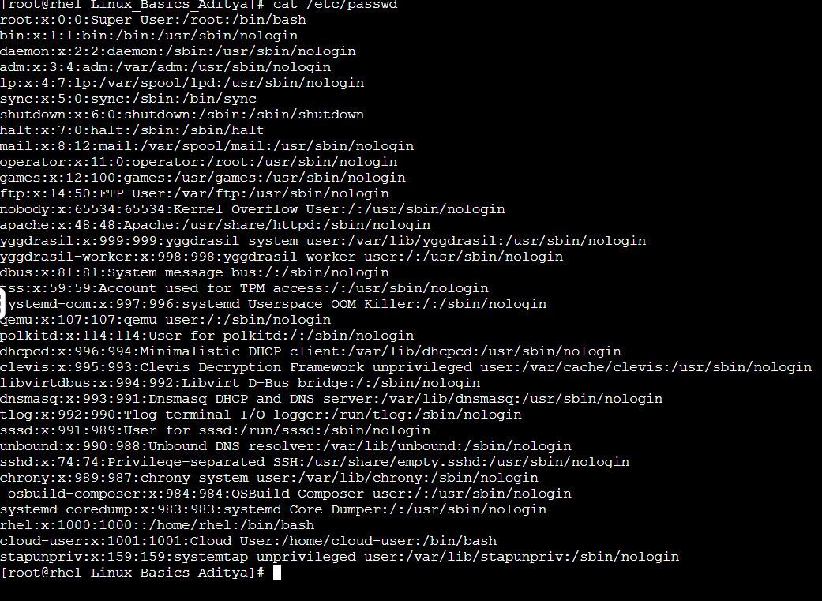

Task 5: View the First Lines of a File
Question: Display the first lines of renamed_example.txt.
Command(s):
head test_dir/renamed_example.txt
Explanation: The head command shows the beginning of a file. By default, it displays the first 10 lines.
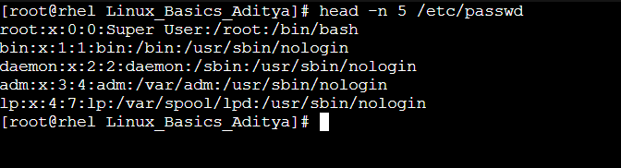

Task 6: View the Last Lines of a File
Question: Display the last lines of renamed_example.txt.
Command(s):
tail test_dir/renamed_example.txt
Explanation: The tail command shows the end of a file. By default, it displays the last 10 lines.
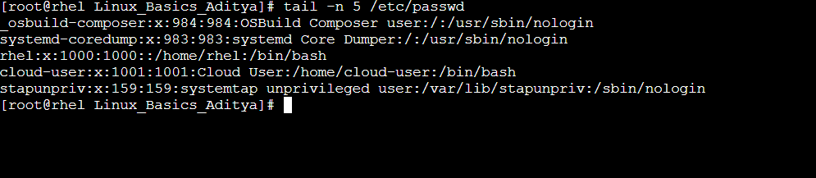

Task 7: Search for a Pattern
Question: Search for a specific word or pattern inside renamed_example.txt.
Command(s):
grep "Linux" test_dir/renamed_example.txt
Explanation: The grep command searches inside a file and displays the lines that match the given word or pattern.
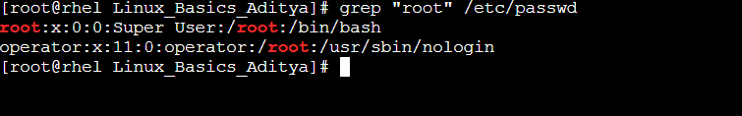

Task 8: Zip a Directory
Question: Compress test_dir into a ZIP file.
Command(s):
zip -r test_dir.zip test_dir
ls
Explanation: The zip command compresses files or directories. The -r option includes the contents of the directory recursively.
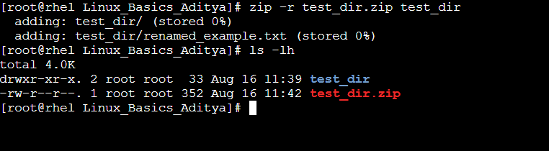

Task 9: Unzip a File
Question: Extract test_dir.zip into a new directory.
Command(s):
mkdir unzipped_dir
unzip test_dir.zip -d unzipped_dir
ls unzipped_dir
Explanation: The unzip command extracts files from a ZIP archive. The -d option chooses the destination directory for the extracted files.
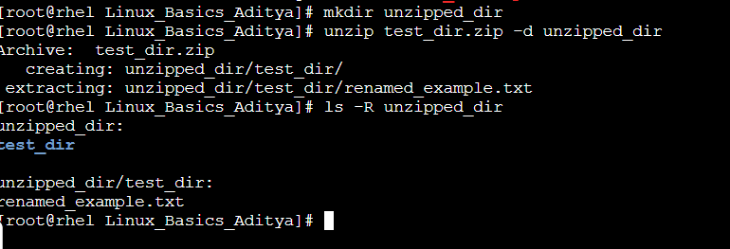

Task 10: Download a File
Question: Use wget to download a file from the internet.
Command(s):
wget <paste-the-file-url-here>
ls
Explanation: The wget command downloads a file from a URL directly into the current directory. Replace the placeholder URL with the URL used during the assignment.
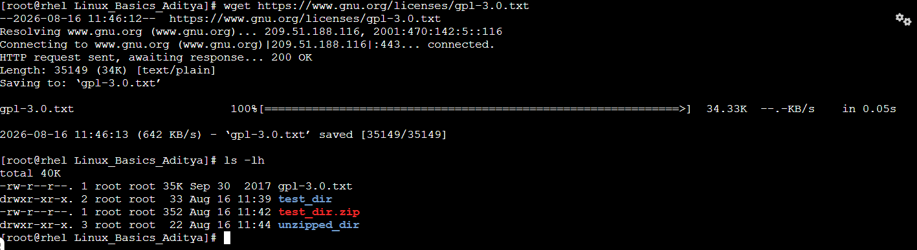

Task 11: Change File Permissions
Question: Create secure.txt and change its permissions to read-only for everyone.
Command(s):
touch secure.txt
chmod 444 secure.txt
ls -l secure.txt
Explanation: The chmod 444 command gives read-only permission to the owner, group, and others. The ls -l command verifies the permission settings.
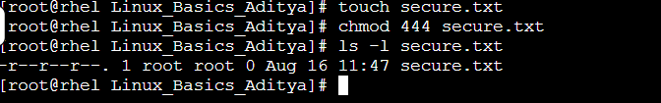

Task 12: Set an Environment Variable
Question: Use export to set MY_VAR to Hello, Linux!.
Command(s):
export MY_VAR="Hello, Linux!"
echo $MY_VAR
printenv MY_VAR
Explanation: The export command creates an environment variable for the current shell session. echo or printenv can be used to verify that the variable was set.
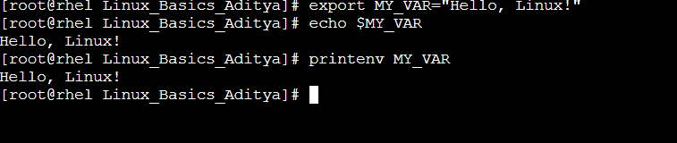

GitHub Repository
Repository Name: tutedude-linux-basics
GitHub URL: https://github.com/adityakittad1/tutedude-linux-basics

