Deputy screens
Deputy System Requirement we can do on our side.

Dashboard for Managers
- Ady we can improvise our dashboard with the following info for managers
  - Availability of employees as shown in the screen shot.
  - Needs Approval – This should show the leave requests, incident reports, or any compliance related requests added or timesheet requests assigned to the manager. Once the requests are approved, it shouldn’t show it here anymore. It should only the ones requested. If nothing is requested then don’t show.
  - What’s happening - birthdays and if anyone didn’t clock in – then it should show here as shown in the screenshot below third column.
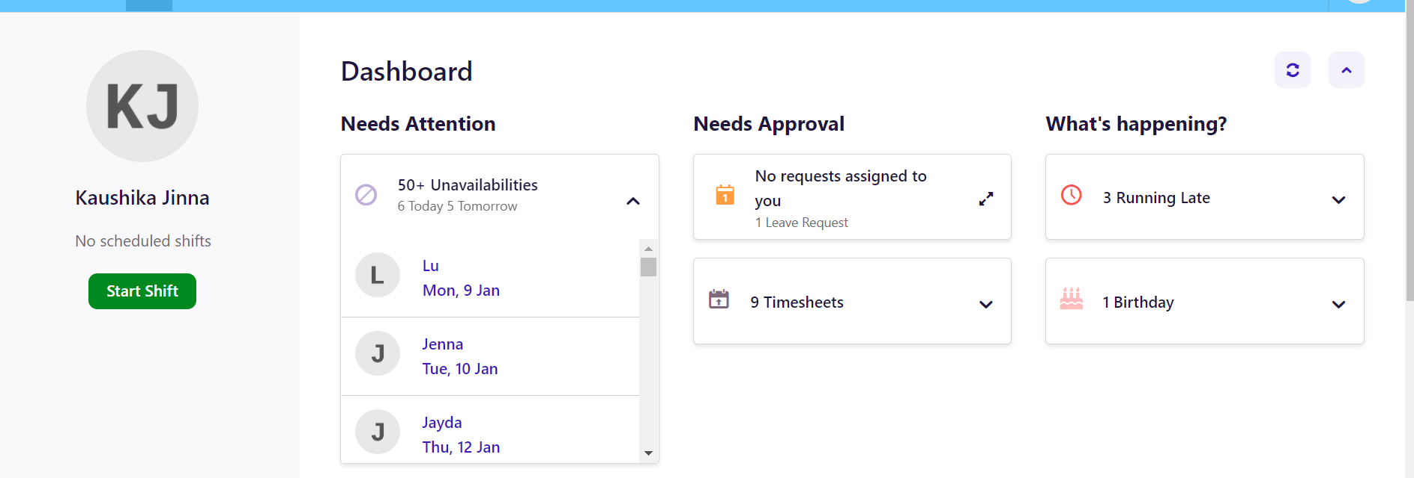

In manager portal dashboard in the second part – we should show Calendar for the managers to tell who all are rostered for that week. Reference below.

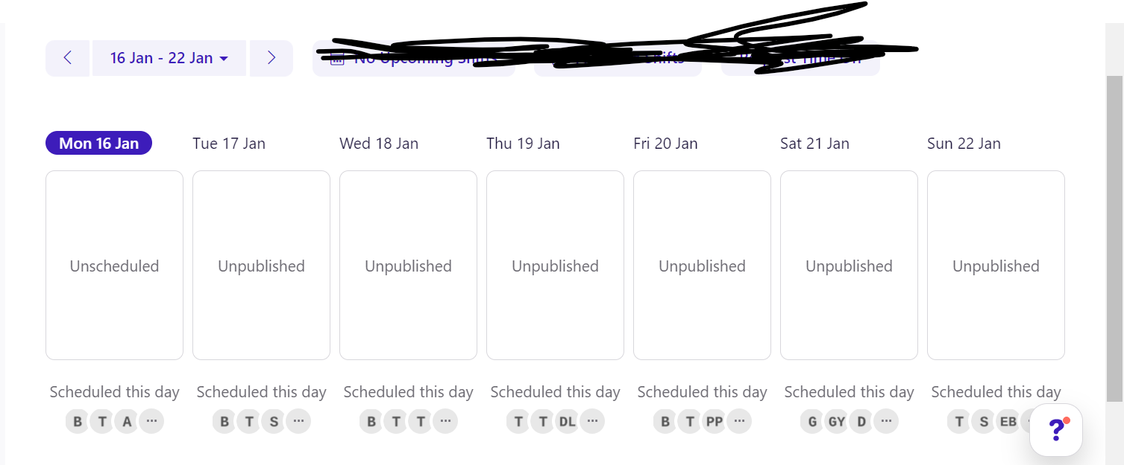
Dashboard for Employees
- Ady we can improve the employee dashboard as follows.
Any new requests employees have requested with the status displaying. So, the employees know if their requests are rejected or approved.
Second part of the section, we should do the following.
- They should be able to see their upcoming shifts, available shifts and they can request leave directly.

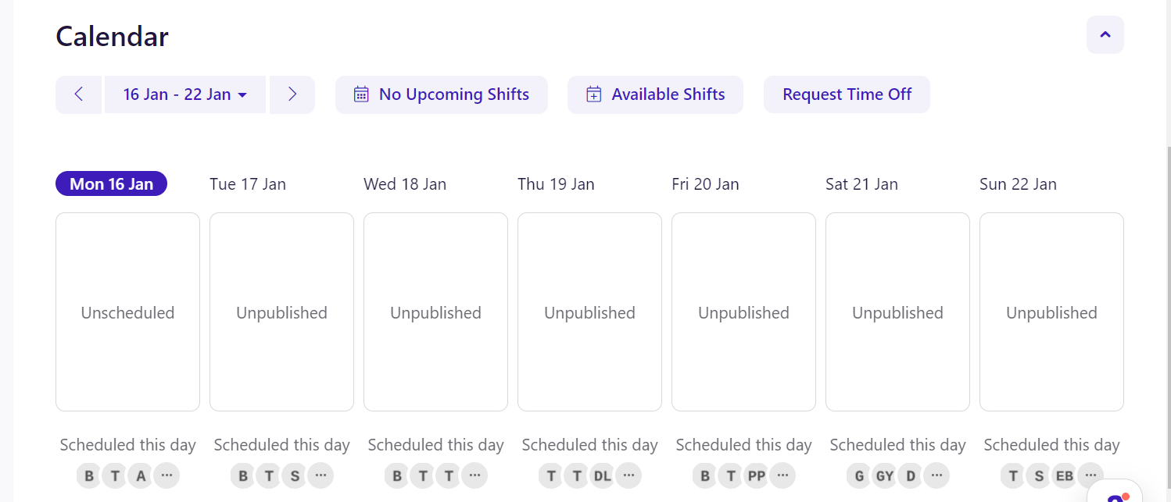

Employee Listing Page:
Additional Features and also look and feel.
- Ady please see look and feel of the page. It is looking fresh.
- We need to add two additional coloums that can displayed if click the check box in display as shown below.
So whatever we select in display can be shown in the list view. Some of our basic stuff should by default shown.

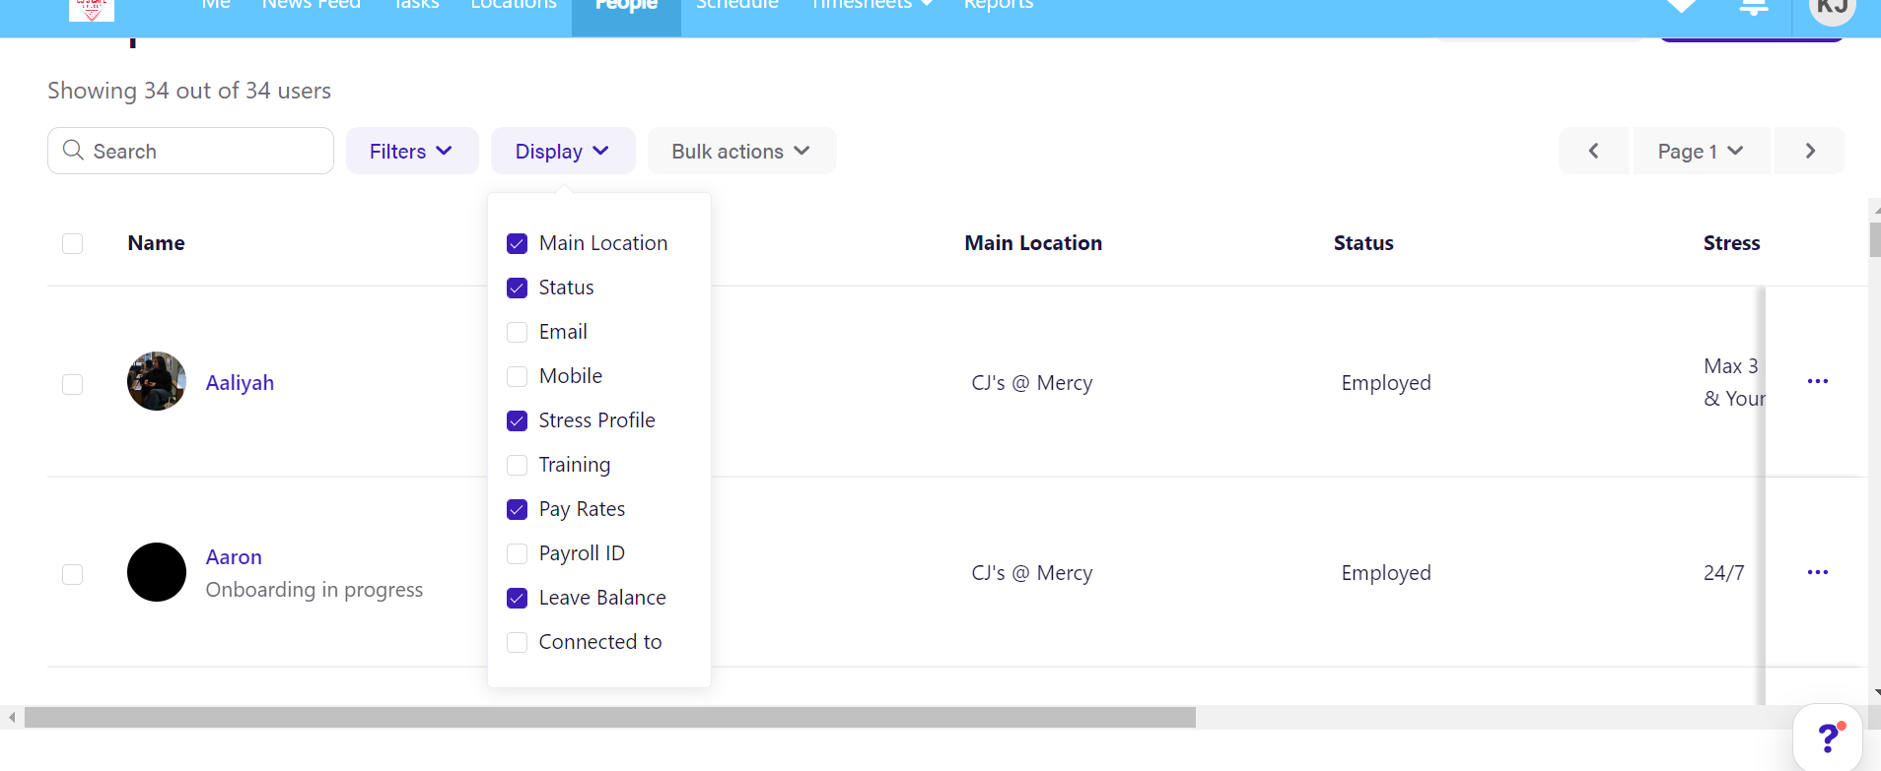
- The two fields we should add are stress profile and Pay rates. Stress Profile should show following information.
  - As per the bday if they are younger than 17yrs old, it should say 17yrs or younger. If they are casual employees then we should show their availability info as shown below. If they are full time then we should just show available full time.
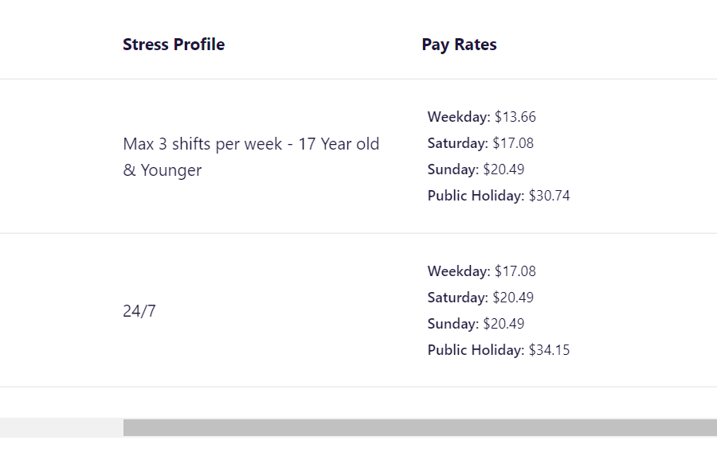
  - We should also display payrates as shown below.
- 

- Employee Inner pages

  - We should have all our info displayed with good look and feel. Please use the site as reference.
  - Other than that please display their pay rates, shifts and leave shown below.
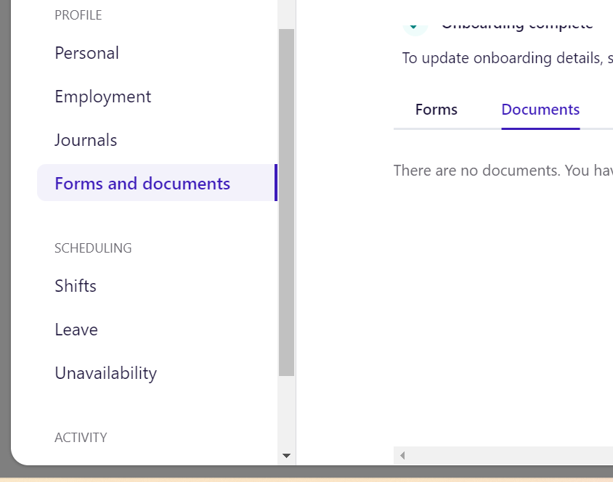

Add New employee Fields.

Roster
Ady if we can implement roster as it is – we are a winner. It is amazing. Please have a look ady.

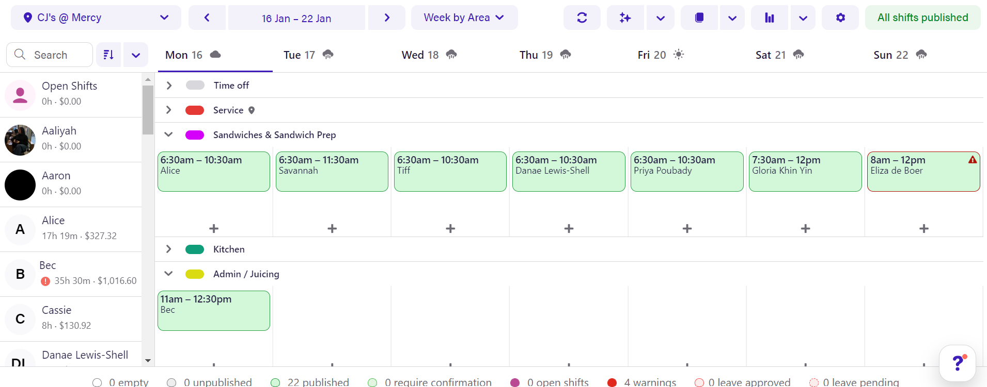
Timesheet

All ok

Employee Details Page
- List View page
  - No need of Finger print section in the list page.
- Inside Page of employee details
  - Pay section should be separate tab and heading should be Pay Details.
  - This should be the fields in Pay Details section.

- 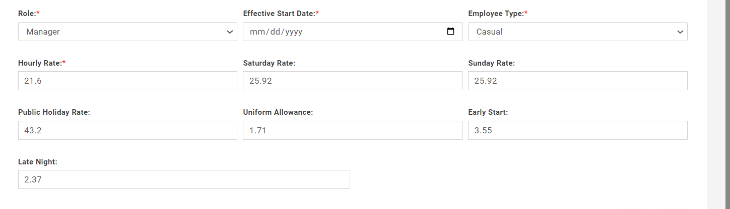
- In required upload section remove the circled option
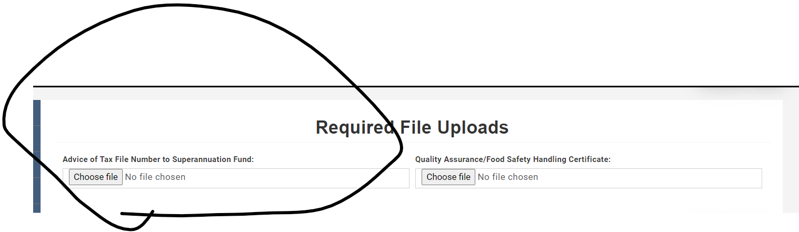

- Police Deductions
  - If the police certificate is already in there then the button should view certificate
  - Button should be big and nice

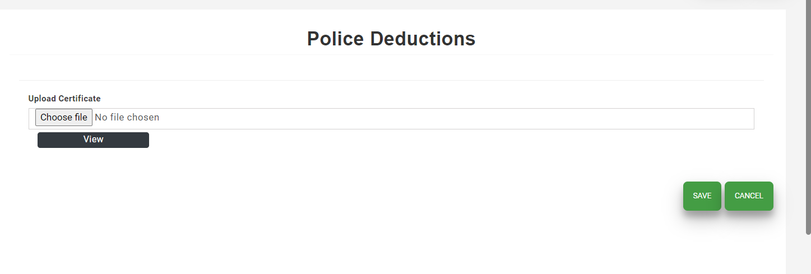

Home address
- Street Name and Street Number should be one field and it should be just called Street Address
Add employee
- Add all pay details field here and they are not mandatory.
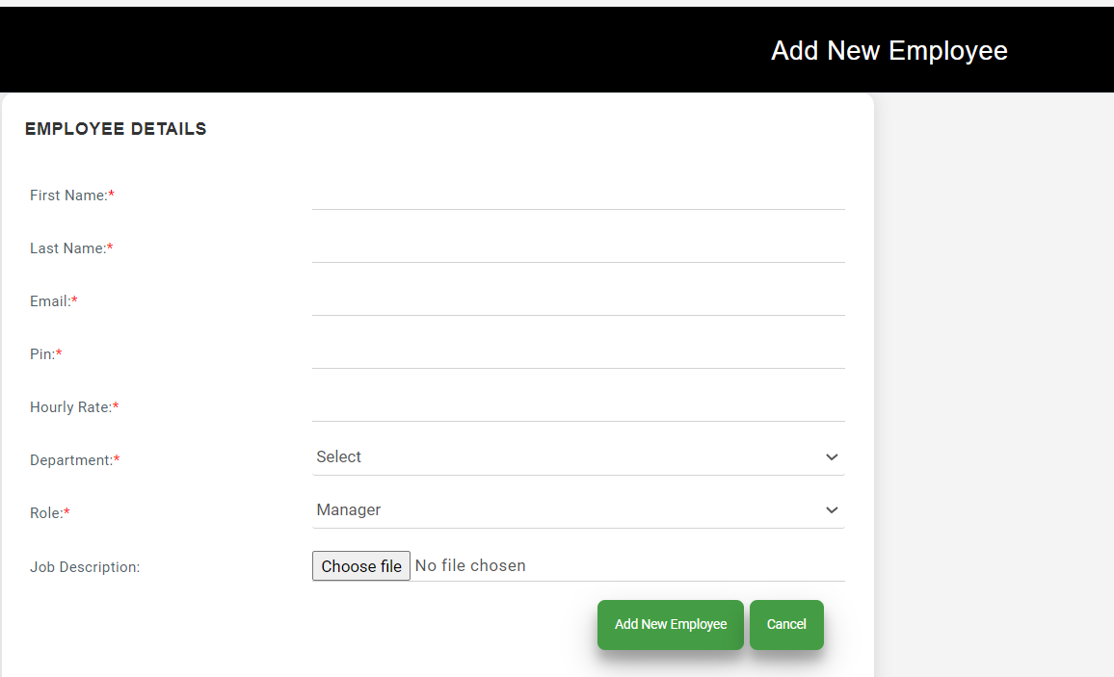
Notifications
- Ady one thing in the meeting was about notifications.
- So when the employee updates or adds new information an email should go to the Admin team and manager saying which field and which section is updated. So they can verify.
- Can we have in the account section where they can add manager email and accounts email.

All the above changes should be reflected in the employee portal too.

- Overall checkboxes and UI should be changed be updated.

Leave Management
- There should be another page here where we can add different leave types.
- Fields are Leave Type Name – where they can add any name like Sick Leave, Annual Leave. Whatever we add in this field should be available for employee to select.
- Manager should be able to add a leave for an employee if he wants.
- The leave manager added should be reflected in the employee portal too.
- When the manager is adding the leave from manager portal, they should have employee list that they can select. Drop down should have a nice UI. When they type the name it should show.
Notifications
- When a new leave is requested, an email should go to the manager with the name of the employee and the dates. Can the manager approve from the email itself?
- When a manager adds a leave on behalf of employee then a email should go to the employee with the leave info in the email and link to login to their portal.
- When the manager approves or rejects or add comments – an email should go to the employee.

Disable following Buttons from view
- Covid
- Reports
In Compliance drop down remove the following
- Remove job keeper notification
- Remove performance self assessment
- Move Survey Under Compliance and rename as Work Satisfaction Survey
- Remove Work Satisfaction feedback from both employee and manager portal.
- Compliance forms filled by employee should display based on location. Right now it is displaying in all locations I think.
Timesheet
Add Timesheet
- Add Timesheet page should be nice
- They should be able to add next week or this week
- And if they want to add anything from past weeks. There should be a button saying add past week timesheet.
- Ady is there a way we can automate the timesheet added automatically instead of manually?
View Timesheet
- Ady this page will be everything that makes the job of the manager easy.
Inner page
- Timesheet name, Total Hours of this timesheet etc – should be visually nice.
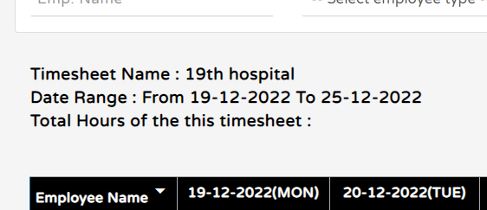
- The way the competitor system has is as follows:
  - The names of the employees are on the left side and the ones approved are automatically highlighted in Green colour.
  - When the employee’s name is clicked, it opens a new page where all the following information is available.
    - Roster hours allocated for that week should show clearly with the heading.
    - Clock in and Clock out hours entered in the timesheet portal by the employee. If there is no entry, then blank fields should display to enter.
    - Break in and break out hours to enter or to display.
    - It should have tolerance of 5 mins before and after to round it up automatically and approve automatically.
    - There should be a button called “round” and when it is clicked then it should be rounded to the nearest value for clock in clock out.
    - There should be a box to write comments to the employee incase manager would like to know why the worker overtime incase. When they click submit button, an email should go to the employee they are checking the timesheet with the message so they can reply. The reply should be shown in the comments for the manager to check and approve the timesheet. When the employee enter the comments then manager should get an email saying the employee has added the comments.
    - Once the manager finishes entering and approving the timesheet, there should be a button called Save and Next so the manager is taken to the next employee automatically so they can do the above process to the next employee.
    - All the values entered in this inner page should show correctly in the below page.
  - 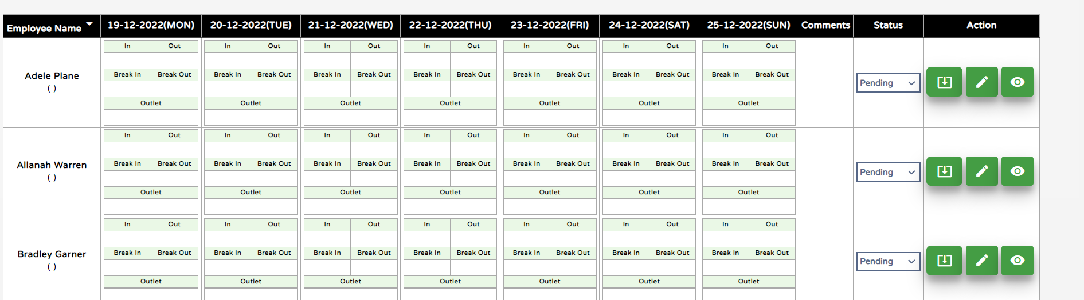

- All the HR pages should have history in the database. Like who updated, when they updated information should be clear in the database.

Roster Management.
- Rostering is something we can improve very much. Please see some of the suggestions.

Create Roster
- On the left side, the employee search should show as shown below.
- Roster once created they should be able to see based on the Employee name as shown below or based on the department in graphical way or based on a day or based on a week or month.
- When adding the roster, it should auto suggest the employees based on their department.
- While adding it should be able to add
  - Start time
  - End time
  - Break Time
  - Break out time
  - Comments.
  - Also, should have the ability to add multiple break times only if needed.
- While adding the roster if the employee is not available or on leave, it should give a validation that the person is not available based on the available times the employee define in their portal.
Another screenshot for your reference
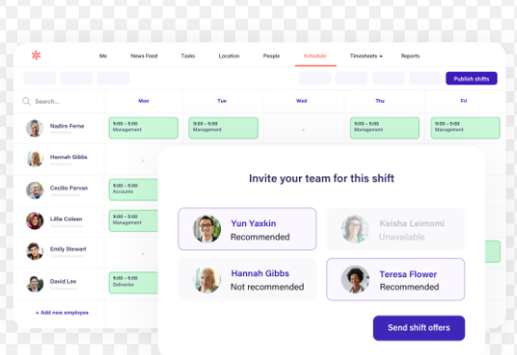
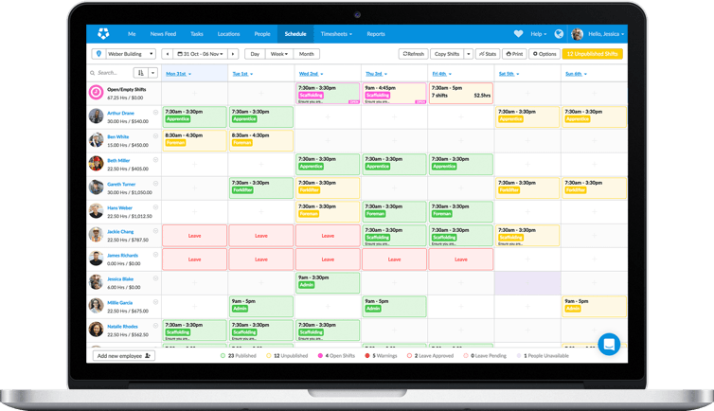

Ady for each department, it should show how employees are assigned in the day as shown below so manager knows the breaks are overlapping.

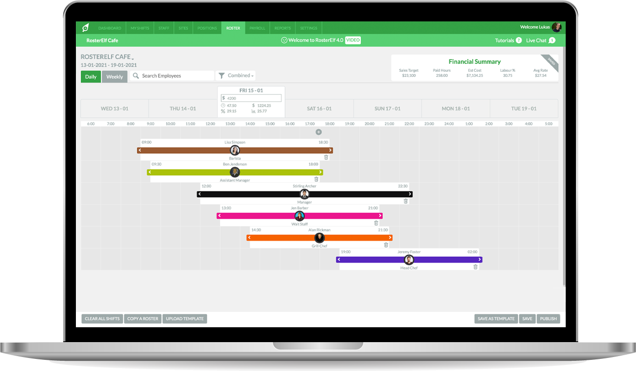

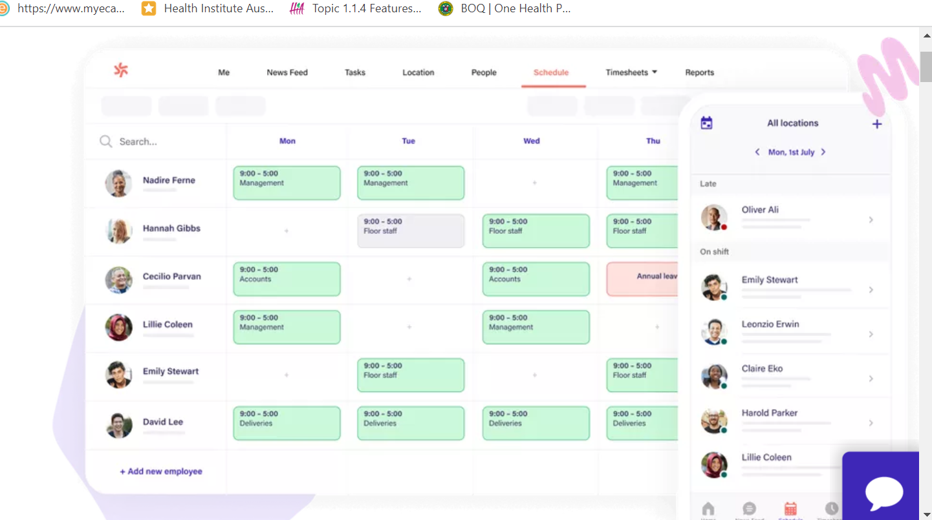

- The system should show on the right side who has clocked in and who is in shift. If someone didn’t sign in it should show that they are late to the shift as shown in the above screenshot.

Available Times
- Employees should be able to add their available times for each week.
- They can add only to future week cannot add for past week.
- We already have this feature but improve the UI.
- A notification sent to manager when they add in employee portal.
- Also when adding rosters, managers to be notified if the available times don’t match.
Integration with Xero
- Able to integrate payroll to Xero

Payslips
- From Xero we should be able to display payslips in our system.

Reports
- Roster reports and costs like we have know but in graphical and also better display ady.

