Export Project (ROUBA’S VERSION)

Request for Offer from Supplier Creation page. (Can turn into a PO)

Once the customer request has been received (email), the next step is to create the supplier request to get the costs from the supplier.
- Templates:
  - NACH FOOD CO PTY LTD AUCED DATE 01/02/2023
  - 47-53 CHIFLEY DRIVE
  - PRESTON VIC 3072
  - PH: 94714411
  - EM: info@nachfoodco.com.au
- Example but instead of Purchase Order – It should say Request for Offer
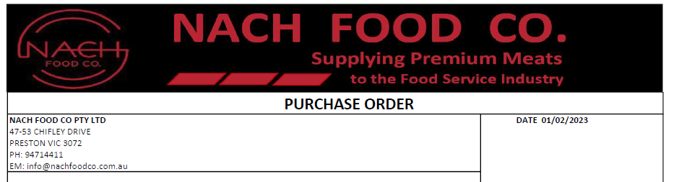
- Reference number – Manually entered field.
- Step 1: Select the supplier from the drop down or if a new supplier then able to create a new one. When we select the supplier – the address details should automatically populate from the database.
- Date – Automatically populate today’s date. Has to be editable.
- Step 2: Manually add the quote items and following at the fields.
- 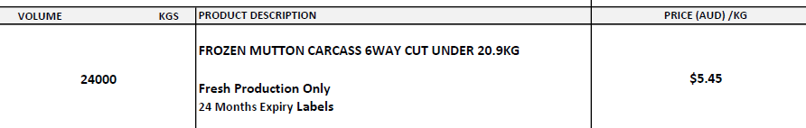
  - Product Name/Description
  - Volume/KG
  - Drop down to specify Categories.
  - Include Product Comment Box
  - Price to be filled out by Supplier (Man)
  - Add Location of the order (MARKET) [Ensure there should be a feature to enter multiple locations]. Multiple locations should be in different lines. (as below)
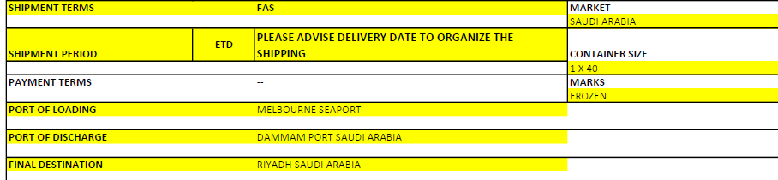
  - FOB or FAS required? This is a mandatory field.
  - Container Size (dropdown field – select Sea or Air) (for Sea: 20 or 40 [supply QTY] – for Air: AV [QTY 1, 2, 3])
  - Marks: Frozen OR Chilled (Mandatory)
- PORT OF LOADING (Highlighted)
- PORT OF DISCHARGE (Highlighted)
  - FINAL DESTINATION (Highlighted)
  - Requirement Box: (completed by NACH)
    - FROZEN PRODUCTS
    - HALAL CERTIFIED
    - INSERT ALL LABELS
    - PRODUCTS SHOULD BE ELIGIBLE FOR ENTRY INTO ---------
    - RFP, INTERIM HALAL AND LOAD OUT DOCS TO BE EMAILED TO NACH FOOD CO PTY LTD (EXPORTER NO: 3518 AND EDI NO:2145) at email address:
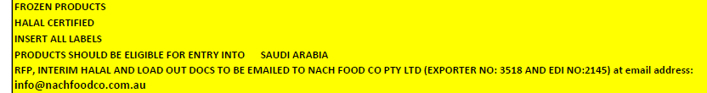
  - Comments box
  - Customer Name and Request Number created above [Ensure this information is only for the manager]. Supplier must not view this information.
  - Send the Request for Offer to the Supplier.

Request for Offer received by the Supplier.

- An email should be sent to the supplier with the Request for Offer created above as a link
- When the supplier opens the link the supplier should see the request like below.
- When the supplier opens the link, they have to see the exact template as created above in the step 1. Only the Price field will be editable in the link. Rest of the fields should be read only.
- The template link should show additional field called Supplier Comments and this field will be editable as well.
- Ensure Customer Name and Request Number created above [Ensure this information is only for the manager]. Supplier must not view this information.

Supplier Listing Page

- Supplier Quote is added in the section 2 will create a record with a PO number.
- The Listing Page will have the following fields
  - Supplier Name
  - Order Date
  - Status
    - Confirmed by the Supplier
    - Sent
    - Viewed
  - Link to create Purchase Order

Create Performa Invoice

Once the quote is received by the supplier, performa invoice has to be created that needs to be sent to the customer.
The format of the invoice should be as follows:

Product Name | Category | Price | USD Price | Margin | Qty/Kg | Total
[Whatever the info created in the section 2] | [Whatever the info created in the section 2] | This section should have the price given by the supplier | Some tool to convert the price given by the supplier to USD. | This is an editable field that we can mention a price. | Qty is editable field | USD Price field + Margin * Qty = Total Value.

Other Information fields
- Location Name
- Comments Field that the manager can write.

7 Generation of Quote for the customer
- Once the performa invoice is created, we need to create a quote to the customer. The quote should have the following information.
PO Number, Order Number, Customer Information.
Product Name | Category | Qty | Total
[Whatever the info created in the performa invoice] | [Whatever the info created in the performa invoice] |  | Value obtained above

Location info
Other info
All the info should be in the customer view page of the quote.

8 Customer Quote Page
- It has following buttons to send the email to the customer.
- Send Approval Email
- Print
- Pdf Quote

9 Customer Receives the Email with the quote.

- Customer receives an email with the quote and three buttons.
- Approve, Reject and Modify.
- Based on whatever the customer has selected, the status should be updated in the system.

Customer Request

This section discusses on the first step where the customer sends an email to the business with all the information. (with their request)
From the information received by the customer, a ‘Request for Offer’ must be created and sent it to the Supplier.
Based on the email information, a new record has to be created for the request with the following information.
- Customer Name
- Customer Company
- Comments to record the email content.
- Order Received Date
- Location of the Delivery
- Location of the FOB
- Click on Proceed. This will create the email request record for reference and helps to track the email request.

Quote from Supplier Creation page. (this should be the first step)
I would suggest naming it a ‘Request for Offer’ this is sent to the supplier requesting them to offer specific items along with pricing.
Based on the email information, a new record has to be created for the request with the following information. Refer to the attachment sent in the email
- Customer Name (Consignee – this includes the customer and company name, address)
- Customer Company
- ADD: Buyer (if different than Consignee) we need to be able to add this information if the end user, the buyer, is different than the consignee, as the consignee could be a buyer’s agent) let me know if this makes sense.
- Comments to record the email content.
- Order Received Date
- Location of the Delivery
- Location of the FOB
- Click on Proceed. This will create the email request record for reference and helps to track the email request.

