OCR

- When you click on Scan OCR link, below should happen.
  - A heading with purple header saying OCR Scan
  - A sentence saying, “Please follow the below instructions to process the OCR Scan.”
  - Step 1: Upload the invoice or take a picture of the invoice with your phone. [Please ensure the invoice is completely captured]
    - Put Upload button, ability to take a picture, ability to upload multiple invoices.
  - Step 2: View Invoice to ensure the complete invoice info is captured in the Step 1.
    - Put View Button.
  - Step 2: Click on the OCR Scan button to process the invoice.
    - Put OCR button.
  - Once OCR is scanned, the user should be redirected to the results page. Heading should be OCR Processed. Also, we need to another dropdown menu option in orders, that will store all these orders that are OCR processed for accounts to check.
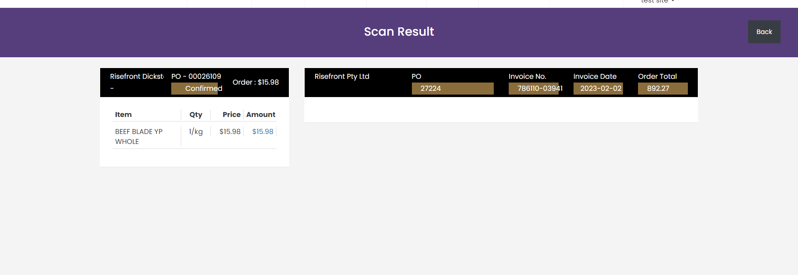
  - Every time we open that order, this page should be displayed. OCR scan page above screenshot should have all the following fields too. So they can finish everything at once.
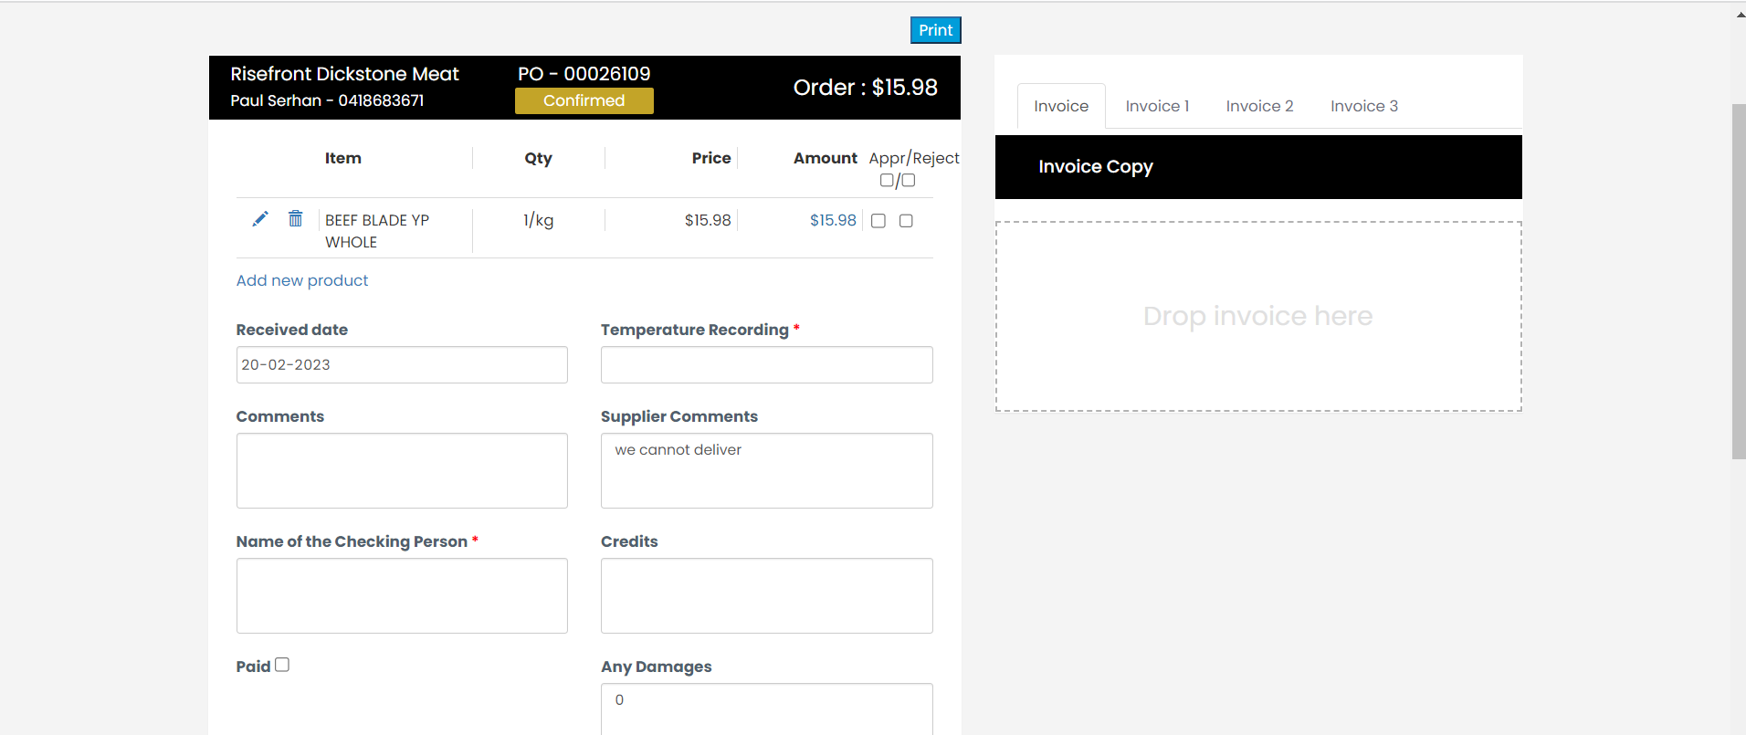
- Once the OCR is scanned, they don’t have to process it again if they open the order again. They should have a button – Upload again to redo it.
- Please GST next to Total
- Please make the below UI in a table format horizontally so it looks nice.

