**NAME:ADITYA KOUL**

**GROUP:G-19**

**ROLLNO:2110992068**

**GITHUB:** **https://github.com/adityakoul2068/endterm_project.git**

**MOVIESP**

-->Moviesp is a website that is made by using reactjs, javascript, css and html. Some common objectives and features you might consider for a movie searching website using React:-

1. **User-Friendly Movie Search:** The primary objective is to provide users with an easy-to-use interface to search for movies. Users should be able to search by title, genre, release date, and other relevant criteria.
2. **Movie Information:** Display detailed information about movies, including cast and crew, plot summaries, ratings, reviews, and trailers. You can integrate with movie databases or APIs like The Movie Database (TMDb) or IMDb for this purpose.
3. **User Reviews and Ratings:** Allow users to submit their own reviews and ratings for movies. Implement a user authentication system to enable user-generated content.
4. **Recommendation System:** Implement a recommendation system that suggests movies to users based on their preferences, viewing history, and user reviews.
5. **Search Filters:** Provide advanced search filters, such as sorting options, filter by rating, genre, and release year.

**TECHNOLOGIES USED IN PROJECT**

Some of the technologies used in moviesp project are llisted below🡪

1. **React**: React is the core front-end library for building user interfaces. It allows you to create interactive and dynamic web pages efficiently.
2. **HTML and CSS**: These are fundamental for structuring the web page and styling the user interface.
3. **JavaScript**: JavaScript is the primary programming language used for enhancing interactivity on the front end.
4. **API Integration:** We used OMDb fetch movie data, posters, and information.
5. **Responsive design:** CSS media queries and frameworks like Bootstrap can help ensure our site works well on various screen sizes.
6. **Version Control:** Use version control system like git to manage and collobrate codebase.
7. **Github:** We use this technology to deploy our code.

**MAIN PAGE:**

--This is the main page of my project which contains logo, search bar nd all the movies which are visible to us with help of react and Api.

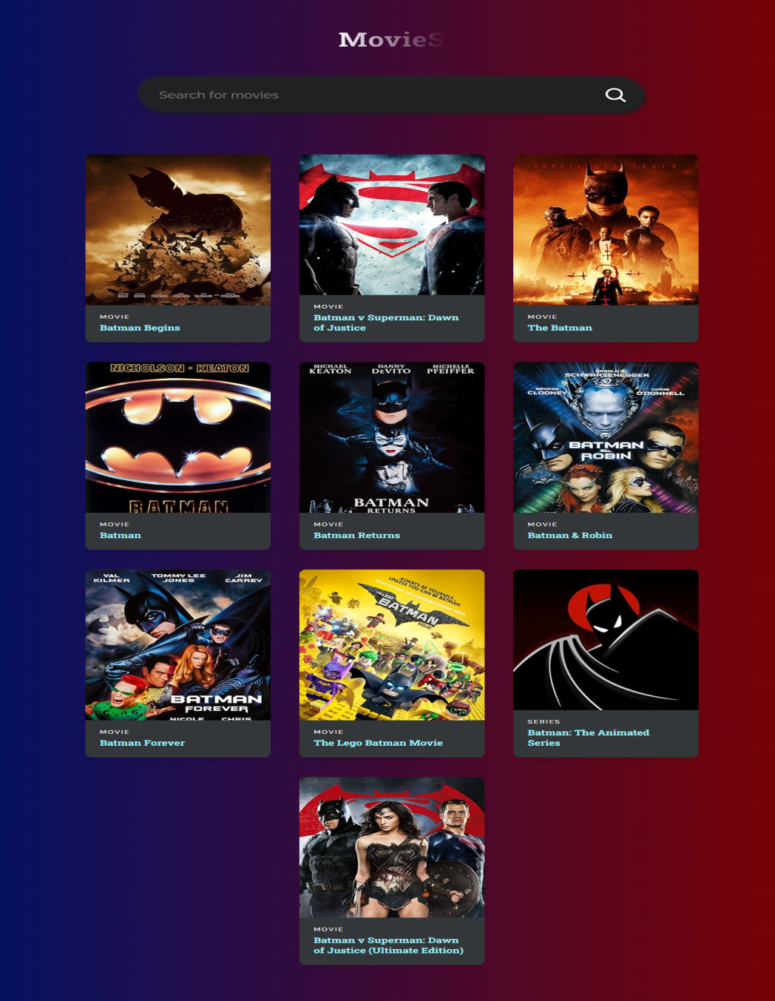

**SCREENSHOTS OF PROJECT**

**INDEX.HTML—Main file**

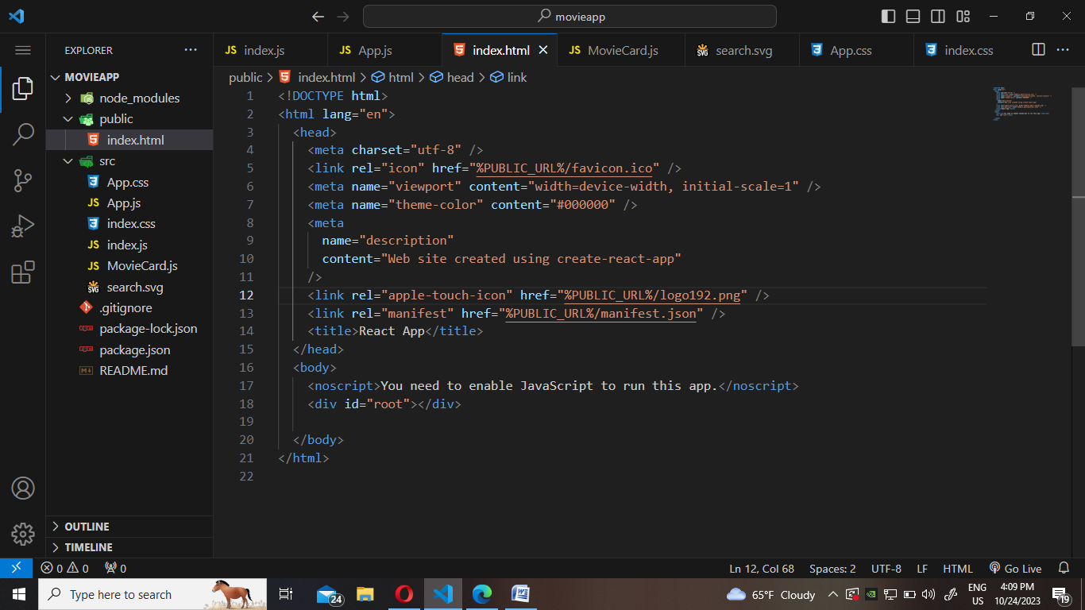

**INDEX.CSS—Main css file**

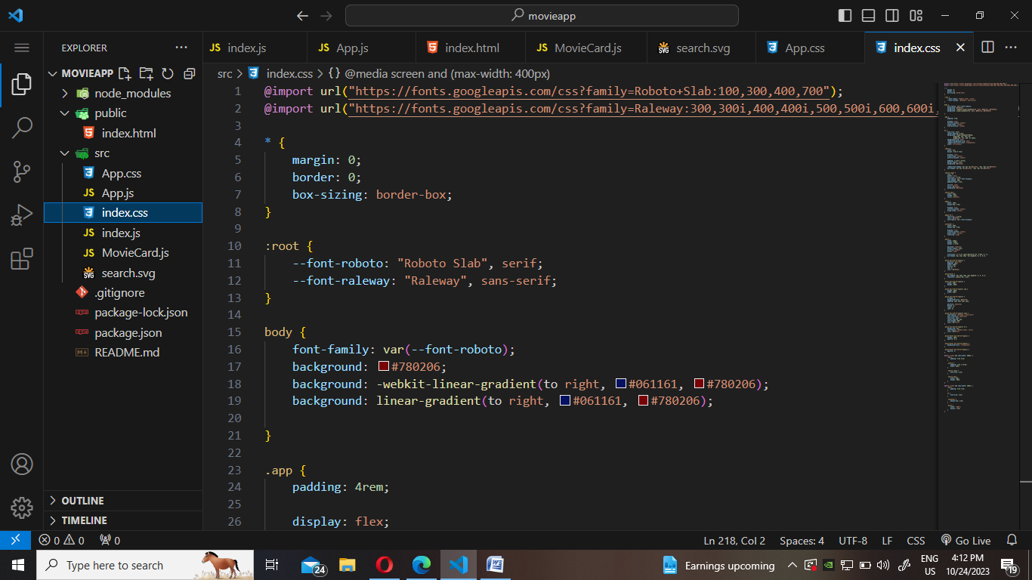

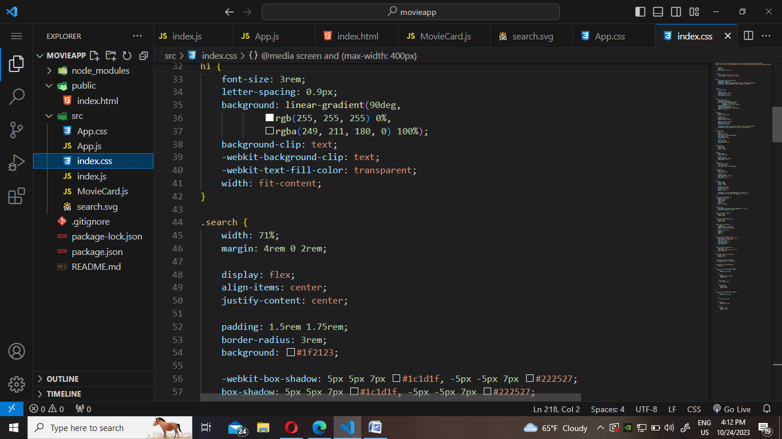

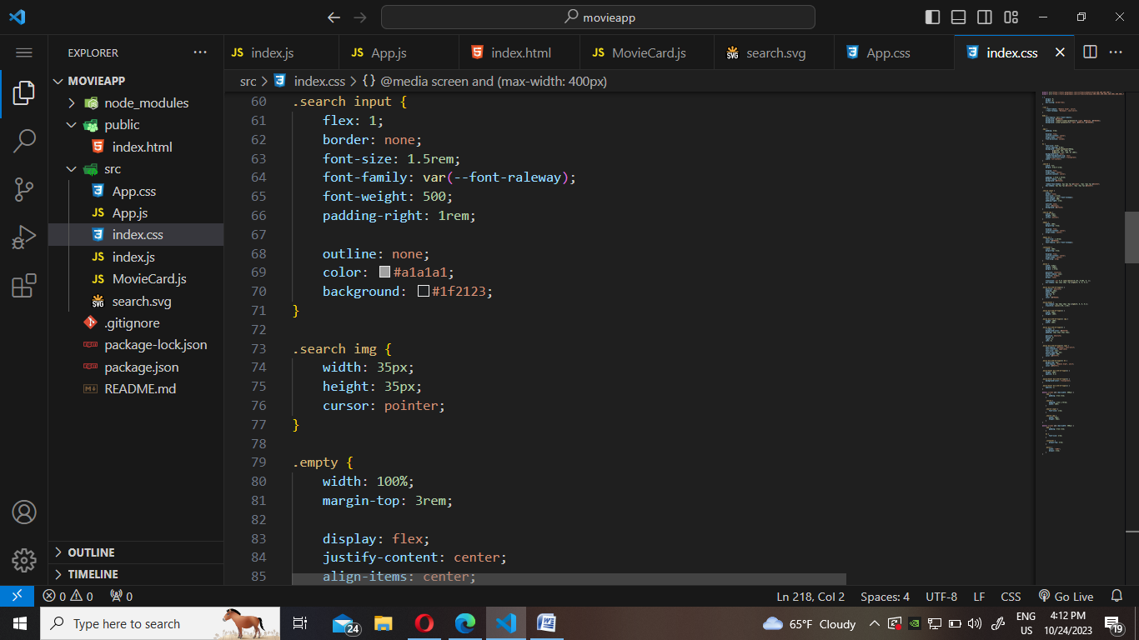

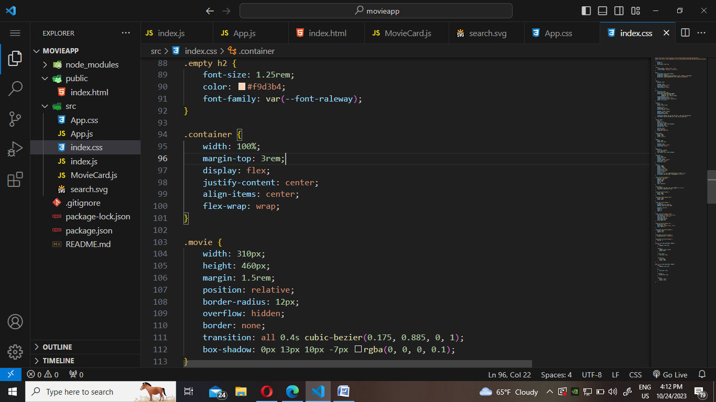

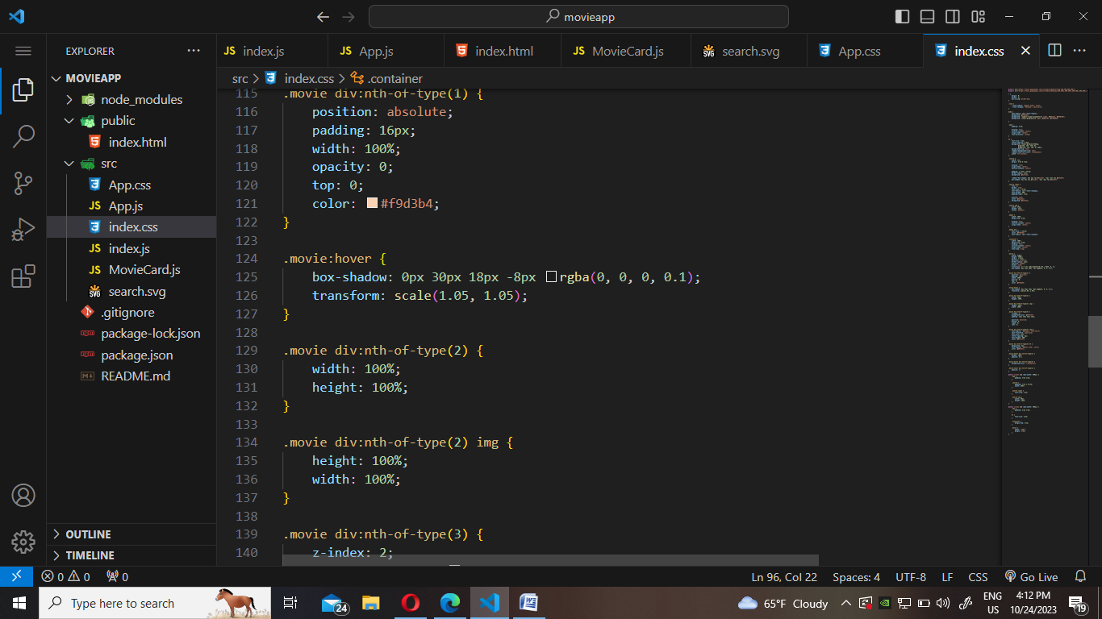

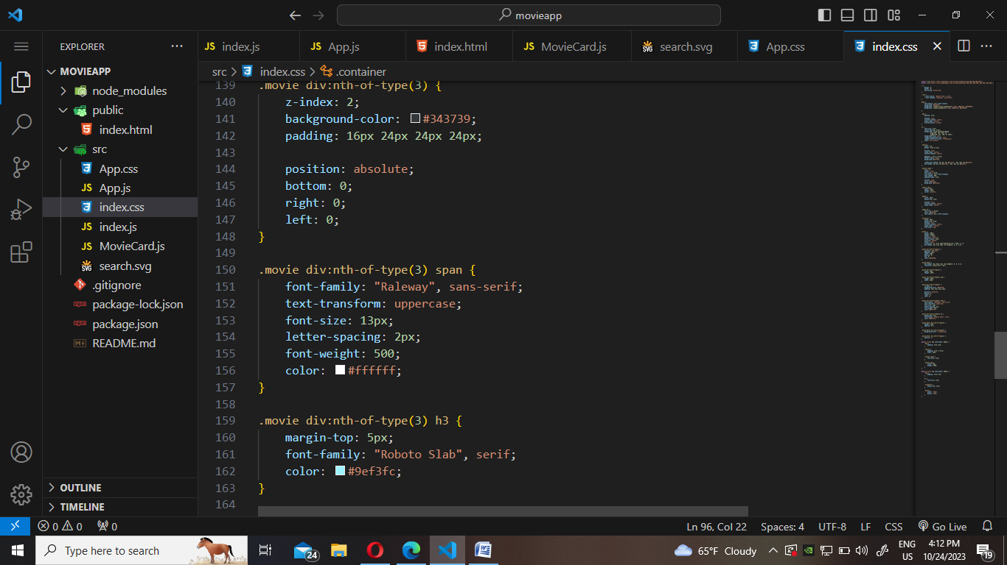

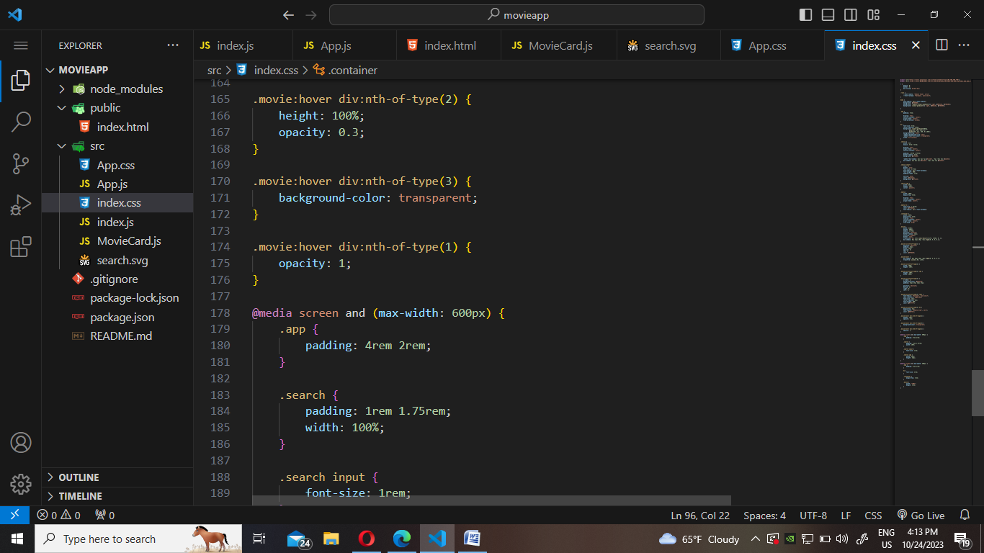

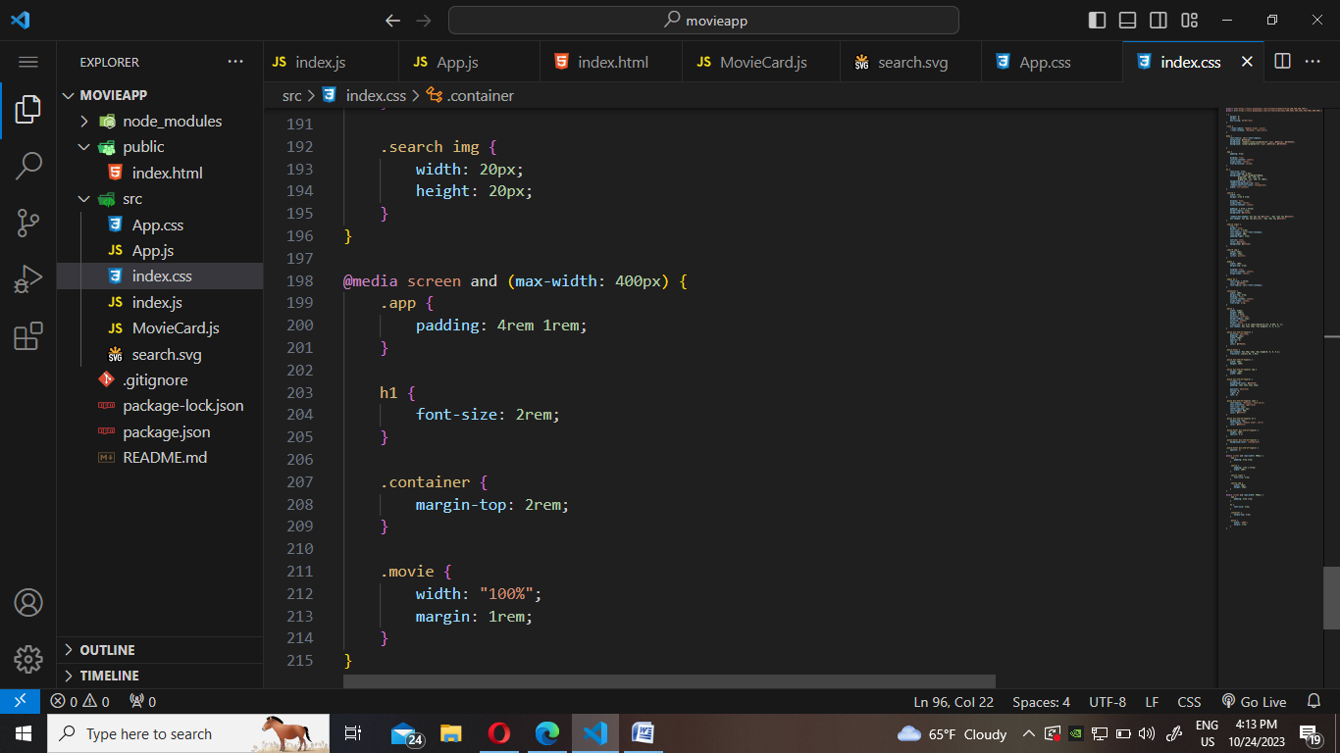

**INDEX.JS—Main js file**

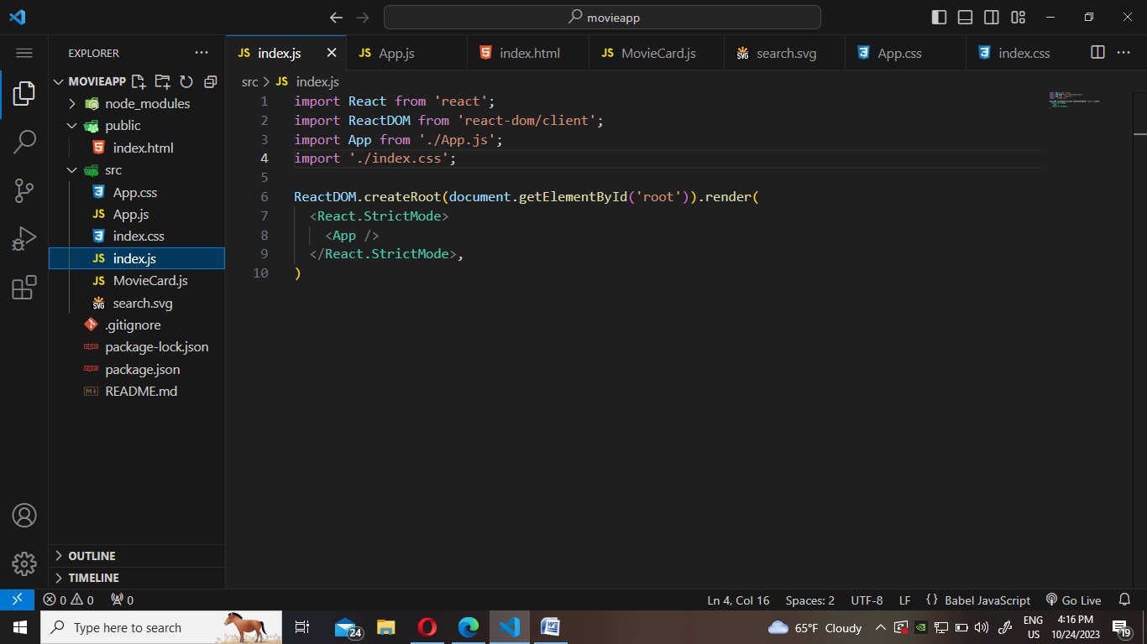

**APP.JS—Main component of js**

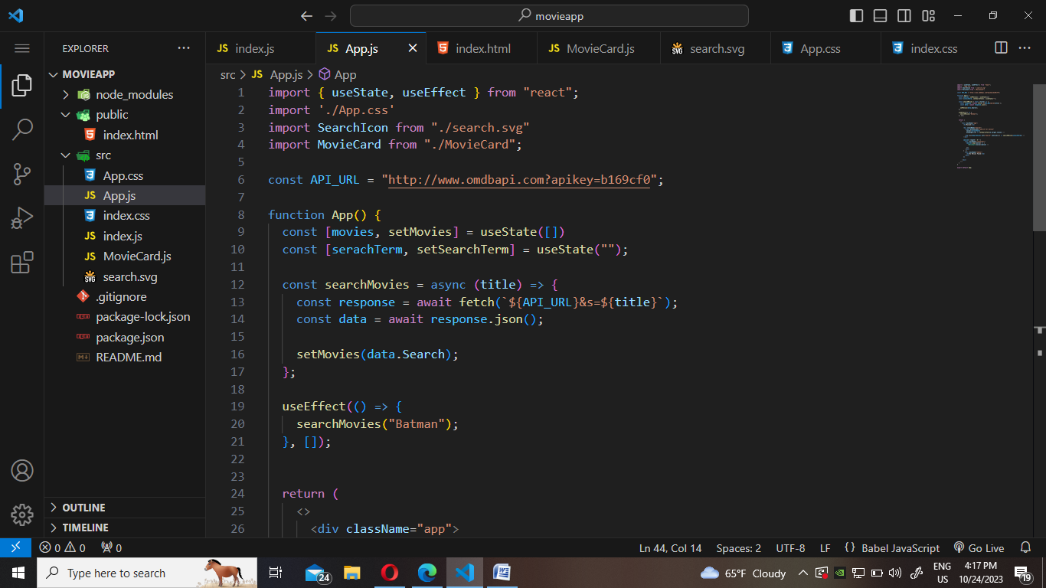

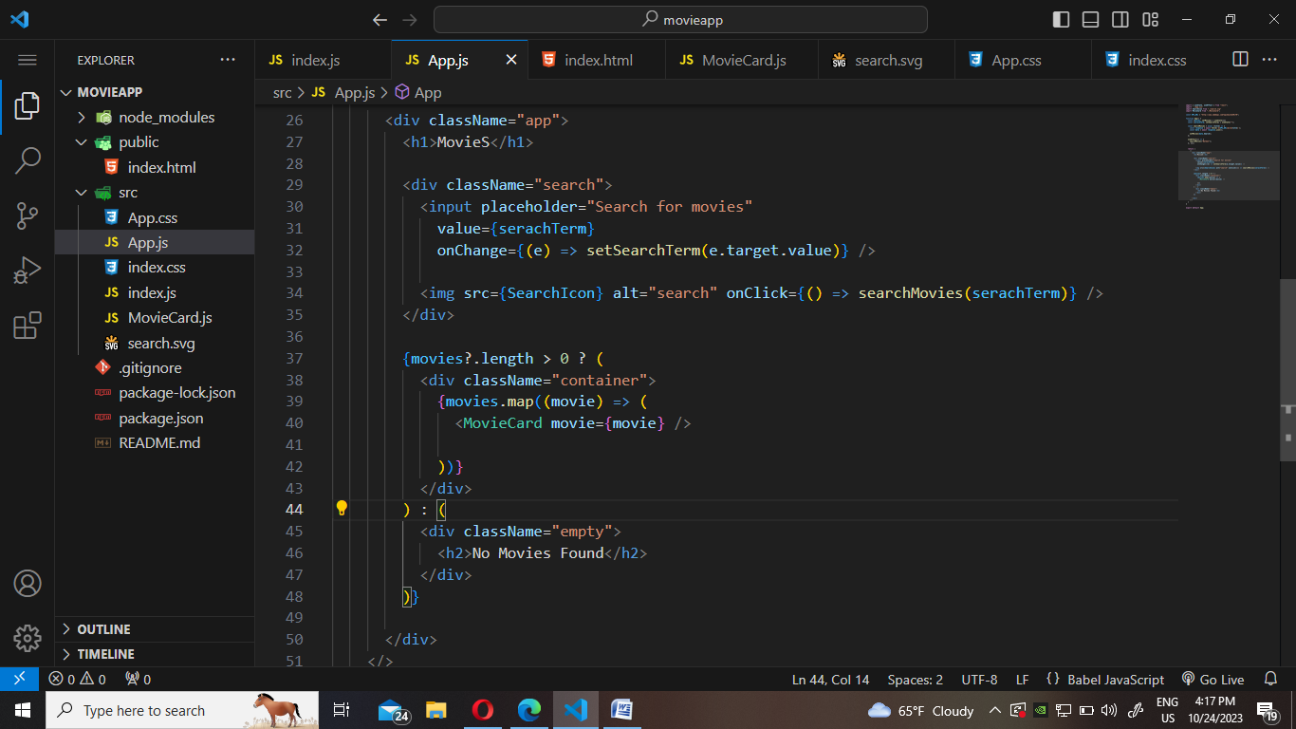

**Moviecard.js—The cards of movie shown on main website**

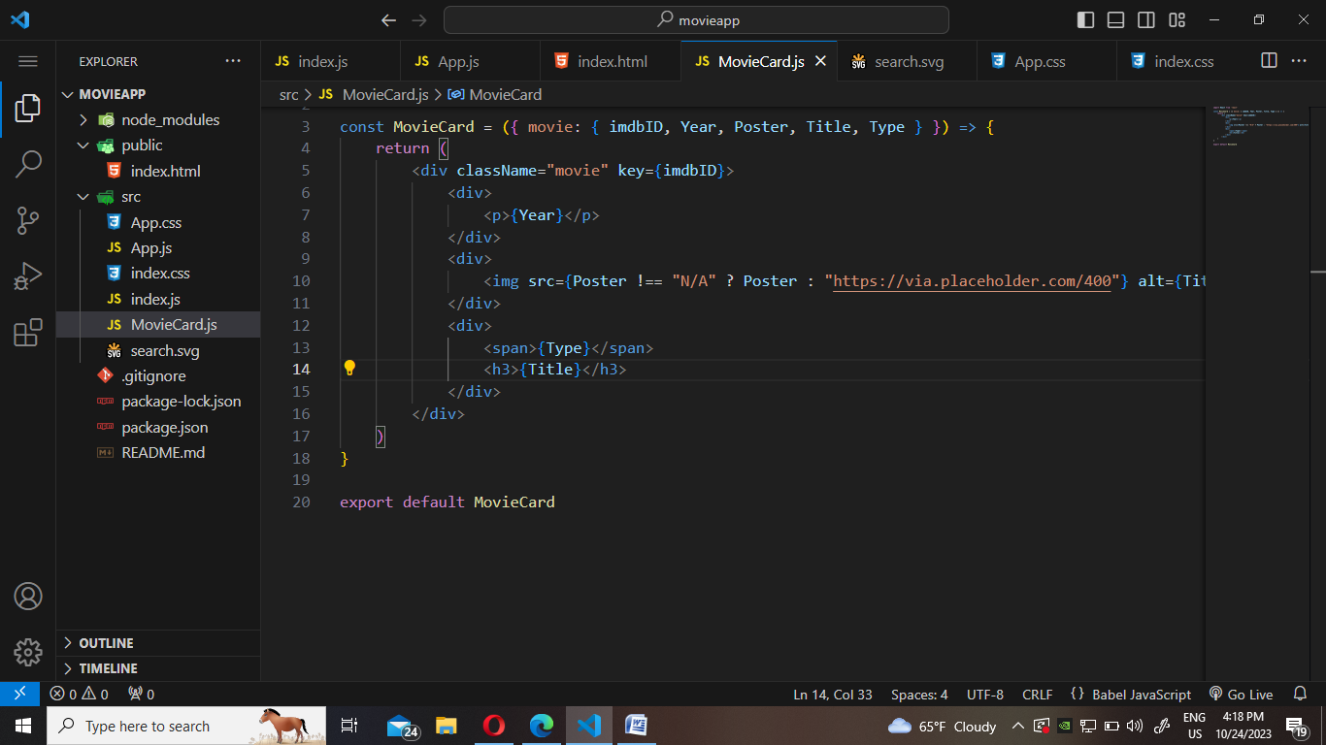

**FLOWCHART**

