**PROJECT-II REPORT**

**On**

**ONLINE MID DAY MEAL PROGRAM**

Submitted to Rajasthan Technical University

in partial fulfillment of the requirement for the award of the degree of

**B.TECH.**

**in**

**COMPUTER ENGINEERING**

**Submitted By**

**Aditya kr sharma (piet15ce009)**

**Deepti yadav (piet15c405)**

**Under the Guidance of**

**Mr. Praveen gupta**

at



**POORNIMA INSTITUTE OF ENGINEERING & TECHNOLOGY, JAIPUR**

**Rajasthan Technical University, KOTA**

**APRIL, 2018**

**CERTIFICATE**

This is to be certified that the project entitled “**quickquiz** ” has been submitted for the Bachelor of Computer Science and Engineering, Poornima Institute Of Engineering & Technology, Jaipur during the academic year 2018-2019 is a bonafide piece of project work carried out by “ **-----------& ----------------**” towards the partial fulfillment for the award of the Degree (B.Tech.) under the guidance of “**Mr.Praveen Guota**” and supervision and no part of thereof has been submitted by them for any degree or diploma.

Project Guide Project Coordinator Mr. Deepak Moud

Mr. Prof. (Dr.) Praveen Gupta (H.O.DCSE)

(Assistant Professor) (Professor)

**CANDIDATE’S DECLARATION**

We,**Aditya kumar sharma** **(PIET15CE009), Deepti yadav(piet15ce405-)** B.Tech (Semester- VIII) of “**Poornima Institute Of Engineering & Technology, Jaipur”**

hereby declare that the Project Report entitled **“Quickquiz”** is an original work and data provided in the study is authentic to the best of our knowledge.This report has not been submitted to any other Institute for the award of any other degree.

|  |  |
| --- | --- |
| **Aditya kumar sharma** | **deepti yadav** |
| **PIET15CE009** | **pIET15CE009** |

|  |  |
| --- | --- |
| **Place: jaipur** |  |
| **Date: 22\10\2018** |  |

**ACKNOWLEDGEMENT**

It is our pleasure to be indebted to various people, who directly or indirectly contributed in the development of this work and who influenced our thinking, behavior and acts during the course of study.

We express our sincere gratitude to ***Dr. O. P. Sharma,*** Director, PIET for providing us an opportunity to undergo this Major Project as the part of the curriculum.

We are thankful to ***Mr. Deepak Moud, HOD, CS*** for his support, cooperation, and motivation provided to us during the training for constant inspiration, presence and blessings.

We are thankful to ***Mr. ---------------------*** for his support, cooperation, and motivation provided to us during the training for constant inspiration, presence and blessings.

We also extend our sincere appreciation to***Prof. (Dr.) Praveen Gupta*** who provided his valuable suggestions and precious time in accomplishing our Project report.

Lastly, we would like to thank the almighty and our parents for their moral support and friends with whom we shared our day-to-day experience and received lots of suggestions that improved our quality of work.

|  |  |
| --- | --- |
| **Aditya kumar sharma** | **deepti yadav** |
| **PIET15CE009** | **pIET15CE009** |

**Contents**

***Page no.***

1. ***Introduction***

***1.1 Relevance………………………………………………***

|  |  |
| --- | --- |
| ***……………….*** | ***5*** |

***1.2 Problem***

***Definition………………………………………………….***

***5***

***1.3 Objective…………………………………………………***

|  |  |
| --- | --- |
| ***……………..*** | ***6*** |

1. ***Basic Concepts & Tools 2.1 Introduction to***

***Java……………………………………………….. 7-9***

***2.2 Android…………………………………………………***

***………………..9-13***

1. ***System Analysis 3.1 Feasibility***

***Study……………………………………………………***

***13-14***

***3.2 Existing***

***System………………………………………………………***

***14-15***

***3.3 Proposed***

***System……………………………………………………***

***16***

1. ***Software requirements……………………………..***

***………………..17***

1. ***Hardware requirements……………………………………………… 17***
2. ***Diagram***

***3.1Data-flow Diagram…………………………………………………..17-***

***18***

5

***3.2 Use-case***

***Diagram……………………………………………………..19***

***3.3 Entity-relationship***

***Diagram……………………………………… 20***

***3.4 Table***

***Diagram…………………………………………………………***

***.. 20***

1. ***Form Design……………………………………………………………***

***………. 21***

1. ***Testing***

***8.1 Objective…………………………………………………***

***……………….. 21-22***

***8.2 Process***

***Overview……………………………………………………***

***.. 22-23***

***8.3 Testing***

***Process………………………………………………………***

* ***23-25***

***8.4 Testing Strategy……………………………………………………***

* ***25***

***8.5 Test Cases…………………………………………………………***

* + ***26-27***

1. ***Results….…………………………………………..***

***………..................... 27-31***

1. ***Future scope and further enhancement of the***

***Project…… 32***

***11. Code ………………………………………………………..***

***……………………33-46***

***12. Conclusion……………………………………………………***

***………………… 48***

***13. References…………………………………………………***

***……………………. 48***

1. ***Bibliography***

***……………………………………………………………….....***

***49***

6

**Introduction:**

**Relevance:**

Quiz Contest is an android application that has general questions related to current affairs and computer. It has multiple choice questions with time limit and it also calculate scores of each correct answer. It is good for students of every age group it helps in increasing general knowledge about world ,Sports and computer etc. Don't need register simply give any user name and password it will saved automatically and you can login again with same user name and password don’t have to worry about the past score. The application helps the user to increase his/her knowledge. Since Smartphone mobiles are being widely used by general population and students, the Quiz Contest application can provide on the Student's mobile.

**Problem Definition:**

Quiz Contest is a application developed to conduct an quiz based on time constraints. Quiz Contest system is accessed by entering the user name and password which is added to the database. Before start of the quiz, the rules and regulations are displayed that includes description of the time limit, number of questions to be answered and scoring methods. Quiz is started by displaying one question with four options each based on computer and general knowledge. if the answer is correct,

7

score is incremented by four and no negative marks for wrong answers . If the time exceeds 20secs next question will come automatically after giving few limited question's answer quiz application will finally direct you to the score page. Final score will be displayed and updated in the database with username.

**Objective:**

The main objective of “Quiz Contest” is to facilitate

a user friendly environment for all users and

reduces the manual effort. In past days quiz is

conducted manually but in

further resolution of the technology we are able to

generate the score and pose the queries

automatically. The functional requirements include to

create users that are going to participate in the quiz,

automatic score and report generation and

administrative tasks like add, delete, update for admin

privilege users. In this application, all the

permissions lies with the administrator i.e., specifying

the details of the quiz with checking result will

show to interviewee or not, addition of question and answers, marks for each question, Set timer for each quiz and generate report with score for each quiz.

8

**Basic Concepts &Tools :**

**Introduction to Java**

Java is a programming language created by James Gosling from Sun Microsystems (Sun) in 1991. The first publicly available version of Java (Java 1.0) was released in 1995. Sun Microsystems was acquired by the Oracle Corporation in 2010. Over time new enhanced versions of Java have been released. The current version of Java is Java 1.7 which is also known as *Java 7*. From the Java programming language the *Java platform* evolved. The Java platform allows software developers to write

9

program code in other languages than the Java programming language and still runs on the Java

virtual machine. The *Java platform* is usually associated with the *Java virtual machine* and the *Java core libraries*.

**Java Virtual machine**

The Java virtual machine (JVM) is a software implementation of a computer that executes programs like a real machine. The Java virtual machine is written specifically for a specific operating system, e.g. for Linux a special implementation is required as well as for Windows.

**Java Runtime Environment vs. Java Development Kit**

A Java distribution comes typically in two flavours, the *Java Runtime Environment* (JRE) and the *Java* *Development Kit* (JDK).The Java runtime environment(JRE) consists of the JVM and the Java class libraries and contains the necessary functionality to start Java programs. The JDK contains in addition the development tools necessary to create Java programs. The JDK consists therefore of a Java

10

compiler, the Java virtual machine, and the Java class libraries.

**Characteristics of Java**

The target of Java is to write a program once and then run this program on multiple operating systems.

Java has the following properties:

**Platform independent:** Java programs use theJava virtual machine as abstraction and do not access the operating system directly. This makes Java programs highly portable. A Java program (which is standard complaint and follows certain rules) can run unmodified on all supported platforms, e.g. Windows or Linux.

**Object-orientated programming language:**

Except the primitive data types, all elements in Java are objects.

**Interpreted and compiled language:** Javasource code is transferred into the byte code format which does not depend on the target platform. These byte code instructions will be interpreted by the Java Virtual machine (JVM). The

11

JVM contains a so called Hotspot-Compiler which translates performance critical byte code instructions into native code instructions.

**Automatic memory management:** Javamanages the memory allocation and de-allocation for creating new objects. The program does not have direct access to the memory. The so-called garbage collector deletes automatically objects to which no active pointer exists.

**Android**

Android is a software platform and operating system for mobile devices. Android is available as open source. It allows developers to write managed code in the Java language, controlling the device via Google-developed Java libraries.

Android SDK was released by Open Handset Alliance in the month of November of the year 2007. Android was actually developed using the kernel of Linux 2.6 and the highlighting features of Android include the following:

* No fees for licensing, distribution and release approval
* GSM, 3G EDGE networks for telephony
* IPC message passing

12

* Background processes and applications
* Complete multimedia hardware control
* API’s for location based services such as GPS.

**Architecture of Android OS**

The skeleton of Android framework and its constituents are shown in the following figure:

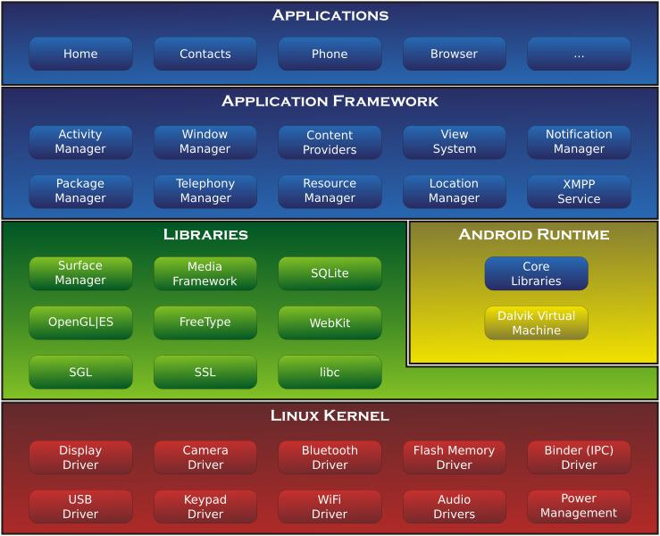

**Architecture of Android OS**

**Applications Layer**

Android ships with a set of core applications including an email client, SMS program, calendar, maps, browser, contacts and others. All applications are built using the Java. Each of the applications aims at performing a specific task that it is actually intended to do.

13

**Application Framework Layer**

The next layer is the application framework. This includes the programs that manage the phone’s basic functions like resource allocation, telephone applications, switching between processes or programs and keeping track of the phone's physical location. Application developers have full access to Android's application framework. This allows them to take advantage of Android's processing capabilities and support features when building an Android application. We can think of the application framework as a set of basic tools with which a developer can build much more complex tools.

**Libraries Layer**

The next layer contains the native libraries of Android. These shared libraries are all written in C or C++, compiled for the particular hardware architecture used by the phone and preinstalled by the phone vendor.

**Android Runtime Layer**

Android Runtime layer includes Dalvik Virtual Machine (DVM) and a set of core java libraries. Every Android app gets its own instance of DVM. Dalvik has

14

been written so that a device can run multiple virtual machines efficiently and it executes files with .dex (Dalvik Executable Format) extension optimized for minimum memory.

**Components of Android**

The basic components of an Android application include Activity, Broadcast Receiver, Service, and Content Provider. Each of the above, which when used for any application, has to be declared in the AndroidManifest.xml. The user interface of the component is determined by the Views. For the communication among these basic components we use Intents and Intent filters which play crucial role during app development.

**Activity**

An Activity is, fundamentally, an object that has a lifecycle. An Activity is a chunk of code that does some work, as necessary. The work can include displaying a UI to the user, though it doesn't have to as some Activities never display UIs. Typically,

15

we designate one of our application's Activities as the entry point to our application.

**Broadcast Receiver**

Broadcast Receiver is yet another type of component that can receive and respond to any of the broadcast announcements.

**Service**

A Service is a body of code that runs in the background. It can run in its own process, or in the context of another application's process, depending on its needs. Other components "bind" to a Service and invoke methods on it via remote procedure calls. An example of a Service is a media player; even when the user quits the media-selection UI, she probably still intends for her music to keep playing. A Service keeps the music going even when the UI has completed.

**Content Provider**

Content Provider is a data storehouse that provides access to data on the device; the classic example is the Content Provider that is used to access the user's list of contacts. Our application can access

16

data that other applications have exposed via a Content Provider, and we can also define our own Content Providers to expose data of our own.

**System Analysis:**

**Feasibility Study**:

The feasibility study is an evaluation and analysis of the potential of a proposed project which is based on extensive investigation and research to support the process of decision making. Depending on the results of the initial investigation the survey is now expanded to a more detailed feasibility study.

**Existing System:**

User has to Login first by giving any user name and password it will be added automatically in database so that user can login again in future by same user name and password.

Then Welcome(user profile) will be appear user has to choose any of three option 'Start Game', 'High Score', 'Logout'.

After choosing start game continue page will be appear to continue game.

After Clicking on continue multiple choice questions will come automatically one by one with a specific time limit.

User has to choose any of four existing options and then user has to hit the submit button and each right answer will automatically count the score.

At the end of the game it will show the score of the user.

All these findings demands new application which will reduce the manual work & do everything automatically. Also the existing systems have some major drawbacks which motivate us to develop new system.

Those drawbacks are as follows:

18

* + Quest won't get update automatically need to update manually.
  + Existing systems has not type of fields in like questions on History,Game,Sports,Geography etc.
  + There is possibility of hanging down the existing systems.

**Proposed System:**

Unlike the websites where you need to make account for every quiz you want to play, using this application based on android, you just have to login by user name and password and then you will get access to all quizzes from it. The proposed system is an application for the Android platform mobiles will help in improving the knowledge and accuracy. Android is a Linux-based operating system designed primarily for touch screen mobile devices such as smart phones and tablet computers, developed by Google in conjunction with the Open Handset Alliance.

The proposed system will be developed for Android mobiles only because the market share of Android is more than other operating systems.

**Table of Comparison :**

Comparison of Existing System & Proposed System

19

|  |  |  |
| --- | --- | --- |
|  |  |  |
| **Parameters** | **Existing** | **Proposed** |
| **Method** | **System** | **System** |
| Manual | Automatic |
| **Time** |  |  |
| More time | Less time |
| **Database** | consuming | consuming |
| Required | Not required |
| **Reliability** |  |  |
| Less | More |



**Software Requirements:**

**Operating System**: Android

**Toolkit:** Software DevelopmentToolkit(SDK)

**Platform :** Java and Android

**Database:** SQLite

**Hardware Requirements:**

2.3 minimum version (API 8)

Android phone (Having Version Above or 2.3)

**Diagram:**

**Data Flow Diagram (DFD):**

A **data flow diagram** (**DFD**) is a graphical representation of the "flow" of data through an information system, modeling

its *process* aspects. A DFD is often used as a preliminary step to create an overview of the

20

system. DFDs can also be used for the visualization of data processing.

A DFD shows what kind of information will be input to and output from the system, where the data will come from and go to, and where the data will be stored. It does not show information about the timing of process or information about whether processes will operate in sequence or in parallel.

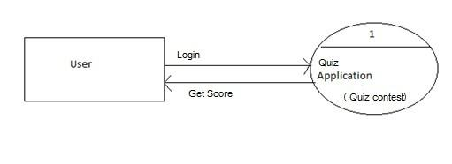**Level 0 DFD:**

**Use Case Diagram:**

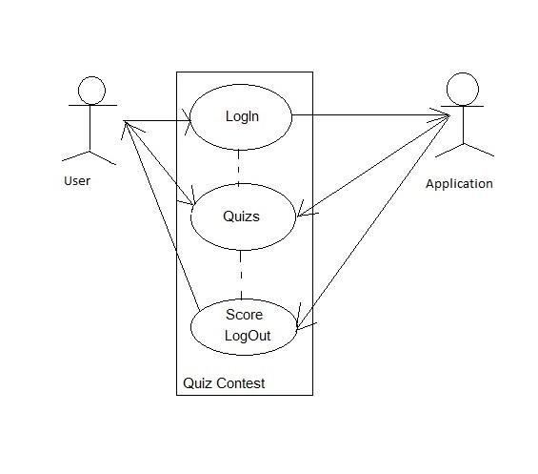

22

Entity-Relationship Diagram:

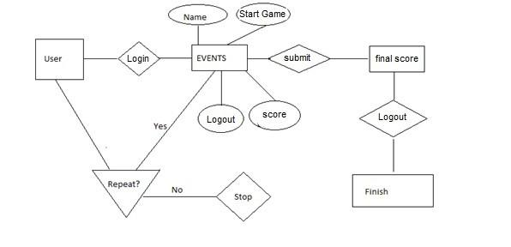

**Table Diagram:**

Design of database table which is named as Events is given below ---

|  |  |
| --- | --- |
|  |  |
| **Attribute Name** | **Attribute type** |
| **Id** | Int |
| **Name** | Text |
| **Info** | Text |
| **Period** | Text |
| **Period_unit** | Text |
| **Start_time** | Text |



23

**Form Design:**

**Components---**

* Linear Layout (Vertical)
* Linear Layout (Horizontal)
* TextView(Medium)
* EditText
* Button
* CheckBox
* ListView
* Spinner
* ImageView
* AlertDialog

**Testing:**

**Objective:**

The objective our test plan is to find and report as many bugs as possible to improve the integrity of our program. Although exhaustive testing is not possible, we will exercise a broad range of tests to achieve our goal. We will also test the user friendliness of our app .The application will

24

be used as an important tool, but we would like to ensure that it could be run on a variety of platforms with little impact on performance or usability.

**Process Overview :**

The following represents the overall flow of the testing process:

Identify the requirements to be tested. All test cases shall be derived using the current Program Specification.

Identify which particular test(s) will be used to test each module.

Review the test data and test cases to ensure that the unit has been thoroughly verified and that the test data and test cases are adequate to verify proper operation of the unit.

Identify the expected results for each test. Document the test case configuration, test

data, and expected results. Perform the test(s).

Document the test data, test cases, and test configuration used during the testing

25

process. This information shall be submitted via the Unit/System Test Report (STR).

Successful unit testing is required before the unit is eligible for component integration/system testing.

Unsuccessful testing requires a Bug Report Form to be generated. This document shall describe the test case, the problem encountered, it's possible cause, and the sequence of events that led to the problem. It shall be used as a basis for later technical analysis.

Test documents and reports shall be submitted. Any specifications to be reviewed, revised, or updated shall be handled immediately.

**Testing Process:**

26

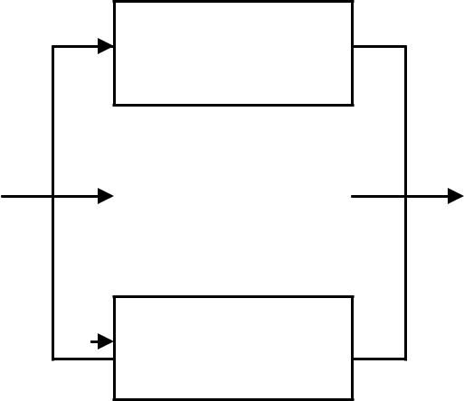

Design

System Test

|  |  |  |  |  |  |  |
| --- | --- | --- | --- | --- | --- | --- |
|  |  |  |  |  |  |  |
| Organize |  | Design/Build |  | Design/Build |  | Signoff |
| Project |  |  | Test Proc. |  |
|  |  |  |  |  |  |  |



Organize

Project

The diagram above outlines the Test Process approach that will be followed.

**Organize Project** involves creating aSystem Test Plan, Schedule & Test

Approach, and assigning responsibilities.

**Design/Build System Test** involvesidentifying Test Cycles, Test Cases, Entrance & Exit Criteria, Expected Results, etc. In general, test conditions/expected results will be identified by the Test Team in conjunction with the Development Team. The Test Team will then identify Test Cases and the Data required. The Test conditions are

27

derived from the Program Specifications Document.

**Design/Build Test Procedures** includes

setting up procedures such as Error Management systems and Status reporting.

**Build Test Environment** includes

requesting/building hardware, software and data setups.

**Execute System Tests** identified in

the Design/Build Test Procedures will be executed. All results will be documented and Bug Report Forms filled out and given to the Development Team as necessary.

**Signoff** happens when all pre-definedexit criteria have been achieved.

**Testing Strategy** :

The following outlines the types of testing that will be done for unit, integration, and

28

system testing. While it includes what will be tested, the specific use cases that determine how the testing is done will be detailed in the Test Design Document. The test cases that will be used for designing use cases is shown below.

**Test Cases:**

|  |  |
| --- | --- |
| **Tested By:** | Aditya kumar |
| **Test Type** | Unit Testing |
| **Test Case Number** | 1 |
| **Test Case Name** | Login |
| **Test Case** | The user should give any user name and |
| **Description** | password. |

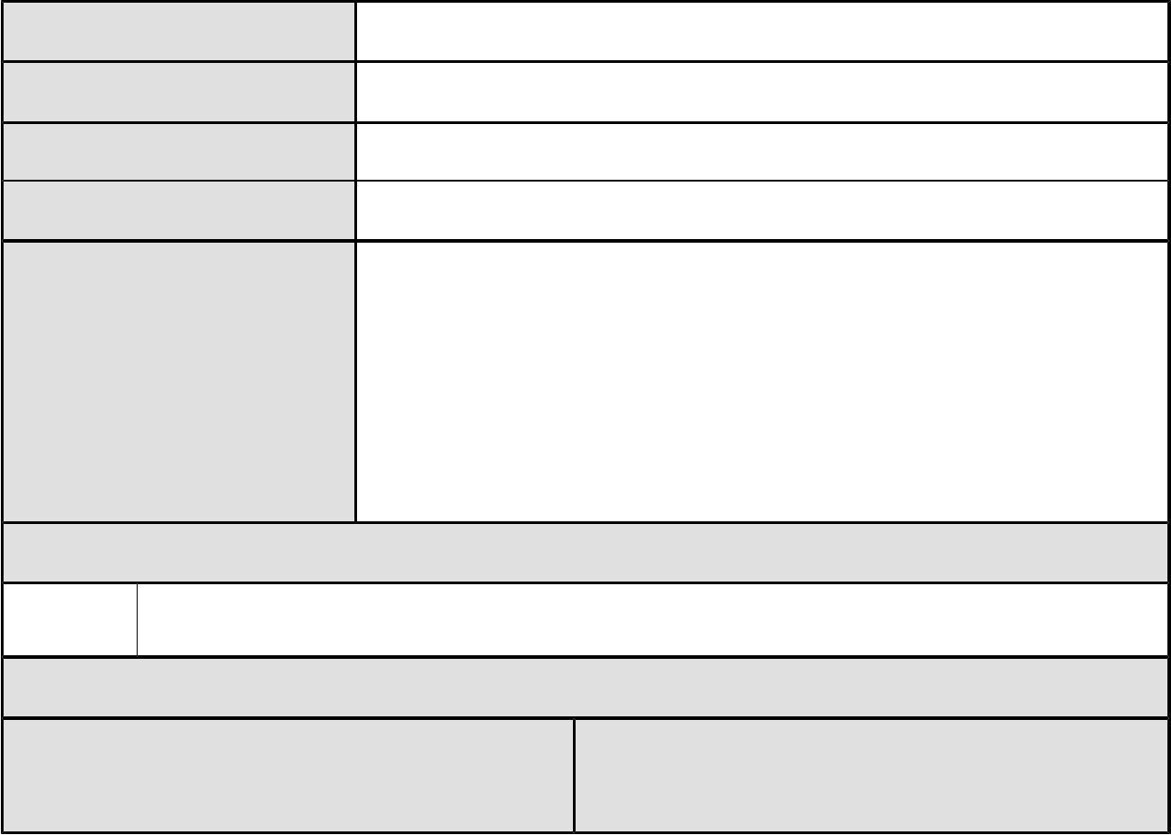

**Item(s) to be tested**

* Verification of Login.

**Specifications**

**Expected**

**Input** **Output/Result**

|  |  |  |
| --- | --- | --- |
|  |  | 29 |
| 1) type the user name and | | 1) Successful welcome user's |
| password |  | profile come |
| 2) Logout |  | 2) Page exits |
| **Tested By:** | Aditya sharma |  |
| **Test Type** | Unit Testing |  |
| **Test Case Number** | 2 |  |
| **Test Case Name** | Checking questions | |
| **Test Case** | The user should choose right option among four | |
| **Description** | options. |  |

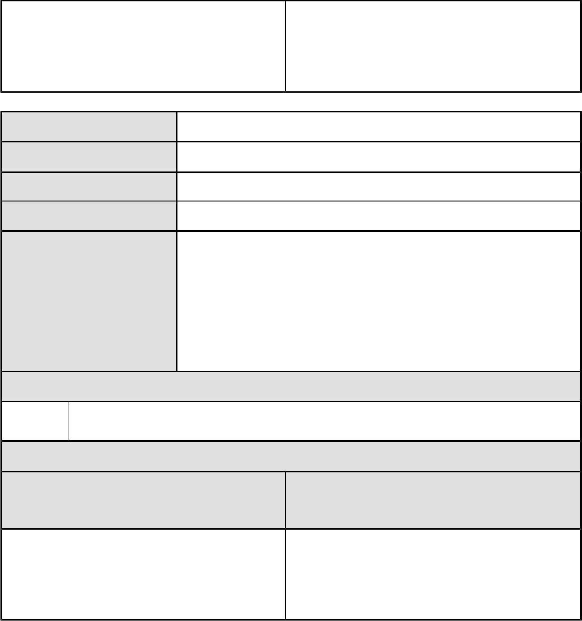

**Item(s) to be tested**

* Verification of right answer whether popup messes age is showing or not.

**Specifications**

**Input**

1. check the score and popup message
2. Logout

**Expected**

**Output/Result**

1. message will be show you are correct or you are wrong
2. Page exits

**Results:**

30

**scope and further enhancement of the Project:**

We have put an endless effort on this application& also provided room for future expansion of this application.

Interface can be enriched later.

Selection of alarm tone are in progress.

Prescription Parameter (PP) contains the necessary information of a medicine including its name M, the dosage size g and the amount n to be taken each time (as multiples of the dosage size) and its therapy duration T during which the patient should take the medicine. A picture of the medicine is also incorporated to assist patients identifying the medicine. This parameter can be added.

Dosage Parameter (DP) states the minimum and maximum dose sizes [dmin, dmax] and the minimum and maximum separations [nsmin, nsmax] between two consecutive doses. It also specifies the supply rate (B, R), which the maximum dosage B is taken within any time interval R and the demand rate (L, P) and which the minimum dosage L is taken in any time interval p. DP parameter should be implemented in future days.

36

**Code:**

**Conclusion**:

Currently there are many medication reminder systems which are operable manually. Due to increased manual work, the available system

51

becomes more time consuming. So in the given work, an attempt has been made to implement fully automatic medication reminder system. It eases the user’s task of recalling when to take the medicine by reminding them of the particular medicine at the correct time thereby reducing the much prevalent manual work.

**References:**

(1) [www.w3Schools.com](http://www.w3Schools.com)

(2) [www.javatpoint.com](http://www.javatpoint.com)

(3) Material Design

(4) Android Studio

(5) [www.android.google.com](http://www.android.google.com)

(6) Firebase