**ASSIGNMENT**

**GIT COMMANDS**

**SUBMIT VIA SCREENSHOT OF YOUR CMD**

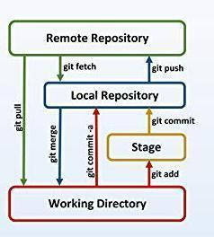

Q. Create a local git repository in your local machine first.

Commit the initial code

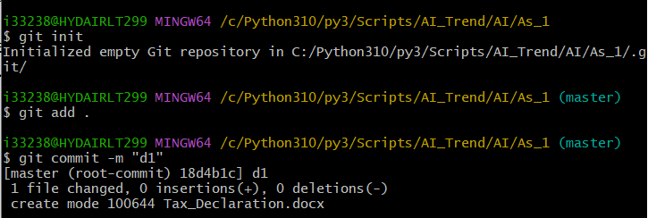

Q. Update the code on the remote server . Also perform some changes on remote n reflect the same on local.[push/pull operations]

Q. Create g1 branch on the github..................Add 1 txt file .................Raise a pull request on remote from g1 towards main........................... and merge without conflicts. [REMOTE MERGING]

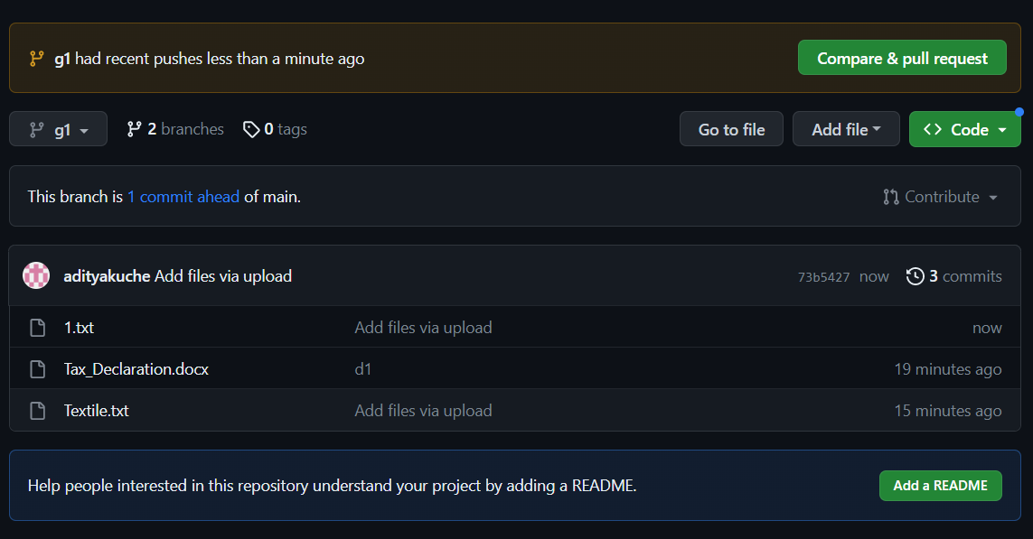

Local git: Use git commands to

o Get the updated files

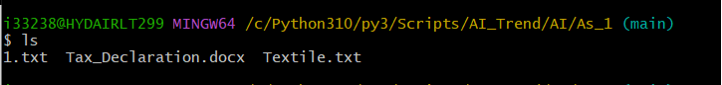

o Perform reset/Revert

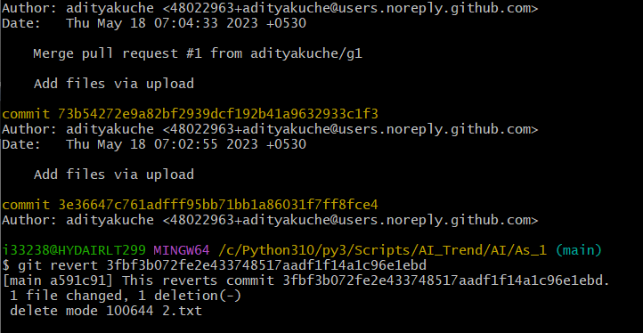

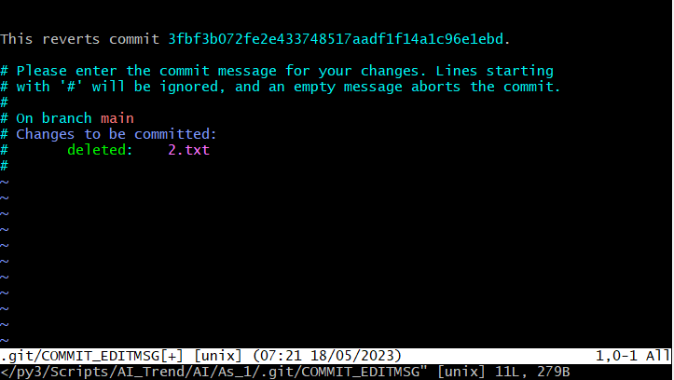

o List the changes [ diff, log, status]

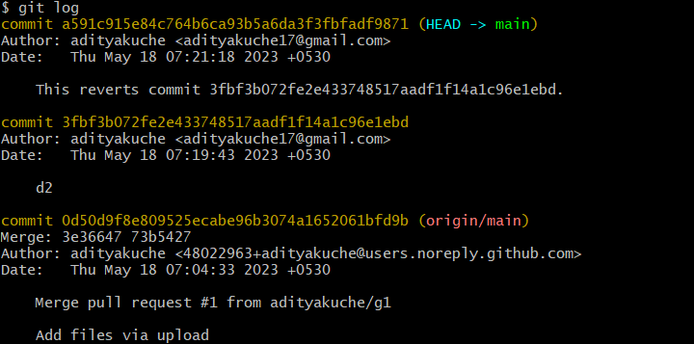

o Create local branches main>>>b1,update........b1>>>>b2,update b2>>>>>b3 and update them as well on Remote.

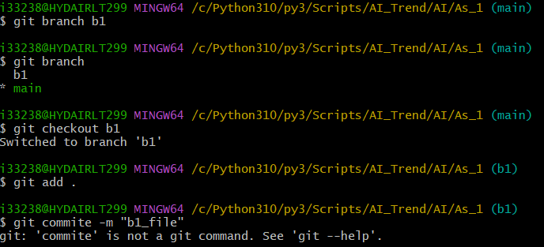

o List the changes between Branches [via diff and via ls]

Demonstrate diff between local branches

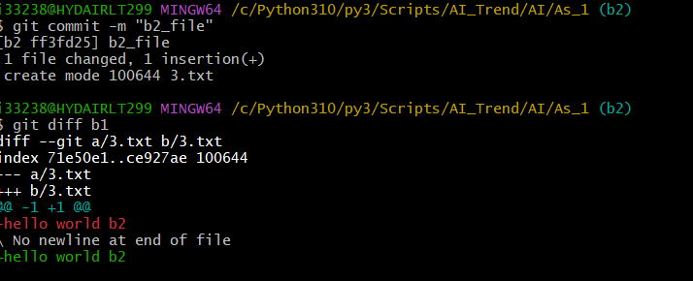

Perform LOCAL merging operation and after that delete the unnecessary ones locally as well as remote

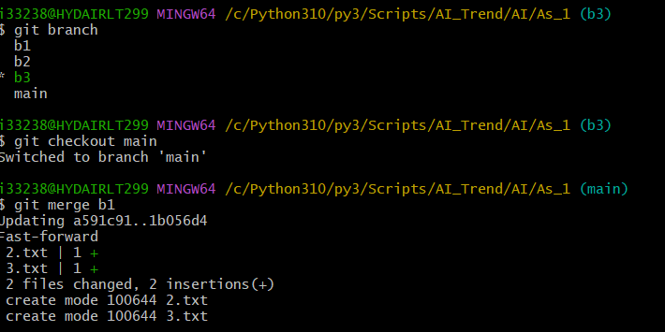

Perform fork operations on your repository as well.

