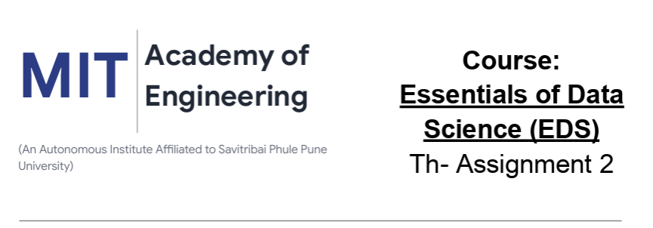

Name : Aditya Santosh Kul
PRN: 202501040236
Batch:CS-3(c-31)

Dataset assigned: SMS Spam Collection

Dataset used: Kaggle- SMS Spam Collection Dataset

1. Total Messages in Dataset
Problem: Find total number of messages.
Solution:
import pandas as pd
df=pd.read_csv("spam.csv",encoding='latin1')
df=df[['v1','v2']]
print(df.shape[0])

2. Total Spam and Ham Messages
Problem: Count spam and ham messages.
Solution:
import pandas as pd
df=pd.read_csv("spam.csv",encoding='latin1')
df=df[['v1','v2']]
print(df['v1'].value_counts())

3. Percentage of Spam and Ham Messages
Problem: Calculate percentage distribution.
Solution:
import pandas as pd
df=pd.read_csv("spam.csv",encoding='latin1')
df=df[['v1','v2']]
print(df['v1'].value_counts(normalize=True)*100)

4. Average Message Length
Problem: Find average message length.
Solution:
import pandas as pd
import numpy as np
df=pd.read_csv("spam.csv",encoding='latin1')
df['Length']=df['v2'].apply(len)
print(np.mean(df['Length']))

5. Average Length of Spam vs Ham Messages
Problem: Compare average lengths.
Solution:
import pandas as pd
df=pd.read_csv("spam.csv",encoding='latin1')
df['Length']=df['v2'].apply(len)
print(df.groupby('v1')['Length'].mean())

6. Longest Message
Problem: Find longest message.
Solution:
import pandas as pd
df=pd.read_csv("spam.csv",encoding='latin1')
df['Length']=df['v2'].apply(len)
print(df.loc[df['Length'].idxmax()])

7. Shortest Message
Problem: Find shortest message.
Solution:
import pandas as pd
df=pd.read_csv("spam.csv",encoding='latin1')
df['Length']=df['v2'].apply(len)
print(df.loc[df['Length'].idxmin()])

8. Standard Deviation of Message Length
Problem: Measure variation.
Solution:
import pandas as pd
import numpy as np
df=pd.read_csv("spam.csv",encoding='latin1')
df['Length']=df['v2'].apply(len)
print(np.std(df['Length']))

9. Median Message Length
Problem: Find median length.
Solution:
import pandas as pd
import numpy as np
df=pd.read_csv("spam.csv",encoding='latin1')
df['Length']=df['v2'].apply(len)
print(np.median(df['Length']))

10. Total Spam Messages
Problem: Count only spam messages.
Solution:
import pandas as pd
df=pd.read_csv("spam.csv",encoding='latin1')
spam=df[df['v1']=="spam"]
print(spam.shape[0])

11. Total Ham Messages
Problem: Count only ham messages.
Solution:
import pandas as pd
df=pd.read_csv("spam.csv",encoding='latin1')
ham=df[df['v1']=="ham"]
print(ham.shape[0])

12. Messages Longer than 100 Characters
Problem: Find long messages.
Solution:
import pandas as pd
df=pd.read_csv("spam.csv",encoding='latin1')
df['Length']=df['v2'].apply(len)
print(df[df['Length']>100])

13. Messages Longer than Average
Problem: Count messages above average length.
Solution:
import pandas as pd
import numpy as np
df=pd.read_csv("spam.csv",encoding='latin1')
df['Length']=df['v2'].apply(len)
avg=np.mean(df['Length'])
print((df['Length']>avg).sum())

14. Top 10 Longest Messages
Problem: Find top longest messages.
Solution:
import pandas as pd
df=pd.read_csv("spam.csv",encoding='latin1')
df['Length']=df['v2'].apply(len)
print(df.nlargest(10,'Length'))

15. Summary Statistics of Length
Problem: Find min, max, mean.
Solution:
import pandas as pd
df=pd.read_csv("spam.csv",encoding='latin1')
df['Length']=df['v2'].apply(len)
print(df['Length'].describe())

16. Correlation Between Length and Spam
Problem: Analyze relationship.
Solution:
import pandas as pd
df=pd.read_csv("spam.csv",encoding='latin1')
df['Length']=df['v2'].apply(len)
df['Spam']=df['v1'].map({'ham':0,'spam':1})
print(df[['Length','Spam']].corr())

17. Messages Containing Numbers
Problem: Find messages with digits.
Solution:
import pandas as pd
df=pd.read_csv("spam.csv",encoding='latin1')
print(df[df['v2'].str.contains(r'\d',regex=True)])

18. Messages with Exclamation Marks
Problem: Count messages containing "!".
Solution:
import pandas as pd
df=pd.read_csv("spam.csv",encoding='latin1')
print(df[df['v2'].str.contains('!')].shape[0])

19. Average Word Count per Message
Problem: Calculate average words.
Solution:
import pandas as pd
import numpy as np
df=pd.read_csv("spam.csv",encoding='latin1')
df['Words']=df['v2'].apply(lambda x: len(x.split()))
print(np.mean(df['Words']))

20. Most Frequent Words
Problem: Find common words.
Solution:
import pandas as pd
from collections import Counter
df=pd.read_csv("spam.csv",encoding='latin1')
words=' '.join(df['v2']).split()
print(Counter(words).most_common(10))

