Statistical Analysis
To quantify mechanical accuracy, a geometric transformation was applied to express all measurements in a common Cartesian framework, as the measured depth does not directly correspond to the Cartesian Z coordinate of the testing platform. Errors in the X and Y axes were calculated as the absolute difference between observed and true positions. For the Z component, error was derived from the depth deviation along the trajectory ($D_{err}$) and the collar angle ($θ$), such that the Cartesian Z error was defined as $z_{err}=D_{err}\sin{θ}$. The three-dimensional Euclidean distance error was then computed as:
$$E_{3D}=\sqrt{x_{err}^{2}+y_{err}^{2}+{\left(D_{err}\sin{θ}\right)}^{2}}$$
This formulation can be interpreted as a weighted Euclidean error, where the depth deviation is projected onto the Cartesian Z axis by the factor $\sin{θ}$. Here, $α=\sin{θ}$ acts as an axis-specific weight, scaling the depth component based on collar angle. When $θ→90°, \sin{θ→1}$ and the full depth error is transferred to the Z axis; when $θ$ is small, the Z contribution is attenuated. This weighting ensures that the 3D error metric appropriately reflects the geometric relationship between depth error and the coordinate system of the testing platform.
Inter-observer error was quantified using the root mean square error (RMSE):
$$RMSE=\sqrt{\frac{1}{n}\sum{{\left(x_{i}-μ_{i}\right)}^{2}}}$$
where μᵢ is the per-target mean across operators and xᵢ is the individual observation. Data normality was assessed using the Shapiro–Wilk test prior to parametric analyses. Given the small sample sizes (n = 18), one-way analysis of variance (ANOVA) was applied for each factor–outcome combination, and for results with $p<0.05$, post hoc Tukey honestly significant difference (HSD) tests were applied with a familywise significance level of $α=0.05$.

Results

Work Envelope and Target Coverage
The system work envelope spanned translational ranges of X = 60–140 mm and Y = 70–170 mm, with angular ranges of 50–90° for the collar and 55–125° for the arc. In a cohort of ventricular catheter placements (N = 17), all recorded entry-point coordinates fell within these limits (Table 1).
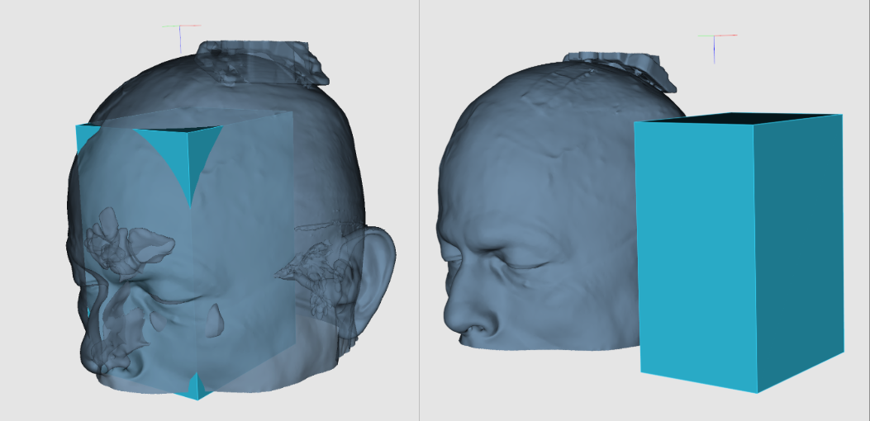
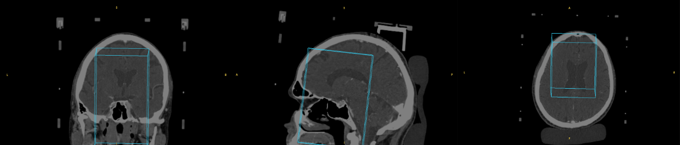
Work envelope of the ventricular catheter frame. The translucent rectangular prism delineates the accessible stereotactic space in 3D relative to the patient’s head (top), with corresponding orthogonal CT views (coronal, sagittal, axial) illustrating the projected translational and angular limits used for target selection.

Mechanical Accuracy – Adjusted Position
Mechanical accuracy was evaluated at five target points on a calibrated testing platform using three operators performing one trial each (n = 3 per target; total observations = 18). The mean three-dimensional Euclidean error across all targets and operators was 1.18 ± 0.49 mm (range: 0.57–2.35 mm). Per-axis mean errors were 0.39 ± 0.36 mm (X), 0.56 ± 0.47 mm (Y), and 0.75 ± 0.52 mm (Z) (Figure 3A).
Per-target mean errors ranged from 0.70 ± 0.17 mm (T3L) to 1.53 ± 0.51 mm (T4). The highest variability was observed at T5 (mean 1.19 ± 1.00 mm), attributable to a single outlier observation (CO: 2.35 mm). No statistically significant differences in total error were detected across operators (one-way ANOVA; p > 0.05 for all outcomes), confirming consistent device usability independent of operator identity.
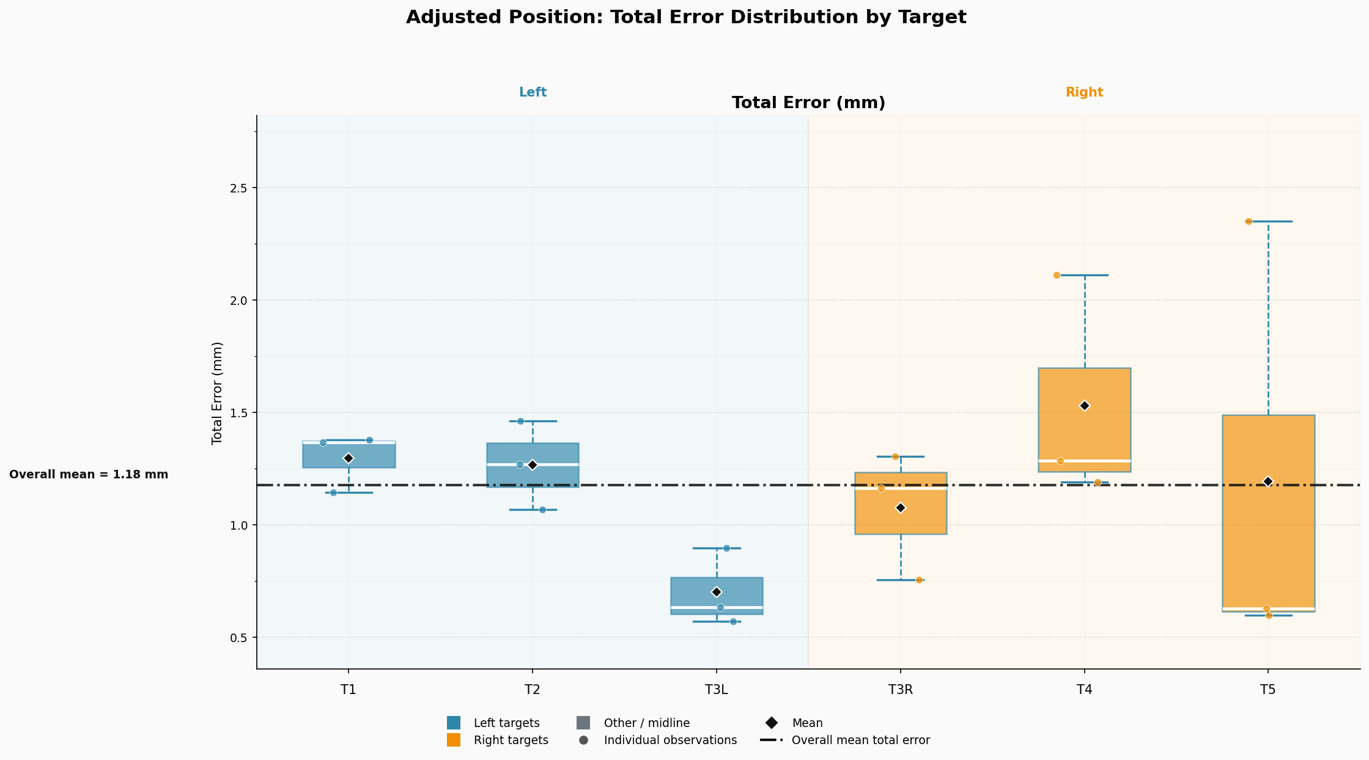
Figure 3A. Three-dimensional Euclidean positioning error at five calibrated target points (T1–T5) evaluated across three operators (AK, CO, MAH). Error bars represent ± one standard deviation. Values are in millimeters. Dashed line indicates the overall mean error (1.18 mm).

Lateral Targeting Differences
Left-sided targets exhibited lower mean depth deviation (diff_distance: 0.43 mm) and Z error (0.42 mm) compared to right-sided targets (diff_distance: 1.02 mm; Z error: 0.99 mm), a pattern confirmed by one-way ANOVA (diff_distance: F = 8.92, p = 0.003; error_z: F = 8.74, p = 0.003). Post hoc Tukey HSD tests identified significant pairwise differences between left and right (p = 0.017 for diff_distance; p = 0.019 for error_z) and between left and midline (p = 0.010 and p = 0.010, respectively). The midline group comprised a single observation (T4, operator MAH) and should be interpreted with caution.
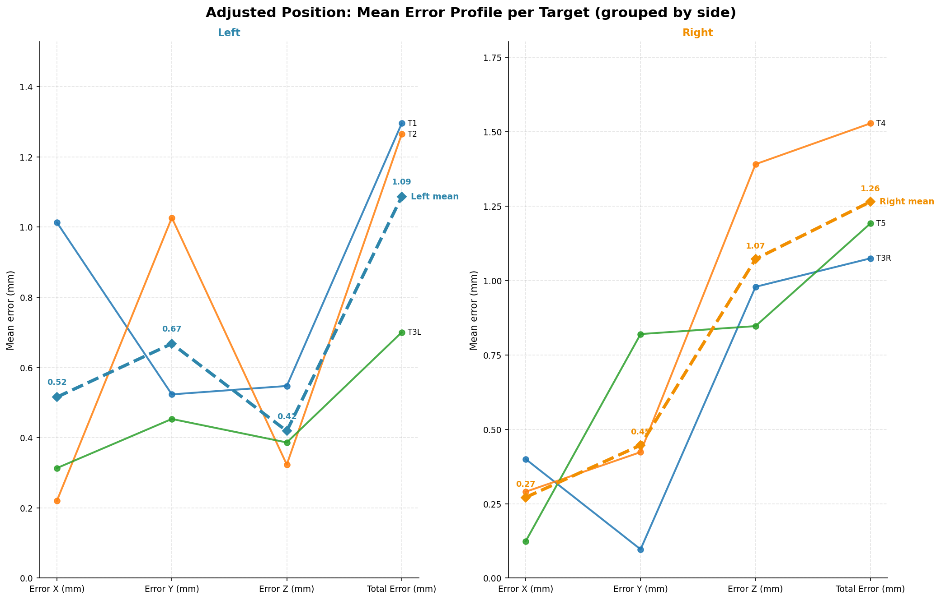

Figure 3A (inset). Mechanical error stratified by target laterality (left vs. right). Left-sided targets demonstrated significantly lower depth deviation and Z error compared to right-sided targets (Tukey HSD, p < 0.05).

Mechanical Accuracy with Z-Adapter (Figure 3B)
Targeting accuracy was independently assessed using depth adapters across four of the five target points (T2–T5; T1 excluded due to unavailable adapter configuration data; n = 3 per target, total observations = 12). The mean three-dimensional Euclidean error was 1.53 ± 0.59 mm (range: 0.64–2.49 mm). Per-target means ranged from 1.30 ± 0.54 mm (T3R) to 1.93 ± 0.49 mm (T2) (Figure 3B).
Operator means were comparable: AK 1.46 ± 0.36 mm, MAH 1.63 ± 0.62 mm, and SM 1.50 ± 0.84 mm. No statistically significant inter-operator differences were observed, consistent with findings from the adjusted-position analysis.
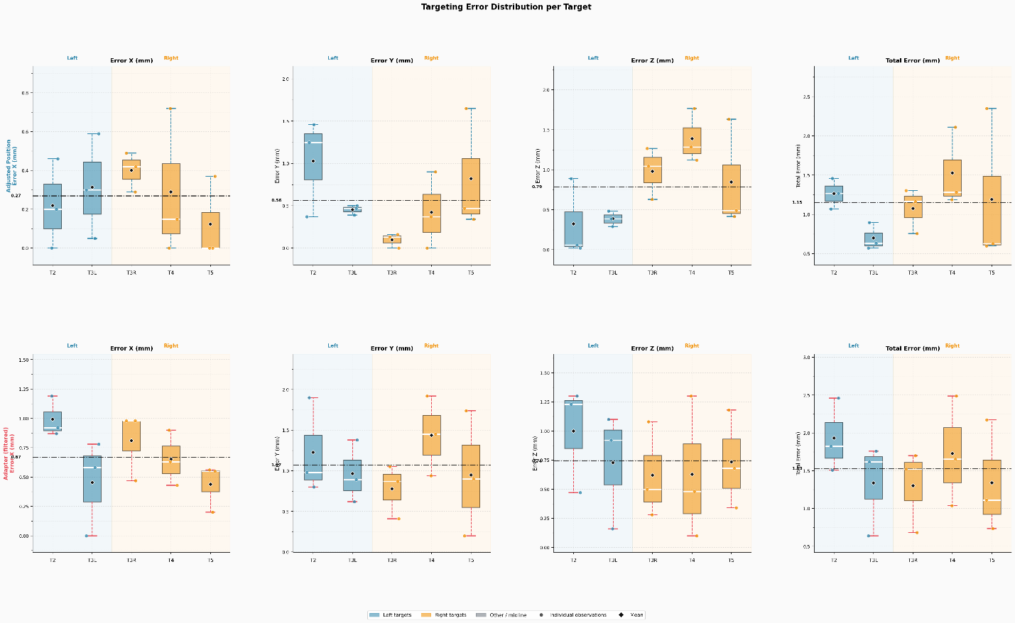
Figure 3B. Three-dimensional Euclidean positioning error measured using Z-depth adapters at four target points (T2–T5) across three operators (AK, MAH, SM). T1 was excluded due to incomplete adapter data. Error bars represent ± one standard deviation. Values are in millimeters.

Effect of Trajectory Angle on Accuracy
To examine the effect of trajectory orientation on targeting accuracy, collar and arc angles were systematically varied across the five target points. Arc angle demonstrated a significant omnibus effect on both depth deviation (ANOVA: F = 3.57, p = 0.042) and Z error (F = 3.50, p = 0.044), with lower errors observed at larger arc angles (arc = 100°: diff_distance = 0.45 mm; arc = 105°: 0.40 mm) compared to smaller angles (arc = 75°: 1.01 mm; arc = 80°: 1.16 mm). However, no individual pairwise contrast survived Tukey HSD correction, suggesting a weak and diffuse angular effect. Collar angle (50–90°) did not significantly affect any error metric (p > 0.05 for all outcomes).

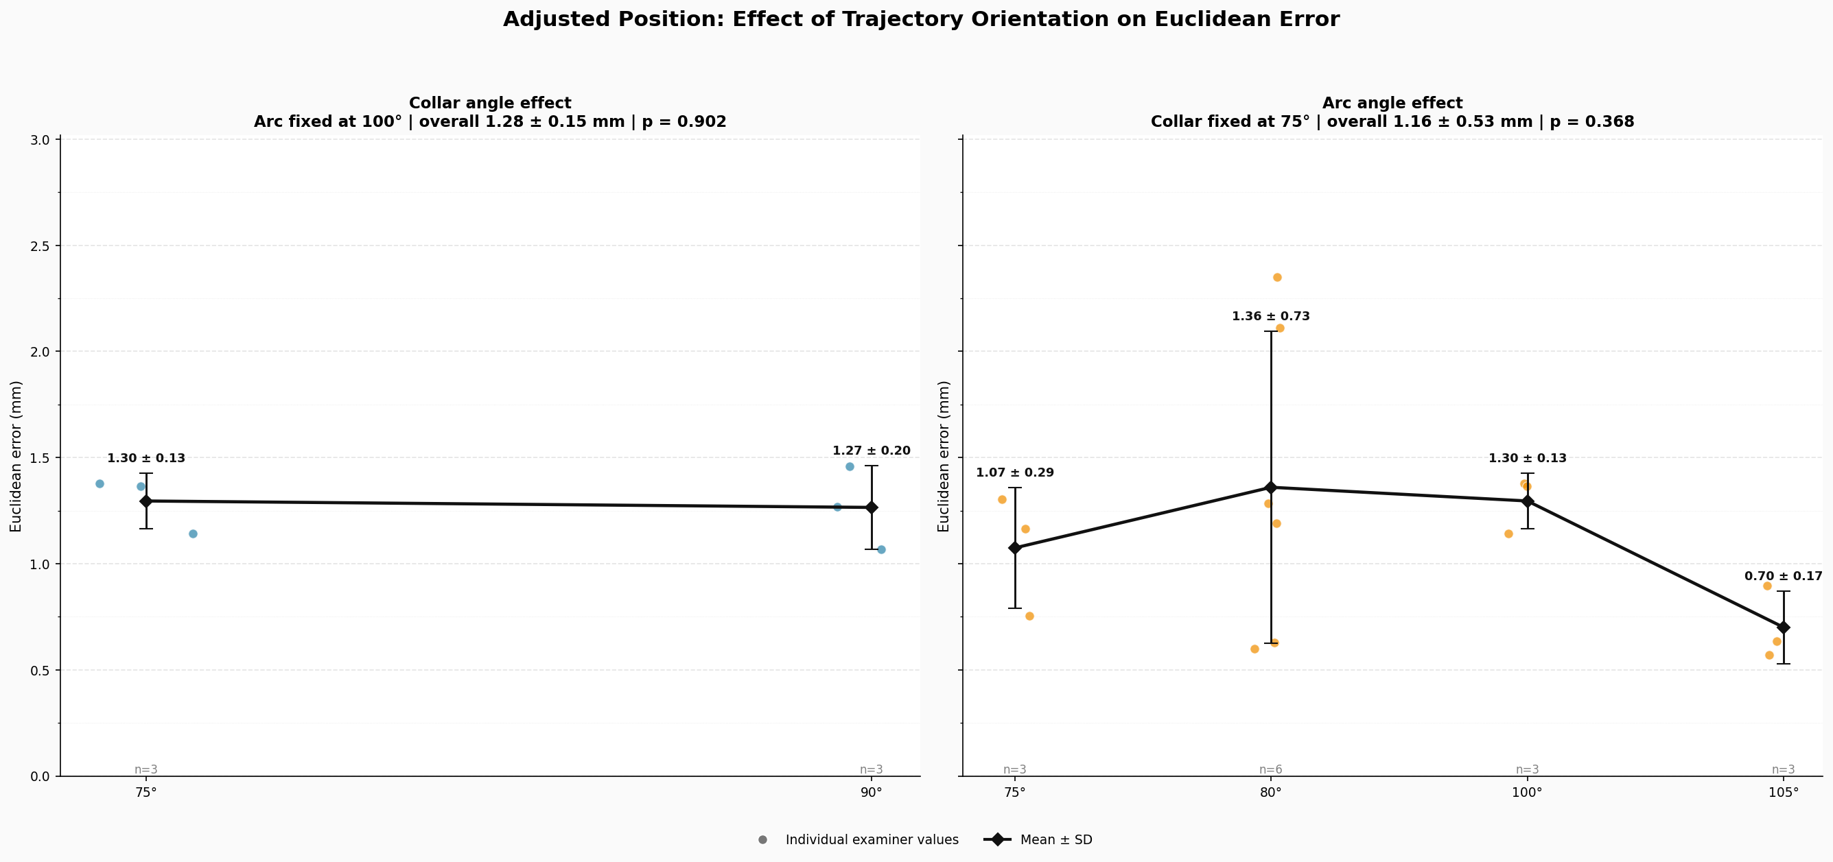
Fig. X. Mean Euclidean error as a function of arc and collar angle settings across three operators (n = 3 per configuration). No statistically significant pairwise differences were detected after Tukey HSD correction. Values are in millimeters.

Inter-Observer Error
Inter-observer reproducibility was quantified by computing the RMSE of individual operator measurements relative to the per-target mean. The global inter-observer RMSE was 0.40 mm. Per-target RMSEs ranged from 0.11 mm (T1) to 0.82 mm (T5), with the elevated T5 value driven by a single outlier observation. Excluding T5, the mean per-target RMSE was 0.21 mm, indicating high inter-operator reproducibility across the evaluated target set.
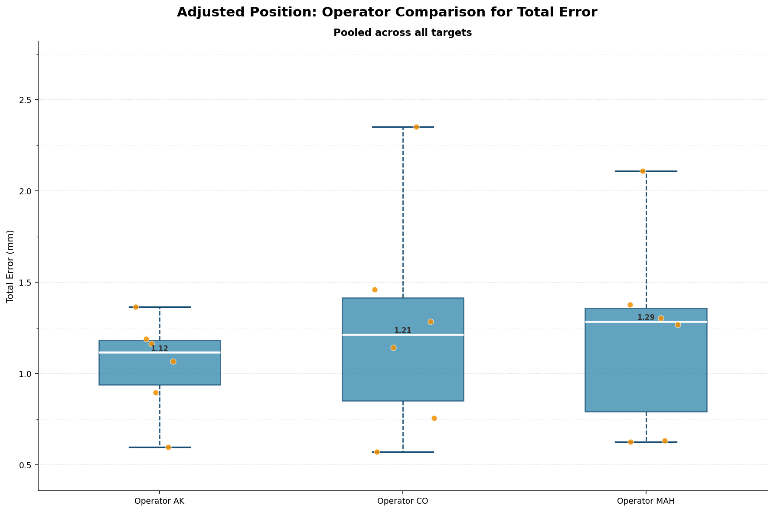
Figure 4. Inter-observer RMSE per target point, computed relative to the per-target mean across operators. T5 exhibited an elevated RMSE attributable to an outlier observation. Values are in millimeters.

Statistical Summary
Data normality was assessed using the Shapiro–Wilk test. Across all 18 observations, error_x (W = 0.893, p = 0.043), error_y (W = 0.860, p = 0.012), and total_error (W = 0.896, p = 0.049) departed from normality; diff_distance and error_z were compatible with normality (p > 0.40 for both). Group-level non-normality was localized to target T5 for error_x and total_error, and to error_y for both left- and right-sided groups. All arc- and operator-level subgroups were consistent with normality. Parametric results should therefore be interpreted with caution, particularly for outcomes showing distributional departures, given the small sample size (n = 18).

