Java Message Service is an API which supports the formal communication called as messaging between computers on a network. It provides a common interface for standard message protocols and message services in support to the Java programs. It provides facility to create, send and read messages. The JMS API reduces the concepts that a programmer must learn to use the messaging services/products and it also provides the features that support the messaging applications. It is a technique which is used in J2EE technology for an application to communicate with the other application in loosely coupled manner. It means that the applications which have to communicate are not connected directly they are connected through a common destination. We will go in detail later in this tutorial.
Table of Contents

Need of JMS
Advantages of JMS
Messaging Domains
Message Consumption
JMS participating objects
JMS Message Components

Need of JMS
In Java, if a person wants to send a message from one application to another in such a way that both application do not know anything about each other, even they may be deployed in separate continents with no dependency at all. For example, one application A is running in India and another application is running in USA, and B is interested in getting some updates/messages from A – whenever something unique happen on A. There may be N number of such applications who are interested in such updates from A.
In this scenario, java provides it’s best solution in form of JMS – and solve the exactly same problem discussed above.
The JMS is also useful when we are writing any event based application like chat server where it needs a publish event mechanism to send messages between the server to the clients who are connected with the server. As the JMS is different from RMI so there is no need of the destination object to be available online while sending a message from the client to the server. Server publish the message and forget it, whenever client comes online, it will fetch the message. It’s very powerful solution for very common problems in today’s world.

Advantages of JMS
- Asynchronous
JMS is asynchronous by default. So to receive a message, the client is not required to send the request. The message will arrive automatically to the client as they become available.
- Reliable
JMS provides the facility of assurance that the message will delivered once and only once. You know that duplicate messages create problems. JMS helps you avoiding such problems.

JMS Messaging Domains
Before the JMS API existed, most messaging products supported either the point-to-point or the publish/subscribeapproach to messaging. The JMS provides a separate domain for each approach and defines the compliance for each domain. Any JMS provider can implement both or one domain, it’s his own choice. The JMS provides the common interfaces which enables us to use the JMS API in such a way that it is not specific to the either domain.
Let’s see both type of messaging domains in more detail:

Point-to-Point Messaging Domain
In the point-to-point messaging domain the application is built on the basis of message queues, senders and receivers. Each and every message is addressed to a particular queue. Queues retain all messages sent to them until the messages are consumed or expired. There are some characteristics of PTP messaging:
- There is only one client for each message.
- There is no timing dependency for sender and receiver of a message.
- The receiver can fetch message whether it is running or not when the sender sends the message.
- The receiver sends the acknowledgement after receiving the message.
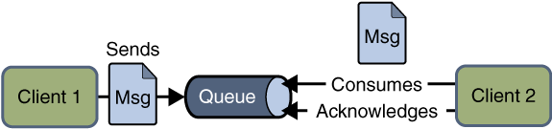Point to point JMS Messaging

Publish/Subscribe Messaging Domain
In publish/subscribe messaging domain, only one message is published which is delivered to all clients through Topicwhich acts as a bulletin board. Publishers and subscribers are generally anonymous and can dynamically publish or subscribe to the topic. The Topic is responsible to hold and deliver messages. The topic retains messages as long as it takes to distribute to the present clients.
Some of the characteristics are:
- There can be multiple subscribers for a message.
- The publisher and subscribe have a timing dependency. A client that subscribes to a topic can consume only messages published after the client has created a subscription, and the subscriber must continue to be active in order for it to consume messages.
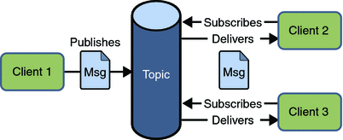Publish Subscribe JMS Messaging
Read More: HornetQ Basic Example

Message Consumption
In JMS, the message consumption can be done in two ways:

Synchronous
In synchronous message consumption, the subscriber/receiver request the message from the destination by calling the receive() method. In the receive() method will block till the message arrives or time out if the message does not arrive within a given time. Just like normal java method calls with some return value.

Asynchronous
In asynchronous message consumption, a subscriber can register (or subscribe) as message listener with the consumer. The message listener is same as event listener, whenever the message arrives at the destination the JMS provider will deliver the message by calling the listener’s onMessage() method which will act on the content of the message.

JMS participating objects
JMS application has some basic building blocks, which are:
- Administered objects – Connection Factories and Destination
- Connections
- Sessions
- Message Producers
- Message Consumers
- Message Listeners
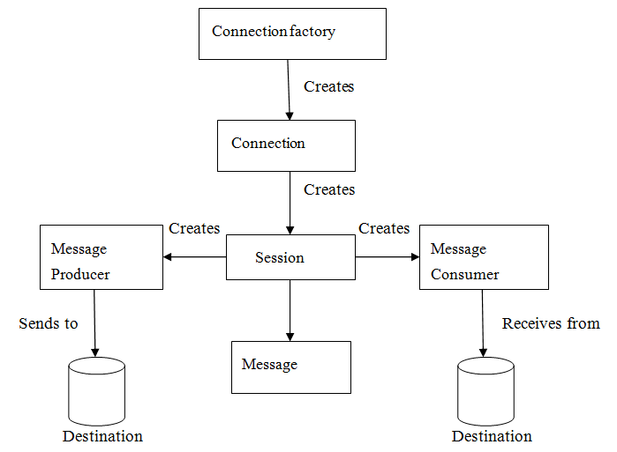JMS API Programming Model

JMS Administered Objects
JMS application provides two types of administered objects:
- Connection Factories
- Destinations
These two administered objects are created by JMS system administrator in JMS Provider by using the Application Server the admin console. These both objects are stored in Application server JNDI Directory or JNDI Registry.

Connection Factories
The client uses an object which is a connection factory used to create a connection to a provider. It creates connection between JMS Provider and JMS Client. When JMS Client such as sender or receiver search out for this object in JNDI Registry, then the JMS Client receives one connection object which is nothing just a physical connection between JMS Provider and JMS Client. Using this connection, client can have communication with the destination object to send or receive messages into Queue or Topic. Let us have an example to understand it to send the message:
QueueConnectionFactory queueConnFactory = (QueueConnectionFactory) initialCtx.lookup ("primaryQCF");
Queue purchaseQueue = (Queue) initialCtx.lookup ("Purchase_Queue");
Queue returnQueue = (Queue) initialCtx.lookup ("Return_Queue");

Destination
Client uses an object known as destination which is used to specify the target of messages it produces and the source of message who consumes it. The JMS application uses two types of destination Queue or Topic. The code specifies queue and a topic.
Create queue session
QueueSession ses = con.createQueueSession (false, Session.AUTO_ACKNOWLEDGE); //get the Queue object
Queue t = (Queue) ctx.lookup ("myQueue"); //create QueueReceiver
QueueReceiver receiver = ses.createReceiver(t);
Create topic session
TopicSession ses = con.createTopicSession (false, Session.AUTO_ACKNOWLEDGE); // get the Topic object
Topic t = (Topic) ctx.lookup ("myTopic"); //create TopicSubscriber
TopicSubscriber receiver = ses.createSubscriber(t);

JMS Connection
The connection encapsulates the virtual connection with a JMS Provider. The connection implements the Connection interface, when it will have a ConnectionFactory object then we can use this to create a connection.
Connection connection = connectionFactory.createConnection();
After creating any connection they should be closed before the application completes using:
connection.close();

JMS Session
The session is a single threaded context which is used for producing and consuming messages. The sessions are used to create the following:
- Message Producers
- Message Consumers
The session implements the Session interface and after creating a Connection object we use this to create a Session.
Session session = connection.createSession(false, Session.AUTO_ACKNOWLEDGE);

JMS Message Producer
The message producer is an object which is created by a session and is used for sending messages to the destination. This implements the MessageProducer interface. We use Session to create a MessageProducer for the destination, queue or topic object.
MessageProducer producer = session.createProducer(dest);
MessageProducer producer = session.createProducer(queue);
MessageProducer producer = session.createProducer(topic);
After creating the message producer is used to send the messages by using the send method.
producer.send(message);

JMS Message Consumer
The message consumer is an object which is created by a session and is used to receive messages sent at a destination. It will implement the MessageConsumer interface. We use a session to create a MessageConsumer for a destination, queue or topic object.
MessageConsumer consumer = session.createConsumer(dest);
MessageConsumer consumer = session.createConsumer(queue);
MessageConsumer consumer = session.createConsumer(topic);

JMS Message Listeners
The message listener is an object which acts as asynchronous event handler for messages. The message listener implements the MessageListener interface which contains the one method onMessage(). In this method we define the actions to be performed when message arrives. By using setMessageListener() we define the message listener with a specific MessageConsumer.
Listener myListener = new Listener();
consumer.setMessageListener(myListener);

JMS Message Components
The JMS Messages are used by the JMS Clients to have communication between systems. The JMS messages have simple format but highly flexible, which allows to create messages which match the formats. The JMS message is divided into three parts. They are:
- Message Header
The JMS message header contains the number of predefined fields which contain those values which are used by the clients and providers to identify and send messages. The predefined headers are:
– JMSDestination
– JMSDeliveryMode
– JMSMessageID
– JMSTimestamp
– JMSCorrelationID
– JMSReplyTo
– JMSRedelivered
– JMSType
– JMSExpiration
– JMSPriority
- Message Properties
In message properties we can create and set properties for messages. The message properties are custom name value pairs which are set or read by applications. The message properties are useful for supporting filtering messages. The JMS API provides some predefined property that a provider can support. The message property is optional.
- Message Body
In message bodies the JMS API defines five message body formats which are also called as message types which allow us to send and receive data in many different forms and also provides compatibility with the existing messaging formats. It basically consists of the actual message sent from JMS sender to receiver. The different message types are:
Text message : Represented by javax.jms.TextMessage. It is used to represent a block of text.
Object message : Represented by javax.jms.ObjectMessage. It is used to represent a java object.
Bytes message : Represented by javax.jms.BytesMessage. It is used to represent the binary data.
Stream message : Represented by javax.jms.StreamMessage. It is used to represent a list of java primitive values.
Map message : Represented by javax.jms.MapMessage. It is used to represent a set of keyword or value pairs.
JMS or Java Messaging Service is an API for messaging (the exchange of information between two separate and independent network entities) based on Java EE. It sets a number of interfaces for sending and receiving messages. There are two messaging models supported by JMS: PTP or point-to-point and publish-subscribe. The first model (PTP) relies on the concept of message queues, where the key features are one consumer per message and no timing dependency between the sender and the receiver. The publish-subscribe model is vice versa: multiple consumers per message and a timing dependency between the sender and the receiver.
The main advantages of using JMS are:
- Asynchronous messaging (in this case, all the parts don’t need to be up for the app to function as a whole).
- Storage (the messages are stored on behalf of the receiver while it is down and then sends them, once it is up.)
So, as usual, let’s try out this technology in the Jelastic Cloud using the GlassFish server!

Create environment
1. Log into your Jelastic account and click Create environment.
2. Select GlassFish as your application server and specify the resource limits for it. Then, type your environment name and click Create.
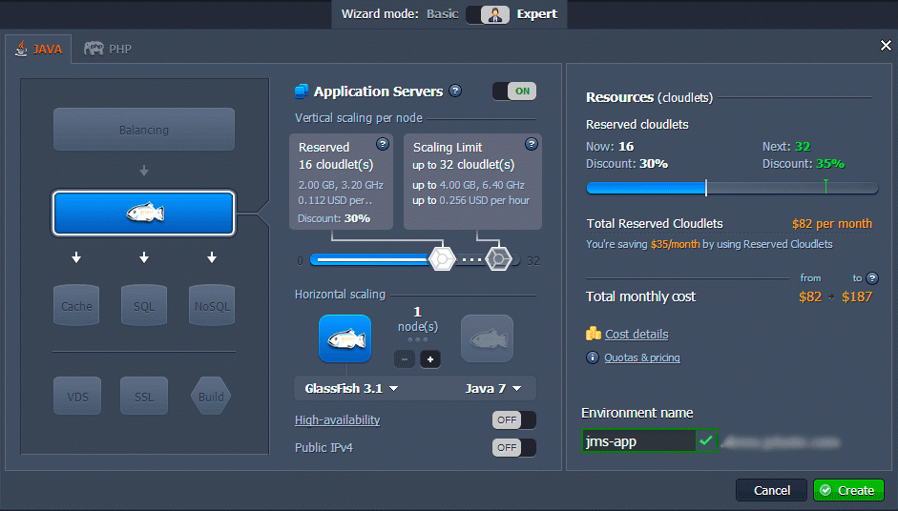
In a few minutes your environment will appear on the Jelastic Dashboard.
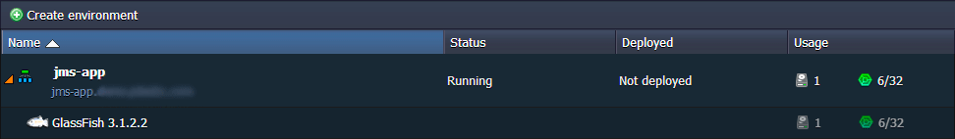

Create JMS application
We're using a JMS application, written by Arun Gupta, which consists of a Sender, Receiver and a simple test servlet for checking the results of program execution.
1. Firstly, create Sender. This is a Stateless EJB that contains only one method for sending messages:
package org.sample.sendmessage;

import javax.annotation.Resource;
import javax.ejb.Stateless;
import javax.jms.*;

@Stateless
public class MessageSender {

@Resource(mappedName = "jms/JMSConnectionFactory")
private ConnectionFactory connectionFactory;

@Resource(mappedName = "jms/myQueue")
Queue queue;

public void sendMessage(String message) {
MessageProducer messageProducer;
TextMessage textMessage;
try {
Connection connection = connectionFactory.createConnection();
Session session = connection.createSession(false, Session.AUTO_ACKNOWLEDGE);
messageProducer = session.createProducer(queue);
textMessage = session.createTextMessage();
//textMessage.setJMSDeliveryMode(DeliveryMode.NON_PERSISTENT);

textMessage.setText(message);
messageProducer.send(textMessage);

messageProducer.close();
session.close();
connection.close();
} catch (JMSException e) {
e.printStackTrace();
}
}
}
2. Now we will create Receiver, which is also EJB with a single method to receive messages synchronously:
package org.sample.sendmessage;

import javax.annotation.Resource;
import javax.ejb.Stateless;
import javax.jms.*;
import java.util.Enumeration;

@Stateless
public class MessageReceiverSync {

@Resource(mappedName = "jms/JMSConnectionFactory")
private ConnectionFactory connectionFactory;

@Resource(mappedName = "jms/myQueue")
Queue myQueue;

private String message;

public String receiveMessage() {
try {
Connection connection = connectionFactory.createConnection();
Session session = connection.createSession(false, Session.AUTO_ACKNOWLEDGE);
QueueBrowser queueBrowser = session.createBrowser(myQueue);
Enumeration enumeration = queueBrowser.getEnumeration();
while (enumeration.hasMoreElements()) {
TextMessage o = (TextMessage) enumeration.nextElement();
return "Receive " + o.getText();

}
session.close();
connection.close();
} catch (JMSException e) {
e.printStackTrace();
}
return "";
}
}
3. Finally let’s create a test servlet which connects all the parts of our code and helps us to check the results of our program execution:
package org.sample.sendmessage;

import java.io.IOException;
import java.io.PrintWriter;
import javax.ejb.EJB;
import javax.servlet.ServletException;
import javax.servlet.annotation.WebServlet;
import javax.servlet.http.HttpServlet;
import javax.servlet.http.HttpServletRequest;
import javax.servlet.http.HttpServletResponse;

@WebServlet(urlPatterns = {"/TestServlet"})
public class TestServlet extends HttpServlet {

@EJB MessageSender sender;

@EJB MessageReceiverSync receiver;

protected void processRequest(HttpServletRequest request, HttpServletResponse response)
throws ServletException, IOException {
response.setContentType("text/html;charset=UTF-8");
try (PrintWriter out = response.getWriter()) {
out.println("");
out.println("");
out.println("JMS2 Send Message");
out.println("");
out.println("");
out.println("JMS2 Send/Receive Message using JMS2 " + request.getContextPath() + "");
String m = "Hello there";
sender.sendMessage(m);
out.format("Message sent: %1$s.", m);
out.println("Receiving message...");
String message = receiver.receiveMessage();
out.println("Message rx: " + message);
out.println("");
out.println("");
}
}

@Override
protected void doGet(HttpServletRequest request, HttpServletResponse response)
throws ServletException, IOException {
processRequest(request, response);
}

@Override
protected void doPost(HttpServletRequest request, HttpServletResponse response)
throws ServletException, IOException {
processRequest(request, response);
}

@Override
public String getServletInfo() {
return "Short description";
}
}
4. Build the application into a WAR package.

Configure GlassFish
1. Open GlassFish in a browser and log into the GlassFish Admin Console using the credentials, which Jelastic sent you when you created the environment.
2. Java EE requires a JMS ConnectionFactory to be configured and accessible to the application under the JNDI name. Firstly, navigate to JMS Resources and create a new factory called jms/JMSConnectionFactory with javax.jms.QueueConnectionFactory type.
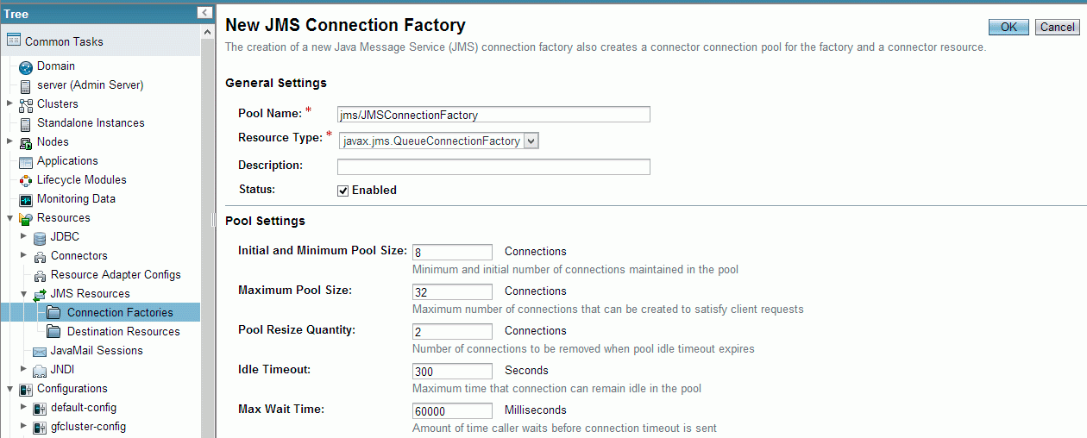
3. Select gfcluster as a target and save the changes.
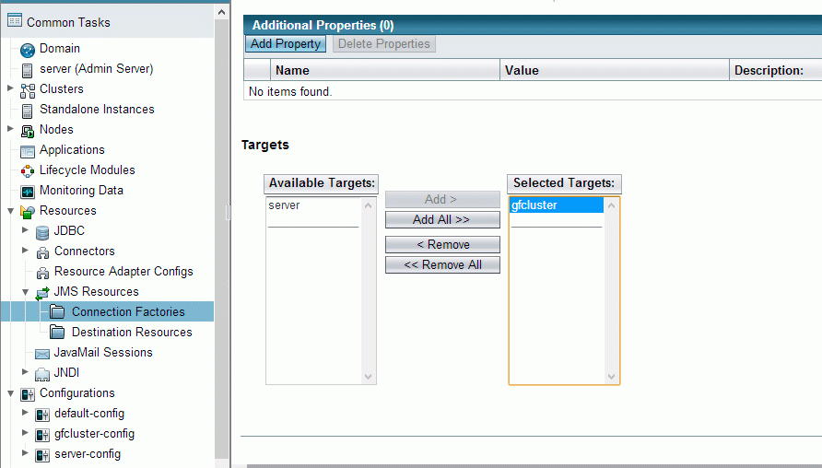
4. Navigate to Destination Resources and create jms/myQueue queue called Queuewith javax.jms.Queue type. The target is also gfcluster.
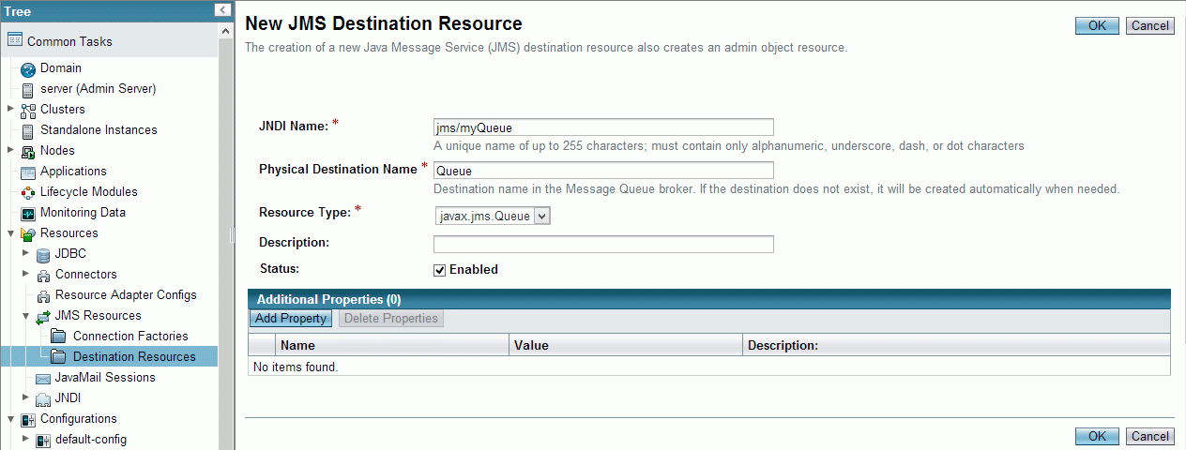

Deploy JMS Application
1. Navigate to the Applications tab, upload your application package and deploy it to the send-message context of the GlassFish cluster.
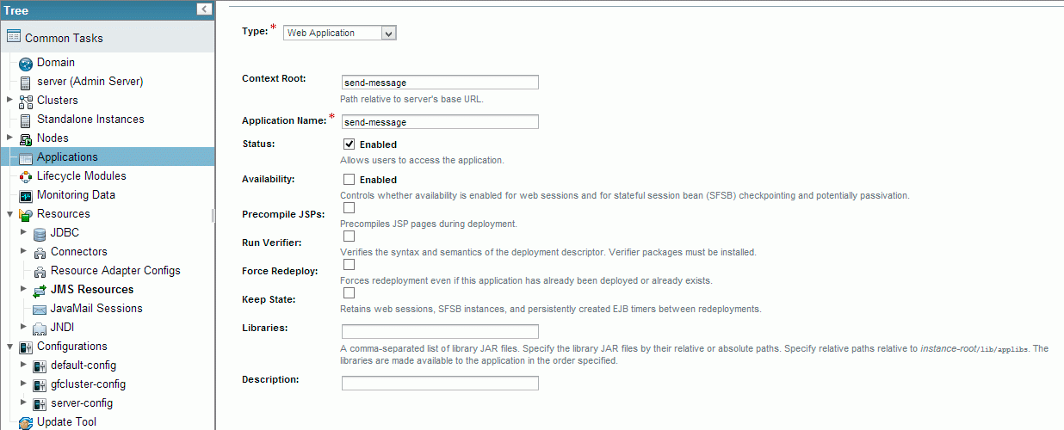
2. Launch your JMS application in a web browser to check the results.
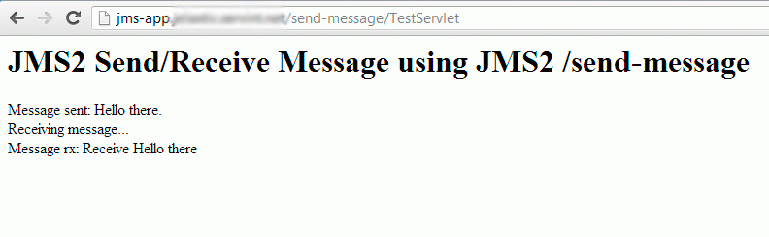

JMS Step 1 - How to Create a Simple JMS Queue in Weblogic Server 11g

By John-Brown.Evans-Oracle on Nov 07, 2012
This example shows the steps to create a simple JMS queue in WebLogic Server 11g for testing purposes. For example, to use with the two sample programs QueueSend.java and QueueReceive.java which will be shown in later examples.
Additional, detailed information on JMS can be found in the following Oracle documentation:
Oracle® Fusion Middleware Configuring and Managing JMS for Oracle WebLogic Server
11g Release 1 (10.3.6)
Part Number E13738-06
http://docs.oracle.com/cd/E23943_01/web.1111/e13738/toc.htm

1. Introduction and Definitions
A JMS queue in Weblogic Server is associated with a number of additional resources:

JMS Server
A JMS server acts as a management container for resources within JMS modules. Some of its responsibilities include the maintenance of persistence and state of messages and subscribers. A JMS server is required in order to create a JMS module.

JMS Module
A JMS module is a definition which contains JMS resources such as queues and topics. A JMS module is required in order to create a JMS queue.

Subdeployment
JMS modules are targeted to one or more WLS instances or a cluster. Resources within a JMS module, such as queues and topics are also targeted to a JMS server or WLS server instances. A subdeployment is a grouping of targets. It is also known as advanced targeting.

Connection Factory
A connection factory is a resource that enables JMS clients to create connections to JMS destinations.

JMS Queue
A JMS queue (as opposed to a JMS topic) is a point-to-point destination type. A message is written to a specific queue or received from a specific queue.
The objects used in this example are:
Object Name | Type | JNDI Name
TestJMSServer | JMS Server
TestJMSModule | JMS Module
TestSubDeployment | Subdeployment
TestConnectionFactory | Connection Factory | jms/TestConnectionFactory
TestJMSQueue | JMS Queue | jms/TestJMSQueue

2. Configuration Steps
The following steps are done in the WebLogic Server Console, beginning with the left-hand navigation menu.

2.1 Create a JMS Server
- Services > Messaging > JMS Servers
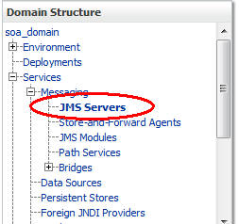
- Select New
- Name: TestJMSServer
Persistent Store: (none)
- Target: soa_server1 (or choose an available server)
- Finish
The JMS server should now be visible in the list with Health OK.
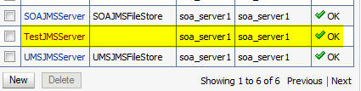

2.2 Create a JMS Module
- Services > Messaging > JMS Modules
- Select New
- Name: TestJMSModule
Leave the other options empty
- Targets: soa_server1 (or choose the same one as the JMS server)
Press Next
- Leave “Would you like to add resources to this JMS system module” unchecked and press Finish .

2.3 Create a SubDeployment
A subdeployment is not necessary for the JMS queue to work, but it allows you to easily target subcomponents of the JMS module to a single target or group of targets. We will use the subdeployment in this example to target the following connection factory and JMS queue to the JMS server we created earlier.
- Services > Messaging > JMS Modules
- Select TestJMSModule
- Select the Subdeployments tab and New
- Subdeployment Name: TestSubdeployment
- Press Next
- Here you can select the target(s) for the subdeployment. You can choose either Servers (i.e. WebLogic managed servers, such as the soa_server1) or JMS Servers such as the JMS Server created earlier. As the purpose of our subdeployment in this example is to target a specific JMS server, we will choose the JMS Server option.
Select the TestJMSServer created earlier
- Press Finish

2.4 Create a Connection Factory
- Services > Messaging > JMS Modules
- Select TestJMSModule and press New
- Select Connection Factory and Next
- Name: TestConnectionFactory
JNDI Name: jms/TestConnectionFactory
Leave the other values at default
- On the Targets page, select the Advanced Targeting button and selectTestSubdeployment
- Press Finish
The connection factory should be listed on the following page with TestSubdeployment and TestJMSServer as the target.

2.5 Create a JMS Queue
- Services > Messaging > JMS Modules
- Select TestJMSModule and press New
- Select Queue and Next
- Name: TestJMSQueue
JNDI Name: jms/TestJMSQueue
Template: None
Press Next
- Subdeployments: TestSubdeployment
- Finish
The TestJMSQueue should be listed on the following page with TestSubdeployment and TestJMSServer.
Confirm the resources for the TestJMSModule. Using the Domain Structure tree, navigate to soa_domain > Services > Messaging > JMS Modules then select TestJMSModule
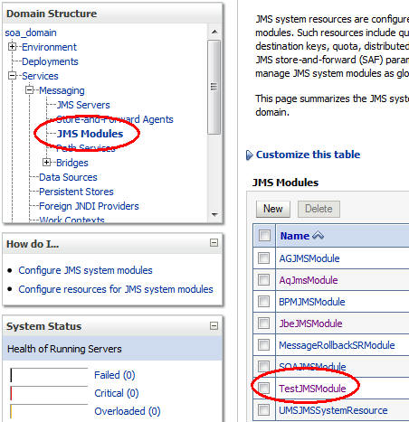
You should see the following resources
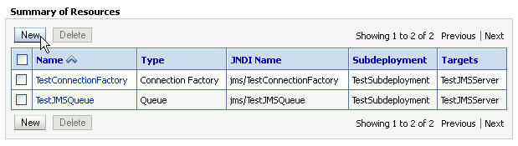
The JMS queue is now complete and can be accessed using the JNDI names
jms/TestConnectionFactory and
jms/TestJMSQueue.
In the following blog post in this series, I will show you how to write a message to this queue, using the WebLogic sample Java program QueueSend.java.

