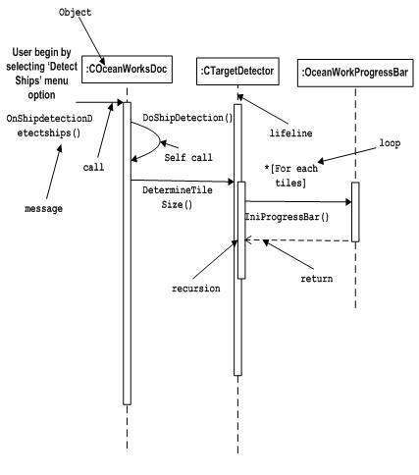

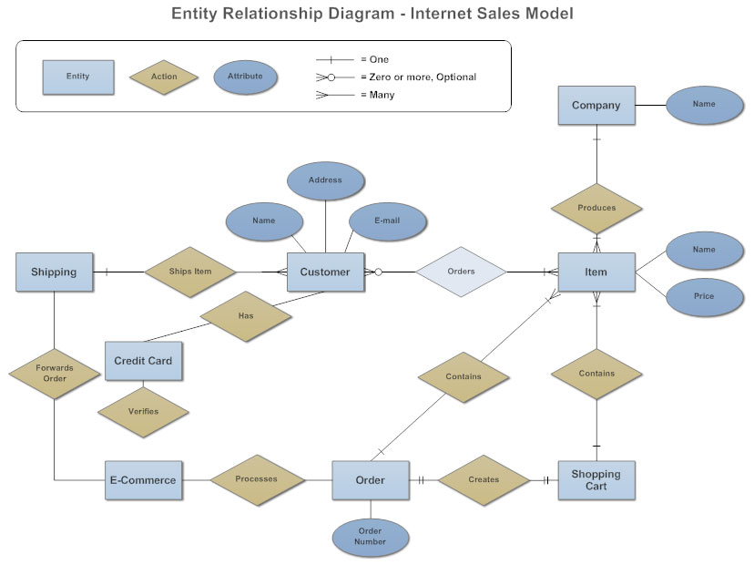

Conduct Information Analysis—Which Classes, Associations, and Attributes Do We Need?
In this work step the main part of the bottom-up analysis is performed. For each query or input a small class diagram is created on the basis of the existing classes. This is achieved by modeling the drafted inputs and outputs of the IT system. Class modeling on a small scale takes place. The questions are:
- What data elements exist in input and output??
- What objects hide behind these data elements?
- What relationships exist between the objects that were found?
- Which of the objects that have already been modeled can be used?
For the passenger list in Figure 4.40, the class diagram in Figure 4.41 can be constructed:
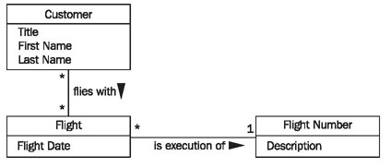
Figure 4.41 Class diagram for the passenger list
Taking into consideration the classes that were already found in the top-down analysis, the class diagram in Figure 4.42 is constructed:
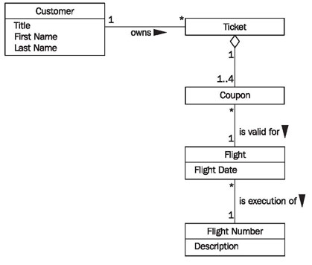
Figure 4.42 Edited class diagram for passenger list

Consolidate Class Diagrams—How Does Everything Fit Together?
In this last work step, if it has not been done yet, the individual class diagrams have to be consolidated into one cumulative class diagram. Here, inconsistencies have to be discovered and corrected. Applicable questions are:
- Are there classes in the individual class diagrams that have different names, but represent the same thing?
- Are there multiple relationships in individual class diagrams that have the same meaning?
- Are there attributes within classes that are named differently, but that have the same meaning?
In fact, when all individual class diagrams are being consolidated to one cumulative diagram, these questions almost pose themselves. Once inconsistencies have been recognized, they can usually be corrected easily. If you used the classes found during top-down analysis for modeling the drafted inputs and outputs, overlaps and conflicts during the consolidation of the individual class diagrams should be limited anyway.

Verify the Class Diagrams—Is Everything Correct?
The completed class diagram in the structural view can be verified with the following checklist:

Checklist 4.5 Verifying Class Diagrams of the Structural View
- Is the class diagram complete? This question will be answered in Interaction View. In the interaction view, we will show how the class diagram can be used to answer all required queries of the IT system. If this is possible, the class diagram is complete.
Is the class diagram correct? The second question, the question about correctness, is a little bit more difficult to answer. Our experience shows that intensive collaborative reading of class diagrams together with the knowledge carriers will bring to light most mistakes. In addition to that, the class diagram can be tested for suspect structure patterns. The best way to do this is with a suitable tool. An introduction to the analysis of structure patterns would go beyond the scope of the text. An explanation of concepts and of a tool that helps analyze structure patterns can be found

