UML structural diagrams are categorized as follows: class diagram, object diagram, component diagram, and deployment diagram.

Class Diagram
A class diagram models the static view of a system. It comprises of the classes, interfaces, and collaborations of a system; and the relationships between them.

Class Diagram of a System
Let us consider a simplified Banking System.
A bank has many branches. In each zone, one branch is designated as the zonal head office that supervises the other branches in that zone. Each branch can have multiple accounts and loans. An account may be either a savings account or a current account. A customer may open both a savings account and a current account. However, a customer must not have more than one savings account or current account. A customer may also procure loans from the bank.
The following figure shows the corresponding class diagram.

UML Class Diagrams Reference
Notation | Description
Class
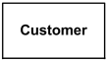  Class Customer - details suppressed. | A class is a classifier which describes a set of objects that share the same  - features  - constraints  - semantics (meaning).  A class is shown as a solid-outline rectangle containing the class name, and optionally with compartments separated by horizontal lines containing features or other members of the classifier.
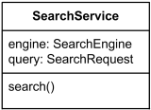  Class SearchService - analysis level details | When class is shown with three compartments, the middle compartment holds a list of attributes and the bottom compartment holds a list of operations. Attributes and operations should be left justified in plain face, with the first letter of the names in lower case.
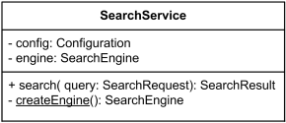  Class SearchService - implementation level details. The createEngine is static operation. | Middle compartment holds attributes and the bottom one holds operations.
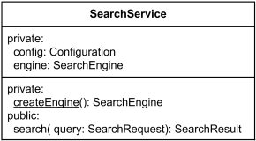  Class SearchService - attributes and operations grouped by visibility. | Attributes or operations may be grouped by visibility. A visibility keyword or symbol in this case can be given once for multiple features with the same visibility.
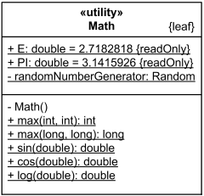  Math is utility class - having static attributes and operations (underlined) | Utility is class that has only class scoped static attributes and operations. As such, utility class usually has no instances.
Abstract Class
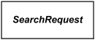  Class SearchRequest is abstract class. | Abstract class was defined in UML 1.4.2 as class that can't be directly instantiated. No object may be a direct instance of an abstract class.  UML 2.4 mentions abstract class but provides no definition. We may assume that in UML 2.x abstract class does not have complete declaration and "typically" can not be instantiated.  The name of an abstract class is shown in italics.
Nested Classifiers
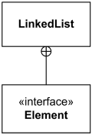  Class LinkedList is nesting the Element interface. The Element is in scope of the LinkedList namespace. | A class or interface could be used as a namespace for various classifiers including other classes, interfaces, use cases, etc. This nesting of classifier limits the visibility of the classifier defined in the class to the scope of the namespace of the containing class or interface.  In obsolete UML 1.4.2 a declaring class and a class in its namespace may be shown connected by a line, with an "anchor" icon on the end connected to a declaring class (namespace). An anchor icon is a cross inside a circle.  UML 2.x specifications provide no explicit notation for the nesting by classes. Note, that UML's 1.4 "anchor" notation is still used in one example in UML 2.4.x for packages as an "alternative membership notation".
Class Template
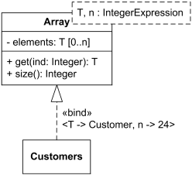  Template class Array and bound class Customers. The Customers class is an Array of 24 objects of Customer class. | UML classes could be templated or bound.  The example to the left shows bound class Customers with substitution of the unconstrained parameter class T with class Customer and boundary parameter n with the integer value 24.
Interface
  Interface SiteSearch. | An interface is a classifier that declares of a set of coherent public features and obligations. An interface specifies acontract.  In UML 1.4 interface was formally equivalent to an abstract class with no attributes and no methods and onlyabstract operations.  An interface may be shown using a rectangle symbol with the keyword «interface» preceding the name.
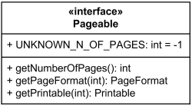  Interface Pageable | The obligations that may be associated with an interface are in the form of various kinds of constraints (such as pre- and postconditions) or protocol specifications, which may impose ordering restrictions on interactions through the interface.
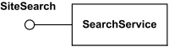  Interface SiteSearch is realized (implemented) by SearchService. | Interface participating in the interface realization dependency is shown as a circle or ball, labeled with the name of the interface and attached by a solid line to the classifier that realizes this interface.
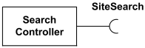  Interface SiteSearch is used (required) by SearchController. | The usage dependency from a classifier to an interface is shown by representing the interface by a half-circle or socket, labeled with the name of the interface, attached by a solid line to the classifier that requires this interface.
Object
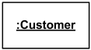  Anonymous instance of the Customer class. | Object is an instance of a class or an interface. Object is not a UML element by itself. Objects are rendered asinstance specifications, usually on object diagrams.  Class instance (object) could have no name, be anonymous.
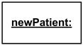  Instance newPatient of the unnamed or unknown class. | In some cases, class of the instance is unknown or not specified. When instance name is also not provided, the notation for such an anonymous instance of an unnamed classifier is simply underlined colon - :.
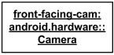  Instance front-facing-cam of the Camera class from android.hardware package. | Class instance (object) could have instance name, class and namespace (package) specified.
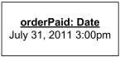  Instance orderPaid of the Date class  has value July 31, 2011 3:00 pm. | If an instance has some value, the value specification is shown either after an equal sign ('=') following the instance name, or without the equal sign below the name.
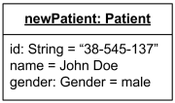  Instance newPatient of the Patient class  has slots with values specified. | Slots are shown as structural features with the feature name followed by an equal sign ('=') and a value specification. Type (classifier) of the feature could be also shown.
Data Type
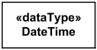  DateTime data type | A data type is a classifier - similar to a class - whose instances are identified only by their value.  A data type is shown using rectangle symbol with keyword «dataType».
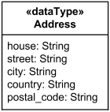  Structured data type Address | A data type may contain attributes and operations to support the modeling of structured data types.
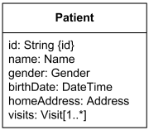  Attributes of the Patient class are of data types Name, Gender, DateTime, Address and Visit. | When data type is referenced by, e.g., as the type of a class attribute, it is shown simply as the name of the data type.
Primitive Type
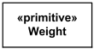  Primitive data type Weight. | A primitive type is a data type which represents atomic data values, i.e. values having no parts or structure. A primitive data type may have precise semantics and operations defined outside of UML, for example, mathematically.  Standard UML primitive types include:  - Boolean,  - Integer,  - UnlimitedNatural,  - String.  A primitive type has the keyword «primitive» above or before the name of the primitive type.
Enumeration
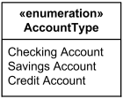  Enumeration AccountType. | An enumeration is a data type whose values are enumerated in the model as user-defined enumeration literals.  An enumeration may be shown using the classifier notation (a rectangle) with the keyword «enumeration». The name of the enumeration is placed in the upper compartment.  A list of enumeration literals may be placed, one to a line, in the bottom compartment. The attributes and operations compartments may be suppressed, and typically are suppressed if they would be empty.
Feature
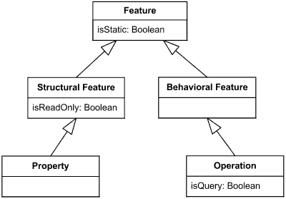
Feature overview diagram
Association Qualifier
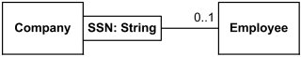  Given a company and a social security number (SSN) at most one employee could be found. | A qualifier is a property which defines a partition of the set of associated instances with respect to an instance at the qualified end.  Qualifiers are used to model hash maps in Java, dictionaries in C#, index tables, etc. where fast access to linked object(s) is provided using qualifier as a hash key, search argument or index.  A qualifier is shown as a small rectangle attached to the end of an association between the final path segment and the symbol of the classifier that it connects to. The qualifier rectangle is part of the association, not part of the classifier. A qualifier may not be suppressed.  In the case in which the target multiplicity is 0..1, the qualifier value is unique with respect to the qualified object, and designates at most one associated object.
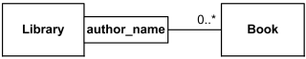  Given a library and author name none to many books could be found. | In the case of target multiplicity 0..*, the set of associated instances is partitioned into possibly empty subsets, each selected by a given qualifier instance.
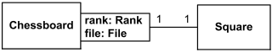  Given chessboard and specific rank and file we'll locate exactly 1 square. UML specification provides no lucid explanation of what multiplicity 1 means for qualifier. | UML 2.4 specification is gibberish explaining multiplicity of qualifier:  The multiplicity of a qualifier is given assuming that the qualifier value is supplied. The “raw” multiplicity without the qualifier is assumed to be 0..*. This is not fully general but it is almost always adequate, as a situation in which the raw multiplicity is 1 would best be modeled without a qualifier.
Operation
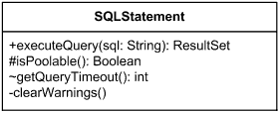  Operation executeQuery is public, isPoolable - protected, getQueryTimeout - with package visibility, and clearWarnings is private. | Operation is a behavioral feature of a classifier that specifies the name, type, parameters, and constraints for invoking an associated behavior.  When operation is shown in a diagram, the text should conform to the syntax defined in UML specification. Note, that UML 2.2 to 2.4 specifications seem to have wrong nesting for operation's properties, making presence of the properties dependent on the presence of return type. The syntax provided here is non-normative and different from the one in the UML 2.4 specification:  operation ::= [ visibility ] signature [ oper-properties ]  Visibility of the operation is optional, and if present, it should be one of:  visibility ::= '+' | '-' | '#' | '~'
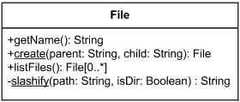  File has two static operations - create and slashify. Create has two parameters and returns File. Slashify is private operation. Operation listFiles returns array of files. Operations getName and listFiles either have no parameters or parameters were suppressed. | Signature of the operation has optional parameter list and return specification.  signature ::= name '(' [ parameter-list ] ')' [ ':' return-spec ]  Name is the name of the operation. Parameter-list is a list of parameters of the operation in the following format:  parameter-list ::= parameter [ ',' parameter ]*  parameter ::= [ direction ] parm-name ':' type-expression [ '[' multiplicity ']' ] [ '=' default ] [ parm-properties ]  Parm-name is the name of the parameter. Type-expression is an expression that specifies the type of the parameter. Multiplicity is the multiplicity of the parameter. Default is an expression that defines the value specification for the default value of the parameter. Parameter list can be suppressed.
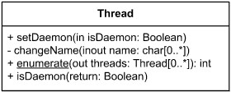  Operation setDaemon has one input parameter, while single parameter of changeName is both input and output parameter. Static enumerate returns integer result while also having output parameter - array of threads. Operation isDaemon is shown with return type parameter. It is presentation option equivalent to returning operation result as: +isDaemon(): Boolean. | Direction of parameter is described as one of:  direction ::= 'in' | 'out' | 'inout' | 'return'  and defaults to 'in' if omitted.  Optional parm-properties describe additional property values that apply to the parameter.  parm-properties ::= '{' parm-property [ ',' parm-property ]* '}'  Optional return specification is defined as:  return-spec ::= [ return-type ] [ '[' multiplicity ']' ]  Return type is the type of the result, if it was defined for the operation. Return specification also has optional multiplicity of the return type.
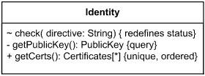  Operation check redefines inherited operation status from the superclass. Operation getPublicKey does not change the state of the system. Operation getCerts returns ordered array of Certificates without duplicates. | Properties of the operation are optional, and if present should follow the rule:  oper-properties ::= '{' oper-property [ ',' oper-property ]* '}'  oper-property ::= 'redefines' oper-name | 'query' | 'ordered' | 'unique' | oper-constraint  Properties of operation describe operation in general or return parameter, and are defined as:  - redefines oper-name - operation redefines an inherited operation identified by oper-name;  - query - operation does not change the state of the system;  - ordered - the values of the return parameter are ordered;  - unique - the values returned by the parameter have no duplicates;  - oper-constraint - is a constraint that applies to the operation.
Abstract Operation
Abstract operation in UML 1.4.2 was defined as operation without implementation - "class does not implement the operation". Implementation had to be supplied by a descendant of the class.
Abstract operation in UML 1.4.2 was shown with its signature in italics or marked as {abstract}.
There is neither definition nor notion for abstract operation in UML 2.4.
Constraint
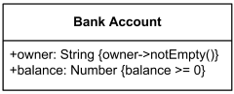  Bank account attribute constraints - non empty owner and positive balance. | Constraint could have an optional name, though usually it is anonymous. A constraint is shown as a text string in curly braces according to the syntax:  constraint ::= '{' [ name ':' ] boolean-expression '}'  For an element whose notation is a text string (such as a class attribute, etc.), the constraint string may follow the element text string in curly braces.
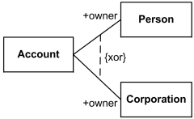  Account owner is either Person or Corporation, {xor} is predefined UML constraint. | For a Constraint that applies to two elements (such as two classes or two associations), the constraint may be shown as a dashed line between the elements labeled by the constraint string in curly braces.
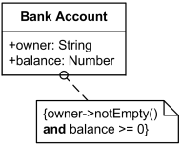  Bank account constraints - non empty owner and positive balance | The constraint string may be placed in a note symbol and attached to each of the symbols for the constrained elements by a dashed line.
Multiplicity
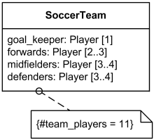  Multiplicity of Players for Soccer Team class. | Multiplicity is a definition of an inclusive interval of non-negative integers to specify the allowable number of instances of described element.  Multiplicity could be described with the following non-normative syntax rules:  multiplicity ::= multiplicity-range [ '{' multiplicity-options '}' ]  Some typical examples of multiplicity bounds:
  0 | Collection must be empty
  1 | Exactly one instance
  5 | Exactly 5 instances
  * | Zero or more instances
  0..1 | No instances or one instance
  1..1 | Exactly one instance
  0..* | Zero or more instances
  1..* | At least one instance
  m..n | At least m but no more than n instances
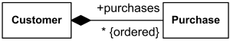  Customer has none to many purchases. Purchases are in specific order and each one is unique (by default).  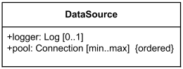  Data Source could have a Logger and has ordered pool of min to max Connections. Each Connection is unique (by default). | Multiplicity options could also specify of whether the values in an instantiation of the element should be uniqueand/or ordered:  multiplicity-options ::=  order-designator [ ',' uniqueness-designator ] |  uniqueness-designator [ ',' order-designator ]  order-designator ::= 'ordered' | 'unordered'  uniqueness-designator ::= 'unique' | 'nonunique'  If multiplicity element is multivalued and specified as ordered, then the collection of values in an instantiation of this element is sequentially ordered. By default, collections are not ordered.  If multiplicity element is multivalued and specified as unique, then each value in the collection of values in an instantiation of this element must be unique. By default, each value in collection is unique.
Visibility
Operation executeQuery is public, isPoolable - protected, getQueryTimeout - with package visibility, and clearWarnings is private. | Visibility allows to constrain the usage of a named element, either in namespaces or in access to the element. It is used with classes, packages, generalizations, element import, package import.  UML has the following types of visibility:  - public (+)  - package (~)  - protected (#)  - private (-)  If a named element is not owned by any namespace, then it does not have a visibility.
Association
Association is a relationship between classifiers which is used to show that instances of classifiers could be eitherlinked to each other or combined logically or physically into some aggregation.
It is normally drawn as a solid line connecting associated classifiers.
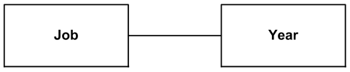  Job is associated with Year. | Binary association relates two typed instances. It is normally rendered as a solid line connecting two classifiers, or a solid line connecting a single classifier to itself (the two ends are distinct). The line may consist of one or more connected segments.
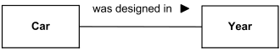  Order of the ends and reading: Car - was designed in -Year | A small solid triangle could be placed next to or in place of the name of binary association (drawn as a solid line) to show the order of the ends of the association. The arrow points along the line in the direction of the last end in the order of the association ends. This notation also indicates that the association is to be read from the first end to the last end.
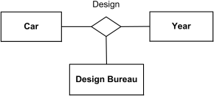  Ternary association Design relating three classifiers. | Any association may be drawn as a diamond (larger than a terminator on a line) with a solid line for each association end connecting the diamond to the classifier that is the end’s type. N-ary association with more than two ends canonly be drawn this way.
Aggregation
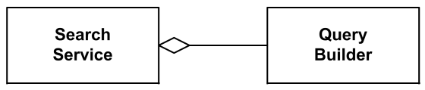  Search Service has a Query Builder using sharedaggregation | Aggregation (aka shared aggregation) is shown as binary association decorated with a hollow diamond as a terminal adornment at the aggregate end of the association line.
Composite Aggregation (Composition)
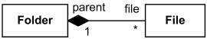  Folder could contain many files, while each File has exactly one Folder parent. If Folder is deleted, all contained Files are deleted as well. | Composite aggregation (aka composition) is a "strong" form of aggregation.  Composition is depicted as binary association decorated with a filled black diamond at the aggregate (composite) end.
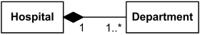  Hospital has 1 or more Departments, and each Department belongs to exactly one Hospital.  If Hospital is closed, so are all of its Departments. | When composition is used in domain models, both whole/part relationship as well as event of composite "deletion" should be interpreted figuratively, not necessarily as physical containment and/or termination.
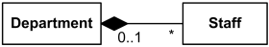  Each Department has some Staff, and each Staff could be a member of one Department (or none). If Department is closed, its Staff is relieved (but excluding the "stand alone" Staff). | Multiplicity of the composite (whole) could be specified as 0..1 ("at most one") which means that part is allowed to be a "stand alone", not owned by any specific composite.
Ownership of Association End
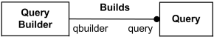  Association end query is owned by classifier QueryBuilderand association end qbuilder is owned by association Buildsitself. | Ownership of association ends by an associated classifier may be indicated graphically by a small filled circle (akadot). The dot is drawn at the point where line meets the classifier. It could be interpreted as showing that the model includes a property of the type represented by the classifier touched by the dot. This property is owned by the classifier at the other end.
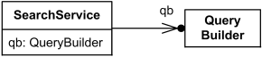  Association end qb is an attribute of SearchService class and is owned by the class. | Attribute notation can be used for an association end owned by a class, because an association end owned by a class is also an attribute. This notation may be used in conjunction with the line arrow notation to make it perfectly clear that the attribute is also an association end.
Association Navigability
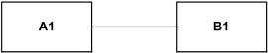  Both ends of association have unspecified navigability. | No adornment on the end of an association means unspecified navigability.
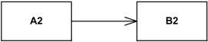  A2 has unspecified navigability while B2 is navigablefrom A2. | Navigable end is indicated by an open arrowhead on the end of an association.
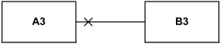  A3 is not navigable from B3 while B3 has unspecified navigability. | Not navigable end is indicated with a small x on the end of an association.
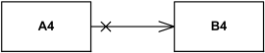
A4 is not navigable from B4 while B4 is navigable from A4.
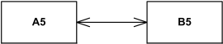
A5 is navigable from B5 and B5 is navigable from A5.
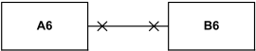
A6 is not navigable from B6 and B6 is not navigable from A6.
Generalization
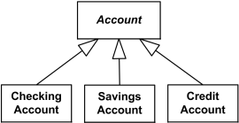  Checking, Savings, and Credit Accounts are generalized by Account. | A Generalization is shown as a line with a hollow triangle as an arrowhead between the symbols representing the involved classifiers. The arrowhead points to the symbol representing the general classifier. This notation is referred to as the "separate target style."
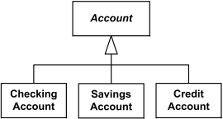  Checking, Savings, and Credit Accounts are generalized by Account. | Multiple Generalization relationships that reference the same general classifier can also be connected together in the"shared target style."
Dependency
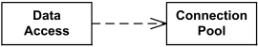  Data Access depends on Connection Pool | Dependency relationship is used on class diagrams to show usage dependency or abstraction.  A dependency is generally shown as a dashed arrow between two model elements. The model element at the tail of the arrow (the client) depends on the model element at the arrowhead (the supplier). The arrow may be labeled with an optional stereotype and an optional name.
Usage
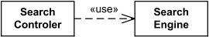  Search Controller uses Search Engine. | Usage is a dependency relationship in which one element (client) requires another element (or set of elements) (supplier) for its full implementation or operation.  For example, it could mean that some method(s) within a (client) class uses objects (e.g. parameters) of the another (supplier) class.  A usage dependency is shown as a dependency with a «use» keyword attached to it.
Create
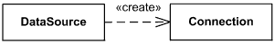  Data Source creates Connection | Create is a usage dependency denoting that the client classifier creates instances of the supplier classifier. It is denoted with the standard stereotype «create».
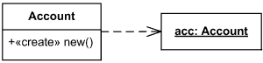  Account constructor creates new instance of Account | Create may relate an instance value to a constructor for a class, describing the single value returned by the constructor operation. The operation is the client, the created instance the supplier. The instance value may reference parameters declared by the operation.
Required Interface
Interface SiteSearch is used (required) by SearchController. | Required interface specifies services that a classifier needs in order to perform its function and fulfill its own obligations to its clients. It is specified by a usage dependency between the classifier and the correspondinginterface.  The usage dependency from a classifier to an interface is shown by representing the interface by a half-circle or socket, labeled with the name of the interface, attached by a solid line to the classifier that requires this interface.
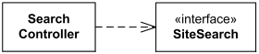  Interface SiteSearch is used (required) by Search Controller. | If interface is represented using the rectangle notation, interface usage dependency is denoted with dependency arrow. The classifier at the tail of the arrow uses (requires) the interface at the head of the arrow.
Interface Realization
Interface SiteSearch is realized (implemented) by SearchService. | The interface realization dependency from a classifier to an interface is shown by representing the interface by a circle or ball, labeled with the name of the interface and attached by a solid line to the classifier that realizes this interface.
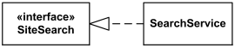  Interface SiteSearch is realized (implemented) by SearchService. | In cases where interfaces are represented using the rectangle notation, interface realization dependency is denoted with interface realization arrow. The classifier at the tail of the arrow implements the interface at the head of the arrow.

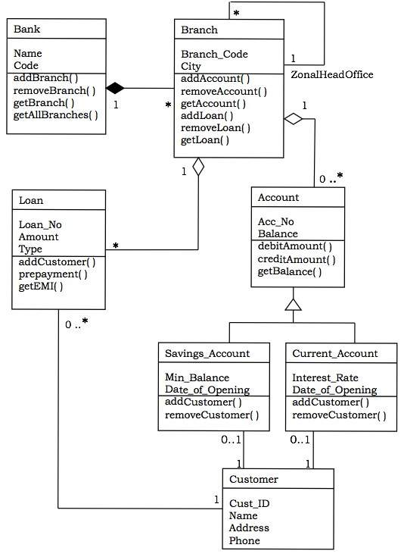

Classes in the system:
Bank, Branch, Account, Savings Account, Current Account, Loan, and Customer.

Relationships:
- A Bank “has–a” number of Branches : composition, one–to–many
- A Branch with role Zonal Head Office supervises other Branches: unary association, one–to-many
- A Branch “has–a” number of accounts : aggregation, one–to–many
From the class Account, two classes have inherited, namely, Savings Account and Current Account.
- A Customer can have one Current Account : association, one–to–one
- A Customer can have one Savings Account : association, one–to–one
- A Branch “has–a” number of Loans : aggregation, one–to–many
- A Customer can take many loans : association, one–to–many

Object Diagram
An object diagram models a group of objects and their links at a point of time. It shows the instances of the things in a class diagram. Object diagram is the static part of an interaction diagram.
Example : The following figure shows an object diagram of a portion of the class diagram of the Banking System.

Entity Relationship Diagram
An entity relationship diagram (ERD) shows the relationships of entity sets stored in a database. An entity in this context is a component of data. In other words, ER diagrams illustrate the logical structure of databases.
At first glance an entity relationship diagram looks very much like a flowchart. It is the specialized symbols, and the meanings of those symbols, that make it unique.
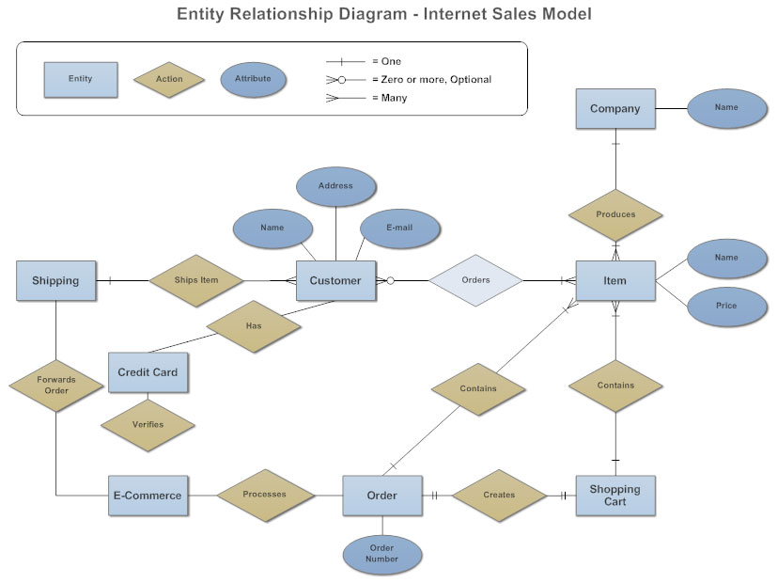

The History of Entity Relationship Diagrams
Peter Chen developed ERDs in 1976. Since then Charles Bachman and James Martin have added some slight refinements to the basic ERD principles.

Structure of an Entity Relationship Diagram with Common ERD Notations
An entity relationship diagram is a means of visualizing how the information a system produces is related. There are five main components of an ERD:
- Entities, which are represented by rectangles. An entity is an object or concept about which you want to store information.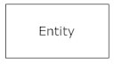A weak entity is an entity that must defined by a foreign key relationship with another entity as it cannot be uniquely identified by its own attributes alone.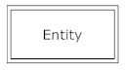
- Actions, which are represented by diamond shapes, show how two entities share information in the database.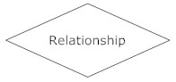In some cases, entities can be self-linked. For example, employees can supervise other employees.
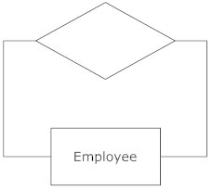
- Attributes, which are represented by ovals. A key attribute is the unique, distinguishing characteristic of the entity. For example, an employee's social security number might be the employee's key attribute.
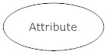A multivalued attribute can have more than one value. For example, an employee entity can have multiple skill values.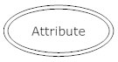A derived attribute is based on another attribute. For example, an employee's monthly salary is based on the employee's annual salary.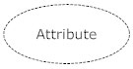
- Connecting lines, solid lines that connect attributes to show the relationships of entities in the diagram.
- Cardinality specifies how many instances of an entity relate to one instance of another entity. Ordinality is also closely linked to cardinality. While cardinality specifies the occurrences of a relationship, ordinality describes the relationship as either mandatory or optional. In other words, cardinality specifies the maximum number of relationships and ordinality specifies the absolute minimum number of relationships.
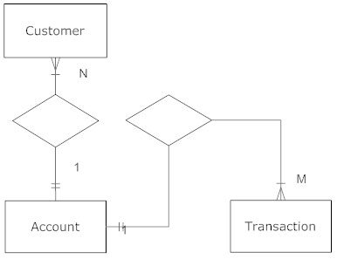There are many notation styles that express cardinality.
Information Engineering Style
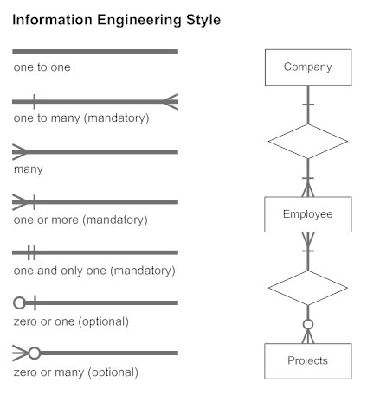Chen Style
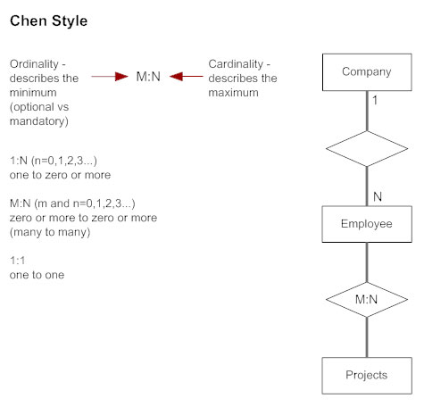Bachman Style
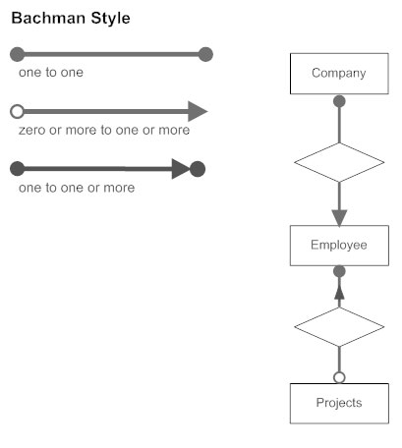Martin Style
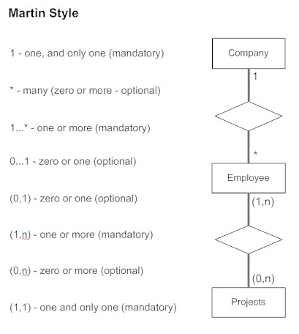

Entity Relationship Diagram Uses
When documenting a system or process, looking at the system in multiple ways increases the understanding of that system. ERD diagrams are commonly used in conjunction with a data flow diagram to display the contents of a data store. They help us to visualize how data is connected in a general way, and are particularly useful for constructing a relational database.

How to Create an Entity Relationship Diagram
Here are some best practice tips for constructing an ERD:
- Identify the entities. The first step in making an ERD is to identify all of the entities you will use. An entity is nothing more than a rectangle with a description of something that your system stores information about. This could be a customer, a manager, an invoice, a schedule, etc. Draw a rectangle for each entity you can think of on your page. Keep them spaced out a bit.
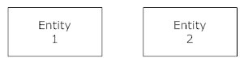
- Identify relationships. Look at two entities, are they related? If so draw a solid line connecting the two entities.
- Describe the relationship. How are the entities related? Draw an action diamond between the two entities on the line you just added. In the diamond write a brief description of how they are related.
- Add attributes. Any key attributes of entities should be added using oval-shaped symbols.
- Complete the diagram. Continue to connect the entities with lines, and adding diamonds to describe each relationship until all relationships have been described. Each of your entities may not have any relationships, some may have multiple relationships. That is okay.

How to Build an Entity Relationship Diagram with SmartDraw
SmartDraw's automated format makes it easy to create an ERD, and hundreds of other diagrams, in minutes.
Start with an ERD template then add entities, actions, and attributes by clicking simple commands in the SmartPanel.
To add an ERD symbol to your page, click on it and without releasing the mouse, drag it to the page or just click once in the page to stamp it.
To connect an attribute or an action to any entity on the page, select the appropriate symbol from the SmartPanel and click "Add Right" to automatically connect it.
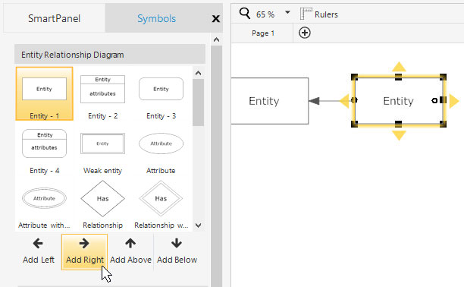
You can also hold down the [CTRL] key and hit the right arrow key to achieve the same effect.
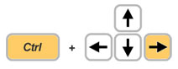
Keep adding symbols as necessary.
If you need to move an entity or attribute, just click to select it and drag it to its new position. As you move the shape, you'll notice SmartDraw's automatic connector will attempt to grab it. SmartDraw shows you a dashed outline of where your step will be if you let go of your mouse. To drop a shape into place, simply let go of your mouse. Your ER diagram will automatically readjust itself without any manual redrawing required.
To delete a step, just select it and hit delete. Again, SmartDraw's automation will allow the diagram to reflow automatically.
Drawing Cardinality
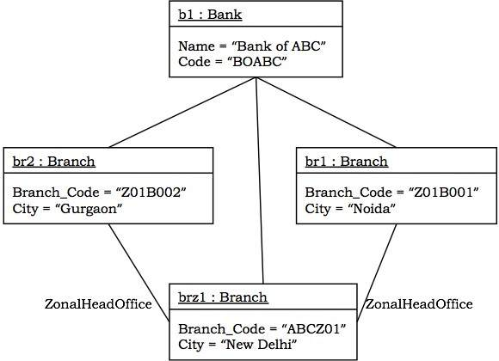

Component Diagram
Component diagrams show the organization and dependencies among a group of components.
Component diagrams comprise of:
- Components
- Interfaces
- Relationships
- Packages and Subsystems (optional)
Component diagrams are used for:
- constructing systems through forward and reverse engineering.
- modeling configuration management of source code files while developing a system using an object-oriented programming language.
- representing schemas in modeling databases.
- modeling behaviors of dynamic systems.

Constructing Class Diagrams
The main problem for constructing class diagrams is finding the "right" classes. We address this problem from two perspectives and construct the class diagram in two work steps.
In top-down analysis, classes are found first on the basis of general understanding of the subject matter. Top-down analysis is about finding a basic structure of classes that the bottom-up analysis, which is more detailed, can build upon. The (simplified) question is:
Which information or domain concepts can be of use for my IT system?
Domain knowledge, verbal descriptions of the area of application, and user representatives are important sources of information. In this way, a basic structure of classes can be found for most IT systems.
In bottom-up analysis, classes are found mainly on the basis of the inputs and outputs of the IT system. The question is:
What information is needed for the individual inputs and outputs of the IT system?
Here, the classes that were found during top-down analysis serve as the basis to find these classes. Already existing inputs and outputs, for instance, screen forms and paper forms are important sources of information.
According to our experience, these two work steps lead to good results in modeling IT systems that manage lots of information. In contrast to this, there are systems that, for example, have the function of running or controlling something, which have a complex functionality but hardly manage any data. For such systems we recommend a less data-intensive approach, for instance, responsibility-driven design. (For this approach compareRebecca Wirfs-Brock, Brian Wilkerson, Lauren Wiener: Designing Object-Oriented Software, Prentice Hall 1998.) The following checklist shows the necessary steps for constructing class diagrams. Subsequently, we will explain the individual steps further.
The following checklist shows the necessary steps for constructing class diagrams. Subsequently, we will explain the individual steps further.

Checklist 4.4 Constructing Class Diagrams in the Structural View

Top-down Analysis
- Identify and model classes—Which classes do we need?
- Identify and model associations—How are the classes connected?
- Define attributes—What do we want to know about the objects?

Bottom-up Analysis
- List required queries and inputs—What does the IT system need to deliver and accept?
- Formulate queries and inputs—How exactly should the display look?
- Conduct information analysis—Which classes, associations, and attributes do we need?
- Consolidate class diagrams—How does everything fit together?
- Verify the class diagrams—Is everything correct?

Identify and Model Classes—Which Classes do We Need?
An analysis of the interrelationships, information needs, and actors and prototypes is conducted on the basis of general domain knowledge, discussions with experts, and documents. The questions that should be asked are:
- What are the most important things that will be worked with in the IT system?
- What classes can be created from this?
The answers to these questions provide a number of potential classes, which we model in a first draft of the class diagram. In practice, the results of this first work step vary greatly. However, we have never experienced a case in which nothing at all was found. If you are still inexperienced in identifying classes, it has proven helpful to run through top-down analysis repeatedly. With time, you will develop a sense for what is a class and what is not (Figure 4.36):
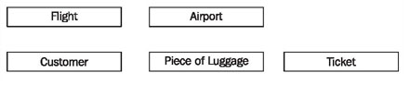
Figure 4.36 Potential classes

Identify and Model Associations—How Are the Classes Connected?
We model the interconnections between the obtained classes and business rules in class diagrams as associations with meaningful names and multiplicities, as shown in Figure 4.37. The questions are:
- What relationships exist among objects??
- How many objects of each class are involved in a relationship?
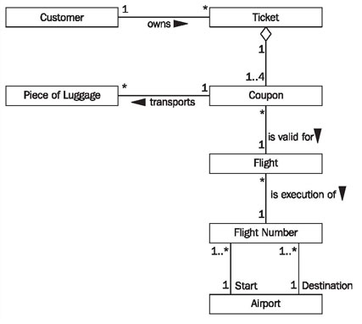
Figure 4.37 Class and Associations
The first question has to be asked for objects of each pair of different classes, for instance, for the classes flight and customer from our case study. Here, it is important to recognize whether the relationship is direct, or if the relationship only exists indirectly through other objects. In our example it turns out that a customer owns a ticket, which in turn, consists of coupons, which are valid for a flight. The goal of the second question is to determine the multiplicity of the relationship, for instance, how many tickets a customer can have, and to how many customers a ticket belongs (Figure 4.37).
Even though at the beginning of this work step we started with previously found classes, because of the domain discussions, we generally find more classes in this work step.

Define Attributes—What do We Want to Know about the Objects?
The required information about a class has to be identified and modeled in the form of attributes. The question for this is:
- Which information about a certain class am I interested in??
This question is about finding obviously needed attributes of the individual classes (see Figure 4.38). This question cannot be answered completely without precisely analyzing inputs and queries, as takes place in bottom-up analysis. Because of this, not too much time should be spent answering this question.
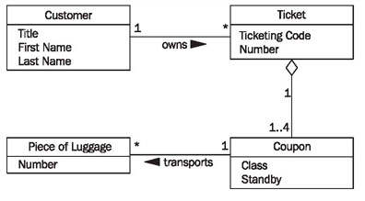
Figure 4.38 Classes and Attributes

List Required Queries and Inputs—What does the IT System Need to Deliver and Accept?
In this first work step of bottom-up analysis, the individual queries and inputs of the IT system have to be identified. The queries are more important here, because answering queries is the real purpose of IT systems. The questions are:
- What information does the IT system have to be able to provide??
- What information does the IT system have to be able to accept?
When answering these questions, you can build upon the use cases already found. Which queries and mutations occur in a use case is already drafted in the use case sequence diagram. Another source of information are the business processes of the business system (see Modeling Business Systems). The result of this work step is a list of information requirements, as illustrated in Figure 4.39:
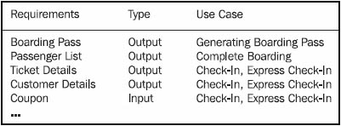
Figure 4.39 List of information requirements

Formulate Queries and Inputs—How Exactly Should the Display Look?
In order to create individual class diagrams for the individual queries and inputs, we first need to be define how they look. Complex query results or inputs are collected or drafted. Figure 4.40 shows a passenger list; further examples can be found in Figure 4.66 (display) and Figure 4.67 (boarding pass). The question is:

Conduct Information Analysis—Which Classes, Associations, and Attributes Do We Need?
In this work step the main part of the bottom-up analysis is performed. For each query or input a small class diagram is created on the basis of the existing classes. This is achieved by modeling the drafted inputs and outputs of the IT system. Class modeling on a small scale takes place. The questions are:
- What data elements exist in input and output??
- What objects hide behind these data elements?
- What relationships exist between the objects that were found?
- Which of the objects that have already been modeled can be used?
For the passenger list in Figure 4.40, the class diagram in Figure 4.41 can be constructed:
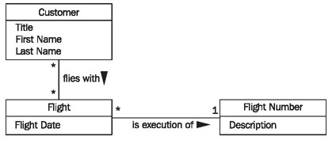
Figure 4.41 Class diagram for the passenger list
Taking into consideration the classes that were already found in the top-down analysis, the class diagram in Figure 4.42 is constructed:
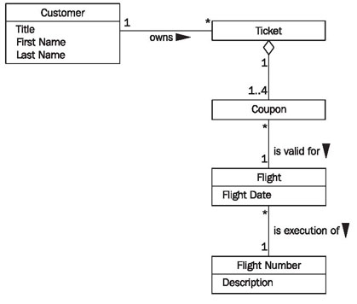
Figure 4.42 Edited class diagram for passenger list

Consolidate Class Diagrams—How Does Everything Fit Together?
In this last work step, if it has not been done yet, the individual class diagrams have to be consolidated into one cumulative class diagram. Here, inconsistencies have to be discovered and corrected. Applicable questions are:
- Are there classes in the individual class diagrams that have different names, but represent the same thing?
- Are there multiple relationships in individual class diagrams that have the same meaning?
- Are there attributes within classes that are named differently, but that have the same meaning?
In fact, when all individual class diagrams are being consolidated to one cumulative diagram, these questions almost pose themselves. Once inconsistencies have been recognized, they can usually be corrected easily. If you used the classes found during top-down analysis for modeling the drafted inputs and outputs, overlaps and conflicts during the consolidation of the individual class diagrams should be limited anyway.

Verify the Class Diagrams—Is Everything Correct?
The completed class diagram in the structural view can be verified with the following checklist:

Checklist 4.5 Verifying Class Diagrams of the Structural View
- Is the class diagram complete? This question will be answered in Interaction View. In the interaction view, we will show how the class diagram can be used to answer all required queries of the IT system. If this is possible, the class diagram is complete.
- Is the class diagram correct? The second question, the question about correctness, is a little bit more difficult to answer. Our experience shows that intensive collaborative reading of class diagrams together with the knowledge carriers will bring to light most mistakes. In addition to that, the class diagram can be tested for suspect structure patterns. The best way to do this is with a suitable tool. An introduction to the analysis of structure patterns would go beyond the scope of the text. An explanation of concepts and of a tool that helps analyze structure patterns can be found athttp://www.knowgravity.com/eng/value/cassandra.htm.

