# Hardware Requirements

* User end HARDWARE: User doesn’t need any hardware to test, develop or compile his software, all this will be done on web platform that we provide.  
  When he feel his software/project is finalized, he can download it and run it on AR – VR devices, for which he does require his hardware.
* Network bandwidth and latency requirements: User should have good network setup, with least latency, to work in real time environment. This is required to tackle the delay from server to user while the user is testing the software on site. Currently, 4K panoramic video only requires 20 to 40 Mbps data rate and 50 ms latency. As 5G networks contribute to considerable improvement in data rate (more than 100 Mbps) and latency (less than 10 ms), users will enjoy more comfortable viewing experiences.

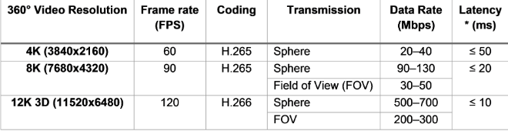

* Video Quality: If user’s network fluctuate frequently, then the video quality in testing process can be compromised. While at the time of downloading of the final project, no compromisation will be required.
* Reference: https://www.gsma.com/futurenetworks/wiki/cloud-ar-vr-whitepaper/