Practical 1a
Aim - Develop a secure messaging application where users can exchange messages securely using RSA encryption. Implement a mechanism for generating RSA key pairs and encrypting/decrypting messages.
Code -
pip install cryptography
from cryptography.hazmat.primitives.asymmetric import rsa, padding
from cryptography.hazmat.primitives import hashes
from cryptography.hazmat.backends import default_backend
def generate_rsa_key_pair():
"""Generates a new RSA public and private key pair."""
private_key = rsa.generate_private_key(
public_exponent=65537,
key_size=2048,
backend=default_backend()
)
public_key = private_key.public_key()
return private_key, public_key

def encrypt_message(public_key, message):
"""Encrypts a message using the recipient's public key."""
ciphertext = public_key.encrypt(
message.encode('utf-8'),
padding.OAEP(
mgf=padding.MGF1(algorithm=hashes.SHA256()),
algorithm=hashes.SHA256(),
label=None
)
)
return ciphertext

def decrypt_message(private_key, ciphertext):
"""Decrypts a ciphertext using the recipient's private key."""
plaintext = private_key.decrypt(
ciphertext,
padding.OAEP(
mgf=padding.MGF1(algorithm=hashes.SHA256()),
algorithm=hashes.SHA256(),
label=None
)
)
return plaintext.decode('utf-8')

if __name__ == "__main__":
print("User 1: Generating RSA key pair...")
user1_private_key, user1_public_key = generate_rsa_key_pair()
print("User 1: Key pair generated.")

print("\nUser 2: Generating RSA key pair...")
user2_private_key, user2_public_key = generate_rsa_key_pair()
print("User 2: Key pair generated.")

original_message_user1 = "Hello User 2, this is a secret message from User 1!"
print(f"\nUser 1: Original message to User 2: '{original_message_user1}'")

encrypted_message_user1_to_user2 = encrypt_message(user2_public_key, original_message_user1)
print(f"User 1: Encrypted message (ciphertext): {encrypted_message_user1_to_user2.hex()[:50]}...")

decrypted_message_user2 = decrypt_message(user2_private_key, encrypted_message_user1_to_user2)
print(f"User 2: Decrypted message: '{decrypted_message_user2}'")

original_message_user2 = "Hi User 1, I received your message securely!"
print(f"\nUser 2: Original message to User 1: '{original_message_user2}'")
encrypted_message_user2_to_user1 = encrypt_message(user1_public_key, original_message_user2)
print(f"User 2: Encrypted reply (ciphertext): {encrypted_message_user2_to_user1.hex()[:50]}...")
s decrypted_message_user1 = decrypt_message(user1_private_key, encrypted_message_user2_to_user1)
print(f"User 1: Decrypted reply: '{decrypted_message_user1}'")
OUTPUT
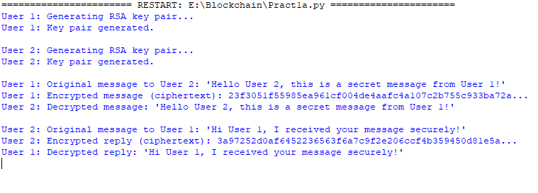

Practical 1b
Aim - Allow users to create multiple transactions and display them in an organised format.
Code :-
import Crypto.Random
import binascii
import datetime
import collections
from Crypto.PublicKey import RSA
from Crypto.Signature import PKCS1_v1_5
from Crypto.Hash import SHA

class Client:
def __init__(self):
self._private_key = RSA.generate(1024)
self._public_key = self._private_key.publickey()
self._signer = PKCS1_v1_5.new(self._private_key)
@property
def identity(self):
return binascii.hexlify(self._public_key.exportKey(format='DER')).decode('ascii')
class Transaction:
def __init__(self, sender, receiver, value):
self.sender = sender
self.receiver = receiver
self.value = value
self.time = datetime.datetime.now()
def to_dict(self):
if self.sender == "Genesis":
identity = "Genesis"
else:
identity = self.sender.identity
return collections.OrderedDict({
'sender': identity,
'receiver': self.receiver,
'value': self.value,
'time': self.time
})
def sign_transaction(self):
private_key = self.sender._private_key
signer = PKCS1_v1_5.new(private_key)
h = SHA.new(str(self.to_dict()).encode('utf8'))
return binascii.hexlify(signer.sign(h)).decode('ascii')

Raj = Client()
print("-" * 50)
print("Nik Public Key:")
print(Raj.identity)
Vai = Client()
print("-" * 50)
print("Sag Public Key:")
print(Vai.identity)
t = Transaction(Raj, Vai.identity, 10.0)
print("-" * 50)
print("Transaction Signature:")
signature = t.sign_transaction()
print(signature)
print("-" * 50)
Output
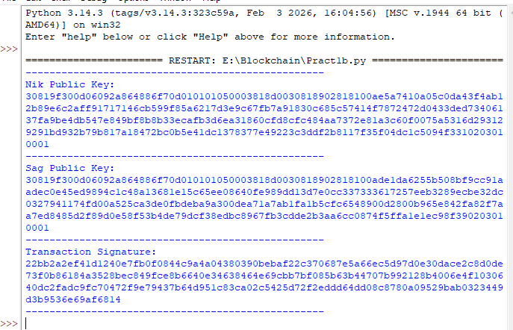

Practical 1c
Aim - Create a Python class named Transaction with attributes for sender, receiver, and amount. Implement a method within the class to transfer money from the sender's account to the receiver's account.
Code
pip install pycryptodome
import Crypto
import binascii
import datetime
import collections
import hashlib
from hashlib import sha256
from Crypto.PublicKey import RSA
from Crypto.Hash import SHA
from Crypto.Signature import PKCS1_v1_5
class Client:
def __init__(self):
random = Crypto.Random.new().read
self._private_key = RSA.generate(1024, random)
self._public_key = self._private_key.publickey()
self._signer = PKCS1_v1_5.new(self._private_key)
@property
def identity(self):
return binascii.hexlify(
self._public_key.exportKey(format="DER")
).decode("ascii")
class Transaction:
def __init__(self, sender, receiver, value):
self.sender = sender
self.receiver = receiver
self.value = value
self.time = datetime.datetime.now()
def to_dict(self):
if self.sender == "Genesis":
identity = "Genesis"
else:
identity = self.sender.identity

return collections.OrderedDict({
"sender": identity,
"receiver": self.receiver,
"value": self.value,
"time": self.time,
})
def sign_transaction(self):
private_key = self.sender._private_key
signer = PKCS1_v1_5.new(private_key)
h = SHA.new(str(self.to_dict()).encode("utf8"))
return binascii.hexlify(
signer.sign(h)
).decode("ascii")
def sha256_hash(message):
return hashlib.sha256(
message.encode("ascii")
).hexdigest()
def mine(message, difficulty=1):
assert difficulty >= 1
prefix = "1" * difficulty
for i in range(1000):
digest = sha256_hash(str(hash(message)) + str(i))
if digest.startswith(prefix):
print("After", i, "iterations found nonce:", digest)
return digest
class Block:
TPCoins = []
def __init__(self):
self.verified_transactions = []
self.previous_block_hash = ""
self.Nonce = ""
def display_transaction(transaction):
tx_dict = transaction.to_dict()
print("Sender:", tx_dict["sender"])
print("-----")
print("Receiver:", tx_dict["receiver"])
print("-----")
print("Value:", str(tx_dict["value"]))
print("-----")
print("Time:", str(tx_dict["time"]))
print("-----")
def dump_blockchain():
print("Number of blocks in chain:", str(len(Block.TPCoins)))

for x in range(len(Block.TPCoins)):
block_temp = Block.TPCoins[x]
print("Block #", str(x))
for transaction in block_temp.verified_transactions:
display_transaction(transaction)
print("-------")
Ninad = Client()
ks = Client()
vighnesh = Client()
sairaj = Client()
transactions = []
t1 = Transaction(Ninad, ks.identity, 15.0)
t1.sign_transaction()
transactions.append(t1)
t2 = Transaction(Ninad, vighnesh.identity, 6.0)
t2.sign_transaction()
transactions.append(t2)
t3 = Transaction(Ninad, sairaj.identity, 16.0)
t3.sign_transaction()
transactions.append(t3)
t4 = Transaction(vighnesh, Ninad.identity, 8.0)
t4.sign_transaction()
transactions.append(t4)
t5 = Transaction(vighnesh, ks.identity, 19.0)
t5.sign_transaction()
transactions.append(t5)
t6 = Transaction(vighnesh, sairaj.identity, 35.0)
t6.sign_transaction()
transactions.append(t6)
t7 = Transaction(sairaj, vighnesh.identity, 5.0)
t7.sign_transaction()
transactions.append(t7)
t8 = Transaction(sairaj, Ninad.identity, 12.0)
t8.sign_transaction()
transactions.append(t8)
t9 = Transaction(sairaj, ks.identity, 25.0)
t9.sign_transaction()
transactions.append(t9)
t10 = Transaction(Ninad, ks.identity, 1.0)
t10.sign_transaction()
transactions.append(t10)
for transaction in transactions:
display_transaction(transaction)
print("*" * 50)
Output
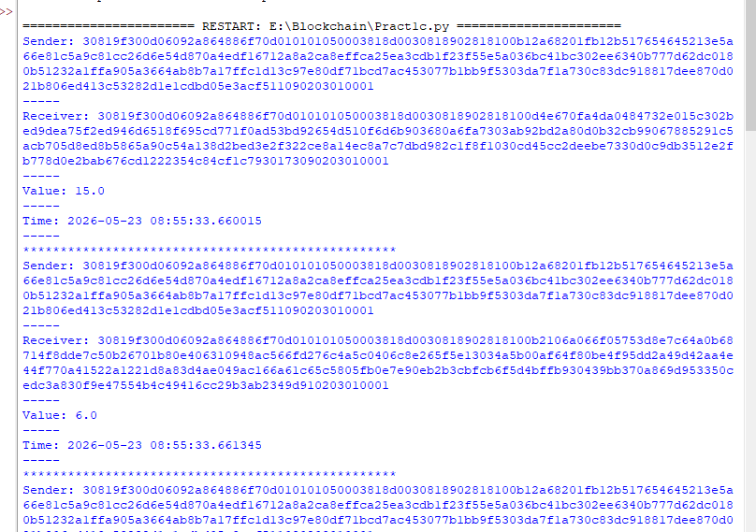

Practical 1d
Aim - Implement a function to add new blocks to the miner and dump the blockchain
Code
import datetime
import hashlib
class Block:
def __init__(self, data, previous_hash):
self.timestamp = datetime.datetime.now(datetime.timezone.utc)
self.data = data
self.previous_hash = previous_hash
self.hash = self.calc_hash()
def calc_hash(self):
sha = hashlib.sha256()
hash_str = self.data.encode("utf-8")
sha.update(hash_str)
return sha.hexdigest()

if __name__ == "__main__":
blockchain = [Block("First block", "0")]
blockchain.append(Block("Second block", blockchain[0].hash))
blockchain.append(Block("Third block", blockchain[1].hash))
for block in blockchain:
print(f"Timestamp: {block.timestamp}")
print(f"Data: {block.data}")
print(f"Previous Hash: {block.previous_hash}")
print(f"Hash: {block.hash}\n")
Output
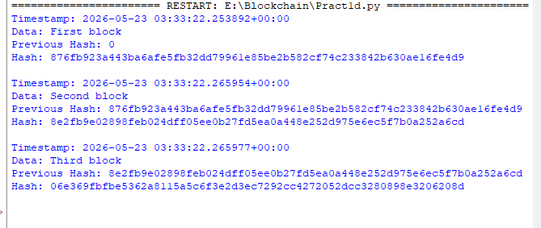

Practical 2a
Aim – Write a python program to demonstrate mining
install nodejs
open in command prompt go to path where you are going to save your code then run
save file in .js format
npm install web3
install Ganache keep it open in background while running the code
Code
const {Web3} = require('web3');
const web3=new Web3(new Web3.providers.HttpProvider('http://127.0.0.1:7545'));
async function mine(){
const accounts=await web3.eth.getAccounts();
const coinbaseacc1=accounts[0];
const coinbaseacc2=accounts[1];
console.log('Mining etheron Ganache with coinbase address:${coinbaseacc1}');
while(true){
try{
await web3.eth.sendTransaction({
from:coinbaseacc1,
to:coinbaseacc2,
value:50,
});
console.log('Hii Shruti mined a new block!');
}catch(err){
console.error(err);
}
}
}
mine();
Output
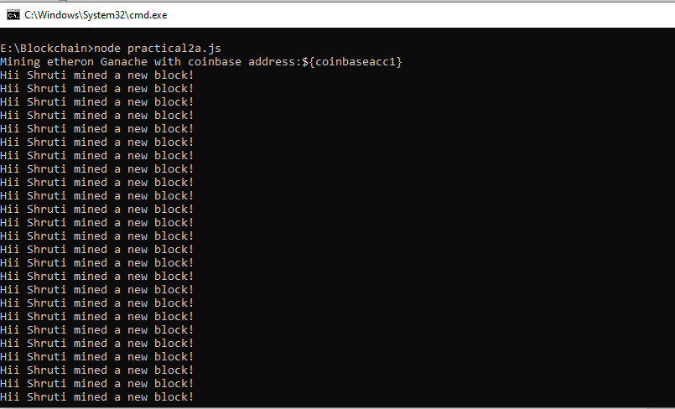

Practical 2b
Aim - Demonstrate the use of the Bitcoin Core API to interact with a Bitcoin Core node.
Code -
import requests
def get_current_block_info():
response = requests.get("https://blockchain.info/latestblock")
block_info = response.json()
print("Current block information:")
print("Block height:", block_info['height'])
print("Block hash:", block_info['hash'])
print("Block index:", block_info['block_index'])
print("Timestamp:", block_info['time'])
def get_address_balance(address):
response = requests.get(
f"https://blockchain.info/q/addressbalance/{address}"
)
balance = float(response.text) / 10**8
print("Balance of address", address, ":", balance, "BTC")
if __name__ == "__main__":
get_current_block_info()
address = "3Dh2ft6UsqjbTNzs5zrp7uK17Gqg1Pg5u5"
get_address_balance(address)

OUTPUT
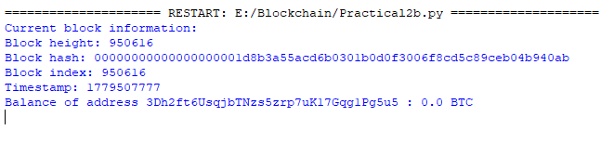

Practical 2c
Aim - Demonstrating the process of running a blockchain node on your local machine
Make Sure you have Installed node.js in their System.
Code
npm install crypto-js
const SHA256=require("crypto-js/sha256");
class Block{
constructor(index,timestamp,data,previousHash=""){ this.index=index;
this.timestamp=timestamp; this.data=data; this.previousHash=previousHash;
this.hash=this.calculateHash();
}
calculateHash(){ return SHA256(
this.index+ this.previousHash+ this.timestamp+ JSON.stringify(this.data)
).toString();
} }
class Blockchain{
constructor(){ this.chain=[this.createGenesisBlock()];
} createGenesisBlock(){
return new Block(0,"09/06/2024","GenesisBlock","0");
} getLatestBlock(){
return this.chain[this.chain.length-1]; }
addBlock(newBlock){ newBlock.previousHash=this.getLatestBlock().hash;
newBlock.hash=newBlock.calculateHash(); this.chain.push(newBlock);
} isChainValid(){
for(leti=1;i<this.chain.length;i++){ constcurrentBlock = this.chain[i];
constpreviousBlock = this.chain[i-1];
if(currentBlock.hash != currentBlock.calculateHash()){ returnfalse;
}
if(currentBlock.previousHash != previousBlock.hash){ return false;
}
}
return true;
} }
//BlockchainImplementation
let myCoin=new Blockchain();
myCoin.addBlock(new Block(1,"09/06/2024",{amount:4}));
myCoin.addBlock(new Block(2,"09/06/2024",{amount:8}));
// console.log('Isblockchainvalid?'+myCoin.isChainValid());
console.log(JSON.stringify(myCoin,null,4))

Output
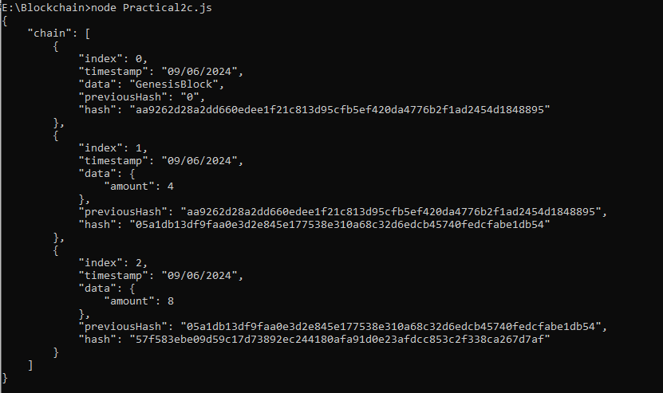

Practical 2d
Aim - Demonstrate mining using geth on your private network.
Step 1 Create an New folder and in that folder create an file names genesis.json Save it as .json file
Open Notepad type the code below
{
"config": {
"chainId": 2345,
"homesteadBlock": 0,
"eip150Block": 0,
"eip155Block": 0,
"eip158Block": 0
},
"alloc": {},
"coinbase": "0x0000000000000000000000000000000000000000",
"difficulty": "0x400",
"extraData": "",
"gasLimit": "0x2fefd8",
"nonce": "0x0000000000000042",
"mixhash": "0x0000000000000000000000000000000000000000000000000000000000000000",
"parentHash": "0x0000000000000000000000000000000000000000000000000000000000000000",
"timestamp": "0x00"
}

Step 2 – Open Command Prompt as administrator go to the folder where the practical is saved till the folder where the genesis code is saved
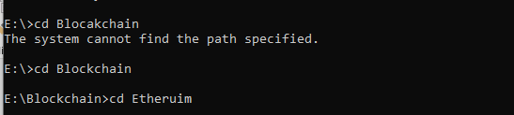
Step 3 – After this command “geth --datadir ./node1 init genesis.json” this will create and node1 file inside the folder
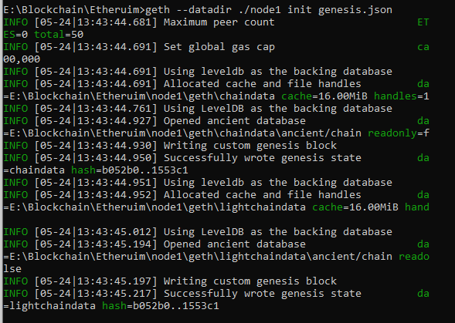
Step 4 – Then type “geth --datadir ./node1 account new” it will ask for the password type easy password to remember like 1234 then retype the password , and copy the Public address key

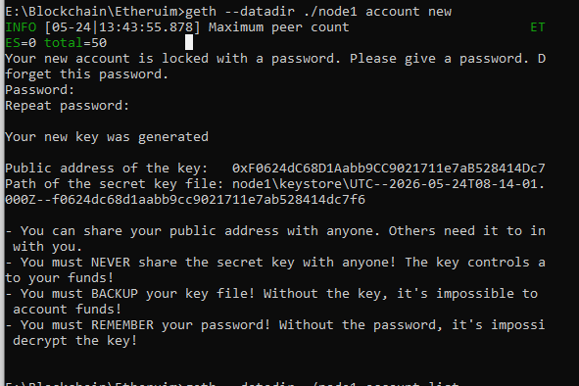
Step 5 – Then type “geth --datadir ./node1 account list” it will the show the list of accounts which will be one at a time
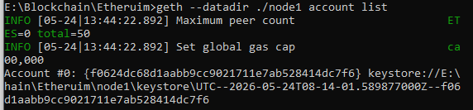
Step 6 - Then type “geth --datadir ./node1 console” this will start the geth it will Welcome to the Geth Javascript Console
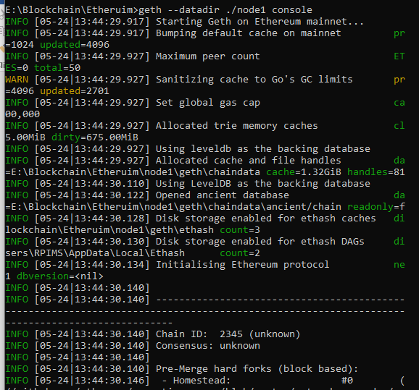
Step 7 – Then type “eth.accounts”
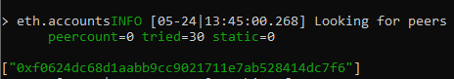
Step 8 – Then type “eth.getBalance("Add your public account number recived from eth.acount")” output will be zero because the accounts is empty here
Step 9 – Then type “miner.setEtherbase(eth.accounts[0])” it will say true then type command “miner.start()”
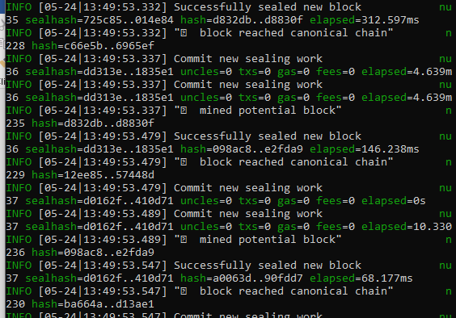
Step 10 – Then type “miner.stop()”
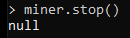

Practical 3a
Aim - Write a Solidity program that demonstrates various types of functions including regular functions, view functions, pure functions, and the fallback function.
Code
For Function
// SPDX-License-Identifier: MIT
pragma solidity >=0.4.22 <0.9.0;
contract Test {
function return_example()
public
pure
returns (
uint256,
uint256,
uint256,
string memory
)
{
uint256 num1 = 10;
uint256 num2 = 16;
uint256 sum = num1 + num2;
uint256 prod = num1 * num2;
uint256 diff = num2 - num1;
string memory message = "Multiple return values";
return (sum, prod, diff, message);
}
}
Output
Compile the file then deploy from deploy and transaction

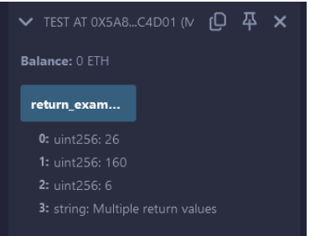
View Function
pragma solidity ^0.5.0;
contract ViewDemo {
uint256 num1 = 2;
uint256 num2 = 4;
function getResult()
public view returns (uint256 product, uint256 sum)
{ product = num1 * num2; sum = num1 + num2; } }
Output
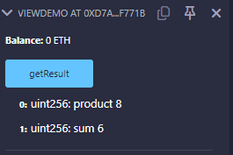
Pure Function
pragma solidity ^0.5.0;
contract PureDemo {
function getResult()
public pure returns (uint256 product, uint256 sum)
{ uint256 num1 = 2; uint256 num2 = 4; product = num1 * num2; sum = num1 + num2; }}
Output
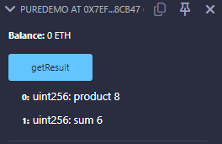

Practical 3B.
Aim- Write a Solidity program that demonstrates function overloading, mathematical functions, and cryptographic functions.
Code -
Function Overloading
pragma solidity ^0.8.0;
contract OverloadingExample {
function add(uint256 a, uint256 b)
public pure returns (uint256)
{ return a + b; }
function add(string memory a, string memory b)
public pure returns (string memory)
{ return string(abi.encodePacked(a, b)); } }
Output
Add the values in it for the results
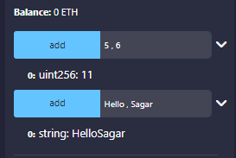

Mathematical Function
Code
Pragma solidity ^0.5.0;
contract Test {
function CallAddMod()
public pure returns(uint)
{ return addmod(7, 3, 3); }
function CallMulMod()
public pure returns(uint)
{ return mulmod(7, 3, 3); } }
Output
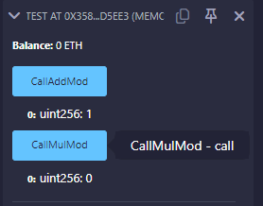
Cryptographic Functions.
Code
pragma solidity ^0.5.0;
contract Test {
function callKeccak256()
public pure returns (bytes32 result)
{ return keccak256(abi.encodePacked("BLOCKCHAIN"));
} function callsha256()
public pure returns (bytes32 result)
{ return sha256(abi.encodePacked("BLOCKCHAIN"));
} function callripemd() public pure returns (bytes20 result)
{ return ripemd160(abi.encodePacked("BLOCKCHAIN")); } }
Output
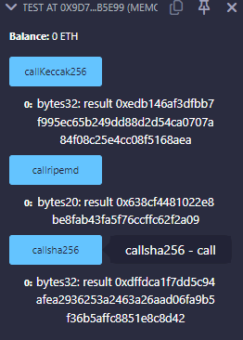

Practical 3c
Aim - Write a Solidity program that demonstrates various features including contracts, inheritance, constructors, abstract contracts, interfaces.
Code
Contract
pragma solidity ^0.5.0;
contract ContractDemo {
string message = "Hello Nikhilesh";
function dispMsg()
public view returns (string memory)
{ return message; } }
output
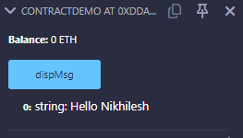

Inheritance
pragma solidity >=0.4.22 <0.6.0;
contract Parent {
uint256 internal sum;
function setValue() external {
uint256 a = 10;
uint256 b = 20;
sum = a + b;
}}
contract Child is Parent {
function getValue() external view returns (uint256) {
return sum;
}}
contract Caller {
Child cc = new Child();
function testInheritance() public returns (uint256) {
cc.setValue();
return cc.getValue();
}
function showValue() public view returns (uint256) {
return cc.getValue();
}}
Output
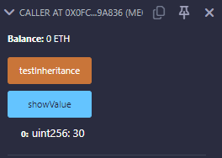

Abstract Contract
pragma solidity ^0.5.17;
// Abstract Contract
contract Calculator {
function getResult() external view returns(uint256);
}
// Child Contract
contract Test is Calculator {
constructor() public {}
function getResult() external view returns(uint256) {
uint256 a = 1;
uint256 b = 2;
uint256 result = a + b;
return result;
}
}
After compiling the file in deploy and run transaction in the contract drop down select the test one option to get the output or else one alert will come
Output
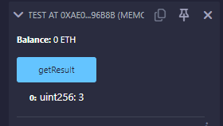

Constructor
Code
pragma solidity ^0.5.0;
// Creating a contract
contract constructorExample {
string str;
constructor() public {
str = "Shankar Narayan College";
}
function getValue() public view returns (string memory) {
return str;
}}
Output
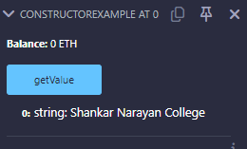
Interfaces:
Code :
pragma solidity ^0.5.0;
interface Calculator {
function getResult() external view returns (uint);
}
contract Test is Calculator {
constructor() public {}
function getResult() external view returns (uint) {
uint a = 1;
uint b = 2;
uint result = a + b;
return result;
}
}
Output
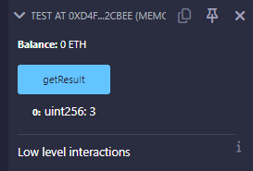

Practical 3d
Aim - Write a Solidity program that demonstrates use of libraries, assembly, events, and error handling.
Code-
1. Libraries
pragma solidity >=0.7.0 <0.9.0;
library myMathLib {
function sum(uint256 a, uint256 b) public pure returns (uint256) {
return a + b;
}
function exponent(uint256 a, uint256 b) public pure returns (uint256) {
return a ** b;
}
}
Output
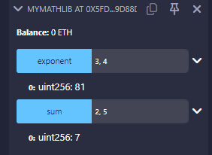

2. Assembly
Code
pragma solidity >=0.4.16 <0.9.0;
contract InlineAssembly {
// Defining function
function add(uint256 a) public view returns (uint256 b) {
assembly {
let c := add(a, 16)
mstore(0x80, c)
{
let d := add(sload(c), 12)
b := d
}
b := add(b, c)
}}}
Output
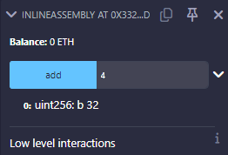
3. Events
// SPDX-License-Identifier: MIT
pragma solidity ^0.5.0;
// Creating a contract
contract eventExample {
// Declaring state variables
uint256 public value = 0;
// Declaring an event
event Increment(address owner);
function getValue(uint256 _a, uint256 _b) public {
emit Increment(msg.sender); // Emitting the Increment event with the caller's address
value = _a + _b; // Updating the value state variable
}}
Output:
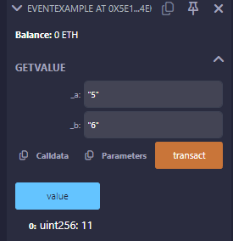

4 . Error handling
Code
pragma solidity ^0.5.17;
contract ErrorDemo {
function getSum(uint256 a, uint256 b) public pure returns (uint256) {
uint256 sum = a + b;
// require(sum < 255, "Invalid");
assert(sum < 255);
return sum;
}
}
Output
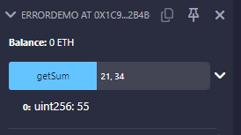

Practical 3e
Aim - Build a decentralized application (DApp) using Javascript for the front end and Truffle along with Ganache CLI for the back end.

STEP 1 — Install Node.js
Open:Node.js Download
Download:
- LTS Version
Install normally.
STEP 2 — Verify Node.js Installation
Open:Command Prompt / PowerShell
Run: node -v
Example output: v18.20.8
Now check npm: npm -v

STEP 3 — Install Truffle
Run: npm install -g truffle
Verify: truffle version

STEP 4 — Install Ganache
Download Ganache GUI: Ganache Download
Install it.
STEP 5 — Open Ganache
- Open Ganache
- Click:
Quickstart Ethereum , Ganache blockchain starts.
You will see:
- accounts
- ETH balances
- blocks
- transactions
Keep Ganache OPEN.
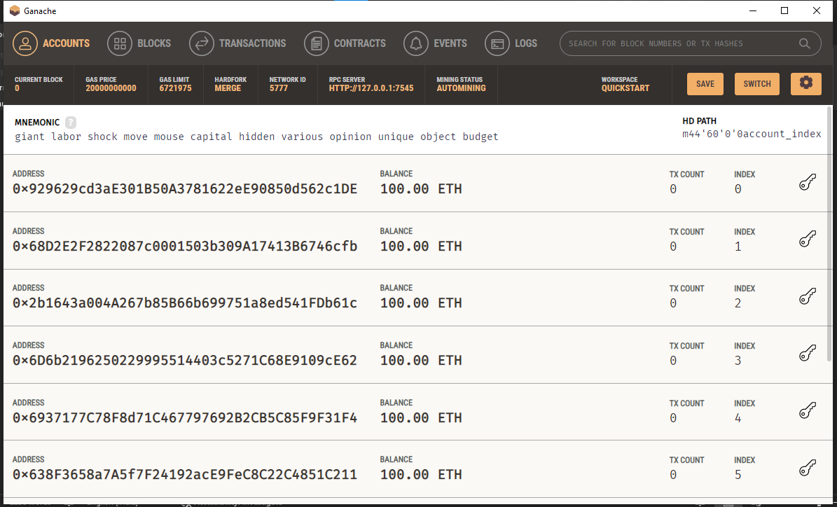
STEP 6 — Create Project Folder
Open terminal.
Run: mkdir Pract_3e
Go inside folder: cd Pract_3e
STEP 7 — Initialize Truffle Project
Run: truffle init
Folders created:
contracts
migrations
test
truffle-config.js
STEP 8 — Create Solidity Contract
Go inside: contracts (With Vscode )
Create file: SimpleStorage.sol
Paste:
// SPDX-License-Identifier: MIT
pragma solidity ^0.8.17;
contract SimpleStorage {
uint256 public data;
function setData(uint256 _data) public {
data = _data;
}
function getData() public view returns(uint256) {
return data;
}
}
Save file.

STEP 9 — Create Migration File
Go inside: migrations
Create file: 2_deploy_contract.js
Paste:
const SimpleStorage = artifacts.require("SimpleStorage");
module.exports = function(deployer) {
deployer.deploy(SimpleStorage);
};
Save file.
STEP 10 — Configure Truffle
Open: truffle-config.js
Replace content with:
module.exports = {
networks: {
development: {
host: "127.0.0.1",
port: 7545,
network_id: "*"
}
},
compilers: {
solc: {
version: "0.8.17"
} }
};
Save file.
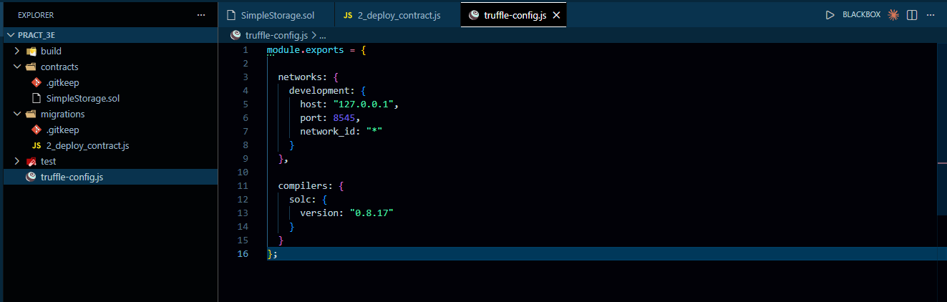
STEP 11 — Compile Smart Contract
Open terminal inside project folder.
Run: truffle compile
Expected output: Compiled successfully
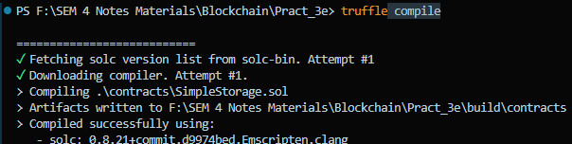
STEP 12 — Deploy Smart Contract
Run: truffle migrate –reset
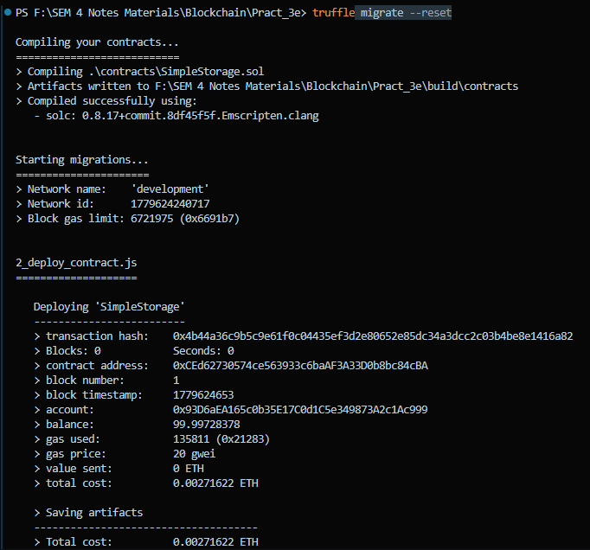
STEP 13 — Open Truffle Console
Run:truffle console
You will see:
truffle(development)>
type this let instance = await SimpleStorage.deployed()
then await instance.setData(100)
then let value = await instance.getData()
then value.toString()
output
