DATA ANALYTICS
Analytical Methods & Insights | Task 1

YuvaIntern — Data Analyst Internship
Prepared by: Aditya Kumar
Project focus: Python basics, statistical foundations, data quality, and visualization

DATA NOTE
All example records and numeric results in this report are generated from a small synthetic dataset for learning purposes. They do not describe real students or a real-world population.

Executive Summary
This assessment demonstrates foundational skills used in entry-level data science and data analysis. It introduces Python variables and data structures, tabular data handling with Pandas, basic numerical workflows, descriptive statistics, data validation, and a simple visualization. A small synthetic dataset is used so that the code can be run locally and the outputs can be reproduced without downloading external data.
The demonstration script generated 10 illustrative records. Its checks found zero missing values and zero duplicate rows in this specific dataset. The synthetic scores had a mean of 69.3 and a median of 68.5. The Pearson correlation between study hours and scores was approximately 0.991 in these constructed examples. Because the dataset is synthetic and very small, these values are examples of calculations—not evidence of a real educational relationship. Correlation does not prove causation.

1. Introduction
Data science combines programming, statistics, domain knowledge, and communication to extract useful information from data. A typical workflow includes defining a question, obtaining data, checking data quality, transforming data, exploring patterns, visualizing results, interpreting limitations, and communicating findings. Strong foundations help prevent errors and unsupported conclusions later in a project.

2. Objectives
- Explain essential Python concepts and common data types used in analytical tasks.
- Demonstrate structured data handling with a Pandas DataFrame and CSV files.
- Calculate and interpret basic descriptive statistics.
- Check for missing values, duplicate rows, and values outside expected ranges.
- Create a chart and explain the limits of the interpretation.
- Provide reproducible code, setup instructions, outputs, and references.

3. Python Fundamentals

3.1 Variables and common data types
A variable is a name that refers to an object. Python's built-in types commonly used in data work include str (text), int (whole numbers), float (decimal numbers), bool (True/False), list (ordered collection), tuple (ordered immutable collection), dict (key-value mapping), and None (absence of a value).
student_id = "S001" # str
study_hours = 2.0 # float
score = 58 # int
is_valid = True # bool
features = ["hours", "score"] # list
record = {"score": 58, "attendance_pct": 80} # dict
Choosing the right type improves clarity and helps catch mistakes. For example, an identifier is usually text even if it contains digits, because arithmetic on an ID generally has no meaning.

3.2 Control flow, functions, and assertions
Conditionals and loops control execution; functions package reusable operations; and assertions check assumptions during development. In the provided script, assertions verify that student IDs are unique and that scores and attendance percentages fall between 0 and 100. Assertions are useful for internal checks, but production systems may need explicit validation and error handling.
def is_valid_score(value):
return 0 <= value <= 100
assert is_valid_score(85)

4. Data Handling with Pandas and NumPy
Pandas provides Series and DataFrame structures for labelled, tabular data. A DataFrame can be created from a list of dictionaries, inspected, filtered, summarized, and exported to formats such as CSV. NumPy supplies efficient numerical arrays and mathematical operations that underpin many Python data workflows. This project uses Pandas for the table and statistics, and NumPy is included as a standard numerical library dependency.
df = pd.DataFrame(records)
df.head()
df.isna().sum()
df.to_csv("data.csv", index=False)

5. Statistical Foundations

5.1 Population, sample, and descriptive statistics
A population is the complete group of interest; a sample is the subset observed. Descriptive statistics summarize the data that were observed. They do not, by themselves, establish that the sample represents a larger population.
- Mean: arithmetic average, calculated as the sum of values divided by the number of values.
- Median: the middle value after sorting; for an even number of observations, it is the average of the two middle values.
- Mode: the most frequent value or values. A dataset can have more than one mode, or no uniquely most frequent value.
- Range: maximum minus minimum.
- Sample standard deviation: describes spread around the sample mean; the common sample formula uses n − 1 in the denominator.
- Correlation: summarizes the strength and direction of a linear relationship between two numeric variables; it does not establish causation.
For sample observations x₁, …, xₙ, the sample standard deviation is:
s = √[ Σ(xᵢ − x̄)² / (n − 1) ]
The script uses Pandas' sample standard deviation default (ddof=1). For a population standard deviation, the population formula uses N in the denominator; the choice depends on the question and data context.

5.2 Results from the synthetic demonstration
Measure | Observed output
Number of synthetic records | 10
Missing values | 0
Duplicate rows | 0
Mean score | 69.3
Median score | 68.5
Sample standard deviation | 13.7
Pearson correlation: study hours vs score | 0.991
Interpretation: these calculations show how to compute and report summary measures. The records were deliberately constructed for demonstration; therefore the strong correlation is not a real-world finding and should not be used to recommend a study strategy or make decisions about individuals.

6. Data Quality and Validation
Data quality checks are an important early step. Missing values can arise from non-response, collection problems, or data integration. Duplicate rows can inflate counts. Invalid ranges may indicate data-entry or transformation errors. The right response depends on the meaning of the field and the reason the issue occurred.
- Missingness check: df.isna().sum() counts null values in each column.
- Duplicate check: df.duplicated().sum() counts fully duplicated rows.
- Uniqueness check: df['student_id'].is_unique verifies that each example identifier is unique.
- Range checks: score and attendance are validated to be between 0 and 100 inclusive.
This dataset has no missing values, so the script does not impute or drop any values. In a real project, missing data should be investigated before choosing a strategy; mean imputation or row deletion should not be automatic.

7. Visualization and Interpretation
The script generates a scatter plot of study hours against score. Scatter plots are useful for exploring potential relationships between two numerical variables, spotting clusters, and identifying unusual points. Axis labels, a clear title, and a light grid make the figure easier to read. Visual patterns should be interpreted alongside data quality, sample size, context, and potential confounding variables.
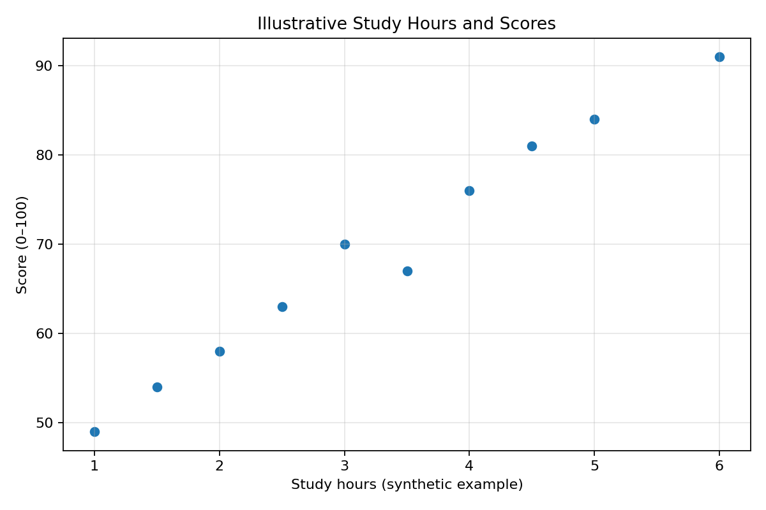
Figure 1. Scatter plot generated from the synthetic demonstration records.

8. Reproducibility and How to Run
Recommended environment: Python 3.10 or newer. From the project root:
python -m venv .venv
# Windows PowerShell: .venv\\Scripts\\Activate.ps1
# macOS/Linux: source .venv/bin/activate
python -m pip install -r requirements.txt
python src/fundamentals_demo.py
On successful execution, the script creates the CSV dataset, descriptive-statistics CSV, JSON run summary, and PNG chart. The generated files can be reviewed to verify the outputs. The project also contains a small test file with checks for record count, valid ranges, unique IDs, mean, and median.

9. Responsible Data Practice and Limitations
- Use data only when you have a legitimate purpose and permission; avoid exposing personal or confidential information.
- Document where data came from, how it was cleaned, and which assumptions were made.
- Avoid claims that exceed the evidence. Synthetic data can demonstrate a method but cannot validate a real-world hypothesis.
- Correlation is not causation. A relationship may be affected by confounders, selection effects, or chance.
- Keep code, dependencies, and instructions together so another person can reproduce the analysis.

10. Conclusion
This assessment covers a practical baseline for data analysis: understanding Python data types, creating a structured table, validating records, computing descriptive statistics, and communicating a numeric relationship with a chart. The included script and documentation are designed to be reproducible. The next learning step is to apply the same workflow to a suitable real dataset, document its provenance, and use domain context to guide the analysis.

References
- Python Software Foundation. Python 3 Documentation. https://docs.python.org/3/
- pandas development team. pandas documentation. https://pandas.pydata.org/docs/
- NumPy Developers. NumPy documentation. https://numpy.org/doc/
- Matplotlib Development Team. Matplotlib documentation. https://matplotlib.org/stable/
- OpenIntro. OpenIntro Statistics (free textbook and supporting resources). https://www.openintro.org/book/os/

Appendix A — Included Project Files
- src/fundamentals_demo.py — reproducible analysis script
- data/illustrative_student_scores.csv — synthetic data generated by the script
- outputs/descriptive_statistics.csv — descriptive summary generated by the script
- outputs/run_summary.json — machine-readable run summary
- outputs/study_hours_vs_score.png — generated visualization
- tests/test_fundamentals_demo.py — basic smoke tests
- README.md and requirements.txt — setup and execution instructions
- submission_description.txt — description for the internship submission form

