Stack operations and bracket checking

Project submitted for the partial fulfillment of the requirements for the course
CSE 201: CODING SKILL - I
Offered by the
Department Computer Science and Engineering
School of Engineering and Sciences

Submitted by
Aditya Kumar, AP24110010618



SRM University–AP
Neerukonda, Mangalagiri, Guntur
Andhra Pradesh – 522 240
[December, 2025]

Acknowledgments

I would like to express my sincere gratitude to my primary course instructors, Mr. Prakash and Mr. Naveen, and my other instructors, in helping me acquire the necessary skills and knowledge that I have used to build and develop my project.

I also thank my peers and friends for their support and encouragement during this intricate but engrossing and enriching process of developing this system.

Contents
Acknowledgments 2
Abstract 4
Introduction 5
Problem Statement 6
Objectives 8
General Objectives 8
Program-Specific Objectives 8
Project Layout / System Architecture 9
Program 1: Stack Operations 9
Program 2: Parenthesis Checker 9
Modules implemented 10
PROGRAM 1 – STACK OPERATIONS 10
PROGRAM 2 – BRACKET CHECKER 10
FEATURES IMPLEMENTED 12
Program 1 12
Program 2 12
Screenshots 13
Conclusion 14
Future enhancements 15
References 16

Abstract

The Stack Operations and Bracket Validation System consists of two C++ programs demonstrating fundamental stack data structure operations and balanced bracket validation.

The first program provides a comprehensive menu-driven stack implementation featuring push, pop, peek, display, and status monitoring operations with robust overflow/underflow protection.

The second program implements an intelligent bracket validation algorithm that processes mathematical expressions containing parentheses `()`, square brackets `[]`, and curly braces `{}`, ensuring proper nesting, matching pairs, and syntactic correctness through LIFO (Last In, First Out) principles. Both programs incorporate extensive input validation, detailed error reporting, and intuitive user interfaces.

Introduction

A stack is a fundamental data structure used extensively in programming, algorithms, compiler design, and operating systems. It follows a strict LIFO (Last In, First Out) structure, where the last inserted element is the first to be removed.
In modern computing, stacks are used for:
- Managing function calls and recursion
- Expression evaluation
- Syntax validation
- Memory management
- Undo/redo operations
- Parsing and compilation
Working with a stack involves:
- Translating LIFO principles into working code with proper boundary conditions
- Managing stack overflow and underflow scenarios to avoid data corruption.
This project aims to develop two programs that: -
- Implement complete stack operations (push, pop, peek, display, size, empty/full checks)
- Demonstrate parenthesis validation using stack for mathematical expressions - Provide robust input validation and error handling - Feature menu-driven interfaces for easy operation
The program code is written in C++. All the same, we are concerned with the features and principles of the stack data structure, and the primary logic behind it. Ultimately, we should understand how and where they are used, and be able to implement them in problem solving.

Problem Statement
Title: Stack Operations and Bracket Validation System
Design and implement a menu-driven C++ program to perform the following stack operations using arrays:
- Push
- Pop
- Peek
- Display
- isEmpty
- isFull
- Size
The program must handle overflow and underflow conditions and use no external libraries or STL.
Input (in order):
Program 1: Stack Operations
1. Maximum stack size (integer)
2. Menu choice (A-G or Q)
3. Values if push operation is selected (integers)
Program 2: Bracket Validation
Mathematical expression (string with brackets: (), [], {})
Output (in order):
Program 1: Stack Operations
Respective operations performed till the end of the program
Program 2: Bracket Validation
1. "Correct syntax!" if brackets are properly balanced
2. Specific error messages for various invalid cases
Constraints:
- Size of the stack must not be less than 0

Objectives

General Objectives
- To analyze how stacks operate at a low level.
- To understand manual array management and memory limitations.
- To apply data structures to solve practical validation problems.

Program-Specific Objectives
Program 1
- To implement all fundamental stack operations.
- To check overflow and underflow conditions manually.
- To display contents from top to bottom.
- To calculate the current size of the stack.
Program 2
- To understand bracket matching logic.
- To extract only bracket characters from expressions.
- To detect invalid bracket sequences.
- To validate nested and non-nested bracket combinations.

Project Layout / System Architecture

Program 1: Stack Operations

Architecture Explanation
- The user defines the maximum size of the stack.
- Based on the user's choice, an operation is performed.
- Overflow is checked before every push.
- Underflow is checked before every pop or peek.
- The program loops until the user quits.

Program 2: Parenthesis Checker
Architecture Explanation
- The expression may contain digits, symbols, spaces, variables, etc.
- Only the bracket characters are extracted in order.
- Initial checks reduce unnecessary computation.
- Stack ensures matching of different types of brackets.

Modules implemented

PROGRAM 1 – STACK OPERATIONS
Module 1: Input Handling
- Reads maximum size of the stack.
- Initializes the static array.
Module 2: Push Operation
- Inserts a new element.
- Checks for overflow (top == max - 1).
- Updates the top pointer.
Module 3: Pop Operation
- Removes the top element.
- Checks underflow (top == -1).
- Decrements the top.
Module 4: Peek Operation
- Displays the topmost element.
- Ensures stack is not empty.
Module 5: Display Operation
- Prints elements from top to bottom.
- Validates non-empty state.
Module 6: isEmpty and isFull
- Checks boundary conditions and displays status.
Module 7: Size Calculation
- Computes top + 1 to get the number of elements.

PROGRAM 2 – BRACKET CHECKER
Module 1: Expression Input
Accepts complete string including spaces.
Module 2: Bracket Extraction
- Creates a bracket-only array.
- Counts bracket symbols.
Module 3: Pre-Validation Checks
- If count is 0 → invalid.
- If count is odd → invalid.
- If first bracket is closing → invalid.
- If last bracket is opening → invalid.
Module 4: Stack-Based Matching Logic
- Push opening brackets: (, {, [
- On closing bracket:
  - Check if stack top matches the type
  - If yes → pop
  - If no → invalid
Module 5: Final Validation
- If stack is empty → balanced
- Else → unbalanced

FEATURES IMPLEMENTED

Program 1
- Manual array-based stack
- Menu-driven interface
- Overflow/underflow protection
- Size counting
- Full set of stack operations

Program 2
- Manually constructed bracket array
- No STL used
- Stack-based validation
- Detects:
  - Wrong starting symbol
  - Wrong ending symbol
  - Type mismatches
  - Improper nesting

Screenshots
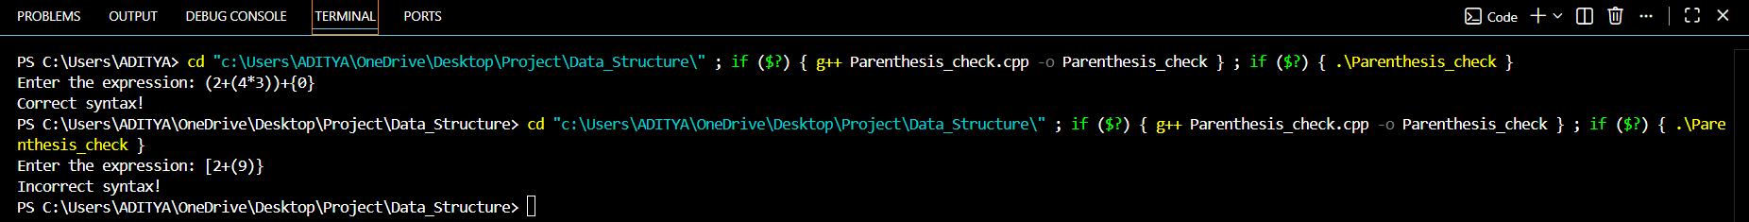

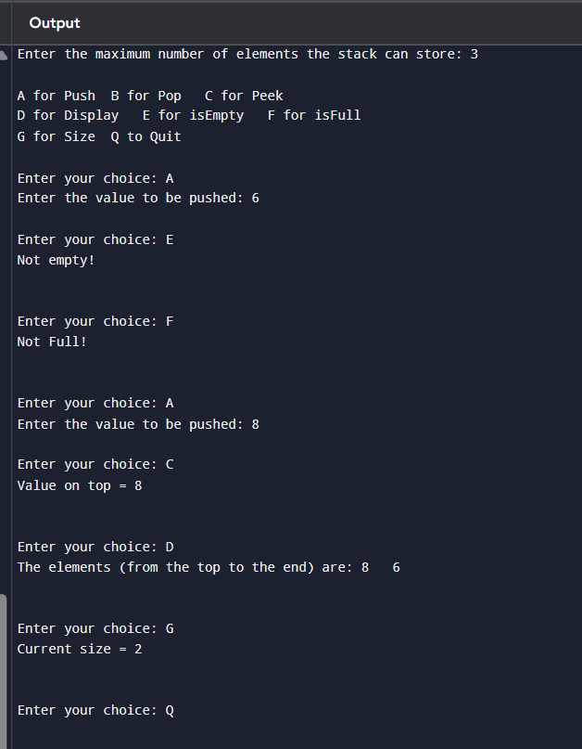

Conclusion
This project successfully demonstrates the implementation of stack operations using arrays and applies stack logic to validate bracket sequences.
The first program built a fully functional stack manually, without STL, reinforcing fundamental data structure concepts.
The second program applied these concepts to a real syntactical checking problem, similar to how compilers validate code.
The project enhances understanding of:
- Memory indexing
- Stack boundaries
- Bracket matching algorithms
- LIFO-based logic

Future enhancements
Program 1
- Implement using linked list for dynamic memory.
- Add reverse-stack and sort-stack operations.
- Create GUI visualization of push/pop.
Program 2
- Extend to include:
  - Quotes " "
  - Angle brackets < >
  - Mathematical operator validation
- Highlight the exact index of error.
- Build a syntax highlighter tool.

References

1. Cormen, Thomas H., et al. Introduction to Algorithms. MIT Press, 2001.

