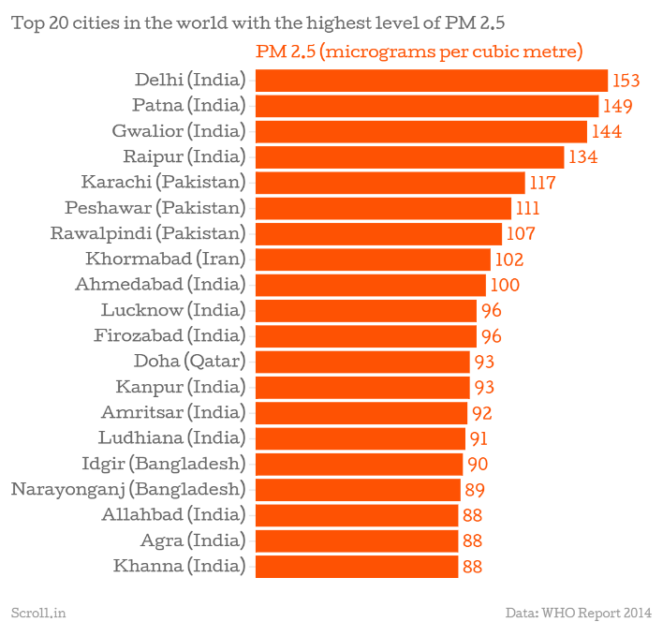 **Problem Statement**

Air pollution is major concern in our country, especially in cities like Delhi, Kanpur, Faridabad, Lucknow and Gurugram. Delhi’s air pollution is triggering health crisis. Coal-burning and industrialization are the major contributing factors to air-pollution. Besides, emissions from motorized vehicles also play a significant role in increasing air-pollution.

The Government (along with judiciary) has made several efforts to check air-pollution like-

* Enforcement of **Renewable Purchase Obligations** and **Renewable Generation Obligations** to increase the share of renewable energy in total generation capacity.
* Enforcement of **Odd-Even rule** to reduce the emissions from the automobiles and also to promote car-pooling.
* Ban on fire-cracker sale and burning in certain states.
* Vacuum cleaning of roads.
* Promotion of **Swachh Bharat Abhiyaan**.
* Launch of **Hawa Badlo App** in Delhi.
* Revision of emission standards for thermal plant, cement plant, etc.

Efforts to clean the polluted air have also been made in the corporate world. While some of these efforts were noteworthy, others were insignificant enough that the air-pollution is still increasing day-by-day. According to recent study by World Health Organization, eleven cities of India are on the list of most polluted twelve cities in the world. So, strict action to prevent the increasing air-pollution is the need of the hour. ADVEC is a step in this direction. It keeps a check on the amount of emissions from the motor vehicles. The exhaust pipe of the car emits nitrogen oxides, carbon-monoxide, particulate matter and sulphur-dioxide due to improper combustion of fuel

along with carbon-dioxide. So, there must be a norm to check the vehicle emission levels to determine how safe they are and whether they contribute to air-pollution. At present, under the **Central Motor Vehicle Rule, 1989**, a **PUC (Pollution-Under Control) certificate** is given to the vehicle after taking a specified PUC test. But this law is not implemented effectively since once the vehicle passes the PUC test, it can run freely on roads without any later check. ADVEC is a device that will help in checking the emissions from vehicles on a more frequent basis and also reduce the scope of human error as it is a digitalized system. It will also take immediate strict action on the detection of higher emission rates from the motor-vehicle.

**Impacts of Vehicular Emissions**

We have always seen that the relationship between the environment and humans has been a delicate one and nature must always be handled with great care. But nowadays people are too busy to care for the nature. Though many campaigns like Swachh Bharat Abhiyan have been set up to control and avoid land pollution but what to do about the pollution that is caused to the atmosphere?

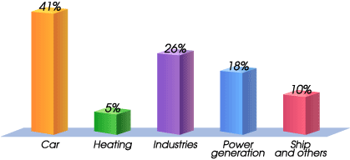  
  
Emissions from automobiles contribute maximum to air pollution. Air pollution effects are bound to be catastrophic. In India, life expectancy is expected to fall at least 10 years by 2022



|  |  |
| --- | --- |
| **Year** | **Total number of Registered Vehicles (in millions)** |
| 2007 | 72.7 |
| 2008 | 82.5 |
| 2009 | 89.6 |
| 2010 | 96.7 |
| 2011 | 105.3 |
| 2012 | 115.0 |
| 2013 | 127.7 |
| 2014 | 141.8 |

**Purpose of ADVEC**

Earlier we have seen how the gases emitted from the vehicles and the factories affect the environment and how adverse the conditions can be if the matter is not taken seriously.

It is not the case that government is showing no concern about the pollution. New devices are being launched in the market and can be used to control the pollution. But the point is how effectively it is being implemented. A device can be successful if its cost is moderate and easy to use so that general public can find it convenient as the government cannot run behind every citizen all the time asking to use pollution control devices.

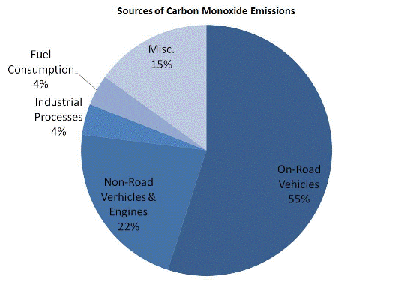 Our project provides a simple and most convenient device to the general public which can also be easily implemented. We are providing the people with a device which can be installed at the exhaust. It consist of sensors which will keep a record of the concentration of the gases emitted and when the level rises above a certain limit, it will send message to the user that the vehicle needs a maintenance. No skills are required by the user to use this device. The user needs to install it once and then it continues to work effectively. The uniqueness of ADVEC lies in the fact that it establishes a connection between the user, the concerned authorities and the device itself.

**Building Blocks of ADVEC**

ADVEC is a multidisciplinarian project that covers mechanical, electrical and networking concepts.

* Arduino Uno
* MOSFET
* MQ-7 Gas Sensor
* Diode

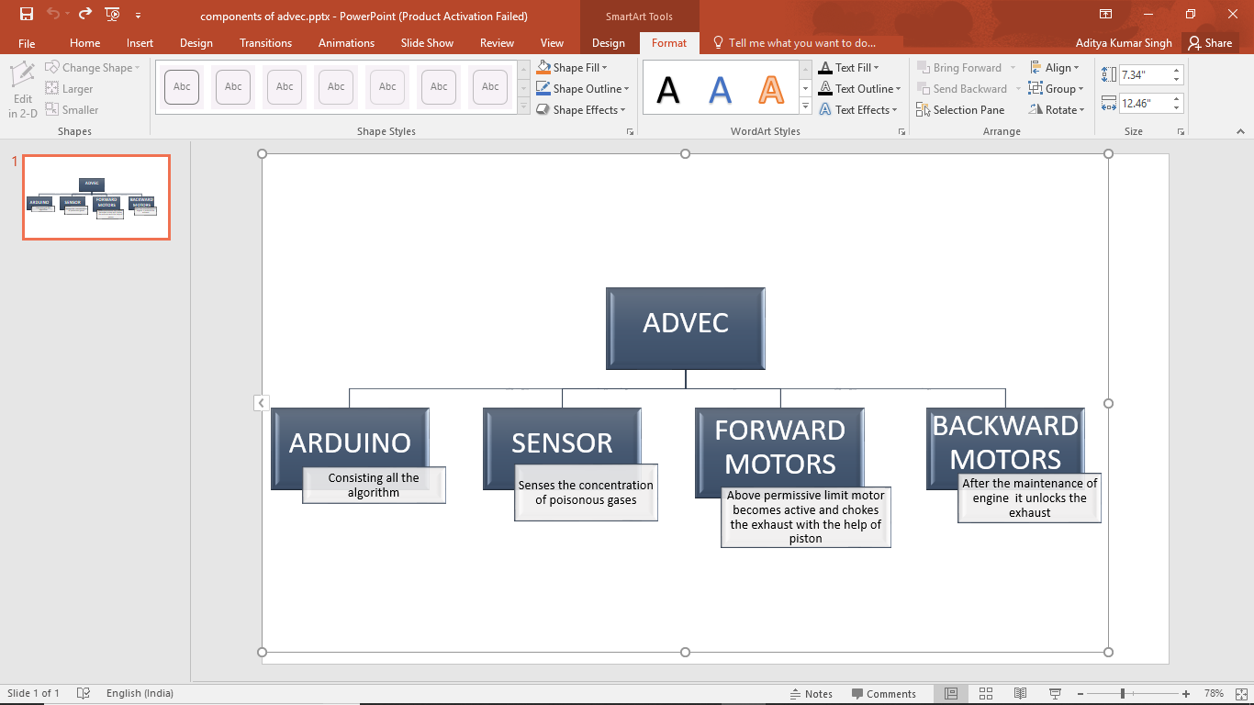  
  
  
  
  
  
  
  
  
  
  
  
  
  
  
  
  
  
The given key functions are accomplished by these components in collaboration:

**1. Arduino Uno**

Arduino is an open source physical computing platform based on simple input and output board and a development environment which implements complex algorithms.

Arduino can be used to develop stand-alone interactive objects or can be connected to a network to work in collaboration with other similar devices. Unlike other circuit boards, Arduino does not need a separate piece of hardware but could be simply connected through a USB cable for its reprogramming. Moreover, Arduino IDE uses a less complicated version of programming languages making it easier to learn to program.

* **Why Arduino?**
* It is an open source commodity both in terms of hardware and software 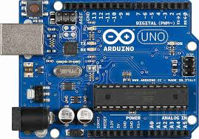
* It is cheap(~ ₹400)
* It can communicate with the computer via serial connection over USB, with local area networks using **ESP8266** and with the World Wide Web using **GSM SIM 900A**.
* It can easily interact with digital signals but is also capable of using Analog signal via **Pulse Width Modulation**.
* **Role of Arduino in ADVEC**

Arduino consist of an analog input pin which interprets the readings using its inbuilt microprocessor. The gas sensor MQ7 receives input via a heating element and transfers the same signal to analog input port of Arduino. Arduino maps the same to the output value readings for movement of corresponding mechanical components. The signals received are converted into analog output using pulse width modulation and are sent to MOSFET (transistor). MOSFET consist of three terminals Source, Drain and Gate. The incoming voltage at gate terminal of MOSFET allows flow of current between source and drain terminals. Motors are connected in series between these two terminals. By this motors will rotate for calculated amount of time which is sufficient enough to create displacement of shaft into the exhaust pipe and would bring vehicle to halt. So, in this way Arduino controls

* Number of rotations of motor
* Displacement of shaft
* Transmission of signals among various components.

Now, after the maintenance of the vehicle when the emissions from exhaust are under control, the Arduino will receive signals from the server to rotate the motors in opposite direction so that the shaft retraces its path and the vehicle will resume its normal functioning.

**2. MOSFET 🡪 MODEL NO. IRFZ34N**

The Metal-Oxide Semi-Conductor Field Effect Transistor is a type of transistor fabricated by the controlled oxidation of silicon used for amplifying or switching electronic signals. It consists of three terminals-drain, source and gate.

* 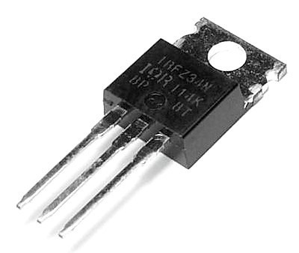**Working Principle of MOSFET**

The aim of the MOSFET is to control the voltage and the current flow between the Source and the Drain. It works almost as a switch. The semi-conductor surface is located between source and drain terminal. A MOSFET is based on the modulation of charge concentration by a MOS capacitance between a body electrode and a Gate electrode located above the body and insulated from all other device regions by a Gate dielectric layer. It can be inverted from p-type to n-type by applying positive or negative voltages respectively. The approaching voltage at gate terminal of MOSFET permits stream of current among Source and Drain terminals. Motors are associated in arrangement between these two terminals. By this, motors will rotate for a certain amount of time which is adequate to make lodging of shaft into the exhaust pipe and would force the vehicle to come to a halt.

**3. Diode 🡪 1N5399**

The diodes are also known for their unidirectional current property, i.e. the electric current is permitted to flow in one direction.

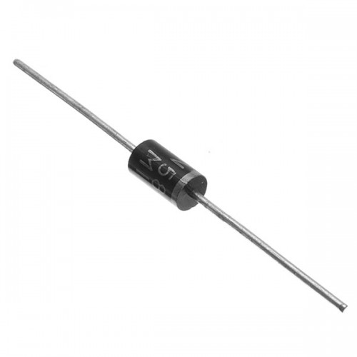 Basically, a diode is used for rectifying waveforms, within radio detectors or within power supplies. They can also be used in various electrical and electronic circuits where ‘one -way’ result of the diode is required. Most of the diodes are made from semiconductors like silicon, but sometimes germanium is also used.

The Diode has lower forward voltage drop than ordinary silicon p-n junction diodes. At low currents, the voltage drop maybe between 0.15 and 0.4 volts as opposed to 0.6 volts for silicon diode. To attain this performance, they are designed in different way to compare with normal diodes having metal to semiconductor contact. These diodes are extensively used in rectifier application, clamping diodes and also in RF application.

* **Role of diode in our project**

After the motors are switched off, they continue to rotate due to inertia of motion. Since the armature will interfere the flux, there will be a back EMF generated in the circuit which will reverse the current flow which is harmful for our components. The diode would prevent the flow of current in the circuit in case of back EMF.

**4. Gas Sensors**

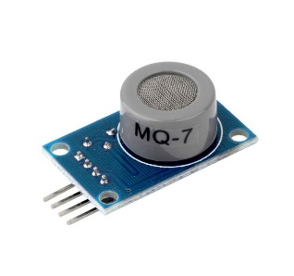Electrochemical-type gas sensors are amperometric fuel cells with two electrodes. The basic components of two electrode gas sensors are a working (sensing) electrode, a counter electrode, and an ion conductor in between them.

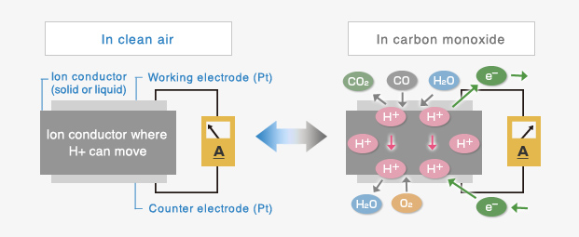When toxic gas such as carbon monoxide (CO) comes in contact with the working electrode, oxidation of CO gas will occur on the working electrode through chemical reaction with water molecules in the air. Connecting the working electrode and the counter electrode through a short circuit will allow protons (H+) generated on the working electrode to flow toward the counter electrode through the ion conductor. In addition, generated electrons move to the counter electrode through the external wiring. A reaction with oxygen in the air will occur on the counter electrode. By measuring the current between the working electrode and the counter electrode, this electrochemical cell can be utilized as a gas sensor.

* **Theory of CO Detection**

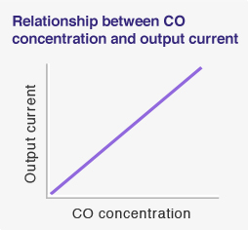In order to measure the sensor’s output current, it must be connected to an external circuit. By controlling gas flowing toward the working electrode with diffusion film, output current flowing across the external circuit will be proportional to gas concentration. The linear relationship of gas concentration to sensor output makes this technology ideal for gas sensing applications.

 **Working of ADVEC**

ADVEC, basically, has three major components viz. mechanical, electronic and software. There is a gas sensor installed in ADVEC to check the emission levels from the vehicle exhaust. As soon as the rate of emission of any gas rises above the set norms, the sensor sends the signal to the Arduino, which in turn transmits the signal to both the owner via an app, and the server. The owner gets the warning of thirty days to get the motor vehicle repaired so as it does not emit gases in excess. If the owner gets the motor vehicle repaired on time, the vehicle continues its usual operation. If the owner does not take the warning seriously and the emissions from car exhaust are not brought under control, the server has the power to choke the vehicle exhaust in order to hinder the performance of the car. The server will transmit a signal, which will be received by the Arduino. The Arduino will supply power to the front motors to rotate a given number of times resulting in the insertion of shaft in the exhaust pipe, thus blocking the exhaust pipe. If the exhaust gases are blocked from getting out through the tailpipe, there will be no room for fresh air to get into the combustion chambers, and the engine won’t run. But in case of emergency, the owner will be given a few kilometers of drive. After the restoration of the automobile is done, an authorized person will send the signal to the server to withdraw the shaft from the tailpipe. The server will further transmit signal to Arduino to retreat the shaft. The Arduino will supply power to the reversal motor attached at the back end of the shaft, to rotate a fixed number of times so as the shaft regains its original position and the vehicle will resume its operation. Now the gas sensors will again check the emissions from the tailpipe in presence of the authorized person, and if the emissions are under check, the motor vehicle will continue its usual performance, otherwise the server will transmit signals to the Arduino to place the shaft in the exhaust pipe and stop its functioning.

**Cost/Efficiency of Various Elements Used in the Project**

To overcome the problem of increasing air pollution there is a strict need to install air pollution controlling devices in automobiles. Controlling air population is not the sole responsibility of government. It would be effective if all the people would come together to make our mother earth a safe place to live on. If we look at the recent data,

No of vehicles per thousand people in India=18

Population of India=1.252 billion

Therefore, total number of cars =22,536,000

According to recent study, passenger car ownership in India would increase by 775% over the next 24 years. To get maximum efficiency out of this project, cost has to be minimum so that anyone can utilize it without thinking of his budget. Overall cost of making the project is-

**Table to be drawn**

The cost of this device is very low in comparison to luxurious cars. Little contribution from everyone could bring a big change.