An Internship Report
Of
Deloitte Data Analytics Job Simulation
Submitted
To
School of Computer Science and Engineering
IILM University, Greater Noida, U.P.
In partial fulfilment of the requirement of degree of
B.Tech (Computer Science and Engineering)

By
Roll Number of Student: 2410031161
Name of Student: ADITYA KUMAR
Section: 2CSE7
Batch: 2024-2028

CANDIDATE'S DECLARATION
I, ADITYA KUMAR, do hereby declare that the internship report titled “Deloitte Data Analytics Job Simulation” has been completed by me to fulfil the requirement for the award of the degree of Bachelor of Technology in Computer Science and Engineering. All the references have been quoted and I have not taken as such any material from any other source. I affirm that this report is my own and has not been submitted to any other institute for any degree/diploma requirement, and further I shall be solely responsible for any kind of copyright violation in this regard.
Signature:-
Student Name: ADITYA KUMAR
Roll No.: 2410031161

ACKNOWLEDGEMENT
I am using this opportunity to express my gratitude to everyone who supported me throughout the Internship Program. I am thankful for their aspiring guidance, invaluably constructive criticism and friendly advice during this work. I am sincerely grateful to them for sharing their truthful and illuminating views on a number of issues related to this work.
I would like to thank Forage and Deloitte Australia for providing me the opportunity and the structured virtual platform to learn and gain hands-on exposure in the domain of data analytics and forensic technology. I am also thankful to my institute, IILM University, Greater Noida, and the faculty of the School of Computer Science and Engineering for their continuous support and encouragement.
I express my gratitude to my parents for their blessings.
Signature:-
Student Name: ADITYA KUMAR
Roll No.: 2410031161

TABLE OF CONTENTS
Chapter No. | Chapter Name | Page Nos.
 | Cover Page
1. | Candidate's Declaration
2. | Acknowledgement
3. | Internship Completion Certificate
4. | Project Description  4.1 Introduction  4.2 Organization Profile  4.3 Problem Statement  4.4 Project Objectives  4.5 Scope of the Project  4.6 Technologies and Tools Used  4.7 System Architecture  4.8 Methodology  4.9 Expected Outcomes  4.10 Certificate of Completion and Communication Proof
5. | Bibliography/References

3. INTERNSHIP COMPLETION CERTIFICATE
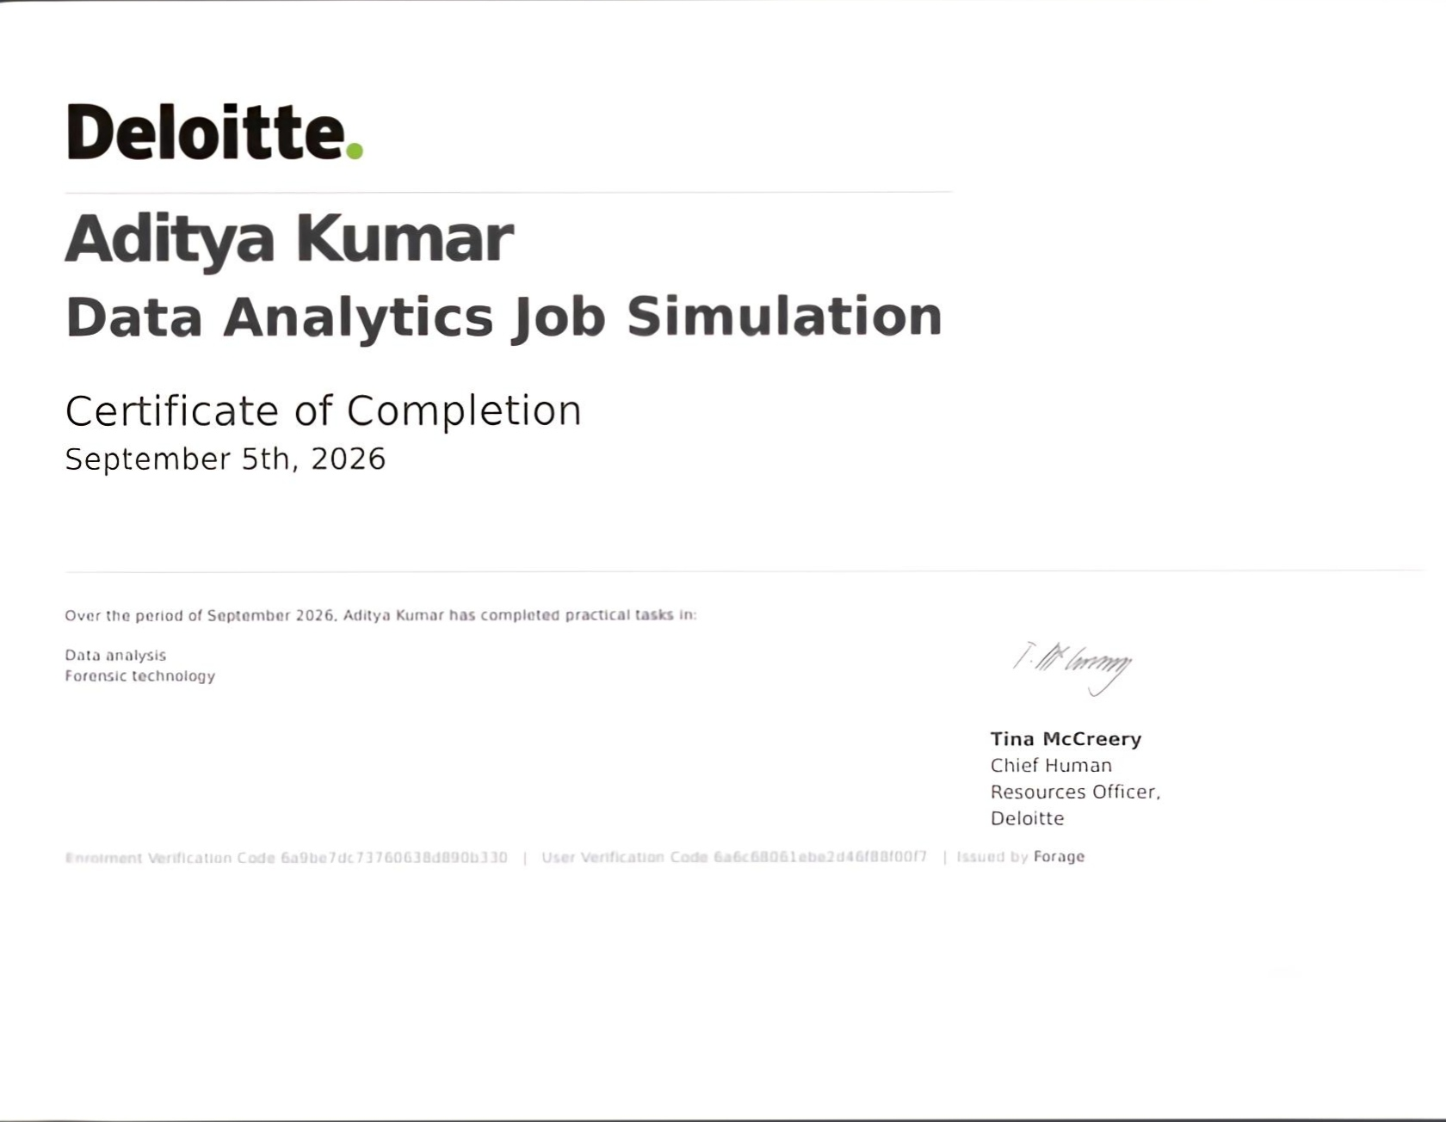

4. PROJECT DESCRIPTION

4.1 Introduction
This report presents a detailed account of the Virtual Job Simulation undertaken on the Forage platform in the domain of “Data Analytics”, offered by Deloitte Australia. The simulation was completed in September 2026 as part of the requirement of the Bachelor of Technology (Computer Science and Engineering) programme at IILM University, Greater Noida. The primary aim of this internship was to build a practical foundation in data analysis and forensic technology by working through realistic consulting scenarios as an entry-level data analyst at Deloitte.
The simulation followed a self-paced, task-based structure combining a real-world business brief, hands-on data-analysis exercises using Excel and Tableau, and a forensic investigation task. On successful completion of all the required practical tasks, a Certificate of Completion was awarded by Deloitte and issued through Forage, verified by Deloitte's Chief Human Resources Officer, Tina McCreery.

4.2 Organization Profile
Deloitte is one of the world's leading professional services networks and a “Big Four” accounting and consulting firm, operating across audit, tax, risk advisory, enterprise technology, and strategy consulting. Deloitte partners with Forage, a virtual work-experience platform, to deliver open-access Job Simulation programs that allow students worldwide to experience realistic, on-the-job tasks without geographic or financial barriers. For the Data Analytics track, Deloitte Australia designed a simulation based on assisting a hypothetical client, Daikibo Industrials, a global machinery manufacturer, with operational and workforce-related data challenges.

4.3 Problem Statement
Although many engineering students learn the theoretical foundations of data analytics, statistics, and spreadsheet tools during their academic coursework, very few get structured, hands-on exposure to applying these concepts to messy, real-world business datasets under a consulting framework. Concepts such as data unification, dashboard design, and forensic data analysis are often understood only at a theoretical level, with little practice in cleaning raw data, building visual dashboards, and drawing defensible business conclusions from evidence. The problem addressed by this internship was to practically learn and apply a data-analytics and forensic-technology workflow – from unifying raw telemetry data, to building an interactive dashboard, to conducting a forensic pay-equity investigation – in the way a Deloitte data analyst would.

4.4 Project Objectives
- To understand how real-world business datasets are cleaned, unified, and prepared for analysis.
- To consolidate telemetry data received from multiple factory sites, supplied as a single JSON file, into one usable dataset.
- To identify operational bottlenecks and downtime trends from the unified dataset.
- To design and build an interactive dashboard in Tableau to communicate operational insights to business stakeholders.
- To learn the fundamentals of forensic data analysis as applied to workforce and compliance issues.
- To apply a forensic algorithm in Excel to quantify the level of gender pay equality across roles and locations.
- To classify complex datasets and identify roles/locations where pay gaps were most prevalent.
- To propose clear, evidence-based business conclusions to a forensic lead.
- To successfully complete all practical tasks required for the Deloitte Data Analytics Job Simulation Certificate.

4.5 Scope of the Project
The scope of this internship spans the core data-analytics and forensic-technology workflow used in Deloitte's consulting practice – starting from raw data ingestion and cleaning, moving to dashboard-based operational analysis, and extending into a forensic investigation of pay equity using classification and quantitative reasoning in Excel. The internship was limited to a virtual, simulation-based learning environment provided by Forage and Deloitte Australia, and did not involve access to any live client data or deployment on an actual organizational system.

4.6 Technologies and Tools Used
- Data Handling: JSON data unification, data cleaning and preparation
- Analysis & Visualization: Microsoft Excel, Tableau
- Techniques: Trend analysis, forensic/quantitative pay-equity analysis, data classification, dashboard design
- Learning Platform: Forage virtual work-experience platform

4.7 System Architecture
The general workflow followed during the simulation can be summarized in the following layers:
- Data Layer: Raw telemetry data from four global factories, supplied as a single JSON file, forms the base input for operational analysis.
- Processing Layer: Data cleaning and unification steps convert the raw JSON telemetry data into a structured, analysable dataset.
- Analysis Layer: Trend and bottleneck analysis is performed on the unified dataset to identify operational issues.
- Visualization Layer: An interactive Tableau dashboard presents operational insights to business stakeholders.
- Forensic Layer: A forensic algorithm in Excel quantifies gender pay equality across roles and locations using classified workforce data.
- Reporting Layer: Business conclusions from both the operational dashboard and the forensic investigation are compiled and proposed to stakeholders/the forensic lead.

4.8 Methodology
The internship followed a task-based methodology combining a business brief, hands-on data work, and stakeholder-style reporting, as summarized in the table below.
Task | Module | Description
1 | Data Analysis – Operational Insights (Daikibo Industrials) | Unified telemetry data received from four global factories, supplied as a single JSON file, into a consolidated dataset. Identified operational bottlenecks and downtime patterns, and designed an interactive dashboard in Tableau to visualise trends for business stakeholders.
2 | Forensic Technology – Pay Equity Investigation | Investigated an internal complaint regarding salary inequality across global roles. Applied a forensic analysis algorithm in Excel to quantify the level of gender pay equality across roles and locations, classified complex datasets, and proposed business conclusions to the forensic lead.

Note: This was a self-paced, unpaid virtual job simulation; there was no stipend associated with it.
Each task was based on a realistic business brief from a hypothetical Deloitte client, Daikibo Industrials. On successful completion of both practical tasks, a Certificate of Completion was issued.

4.9 Expected Outcomes
- Ability to clean and unify raw, multi-source data (e.g., JSON telemetry data) into a single analysable dataset.
- Practical understanding of identifying operational bottlenecks and trends from business data.
- Hands-on exposure to building interactive dashboards in Tableau for stakeholder communication.
- Capability to apply forensic, quantitative techniques in Excel to investigate workplace pay equity.
- Skill to classify complex datasets and draw defensible, evidence-based business conclusions.
- A completed Deloitte Data Analytics Job Simulation Certificate of Completion, issued by Forage and verified by Deloitte's Chief Human Resources Officer.

4.10 Certificate of Completion and Communication Proof
The Certificate of Completion issued by Deloitte through Forage, confirming successful completion of practical tasks in Data Analysis and Forensic Technology as part of the Deloitte Data Analytics Job Simulation, is attached in Chapter 3 of this report.

5. BIBLIOGRAPHY/REFERENCES
1. Forage, “Deloitte Australia – Data Analytics Job Simulation,” Certificate of Completion, September 2026.
2. Deloitte Australia, Data Analytics Job Simulation on Forage, https://www.theforage.com/simulations/Deloitte%20Australia/data-analytics-s5zy
3. Forage, Virtual Work Experience Platform, https://www.theforage.com/
4. Deloitte, https://www2.deloitte.com/
5. Microsoft Excel Documentation, https://support.microsoft.com/excel
6. Tableau Documentation, https://help.tableau.com/

