AWS Lambda – Author

Step 1: Open AWS Console
- Login to the AWS Console and search for "Lambda" in the search bar, then click on the Lambda service.
- On the Lambda home page, click on the "Create a function" button.

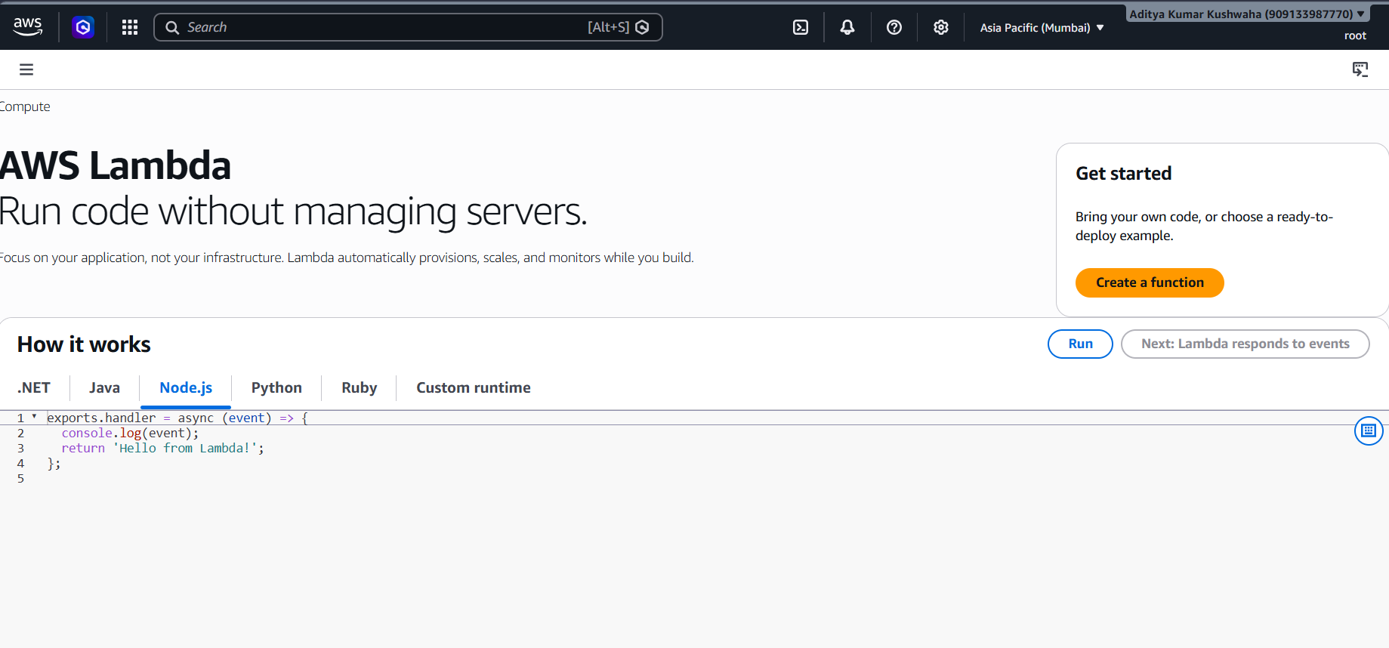

Step 2: Choose the Function option
On the "Create function" page, you will see three options:
- Author from scratch — select this option (it will already be selected by default)
- Use a blueprint
- Container image
- Function name: Enter your function name (for example: aditya-lambda-function)
Runtime: Select Python 3.12 (or according to your requirement)

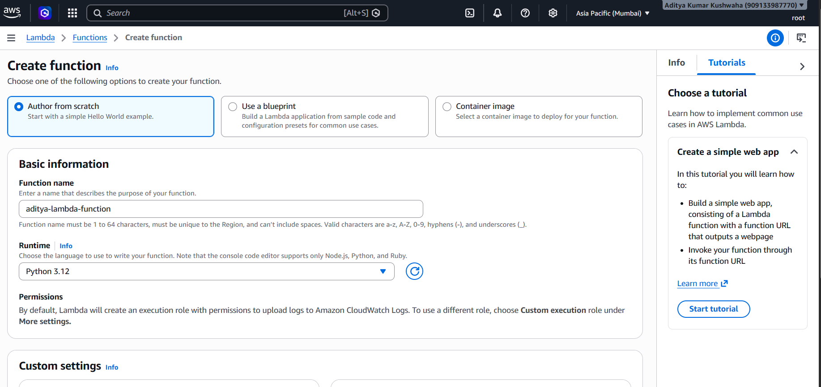

Step 3: Click on Create function
- Scroll down and click on the "Create function" button. A success message will appear — "Successfully created the function aditya-lambda-function".
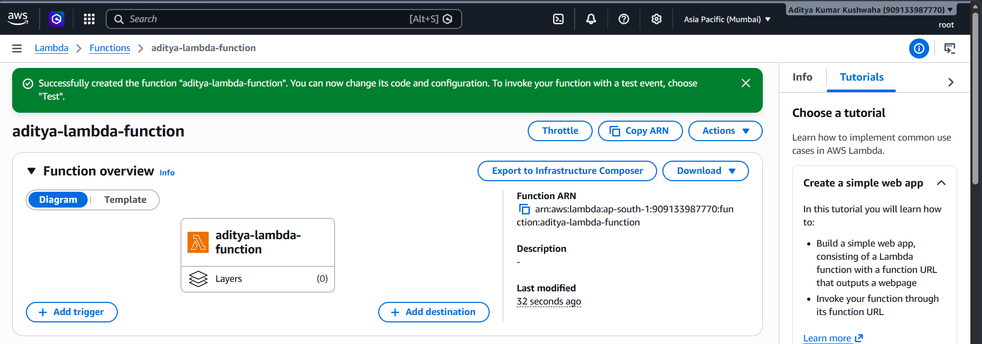
Step 4: View/Edit the Function Code
- After the function is created, the lambda_function.py file will automatically open in the Code section, containing the default code.

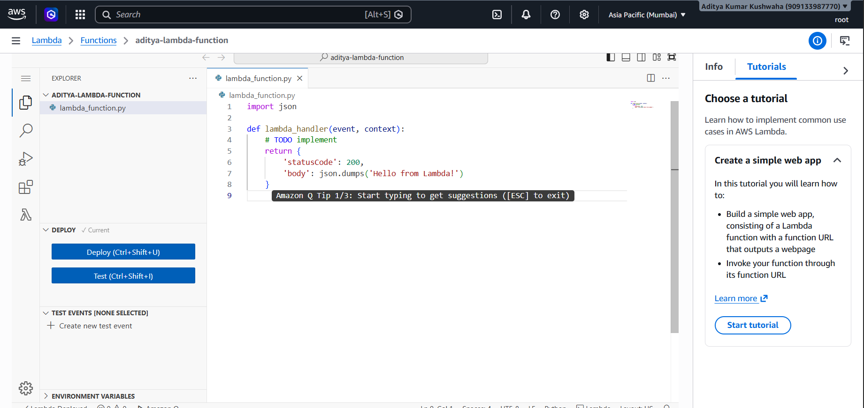

Step 5: Deploy the Function

- After editing the code, click on the Deploy button on the left side to save and deploy your code.

Step 8: Test the Function

- After deploying, click on the Test button to test the function.

