IAM – Group User

Objectives
After completing this lab, you will know how to:
- Navigate the IAM Dashboard and access the Groups section
- Create an IAM Group with specific permission policies attached
- Create multiple IAM users with console access
- Add users to an existing IAM group
- Verify that group permissions are inherited by all group members
- Log in as a group user and confirm access

Step 1: IAM Dashboard
- Log in to your AWS Management Console using the root or admin account.
- Type IAM in the top search bar and select IAM from the results.
- The IAM Dashboard opens showing an overview of users, groups, roles, and policies.
- Review the security recommendations panel on the right side.

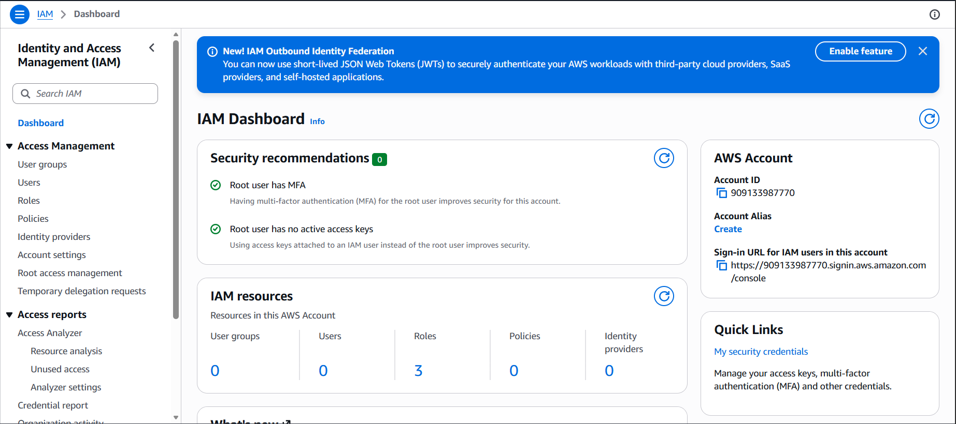

Step 2: Navigating to the User Groups Section
- In the left-hand navigation panel, click on User groups.
- The User Groups page displays all existing groups in your AWS account.
- Click the Create group button at the top right to create a new group.

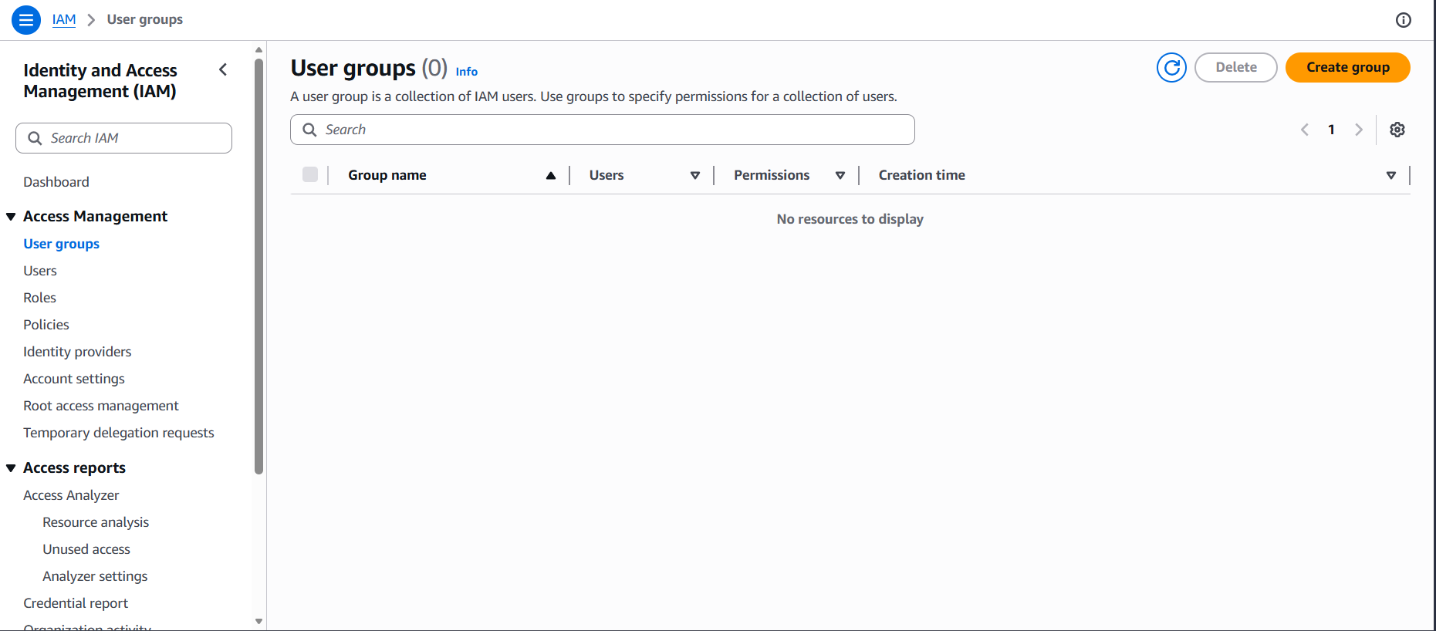

Step 3: Naming the Group
- Enter the Group name: aditya-s3-group
- A descriptive name like this makes it easy to identify the group's purpose.
- Group names must be unique within your AWS account.

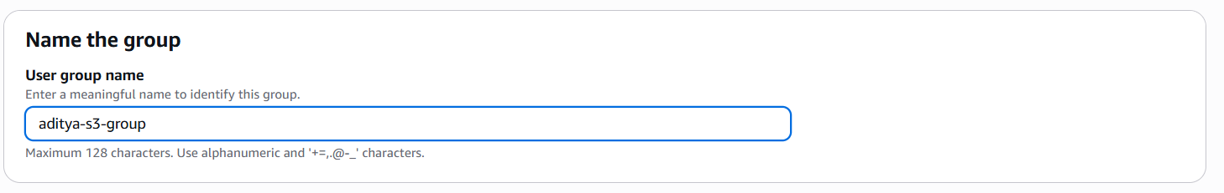

Step 4: Attaching Permissions Policy to the Group
- Scroll down to the Attach permissions policies section.
- In the search box, type AmazonS3FullAccess.
- Check the checkbox next to AmazonS3FullAccess.
- This grants all users in this group full access to Amazon S3 services.
- You can attach multiple policies to a group as needed.

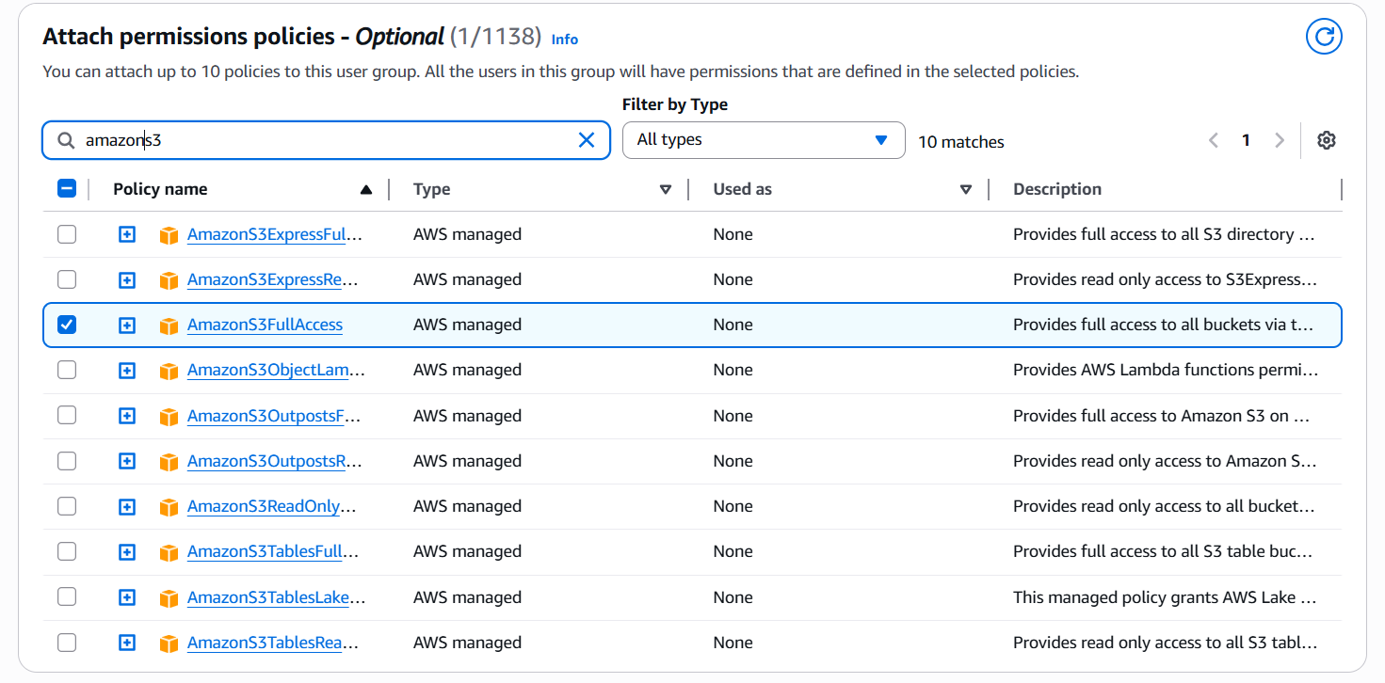

Step 5: Creating the Group
- Review the group name and attached policies.
- Click Create group to complete the process.
- The group "aditya-s3-group" will now appear in the User Groups list.

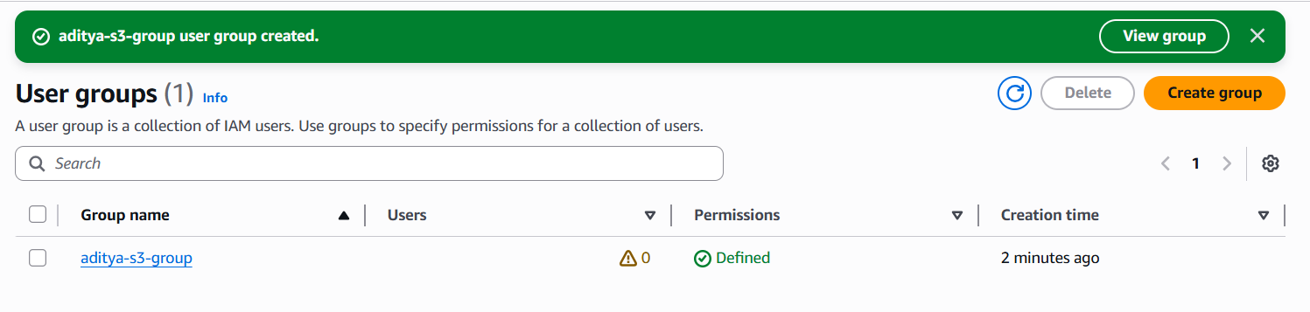

Step 6: Navigating to the Users Section
- In the left-hand navigation panel, click on Users.
- The Users page displays all existing IAM users.
- Click Create user to begin creating the first user.

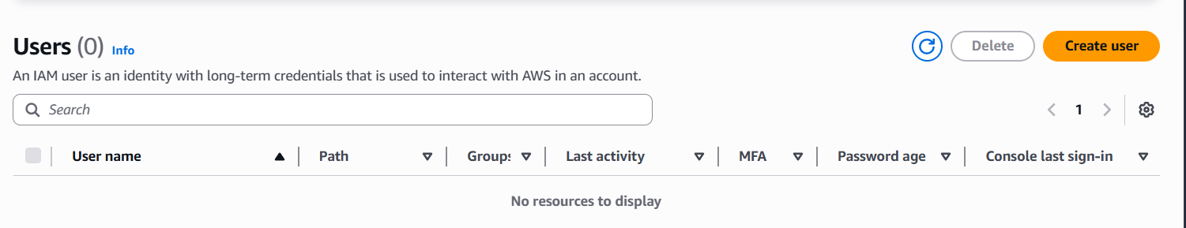

Step 7: Creating User 1 – aditya-group-user1
- Enter the username: aditya-group-user1
- Enable Provide user access to the AWS Management Console.
- Under Console password, select Custom password and enter a strong password.
- On the Set permissions page, select Add user to a group.
- Select the group: aditya-s3-group from the list.
- Click Next, review the details, and click Create user.

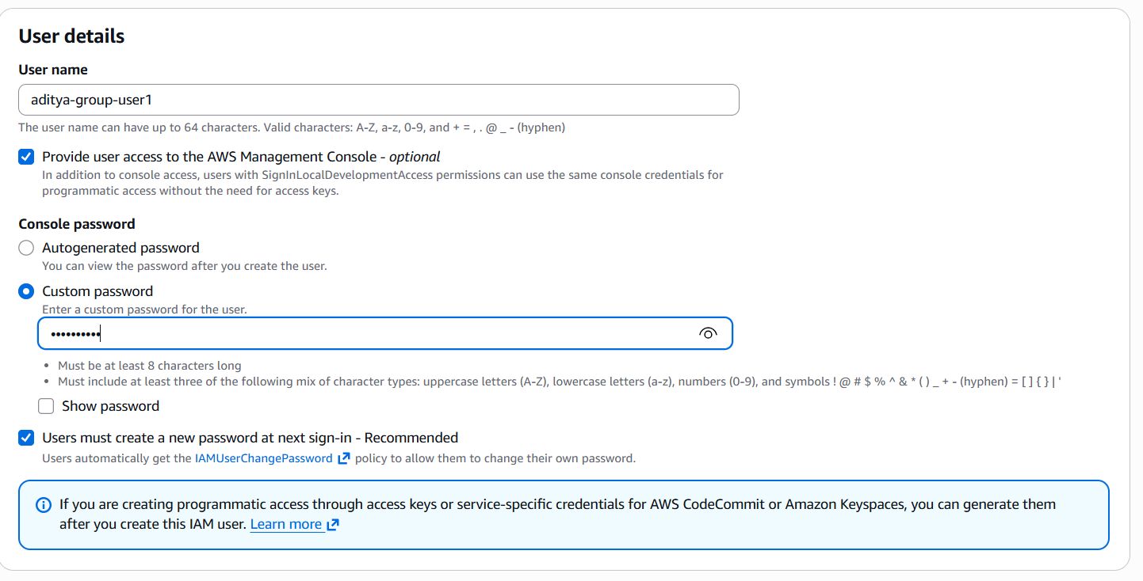

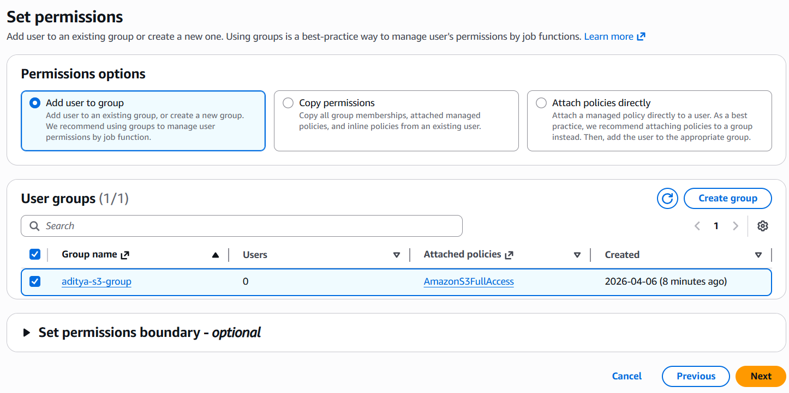

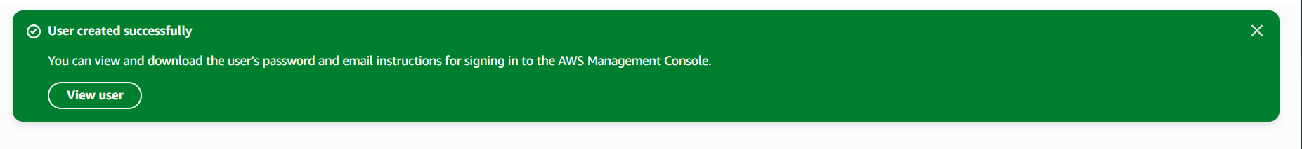

Step 8: Creating User 2 – aditya-group-user2
- Enter the username: aditya-group-user2
- Enable Provide user access to the AWS Management Console.
- Set a custom password for this user.
- On the Set permissions page, select Add user to a group.
- Select the group: aditya-s3-group from the list.
- Click Next, review the details, and click Create user.

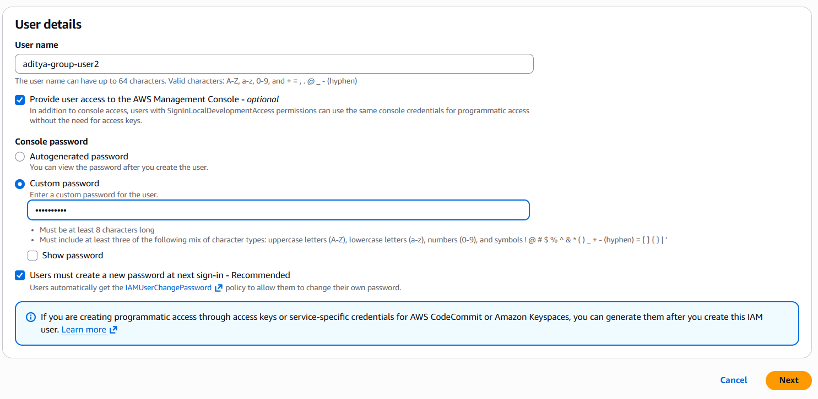

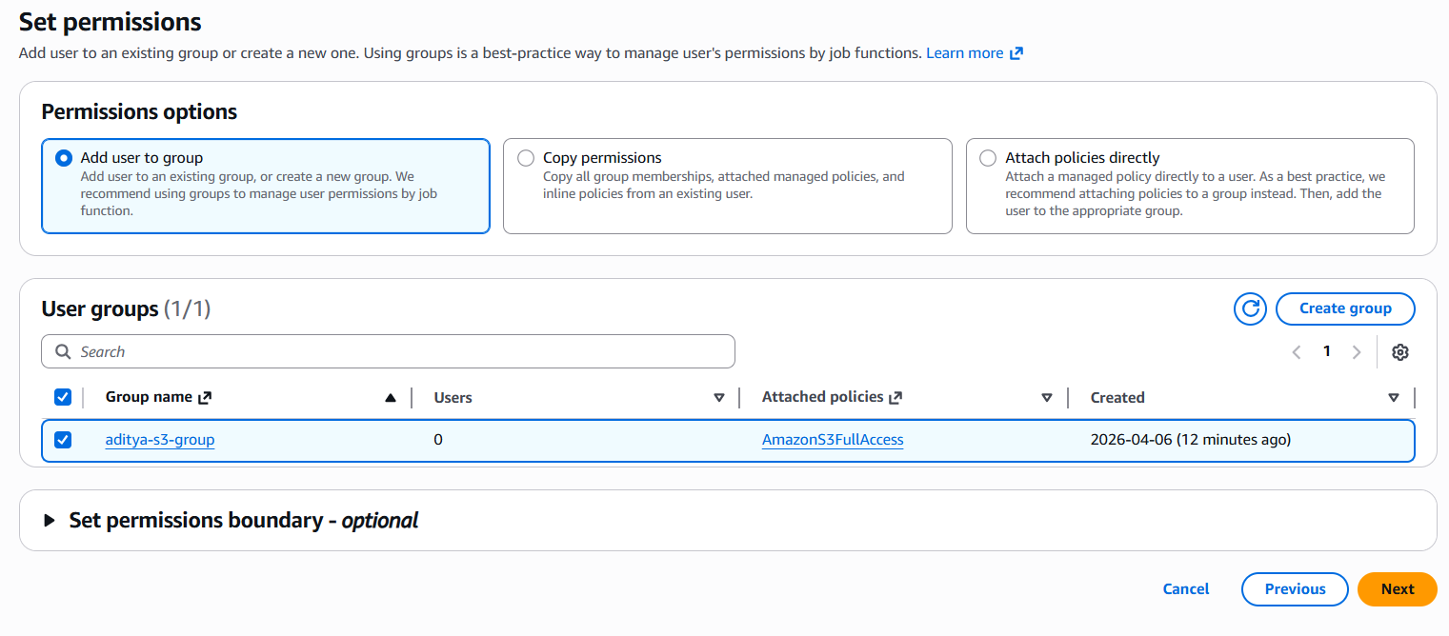

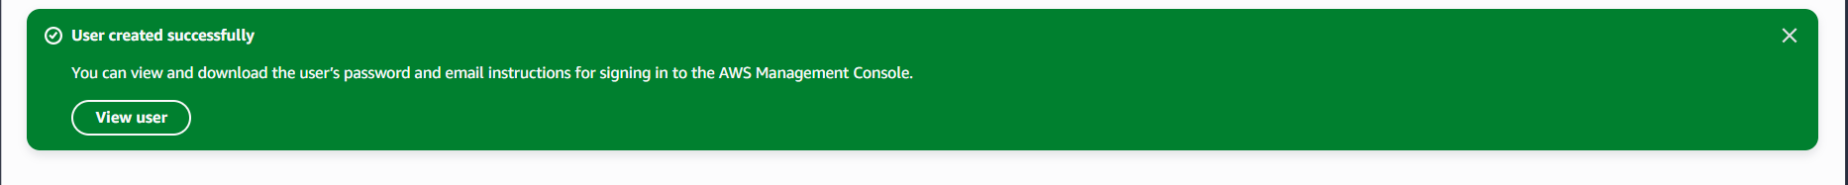

Step 9: Verifying Users Are Added to the Group
- Navigate to IAM > User groups > aditya-s3-group.
- Click on the Users tab inside the group detail page.
- Both "aditya-group-user1" and "aditya-group-user2" should appear in the members list.
- This confirms they will inherit all permissions attached to the group.

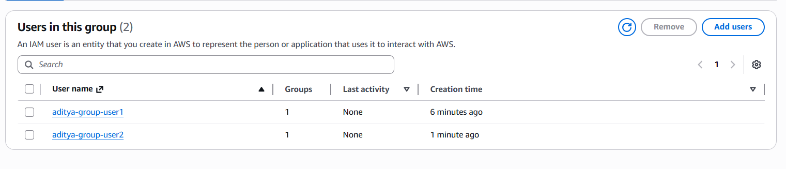

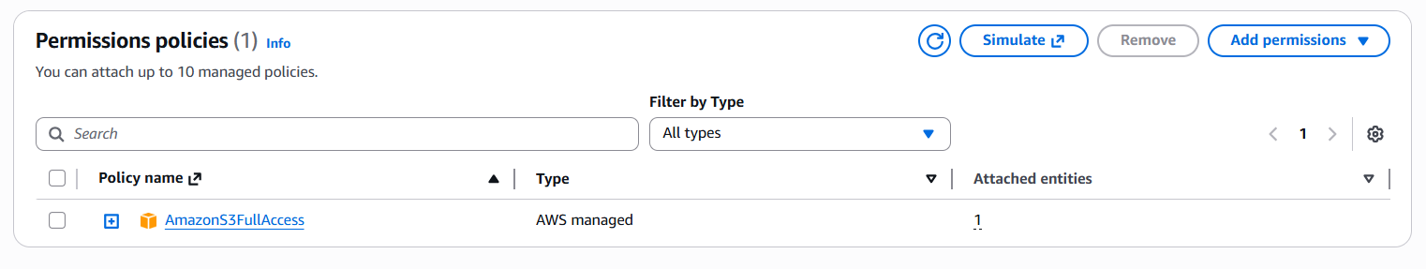

Step 10: Retrieving Sign-In Credentials for Both Users
- Go to IAM > Users and click on each user to view their details.
- Click Security credentials tab to find the console sign-in URL.
- Download or copy the sign-in URL, username, and password for each user.

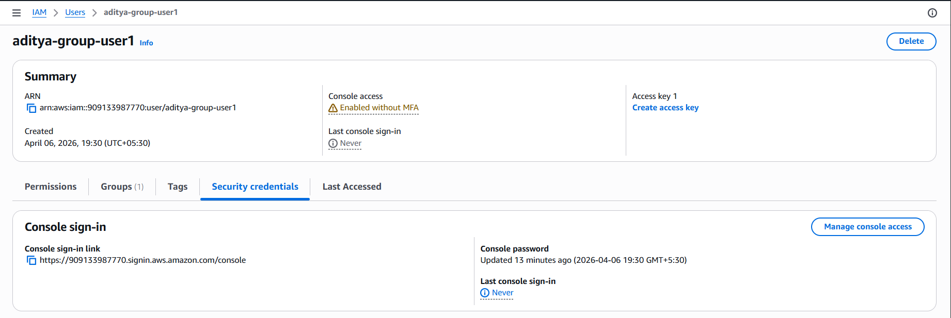

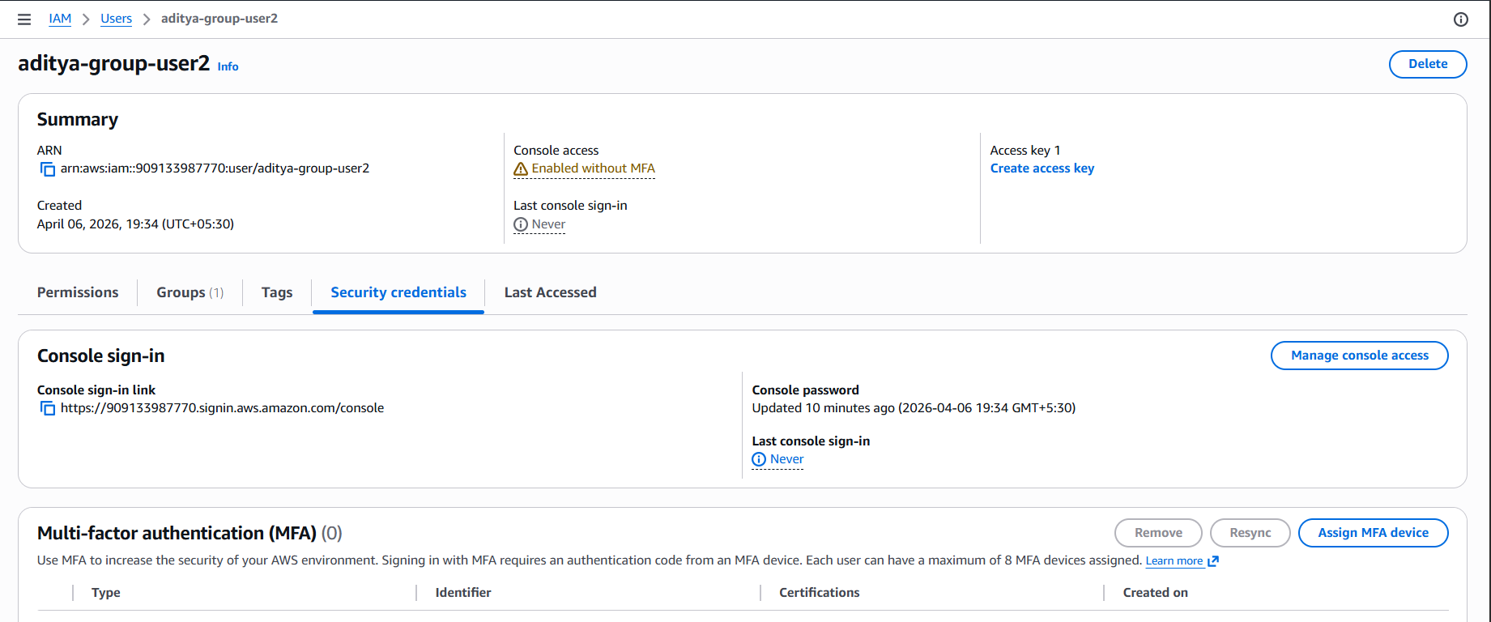

Step 11: Logging in as Group Users (Incognito Mode)
- Open an incognito or private browser window.
- Paste the Console sign-in URL into the address bar.
- Log in as "aditya-group-user1" with the configured password.
- Navigate to Amazon S3 — full access should be available (inherited from group).
- Log out and repeat the same steps to verify access for "aditya-group-user2".

