IAM – Single User

Objectives
After completing this lab, you will know how to:
- Navigate the IAM Dashboard in the AWS Management Console
- Create a single IAM user with AWS Management Console access
- Set a custom password for the IAM user
- Attach a permission policy directly to the user
- Review, create, and retrieve IAM user credentials
- Log in as the IAM user and verify access

Step 1: IAM Dashboard
- Log in to your AWS Management Console using the root or administrator account.
- In the top search bar, type IAM and select IAM from the dropdown results.
- The IAM Dashboard opens, displaying a summary of users, groups, roles, and policies.
- It also shows security recommendations such as enabling MFA for the root account.

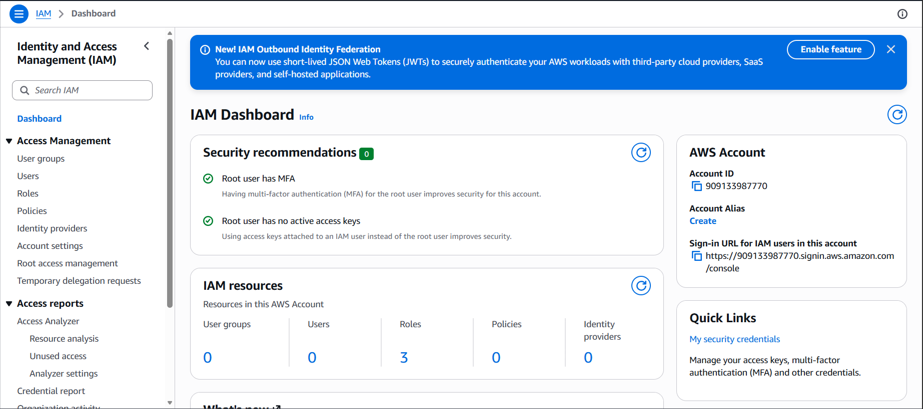

Step 2: Navigating to the Users Section
- In the left-hand navigation panel, click on Users.
- The Users page shows a list of all existing IAM users in the account.
- Click the Create user button at the top right of the page to begin.

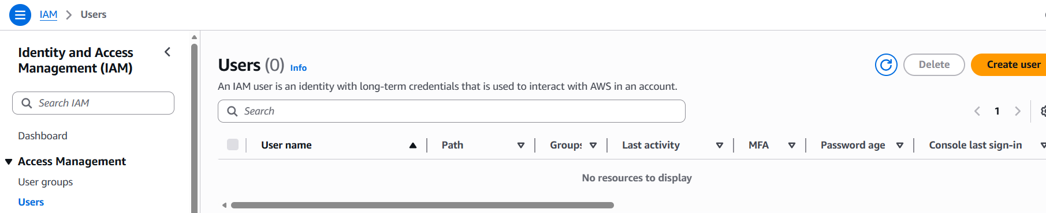

Step 3: Specifying User Name and Console Access
- Enter the username: aditya-single-user
- Check the option: Provide user access to the AWS Management Console.
- Under Console password, select Custom password and enter a strong password.
- Optionally uncheck 'Users must create a new password at next sign-in' to keep the same password.
- Click Next to proceed to the permissions step.

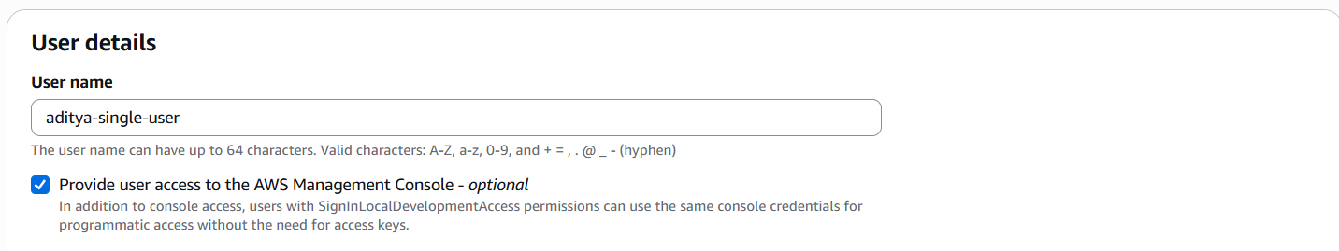

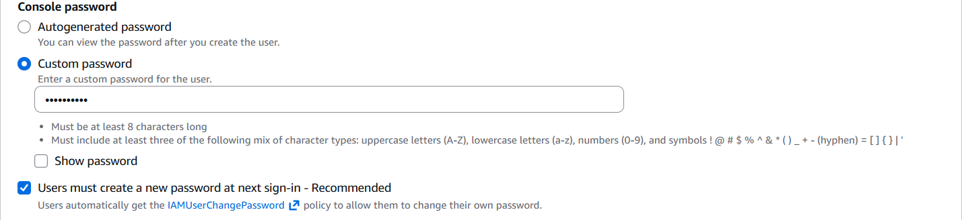

Step 4: Setting Permissions – Attach Policies Directly
- On the Set permissions page, select Attach policies directly.
- In the search box, type AmazonS3FullAccess.
- Check the checkbox next to AmazonS3FullAccess to select it.
- This policy gives the user full control over Amazon S3 — create, read, update, and delete.
- Click Next to proceed to the review step.

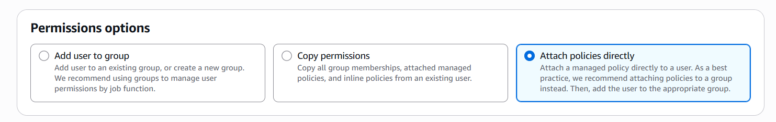

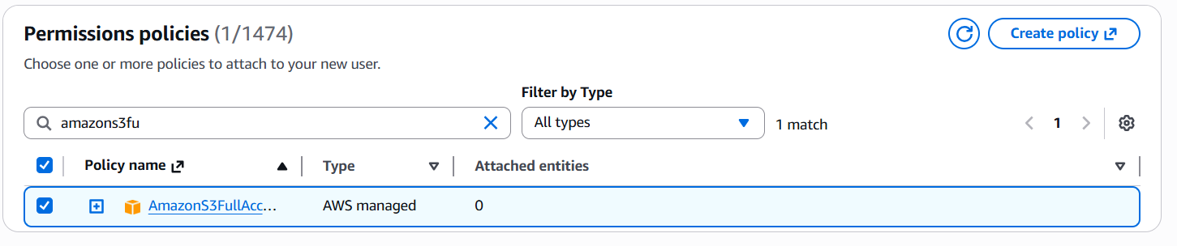

Step 5: Adding Tags (Optional)
- On the Tags page, you can optionally add key-value pairs.
- Example: Key = Department, Value = Cloud-Lab
- Tags are optional — click Next to skip if not required.

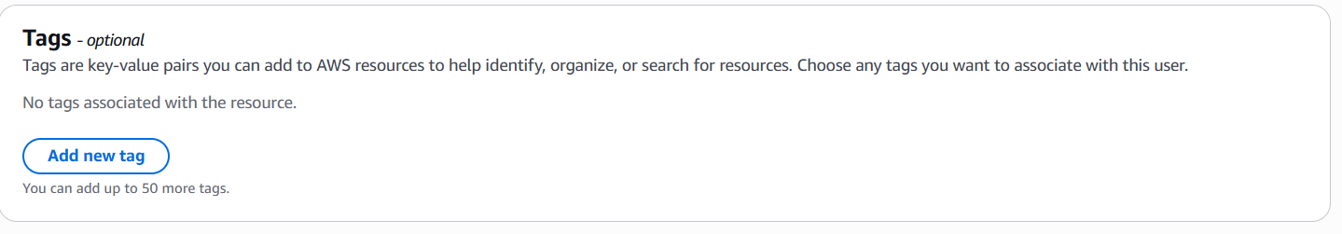

Step 6: Review and Create User
- Verify the username is correct.
- Confirm that AmazonS3FullAccess appears under the Permissions summary.
- Check the console access and password settings.
- Click Create user to finalize.

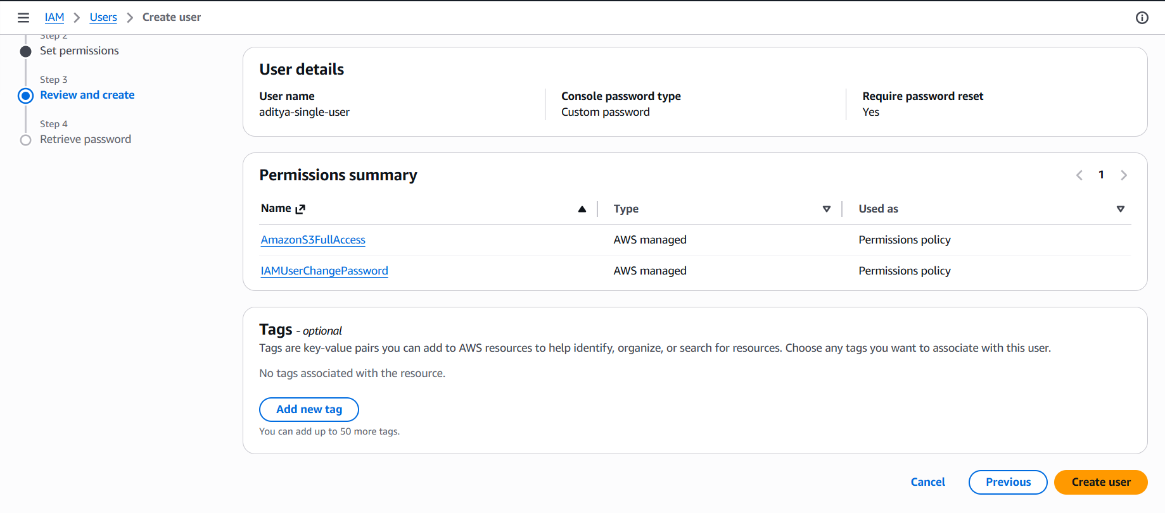

Step 7: Retrieving Sign-In Credentials
- The page shows the Console sign-in URL, username, and password.
- Click Download .csv to save all credentials to a file.
- Alternatively, copy the sign-in URL, username, and password manually.

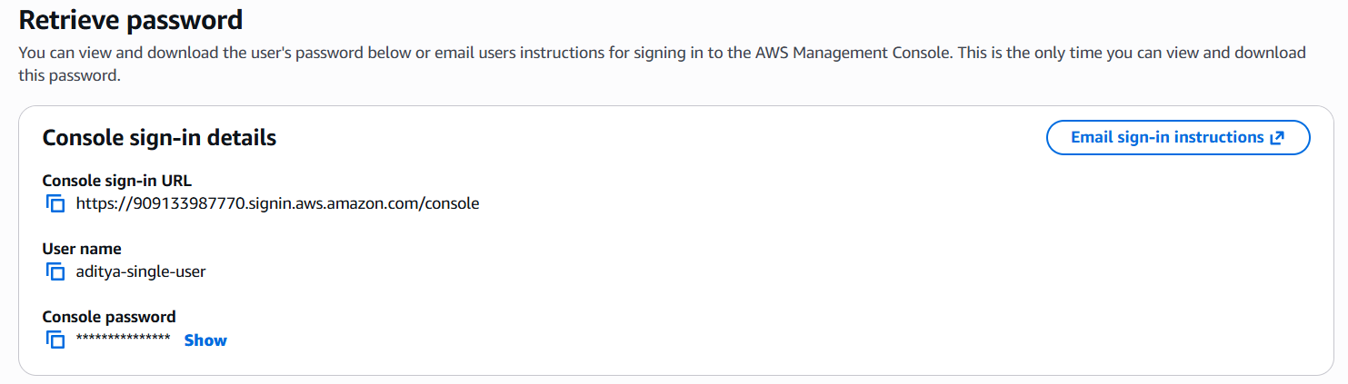

Step 8: Logging in as the IAM User (Incognito Mode)
- Open an incognito or private browser window.
- Paste the Console sign-in URL into the address bar.
- Enter the username: aditya-single-user and the configured password.
- Click Sign in.
- The AWS Console Home page loads, confirming successful login as the IAM user.
- Try navigating to Amazon S3 — full access should be available.

