Objectives
After completing this lab, you will know how to:
- Navigate the EC2 Dashboard in the AWS Management Console
- Launch a new EC2 instance with a chosen AMI and instance type
- Create and download a Key Pair for secure SSH access
- Configure a Security Group with appropriate inbound rules
- Configure storage (EBS volume) for the instance
- Launch the instance and monitor its running state
- Connect to the EC2 instance using EC2 Instance Connect
- Stop and terminate the EC2 instance

Step 1: EC2 Dashboard
The EC2 Dashboard is the central place to manage all your virtual machines on AWS.
- Log in to your AWS Management Console using your root or IAM user account.
- In the top search bar, type EC2 and select EC2 from the results.
- The EC2 Dashboard opens, showing a summary of running instances, key pairs, security groups, and volumes.
- Click the Launch instance button to begin creating a new virtual machine.

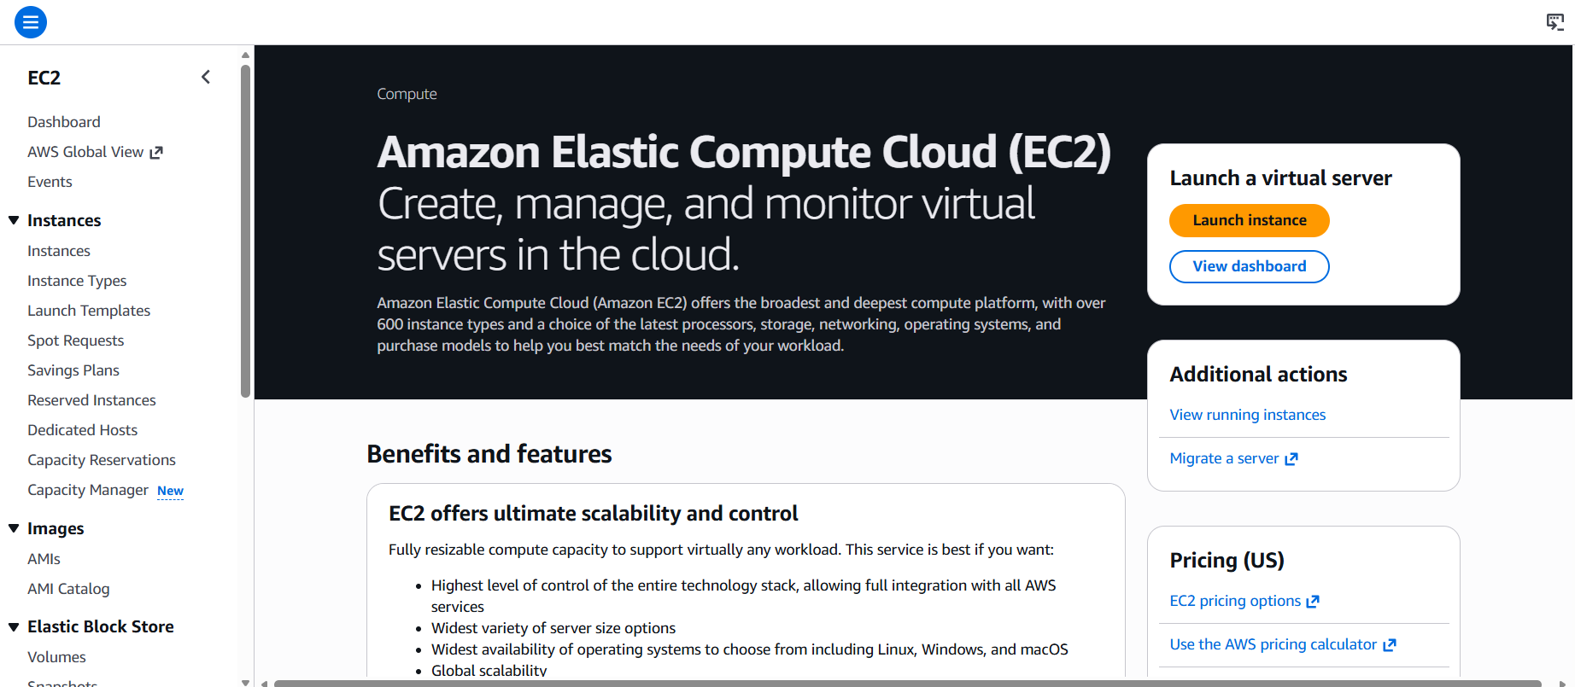

Step 2: Naming the Instance
Every EC2 instance should be given a descriptive name for easy identification.
- In the Name and tags section, enter the instance name: aditya-ec2-instance
- This name appears as a tag (Key = Name) on your instance.
- A clear, descriptive name helps manage multiple instances in larger environments.
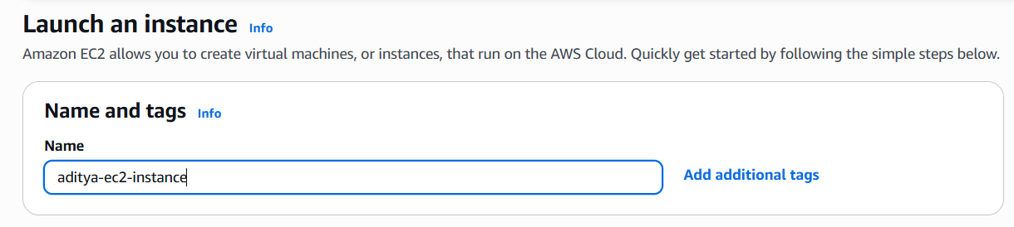

Step 3: Choosing an Amazon Machine Image (AMI)
An AMI is a pre-configured template that contains the operating system and software for your instance.
- Under Application and OS Images (Amazon Machine Image), click the search bar.
- Select Amazon Linux 2023 AMI (Free tier eligible) — this is a lightweight, AWS-optimized Linux OS.
- Alternatively, you can choose Ubuntu Server 22.04 LTS or Windows Server as per your requirement.
- Ensure the selected AMI is marked as Free tier eligible to avoid charges.

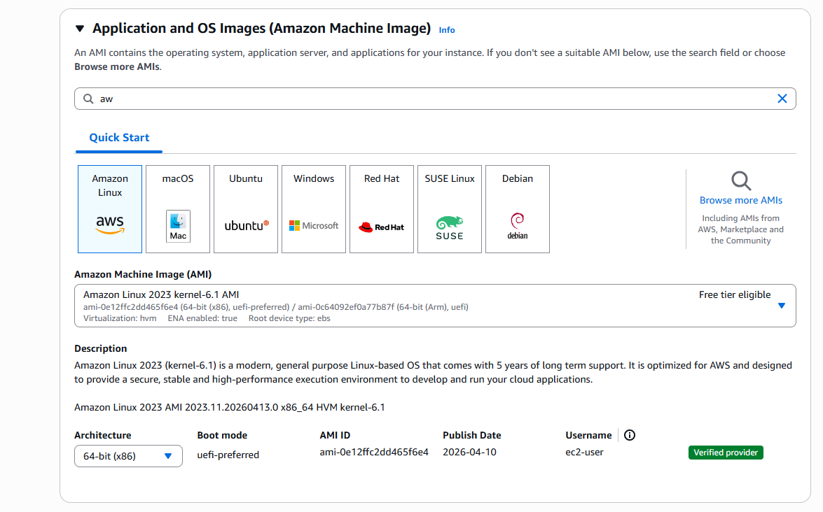

Step 4: Selecting Instance Type
The instance type defines the CPU, memory, and networking capacity of your virtual machine.
- Under Instance type, the default t3.micro is already selected.
- t3.micro is Free tier eligible — 1 vCPU and 1 GB RAM.
- This is sufficient for testing, learning, and small web applications.
- For production workloads, you can choose larger types like t3.medium or m5.large.

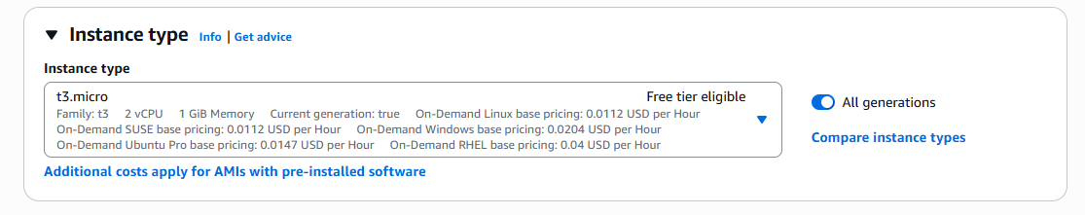

Step 5: Creating a Key Pair
A Key Pair is used to securely connect to your EC2 instance via SSH.
- Under Key pair (login), click Create new key pair.
- Enter the Key pair name: aditya-key-pair
- Key pair type: Select RSA.
- Private key file format: Select .pem (for Linux/Mac) or .ppk (for Windows with PuTTY).
- Click Create key pair — the private key file will be automatically downloaded.
- Store this file securely — it cannot be downloaded again.

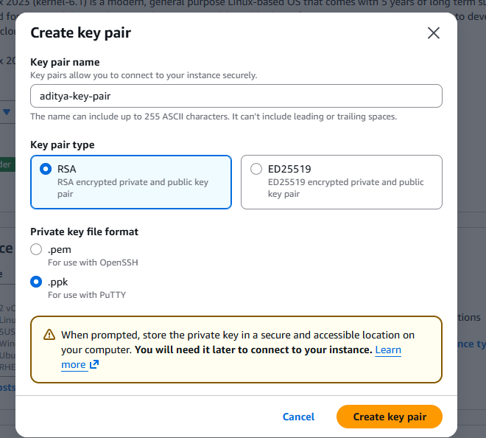

Step 6: Configuring the Security Group
A Security Group acts as a virtual firewall that controls inbound and outbound traffic to your instance.
- Under Network settings, click Edit to configure the security group.
- Security group name: aditya-sg
- Description: Security group for aditya EC2 instance.
- Add an inbound rule: Type = SSH, Protocol = TCP, Port = 22, Source = My IP (for secure access).
- Add another rule if needed: Type = HTTP, Protocol = TCP, Port = 80, Source = Anywhere (0.0.0.0/0) for web access.
- Click Save rules.
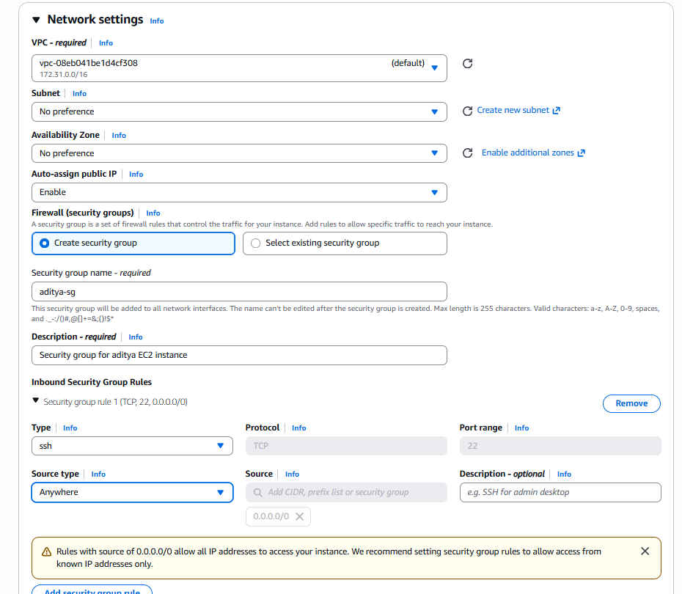

Step 7: Configuring Storage (EBS Volume)
Every EC2 instance requires at least one storage volume (EBS - Elastic Block Store).
- Under Configure storage, the default is 8 GiB gp3 (General Purpose SSD).
- This is sufficient for most lab and development purposes.
- You can increase the size up to 30 GiB within Free Tier limits.
- gp3 volumes offer better performance than gp2 at the same cost.
- Keep the default settings and proceed.

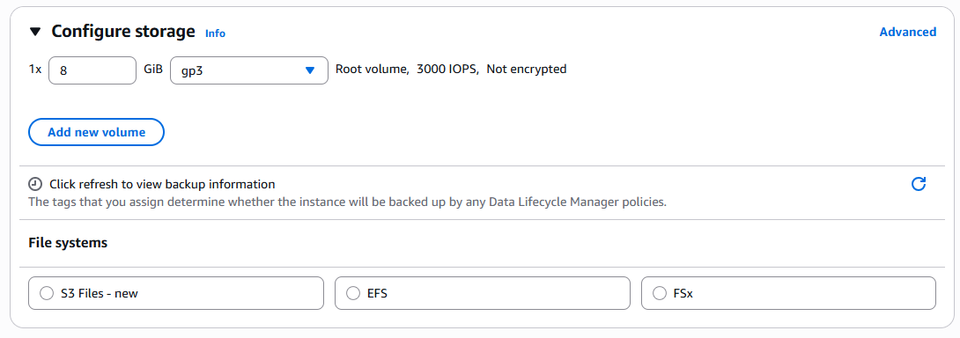

Step 8: Reviewing and Launching the Instance
Before launching, all configurations are reviewed in the Summary panel.
- On the right side, review the Summary panel showing instance count, AMI, instance type, key pair, and storage.
- Verify all settings are correct.
- Click the Launch instance button.
- A success message will confirm the instance has been launched.
- Click View all instances to go to the Instances page.

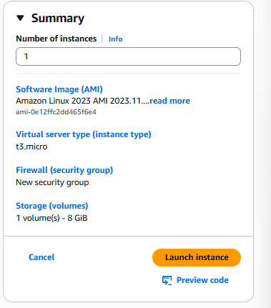

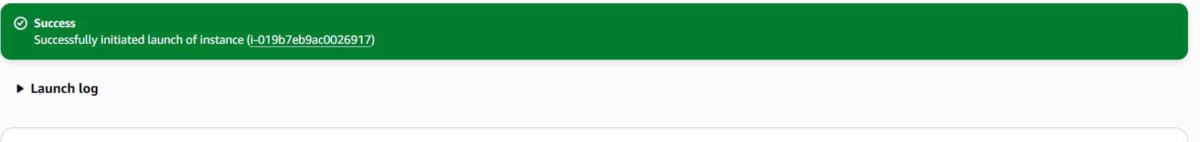

Step 9: Monitoring the Running Instance
After launching, monitor the instance state from the EC2 Instances page.
- On the Instances page, find your instance named aditya-ec2-instance.
- Wait for the Instance state to change from Pending to Running.
- The Status check column should show 2/2 checks passed.
- Note the Public IPv4 address — this is used to connect to your instance.
- Click the Instance ID to open the instance detail page.

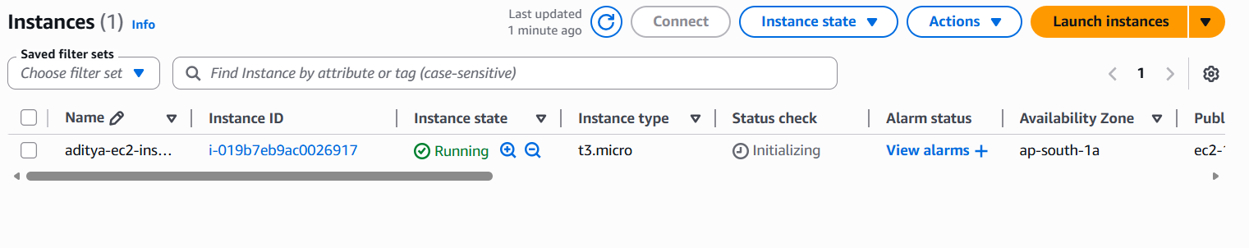

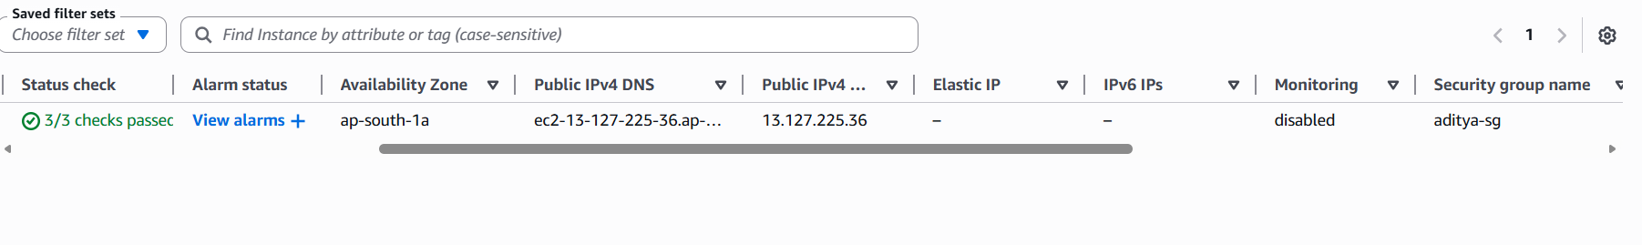

Step 10: Connecting to the EC2 Instance
AWS provides EC2 Instance Connect as an easy browser-based method to connect to your Linux instance.
- Select your running instance and click the Connect button at the top.
- Choose the EC2 Instance Connect tab.
- The username is pre-filled as ec2-user (for Amazon Linux).
- Click Connect — a browser-based terminal opens.
- You are now logged in to your EC2 virtual machine!
- Try running a command: sudo yum update -y to update packages.

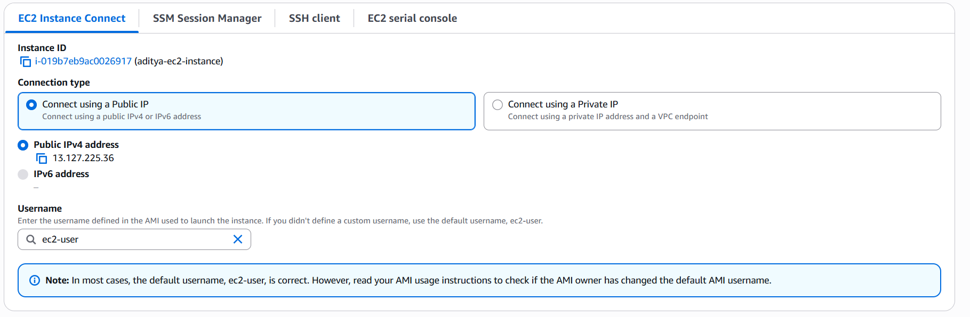

Step 11: Stopping and Terminating the Instance
When the instance is no longer needed, it should be stopped or terminated to avoid charges.
- Select your instance on the Instances page.
- Click Instance state dropdown at the top.
- To pause the instance: Click Stop instance — the instance state changes to Stopped. (EBS storage charges still apply.)
- To permanently delete the instance: Click Terminate instance — the instance and its storage are deleted.
- A confirmation dialog appears — confirm by clicking Terminate.
- The instance state will change to Shutting-down, then Terminated.

