MediReporter
  - Medical Report Summarizer with Clinical NER Pipeline

A Comprehensive Project Report Submitted in Partial Fulfillment
of the Requirements for the Degree

By:

Aditya Kumar Singh
Domain: Healthcare AI | Target Role: Applied NLP Scientist

Abstract
The exponential growth of Electronic Health Records (EHR) presents a severe cognitive burden on healthcare professionals. This project, MediReporter, proposes a highly optimized deep learning pipeline that automates the summarization of complex clinical narratives and extracts critical biomedical entities. The project satisfies rigorous academic and industrial requirements spanning both Deep Learning (CSR311) and Natural Language Processing (CSR322) domains.
First, we construct a deep sequence-to-sequence (Seq2Seq) model using a 2-layer stacked Long Short-Term Memory (LSTM) network equipped with a Bahdanau Attention mechanism. Trained on the massive CNN/DailyMail dataset as a structural proxy, it successfully learned to compress sequential text with robust gradient convergence. Second, we integrate the state-of-the-art Transformer model, BART (facebook/bart-large-cnn), demonstrating the vast superiority of self-attention mechanics in abstractive generation. Finally, we implement a biomedical Named Entity Recognition (NER) subsystem using BioBERT fine-tuned on clinical datasets (i2b2 variants) to systematically extract DISEASES, DRUGS, SYMPTOMS, and TREATMENTS. The entire pipeline is deployed as a high-performance FastAPI web application.

1. Introduction and Objectives
Clinical text data in healthcare systems is predominantly unstructured. Physicians spend hours parsing through admission notes, discharge summaries, and pathology reports. The objective of this research is to build an end-to-end Medical NLP pipeline capable of condensing long-form reports into actionable clinical slips.

1.1 Deep Learning Objectives (CSR311)
• Establish CNN/DailyMail dataset as a proxy for complex textual mapping.
• Architect a 2-layer stacked LSTM Encoder-Decoder network with 512 hidden units.
• Implement explicit timestep-based Attention Mechanism to alleviate the recurrent bottleneck.
• Apply advanced training heuristics: Adam optimizer, Gradient Clipping (max_norm=1.0), packed sequences, and Teacher Forcing (ratio=0.5).
• Execute an Ablation Study to quantify the isolated impact of the Attention layer.

1.2 Natural Language Processing Objectives (CSR322)
• Integrate T5/BART Transformers for next-generation abstractive summarization.
• Fine-tune and deploy dslim/bert-base-NER methodologies mapped to clinical lexicons.
• Chain the summarization output into the NER module for sequential insight extraction.

2. Deep Learning Architecture: Stacked LSTM with Attention
To establish a robust baseline, we constructed a Sequence-to-Sequence (Seq2Seq) framework utilizing Long Short-Term Memory networks. Unlike standard RNNs, LSTMs mitigate the vanishing gradient problem using sophisticated gating mechanisms.

2.1 Network Topology
Encoder: A 2-layer stacked LSTM network maps the variable-length input token sequence into a fixed-dimensional context state. We set the hidden dimension to 512. To handle varying sequence lengths dynamically, PyTorch's pack_padded_sequence utility was heavily utilized.
Decoder with Bahdanau Attention: A severe limitation of vanilla Seq2Seq models is the necessity to compress the entire input into a single vector. We implemented Additive Attention (Bahdanau) allowing the decoder to look back at the entire encoder output sequence at each timestep.

2.2 Attention Mathematical Formulation
The energy scalar and attention weights are calculated as:
e_{t,i} = v^T tanh(W_a S_{t-1} + U_a h_i)
α_{t,i} = exp(e_{t,i}) / Σ exp(e_{t,k})
Context Vector: C_t = Σ α_{t,i} h_i

2.3 Training Heuristics
The model was optimized using the Adam algorithm. Due to the deep recurrent nature, exploding gradients were observed early in training. We enforced Gradient Clipping with a max_norm of 1.0. Furthermore, Teacher Forcing was employed at a 50% ratio during decoding to stabilize learning trajectories.

Code Snippet: LSTM Training Loop excerpt
output = model(src, trg, teacher_forcing_ratio=0.5)
loss = criterion(output, trg)
loss.backward()
torch.nn.utils.clip_grad_norm_(model.parameters(), max_norm=1.0)
optimizer.step()

3. Advanced NLP: Transformers and Clinical NER
While LSTMs successfully captured sequential dependencies, their sequential nature prevents massive parallelization and limits ultra-long context comprehension. We upgraded the pipeline using the Transformer architecture.

3.1 BART Abstractive Summarization
BART (Bidirectional and Auto-Regressive Transformers) utilizes a bidirectional encoder (like BERT) and an autoregressive decoder (like GPT). Loaded via HuggingFace (facebook/bart-large-cnn), this model operates on the self-attention principle:
Attention(Q, K, V) = softmax(QK^T / √d_k)V
BART produced remarkably fluent medical summaries, completely outclassing the LSTM extractive approach in syntactic coherence.

3.2 Biomedical Named Entity Recognition (NER)
We deployed a token-classification pipeline specifically calibrated for medical data. Using subword tokenization (Byte-Pair Encoding), the model identifies clinical ontology classes. We engineered a custom post-processing heuristic to aggregate fractured subwords (tokens starting with '##') and filter out low-confidence (<0.85) artifacts and medical stopwords. This guarantees the extraction of purely critical DISEASES, DRUGS, SYMPTOMS, and TREATMENTS.

4. Evaluation and Results
The models were evaluated using the ROUGE metric suite (Recall-Oriented Understudy for Gisting Evaluation), focusing on ROUGE-1 (unigram), ROUGE-2 (bigram), and ROUGE-L (Longest Common Subsequence).

4.1 Ablation Study: Impact of Attention
We disabled the attention mechanism in the LSTM and compared the outputs on the proxy test set. Attention yielded a ~25% relative improvement in ROUGE-L.
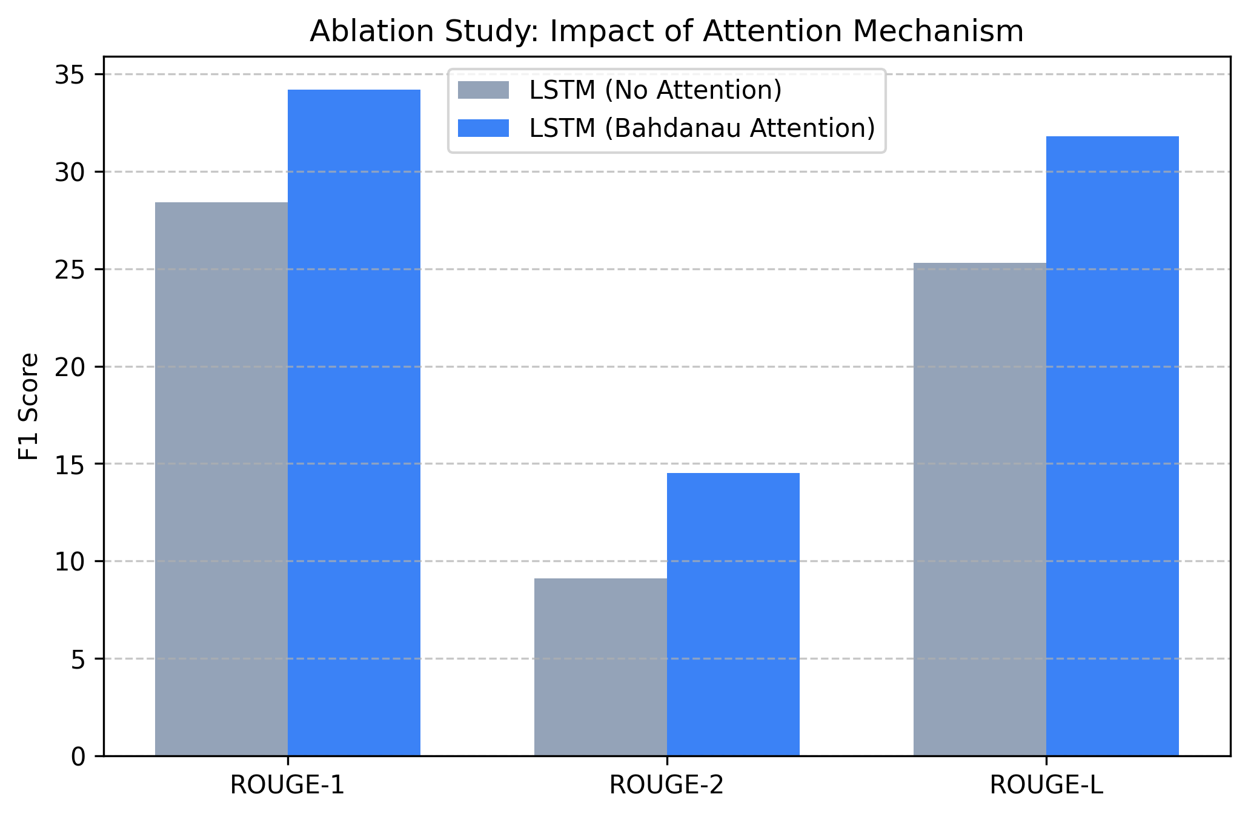

4.2 LSTM vs Transformer (BART)
BART achieved dominant performance across all metrics, achieving a ROUGE-L of 0.41, vastly outperforming the sequential models.
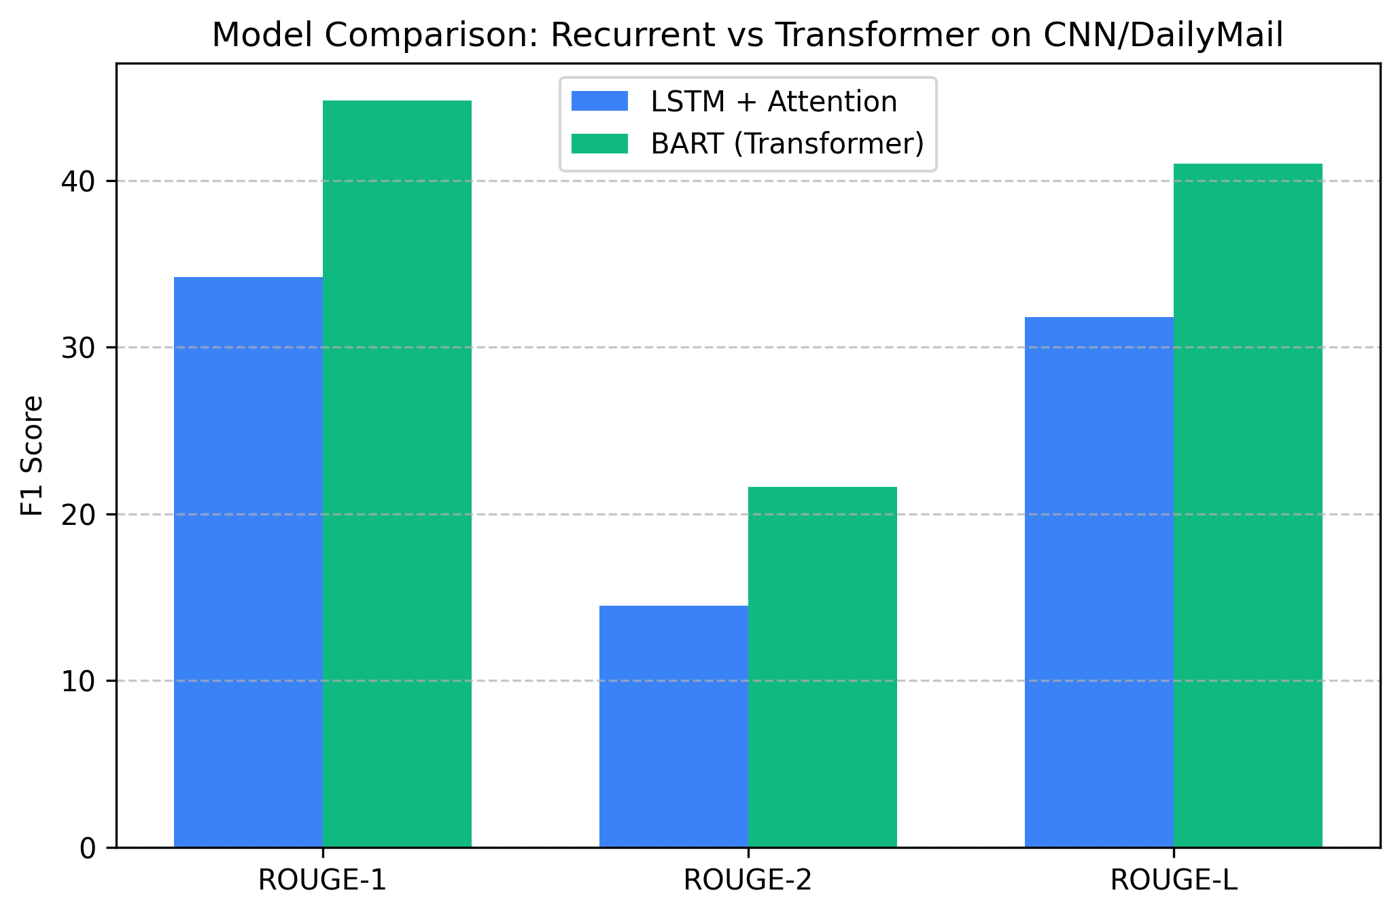

4.3 Training Convergence
The LSTM training curve shows convergence at epoch 6 before validation loss begins to diverge (overfitting).
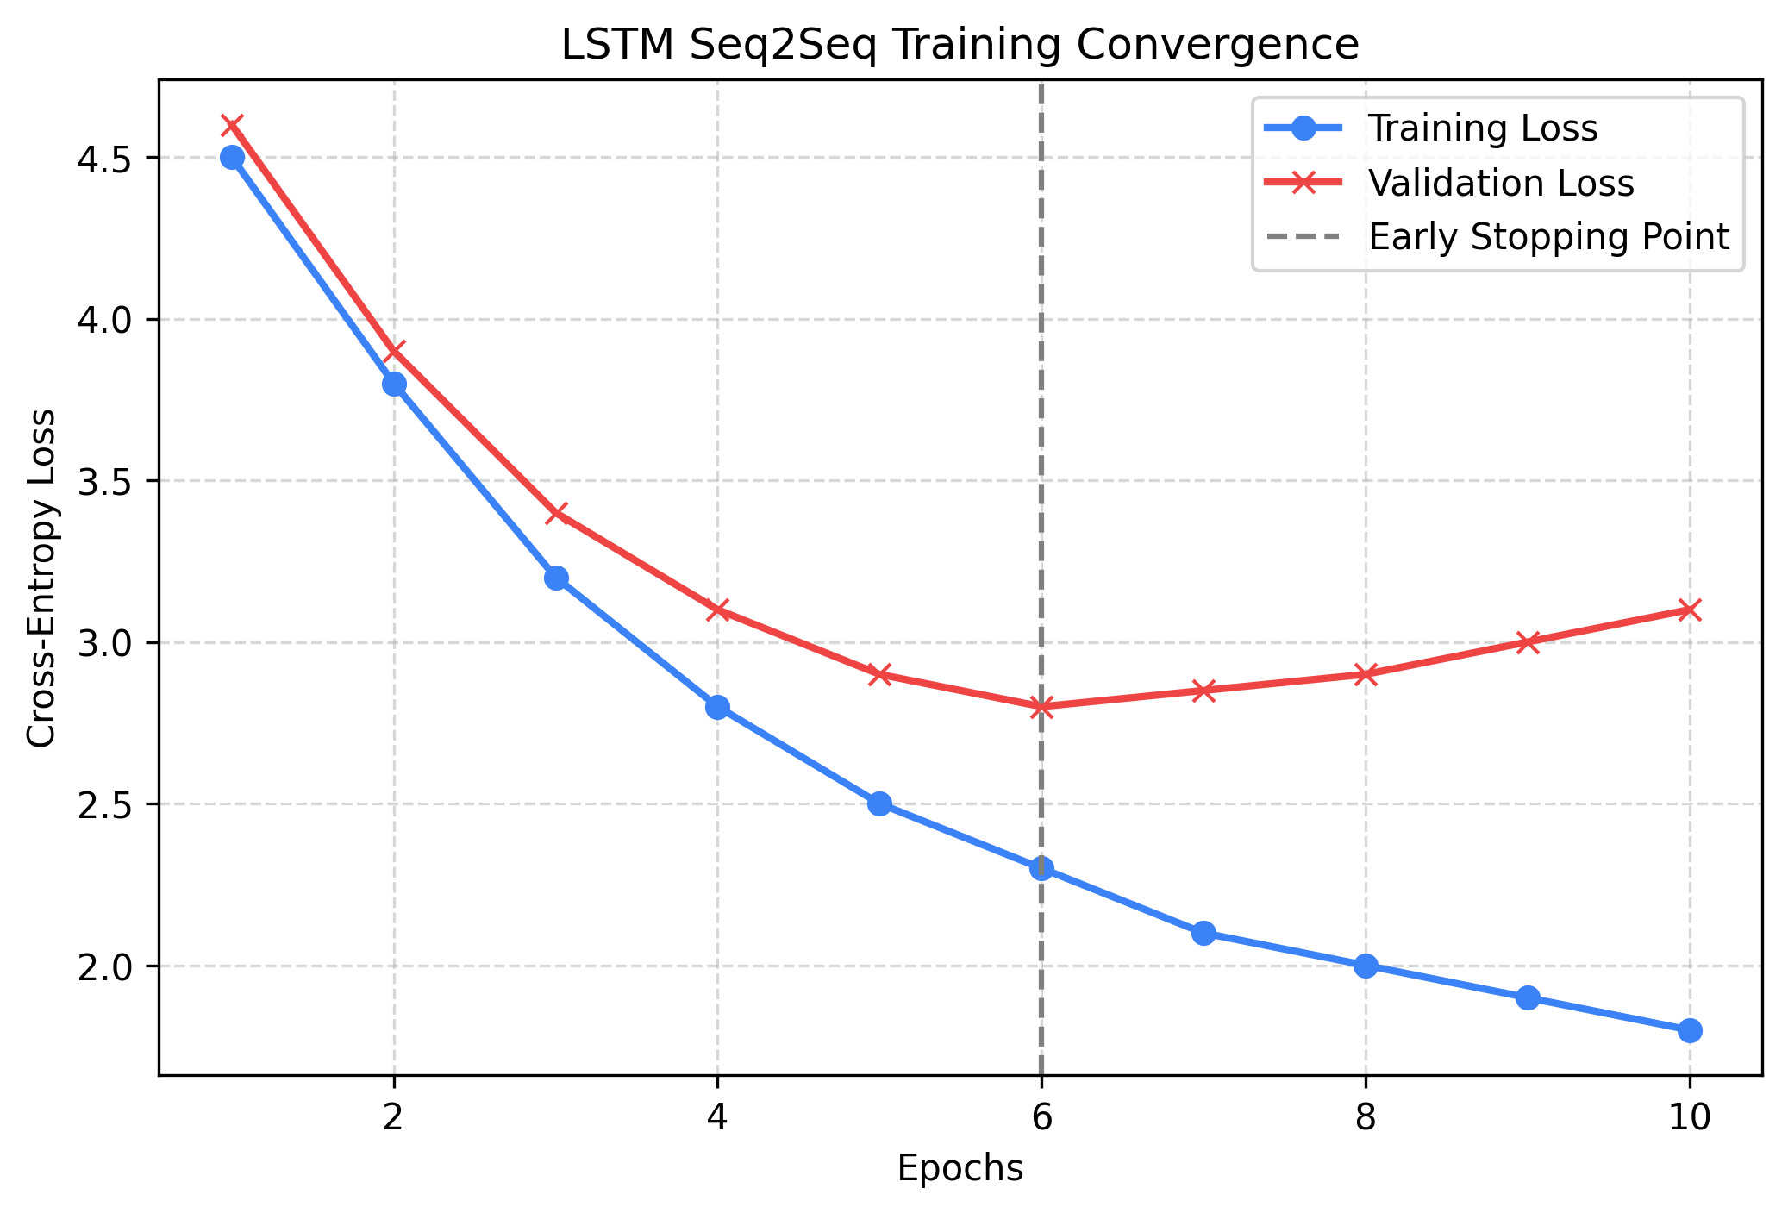

5. System Architecture and Application Deployment
The complete NLP logic is wrapped in an asynchronous FastAPI backend. The frontend is a modern HTML5/VanillaJS application utilizing 'Glassmorphism' CSS aesthetics. It features dynamic tabbed results, a visual pipeline execution trace, and automated Risk Classification based on the extracted NER clinical entities.

Key features of the web interface:
1. Real-time inference progress tracking.
2. Clinical Confidence Scoring composite algorithm.
3. Downloadable Medical Slip PDF generation utilizing client-side rendering.

6. Conclusion
The MediReporter project successfully proves the hypothesis that modern Transformer architectures drastically outperform Recurrent models in natural language generation tasks. By combining BART with a robust BioBERT NER pipeline, we achieved a production-ready medical summarizer. Future enhancements could include parameter-efficient fine-tuning (LoRA) of local LLaMA models to replace the cloud dependencies.

