# Introduction

As part of the research on pedestrian crashes, I came up with an idea to develop windows form application which could real time information about the signal location and the possible crossing to prevent pedestrian crashes.

While developing this application I used technologies like ASP.NET and C#. I used ADO.NET to connect webpages to the database. The webpages which are front end component are used in this application to provide information regarding available parking spaces and allow new user to register. The database is connected to these webpages using ADO.NET technology.

Databases in this application are used to provide real time information, to authenticate user and provide intersection details like intersection name and crossings. Since it was my first experience with ASP.NET, I learn a lot during this course as well as during development of this project.

# Objective

The objective of this web form application was to give timely updates of all the current signal crossing that is in proximity to the pedestrian and allow him to safety cross the crossing. The system gives updates of crossing at different USF crossing locations. The application further assists to reduce wait time for pedestrian thus decreasing accidents /crashes.

# Functioning

The system has 6 web pages:

LoginForm.aspx

RegistrationForm.aspx

Location.aspx

CrossStreet.aspx

CountDown.aspx

The two tables are used from the database “USFPedestrianCrossing.mdb”:

Registration

Signals

Login form has two textbox ie “TextBox1_usrname” and “TextBox2_pwd” which take input ie username and password from the table “Registration’ of the database. It has two buttons one for Login and other for Registration. The login button redirects to next page ie “Location.aspx” and the Registration button redirect to registration page ie “RegistrationForm.aspx”

The button “download android application” redirects to url that host static website on amazon web services S3 bucket and allows user to download the application.

In click event of Login button, the entered values in the two textboxes are cross verified from database table. If they match, then the login button redirects to new webform ie “Location.aspx” else it gives message “not found”.

The “Location.aspx” has one label “lblusrName” which fetches the data from database to display signed in user’s full name. This web form has button named “Cross Street” that once clicked redirects to next page “CrossStreet.aspx”. The “CrossStreet.aspx” web form creates session variable that stores the fetched data from database table containing attributes street name, crossing1, crossing2, crossing3, and crossing4. The “CrossStreet.aspx” also creates session variables that fetch data from table “signal” of database containing attributes “coordinate_X” and “coordinate_Y”.

The “CrossStreet.aspx” has one label and 5 buttons. The label named “lblSignalName” displays the name of the signal. The 5 buttons are:

* Search your Location (Button1_searchlocation)
* Button(Button1_Crossing1)
* Button(Button2_Crossing2)
* Button(Button3_Crossing3)
* Button(Button4_Crossing4)

“Search your location” button redirects to web form “GoogleMap.aspx” and other 4 buttons click event redirect to “CountDown.aspx” web form. All 5 buttons have if else condition that check if the fetched data in session variable from the database table “signal” has some value and display them as button’s text. Else they show invalid text.

The web form “CountDown.aspx” has one textbox that display the countdown starting from 30 seconds and redirect to “Location.aspx” once the timer value is less than 1 second.

The “GoogleMap.aspx” has two textboxes and one map. The two textboxes store the text retrieved from session variables containing X, Y coordinates. The map shows the current location based on X and Y coordinates (fetched from database and stored in session variable) by calling google API

## Issues1

While running project following error occurred:

To overcome it, following website and code was used:

<https://stackoverflow.com/questions/18981118/http-error-403-14-forbidden-the-web-server-is-configured-to-not-list-the-con>

  <system.webServer>

    <defaultDocument>

      <files>

        <add value="LoginForm.aspx" />

      </files>

    </defaultDocument>

    <directoryBrowse enabled="false" />

  </system.webServer>

## Failures

As part of the application development, I needed information for second database. The information must include details of street lights in and near USF. On contacting FDOT representative: Tina hatcher(Transportation Application Coordinator), a zip file [“traffic_signal_location”](traffic_signal_locations) containing the shape file for traffic signal was provided.

ArcGIS was used to work on shape file. The following information was present in shape file.

* FID
* RDWYID
* SIDE
* VALUE_
* EFFDATE
* CNTLRDES
* MAINTAGC : Maintaining Agency Name
* SDESTRET : Side Street Name
* SIGNALID : Signal Cabinet ID Number
* SIGNALC : Non-counted Signal
* SIGSTRCT : Type of Signal Structure

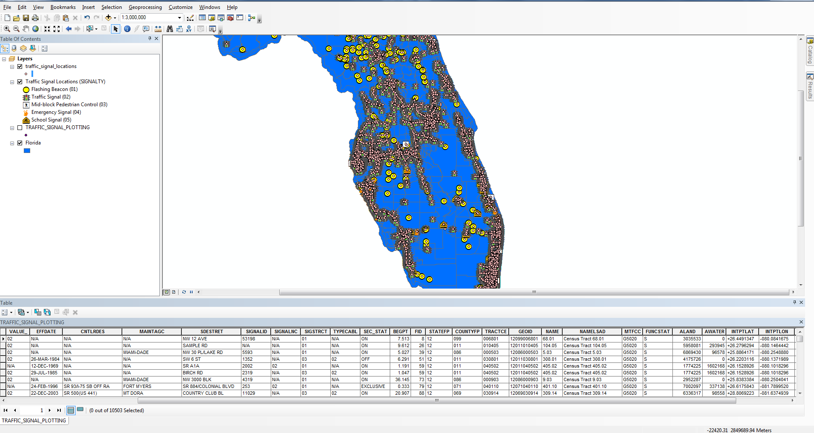

The metadata file “[322-signal](322%20-%20Signals.pdf)” contains information of the attributes. Since the data does not contain the traffic lights coordinates, the points of geospatial data of traffic signal file “[traffic_singnal_location](traffic_signal_locations)” was plotted on geospatial layer of Florida state and join operation was applied. The obtained file was “[signal_plotting_florida](signals_plotting_on_florida.xls)”

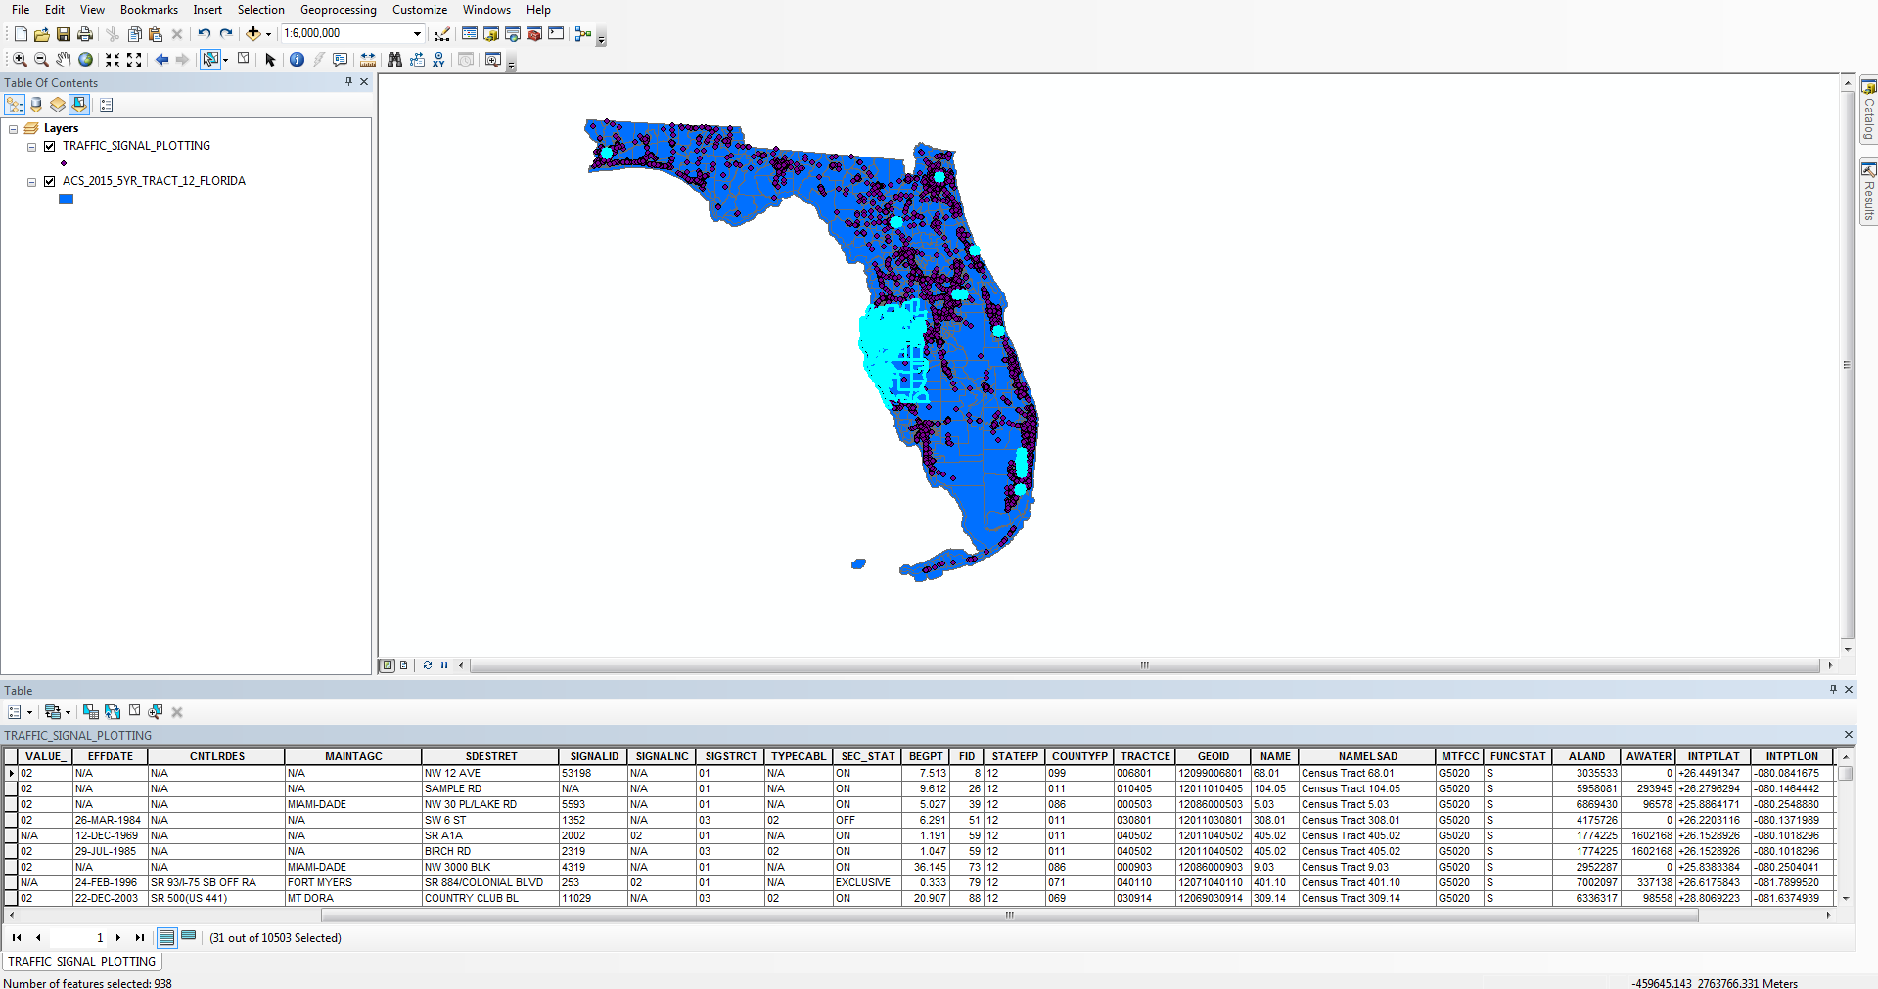

On further analysis of the data, by using features like select by attribute and using SQL query in “select by attribute option” the data was analyzed.

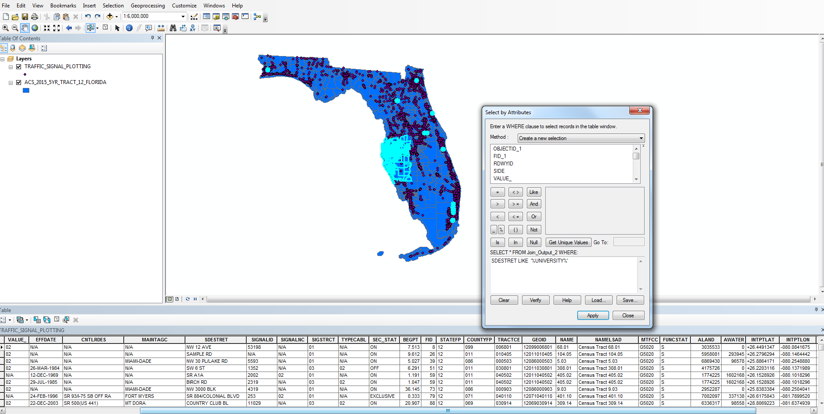

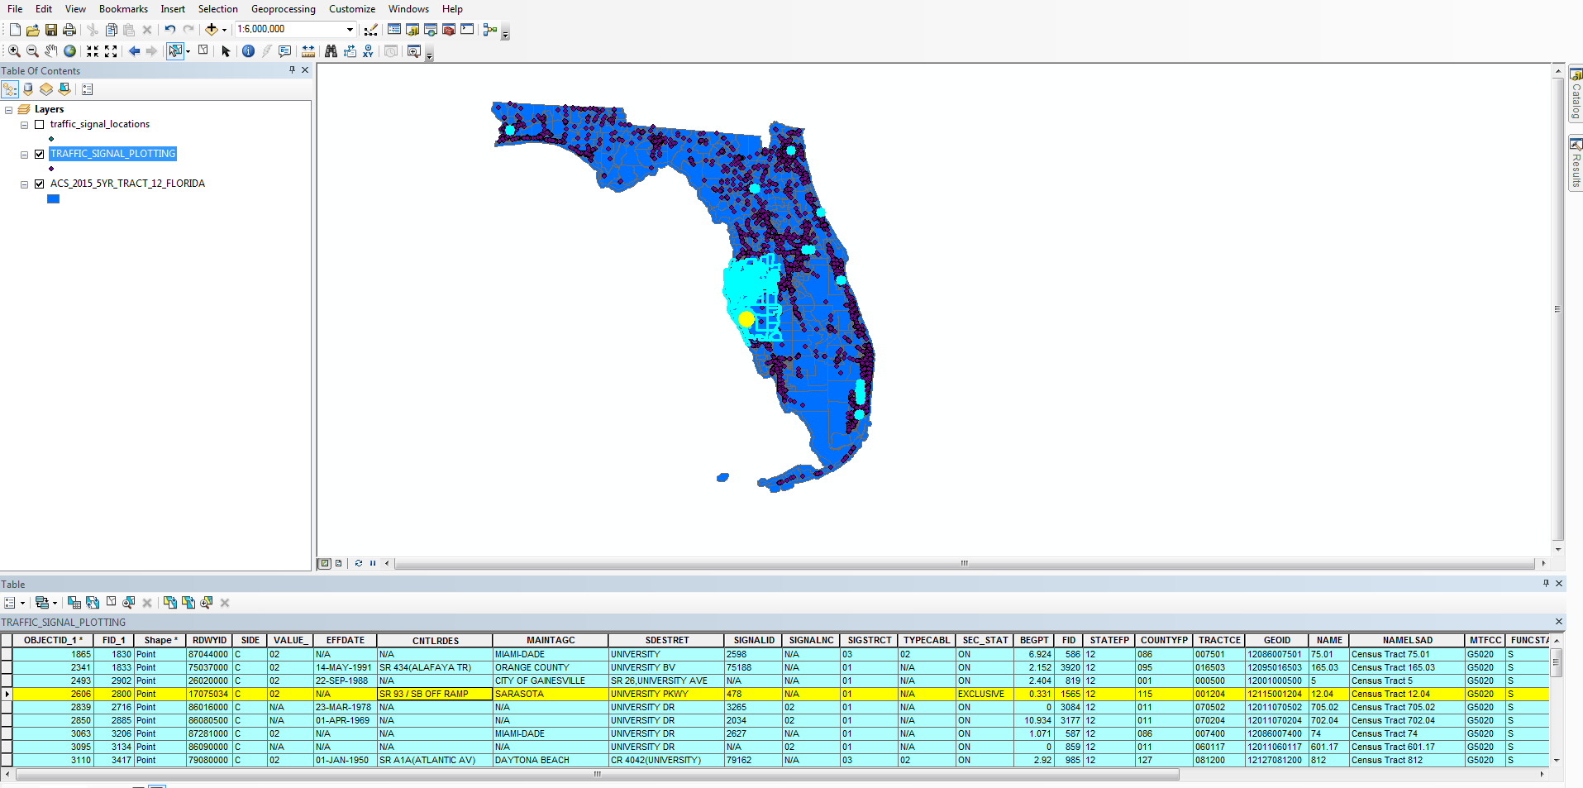

It was found that the data was not available for traffic signal near USF. Moreover, the data available had many null values meaning it was not properly mapped. Also, the attributes for data did not have information about the traffic signal intersection. To conclude, the data obtained was not relevant or complete.

The other options available was to visit University transportation department and ask for data or manually collecting some data from USF signals.

I ended up collecting the data manually by visiting the signal site. Also, used google map to find the coordinates of the location.

## Challenges

One major challenge I faced during this project was making google maps work. For this I had to call google API, also I had to use JavaScript code. Since, I haven’t worked on JavaScript before I faced challenge in fetching the coordinates and displaying them on google map using JavaScript code.