Name :- Atharva Virkar
Rollno :- 68

Code :-

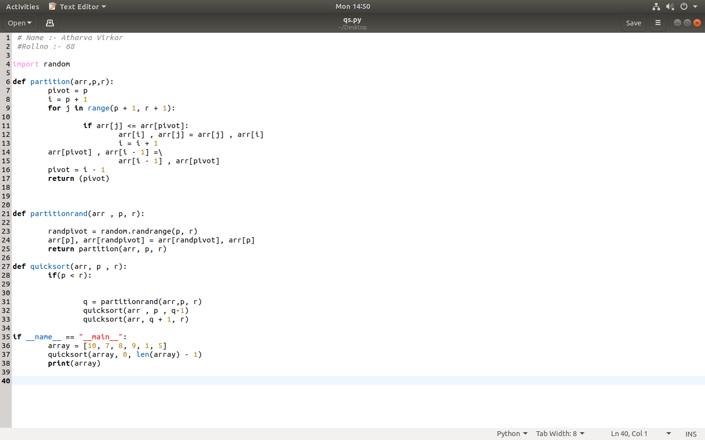

Output :-

