Aditya More Roll No:-34

**Practical no 5**

**Aim :** Design n-Queens matrix having first Queen placed. Use backtracking to place remaining Queens to generate the final n-queen‘s matrix.

**Code In Editor:**

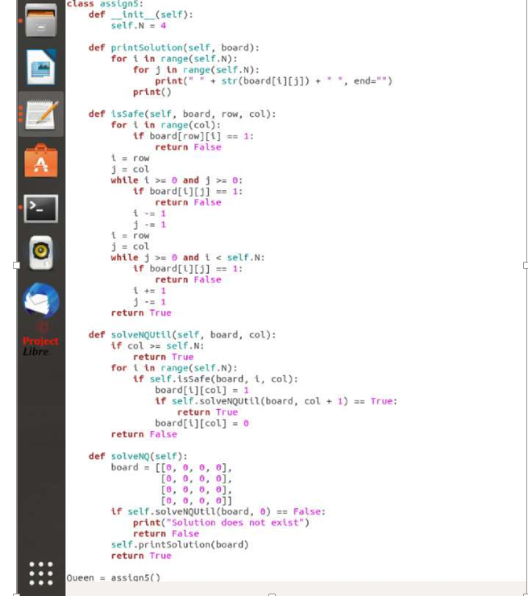

**Code In terminal :**

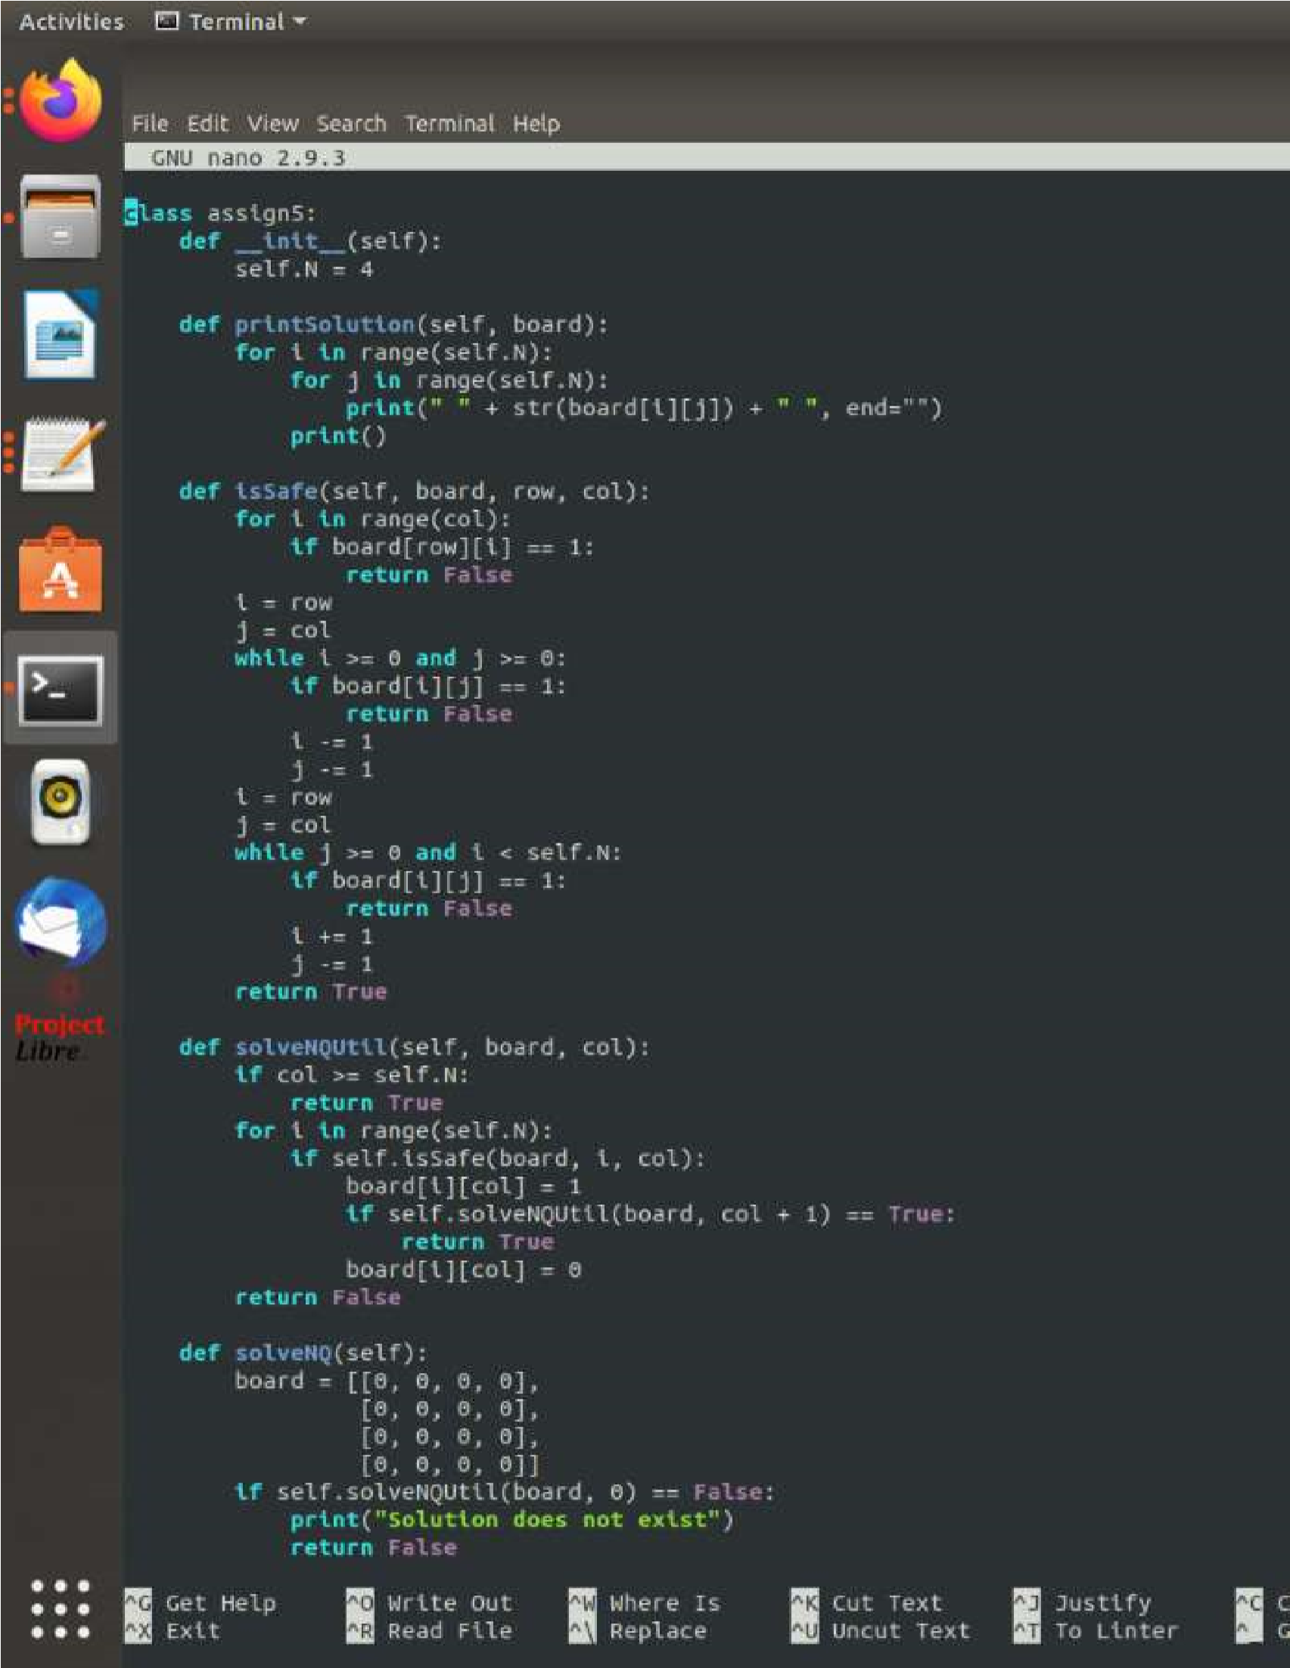

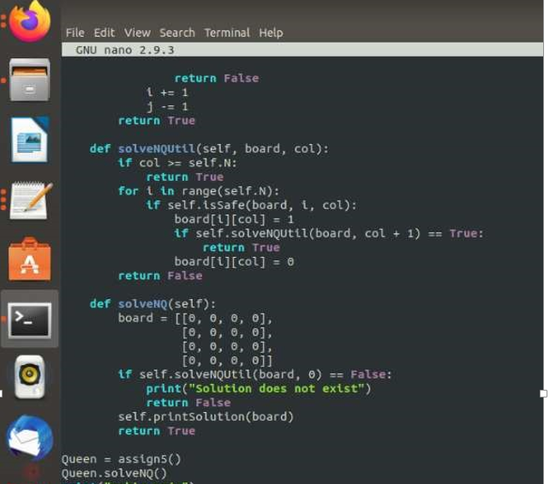

**Output:**

