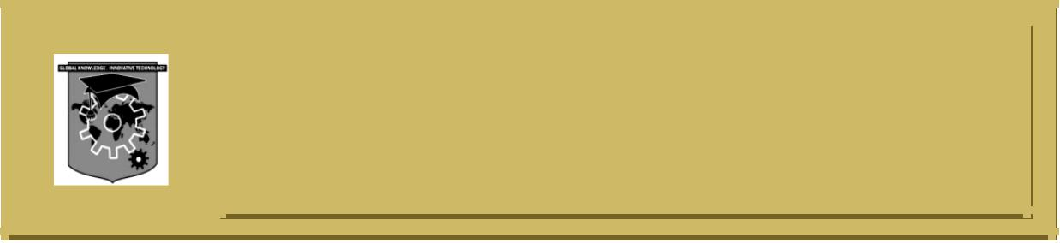**ACS COLLEGE OF ENGINEERINGC:\Documents and Settings\Administrator\Desktop\update kk\New Folder\naac-a-new.png**

**#207, Kambipura, Mysore road, Banglore-74**

**Department of Computer Science & Engineering**

**MODULE -3**

**REASONING, WEAK SLOT AND FILLER STRUCTURES**

1. What are the key issues which needs to be addressed by non monotonic reasoning system? Explain.
2. Briefly explain the motivation for fuzzy logic.
3. Explain how semantic networks are used in representation and reasoning.
4. Explain non monotonic logic and default logic with example. Which are the two common kinds of nonmonotonic reasoning defined in these logics?
5. State Baye’s theorem. How it is used in statistical reasoning?
6. Write a short note on Frames.
7. Define Frame. State the bayes theorem and explain the notation used.
8. Write a note on Justification based Truth Maintenance System (JTMS).
9. Write a note on closed world assumption.
10. Explain Bayesian network.
11. Explain abduction and inheritance.
12. Write a note on Dempster Shafter theory with example.
13. Define semantic network with an example.