Pain Recognition With Physiological Signals Using Multi-Level Context Information

In propose paper author employing multilevel deep learning algorithms for pain recognition as all existing uni-level traditional machine learning algorithms are not good at recognition. Multilevel algorithm giving good accuracy compare to uni-level algorithms like SVM, Random Forest, Linear Regression etc. In propose work author optimizing, selecting features and performing classification using multilevel algorithms like CNN + BI-LSTM (bi-directional LSTM).

Propose CNN + BI-LSTM is a multilevel algorithm where CNN will be using for features optimization and then BI-LSTM will select or extract relevant optimized features from CNN and then train a model for pain recognitions.

To train and test all algorithms author has used different datasets like BioVid Heat Pain database and the Emopain 2021 dataset. This datasets contains two different pain signals such as EEG and EDA and author done experiment on both datasets but this datasets are not freely available to download so from GITHUB we have downloaded few subjects EEG pain signals dataset and then train with above mention algorithms. Each algorithm performance is evaluated using different metrics like Accuracy, precision, recall, FSCORE and LOSO (Leave-One-Subject-Out cross-validation evaluation). LOSO will evaluate model for each label by leaving and selecting one label so by applying this algorithm we can have accurate score of the model based on each class label.

We have calculated correct prediction for each pain type using Confusion matrix graph and then calculated overall model score using LOSO.

Automatic pain recognition is essential in healthcare. In previous studies, automatic pain recognition methods preferentially apply the features extracted from physiological signals for conventional models. These methods provide good performance but mainly rely on medical expertise for feature extraction of physiological signals. This paper presents a deep learning approach based on physiological signals that have the role of both feature extraction and classification, regardless of medical expertise. This paper proposes multilevel context information for each physiological signal discriminating between pain and painlessness. Experimental results prove that multi-level context information performs more significantly than uni-level context information based on Part A of the BioVid Heat Pain database and the Emopain 2021 dataset. For Part A of the BioVid Heat Pain database, our experimental results for pain recognition tasks include Pain 0 and Pain 1, Pain 0 and Pain 2, Pain 0 and Pain 3, and Pain 0 and Pain 4.

To train all algorithms we have used below dataset which consists of 5 different pains from 0 to 4 and contains 57 subjects data. In below screen displaying entire dataset details

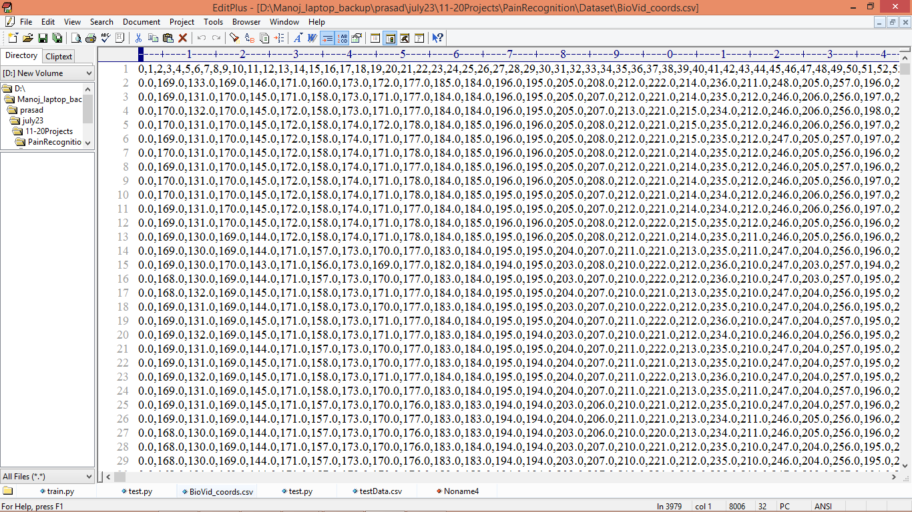

In above dataset screen first row contains dataset column number and remaining rows contains EEG signals and by using this dataset will train and test each algorithm performance.

Extension Concept

In propose work author has used multilevel or two level features selection algorithms like CNN + BI-LSTM and in extension work we have added 3 levels features optimization by combining CNN + BI-LSTM + BI-GRU where CNN optimized features will be selected by BI-STM and then BI-LSTM optimized features will be selected by BI-GRU and three level features optimization and selection helps in enhancing accuracy.

SCREEN SHOTS

To implement this project we have used JUPYTER notebook and below are the code and output screens with blue colour comments

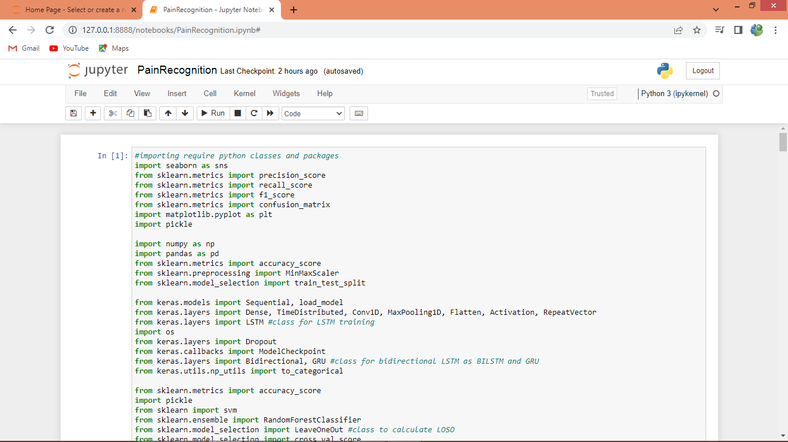

In above screen loading require classes and packages

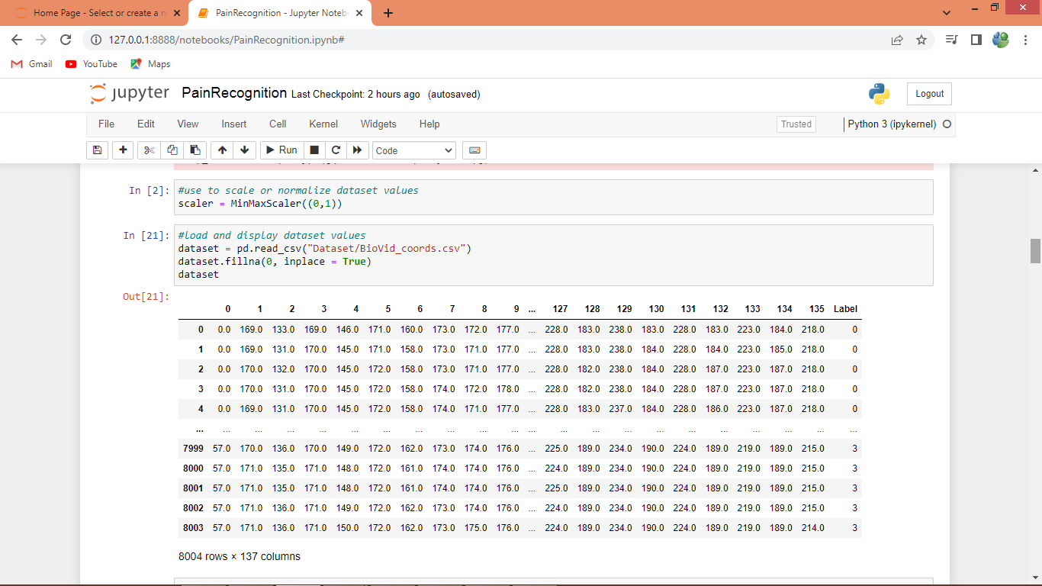

In above screen defining code for features normalization and then reading and displaying dataset where first column contains subject ID and last column contains Pains labels from 0 to 4

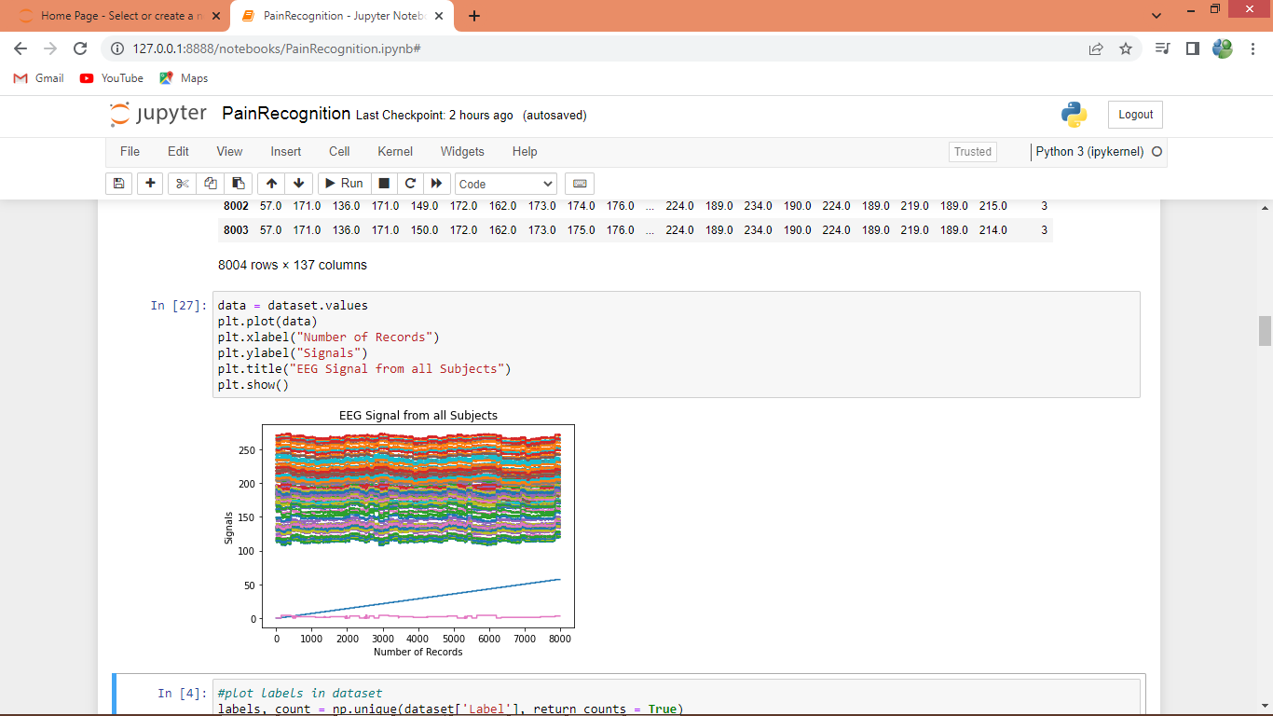

In above graph plotting EEG signals from all subjects where x-axis represents EEG record number and y-axis represents EEG signal values from all subjects

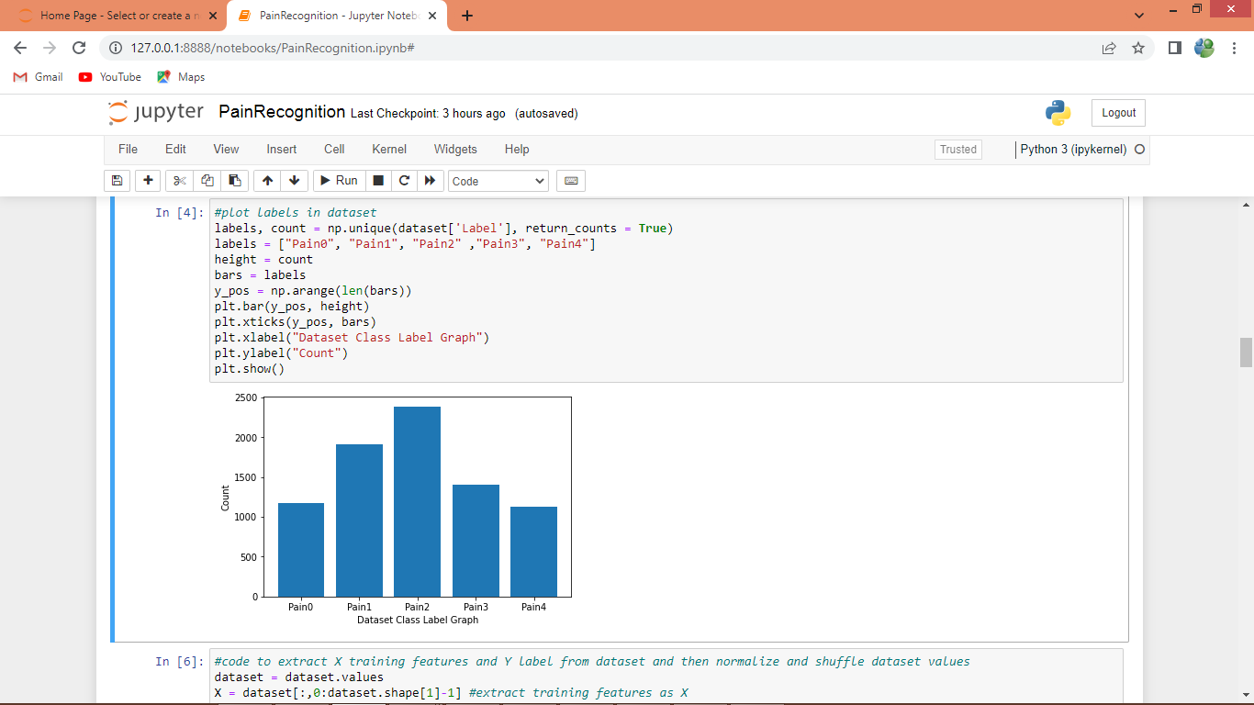

In above screen finding and plotting graphs of different pains and count of those pains ECG signals and in graph x-axis represents Pain Type and y-axis represents count

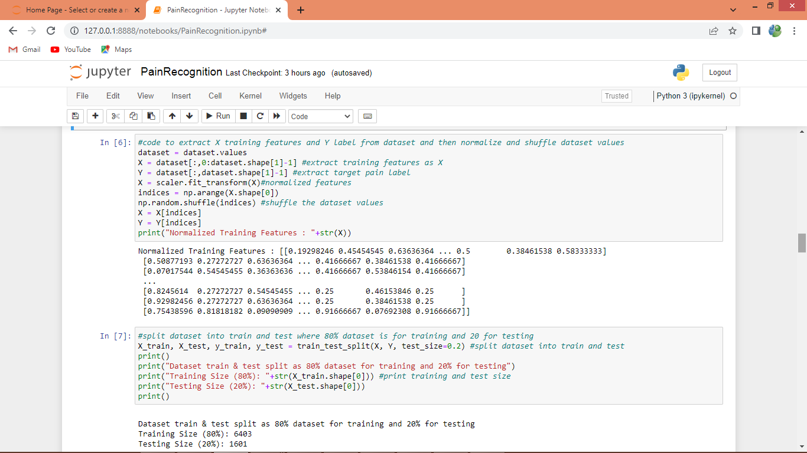

In above screen performing various dataset processing like features normalization, shuffling and splitting into train and test

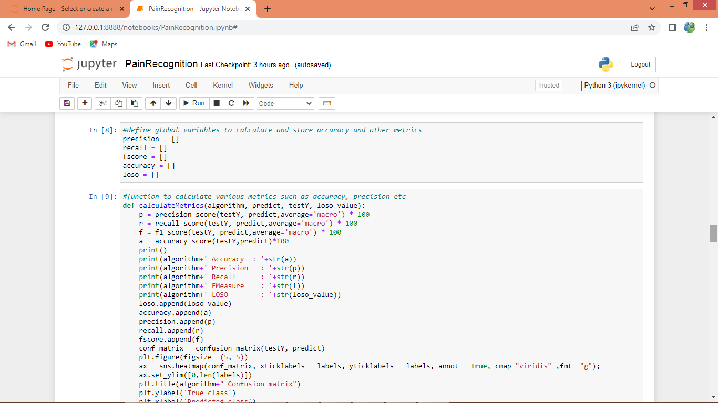

In above screen defining function to calculate accuracy, LOSO and other metrics

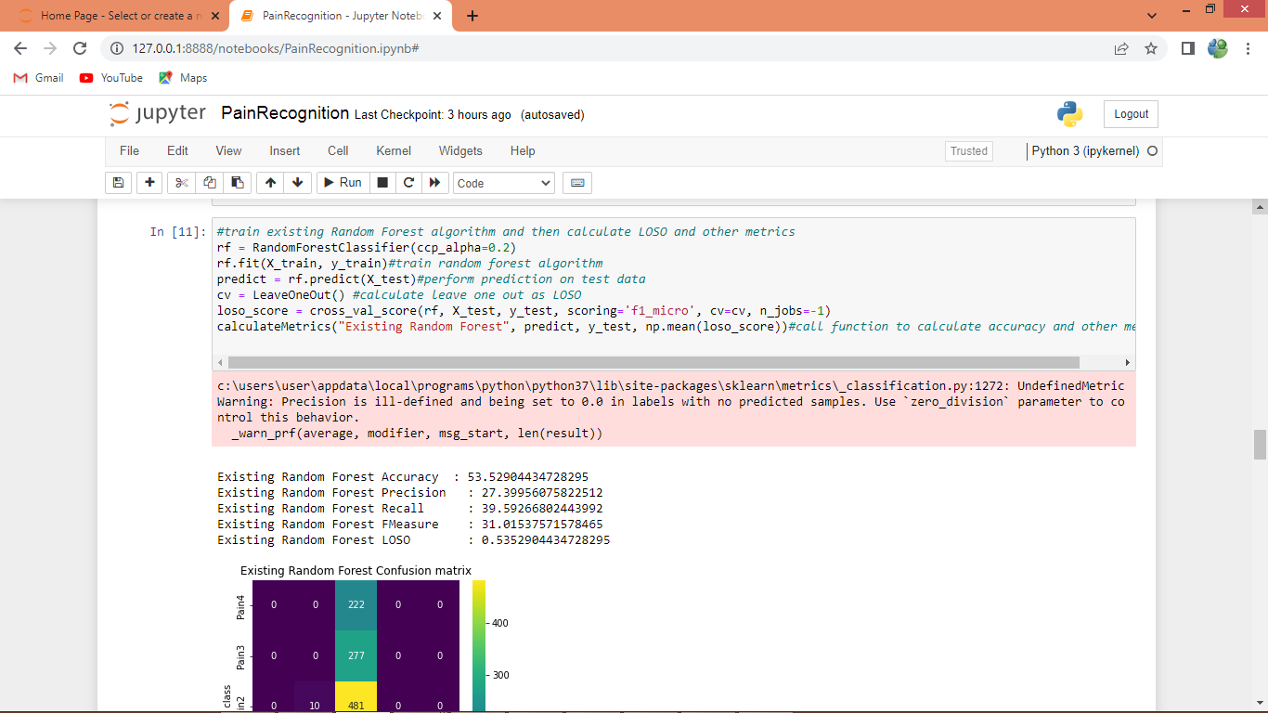

In above screen training existing algorithm called Random Forest and after execution will get below output

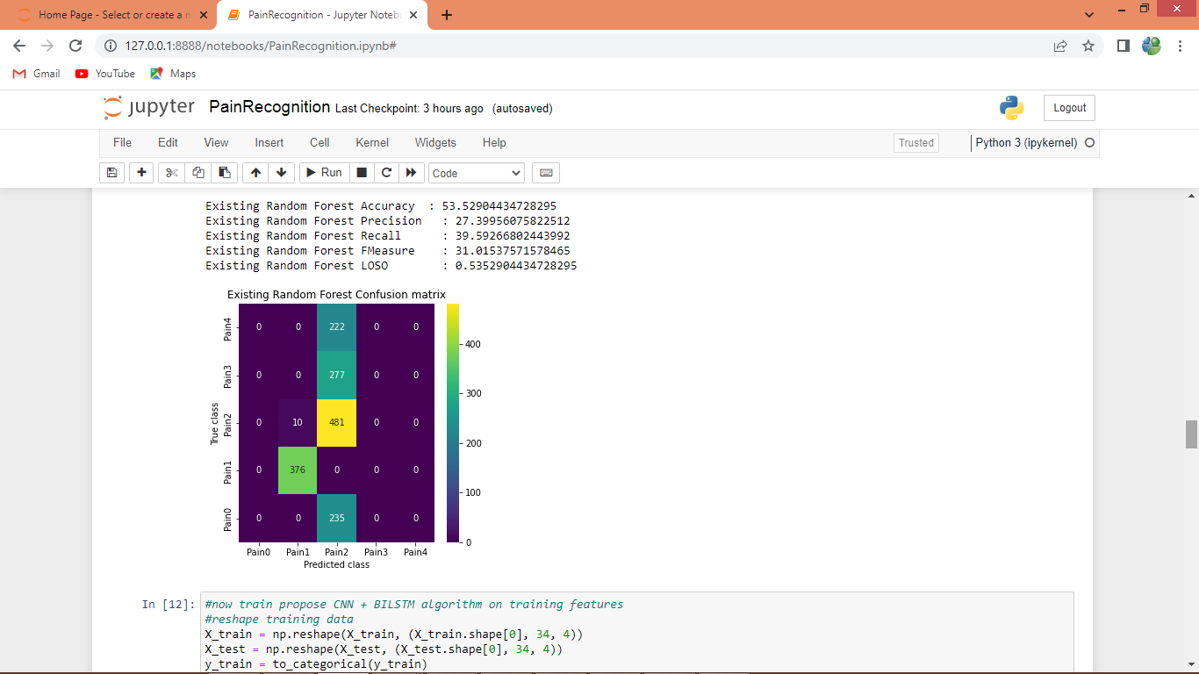

In above screen Random Forest got 53% accuracy and LOSO also as 53% and in confusion matrix graph x-axis represents Predicted Pain Labels and y-axis represents True Labels and we can see Random Forest predict all test data into single Pain Type which is wrong and below is the propose algorithm

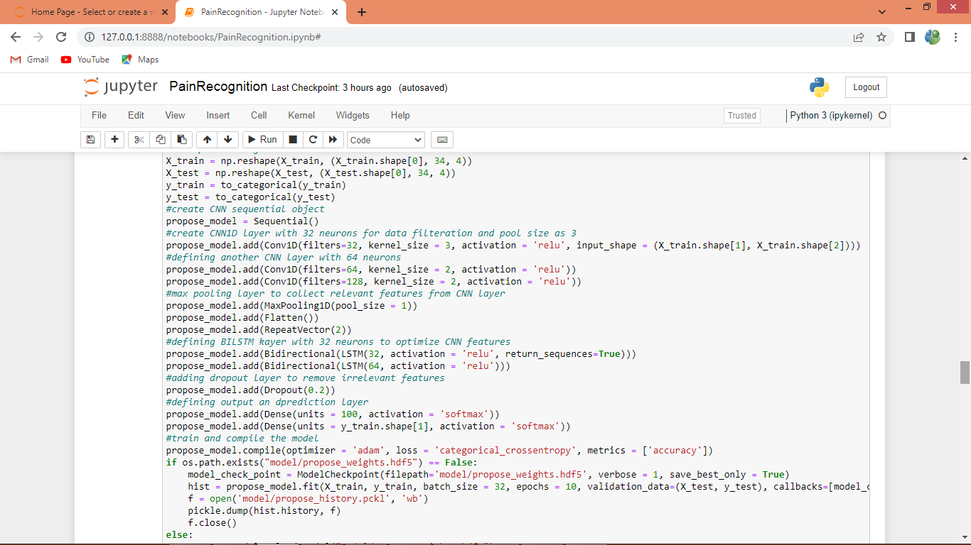

In above propose algorithm we are defining multilevel algorithm with CNN + BILSTM and after execution will get below output

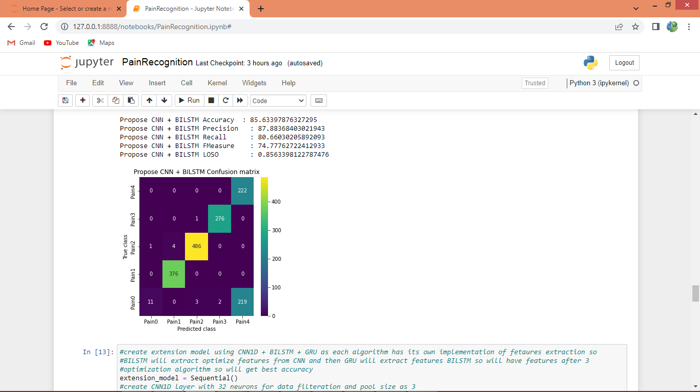

In above screen with propose multilevel algorithm we got 85% accuracy and in confusion matrix graph x-axis represents Predicted Labels and y-axis represents True Labels and all different colour boxes in diagnol contains correct prediction count and remaining blue boxes contains incorrect prediction count and in above graph we can see propose algorithm predicted all types of PAINS.

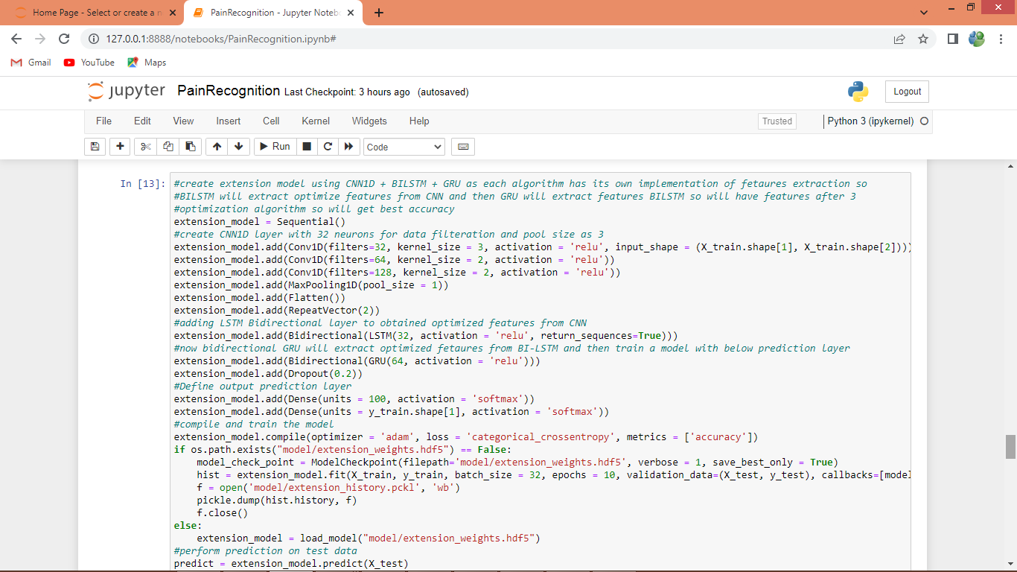

In above screen defining extension algorithm with CNN + BILSTM + BIGRU with 3 multilevel algorithms for features selection and optimizations and after execution of above block will get below output

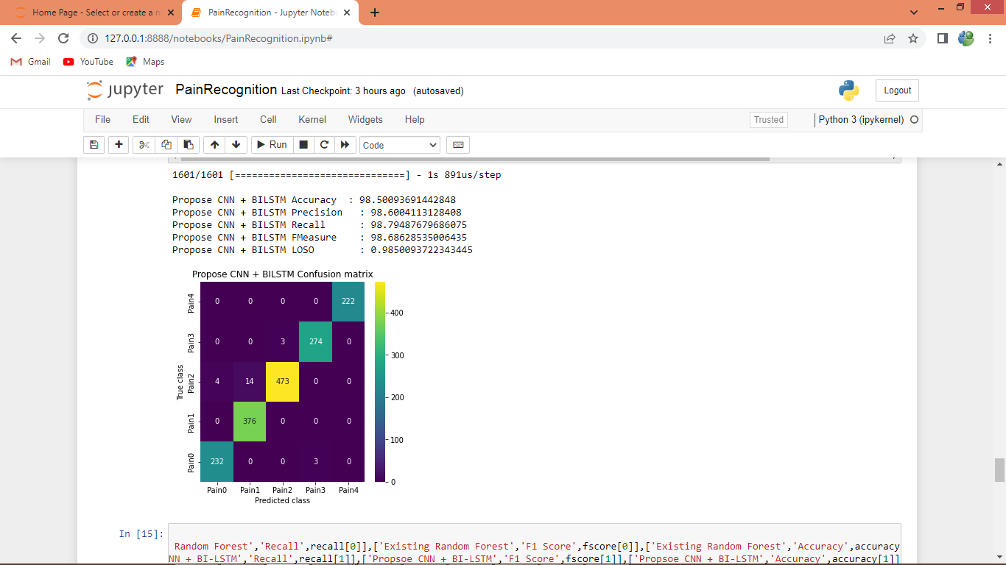

In above screen extension got 98% accuracy and in confusion matrix we can see all pains are predicted correctly which you can analyse in diagnol both x and y-axis pains are matching

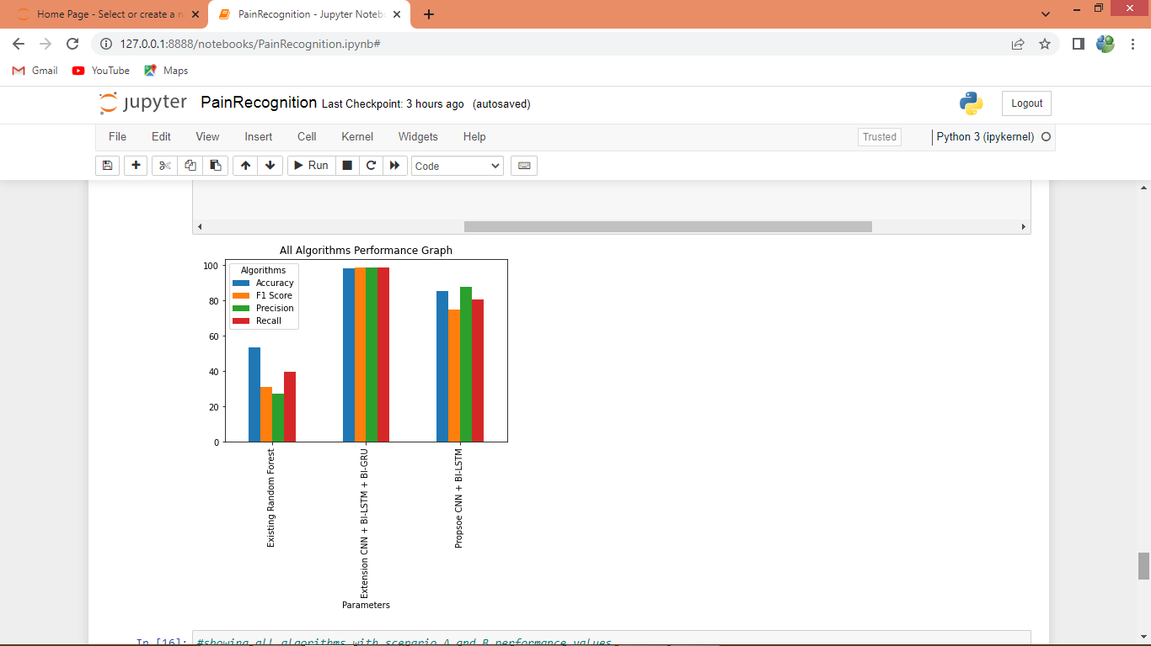

In above graph x-axis represents algorithm names and y-axis represents accuracy and other metrics in different colour bars and in all algorithms Extension got high accuracy

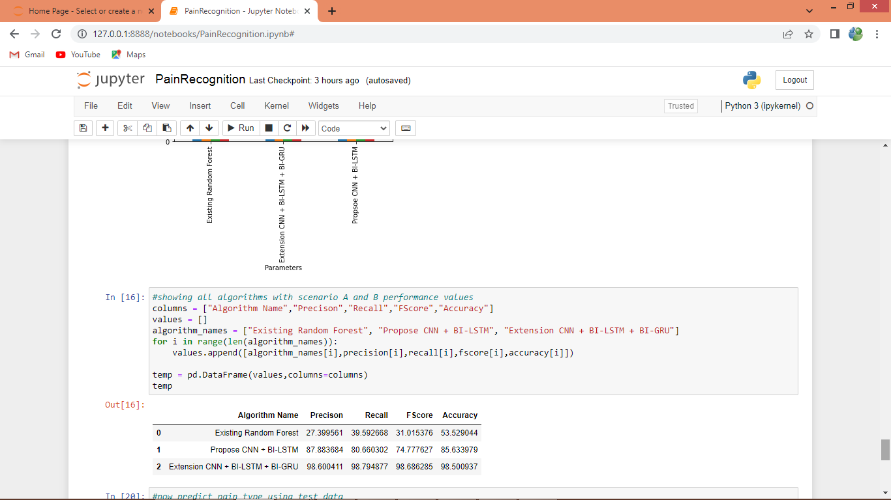

In above screen displaying all algorithm performance in tabular format

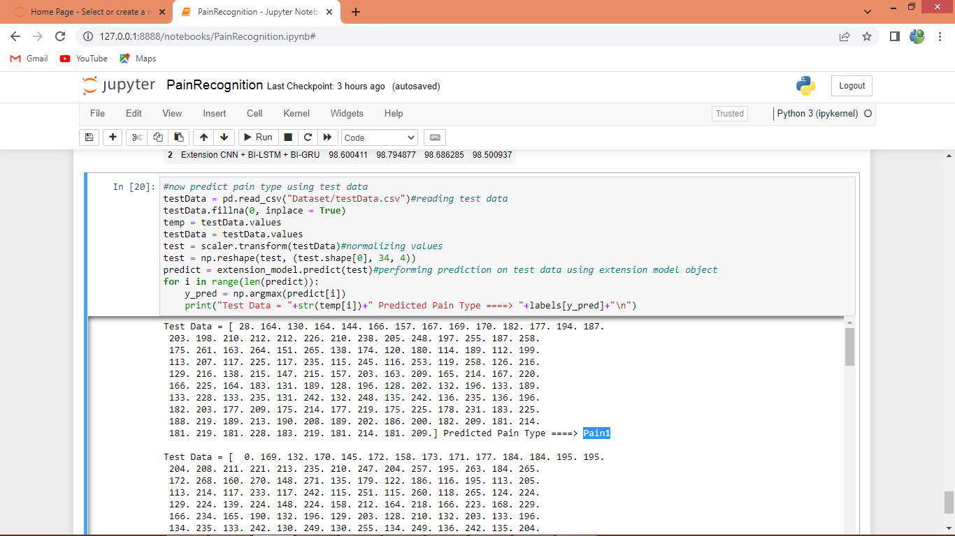

Above code reading test data from file and then normalizing and predicting pain type using extension model and in output before =🡺 symbol we can see ECG test data and after =🡺 arrow symbol we can see predicted PAIN type. In above screen predicted pain type showing in blue colour

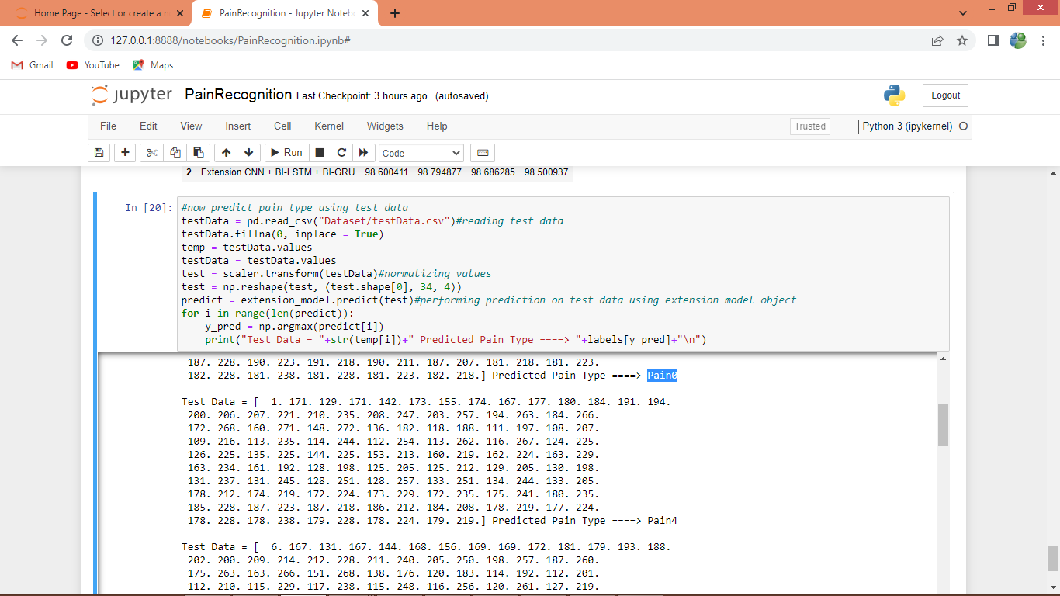

In above screen can see other predicted pain type