PLANT SAGE

CAPSTONE PROJECT PHASE- 2

Phase – II Report
Submitted by-

Aditya Mahaur | 21BCE11653
Naman Roy | 21BCE11639
Ayush Thakur | 21BCE11277
Anushka Gupta | 21BCE11309

in partial fulfillment of the requirements for the degree of Bachelor of Engineering and Technology


VIT Bhopal University Bhopal
Madhya Pradesh

April , 2025



Bonafide Certificate

Certified that this project report titled “PLANT SAGE” is the bonafide
work of
“Aditya Mahaur | 21BCE11653,
Naman Roy | 21BCE11639,
Ayush Thakur  Anushka Gupta | 21BCE11277,  21BCE11309 ’’ who carried out the project work under my
supervision. This project report of Phase-II is submitted for the DSN4095 Capstone Project ‘Review 2’ scheduled between 01.04.2025 and 07.04.2025.

Mr. VIJAY KUMAR TRIVEDI
Supervisor

Mr. VISHAL SINGH BHATI
Reviewer 1

Mrs. PAVITHRA RATHINAVEL
Reviewer 2



Declaration of Originality

We hereby declare that this report entitled “PLANT SAGE” represents our original work carried out for the DSN Capstone project as a student of VIT Bhopal University and, to the of our knowledge, it contains no material previously published or written by another person, nor any material presented for the award of any other degree or diploma of VIT Bhopal University or any other institution. Works of the other authors cited in this report have been duly acknowledged under the section” References”.

Acknowledgement

We would like to extend our heartfelt gratitude to our project supervisor, Mr. Vijay Kumar Trivedi, for his invaluable guidance, support, and encouragement throughout the course of this project. His expertise, insightful feedback, and unwavering commitment have been instrumental in shaping the direction of our work and helping us overcome numerous challenges along the way.

We also sincerely thank our reviewers, Mr. Vishal Singh Bhati and Mrs. Pavithra Rathinavel for their constructive feedback and valuable suggestions, which have greatly contributed to refining our project. Their insights have helped us enhance the accuracy, efficiency, and overall impact of our work, ensuring that Plant Sage meets its objectives effectively.
We wish to express our sincere thanks to VIT Bhopal University for providing the necessary resources and fostering an environment that facilitated the successful completion of this project. Our appreciation also goes out to our reviewers, whose contributions and collaboration added valuable perspectives and enriched the quality of the project.
Furthermore, we are deeply grateful to our family and friends for their understanding, encouragement, and patience during this journey. Their support has been a constant source of motivation and inspiration.
Lastly, we would like to thank everyone who contributed, directly or indirectly, to the success of this project—whether through feedback, discussions, or encouragement. Your contributions have been instrumental in shaping the final outcome of this work.

Index

Sl. No. | Topic | Page No.
1 | Introduction | 6
1.1 | Motivation | 6
1.2 | Objective | 7
2 | Existing Work | 8
3 | Technology Used | 9
4 | Methodology | 10
4.1 | Architecture Overview | 10
4.2 | System Components | 11
4.3 | Working Principle | 12
5  6  6.1  6.2  6.1 | Individual Contribution  Progress Section  Progress Overview  UI Snapshots  ML Model Development | 14  16  16  17  18
6.4 | Next Steps and Future Work | 19
7  8 | Conclusion  References | 22  23

CHAPTER 1: INTRODUCTION
Plant Sage is an innovative web application designed to assist farmers, gardeners, and plant enthusiasts in accurately diagnosing plant diseases with minimal effort. By simply capturing an image of an affected plant, users receive real-time feedback on the disease, including detailed insights on its causes, symptoms, and possible treatment methods. Leveraging cutting-edge machine learning models, the app ensures precise identification by analysing a vast dataset of plant diseases, spanning multiple plant species and environmental conditions.
To deliver a seamless and intuitive user experience, Plant Sage is built as a web app, ensuring high performance and accessibility across different devices. This allows users to access the platform effortlessly, making advanced agricultural technology available to a wider audience.

Motivation
Plant diseases are a significant hurdle for both agriculture and home gardening, leading to reduced crop yields, financial setbacks, and threats to food security. Preventing widespread damage and ensuring plant health requires early identification and timely intervention. However, traditional disease detection methods often rely on expert analysis, which is not always accessible, particularly for farmers in remote or rural areas. Without proper diagnosis, infections can spread rapidly, affecting entire fields or gardens and causing severe losses.
Many small-scale farmers and gardeners lack access to specialized knowledge or professional advice, making it difficult to identify plant diseases accurately. This often results in misdiagnoses or delays in treatment, leading to ineffective solutions, excessive pesticide use, and long-term environmental harm. To address these challenges, Plant Sage was developed as a smart, user-friendly mobile application that enables instant disease detection through image recognition. By leveraging AI-driven analysis, the app eliminates uncertainty, providing users with precise diagnoses and actionable recommendations to protect their plants. The goal is to make plant disease detection more accessible, efficient, and reliable, reducing dependence on external expertise while promoting sustainable agricultural practices.

Objective
The primary objective of Plant Sage is to mitigate the effects of plant diseases by enabling early detection and informed decision-making. By leveraging AI and machine learning, the app enhances agricultural productivity, reduces losses, and fosters healthier plant growth.
Key objectives include:
- Instant Disease Detection: Utilize advanced Convolutional Neural Networks (CNNs) to analyse plant images and accurately classify diseases within seconds.
- Actionable Recommendations: Provide users with step-by-step guidance on treatment options, preventive measures, and best practices tailored to the identified disease.
- Interactive and Easy-to-Use User Experience: Ensure ease of use through an intuitive interface designed with web technologies, making the platform accessible to users with varying levels of technical expertise.
- Cross-Platform Accessibility: Enable smooth operation on both Android and iOS devices, reaching a broad spectrum of users across different regions.

By simplifying the process of disease identification and providing timely solutions, Plant Sage empowers users to take proactive measures, ultimately contributing to more resilient crops and sustainable agricultural practices. The integration of AI-driven diagnostics with a user-friendly mobile platform ensures that farmers, gardeners, and plant enthusiasts can confidently manage plant health without requiring specialized knowledge or external assistance.

CHAPTER 2: EXISTING WORK
Machine learning models like convolutional neural networks (CNN) and deep learning techniques were employed to detect plant diseases using a dataset of 87,848 leaf images captured in both laboratory and real cultivation conditions. The CNN architectures used include AlexNet, AlexNetOWTBn, GoogLeNet, VGG, and OverFeat, with models trained using Torch7 and LuaJIT.
Three different approaches were explored:
    - Approach 1: The dataset was split into 80% training and 20% testing sets, ensuring a balanced distribution of laboratory and field images.
    - Approach 2: Images were preprocessed and cropped to 256x256 pixels while maintaining the same training/testing ratio.
    - Approach 3: Images were directly sent to a LLM like ChatGPT vision using a prompt to analyze and display the disease

The VGG model achieved the highest performance, with a 99.53% success rate in classifying previously unseen plant images. Models trained on original plant leaves outperformed those using processed images, with the VGG and AlexNetOWTBn architectures demonstrating the best results.
An approach to using deep learning method was explored in order to automatically classify and detect plant diseases from leaf images. The developed model was able to detect leaf presence and distinguish between healthy leaves and 13 different diseases, which can be visually diagnosed. The complete procedure was described, respectively, from collecting the images used for training and validation to image preprocessing and augmentation and finally the procedure of training the deep CNN and fine-tuning. Different tests were performed in order to check the performance of the newly created model.

During the research we found that either the models were based only on CNN or only with an API call to a paid Large Language Model. We could not find a suitable open- source contribution in this field which also offers a prescriptive analysis, all the applications just detected the disease.

CHAPTER 3: TECHNOLOGIES USED

The Plant Sage project combines advanced technologies and deep learning models to develop an effective solution for plant disease detection. Key technologies and machine learning models employed in this project are:

- Web-Based Platform: Plant Sage is developed as a web application, allowing users to access it from any device with a browser. This ensures broader accessibility without the need for platform-specific installations.

- Deep Learning Models: To classify plant diseases from leaf images, Plant Sage leverages deep learning techniques, specifically Convolutional Neural Networks (CNNs). CNNs are highly effective for image classification tasks due to their ability to automatically learn spatial hierarchies of features from input images.

- Computer Vision: Computer vision plays a pivotal role in the Plant Sage project by enabling the automated detection and classification of plant diseases through image analysis. The integration of computer vision techniques allows the application to process and interpret visual data from leaf images captured by users.

- Cloud Storage and Processing: The website utilizes cloud-based solutions for storing images and managing user data efficiently. This ensures scalability, reliability, and security in handling large amounts of data while providing seamless access to past diagnoses.

Plant Sage combines machine learning, cloud computing, and AI-driven insights to create a user-friendly tool for identifying plant diseases. Whether you are a farmer aiming to protect your crops or a home gardener maintaining healthy plants, this website provides expert advice at your fingertips.

CHAPTER 4: METHODOLOGY
The system design and architecture of the Plant Sage application are fundamental to its functionality, scalability, and performance. This section outlines the overall architecture, components, and working principles of the system.

Architecture Overview

- Client Layer: The web application provides users with an intuitive interface to upload leaf images, view disease diagnosis results, and receive recommendations. The platform ensures accessibility for users with varying levels of technical expertise.
• Backend Layer: Acts as the bridge between the web application and AI models. It processes images, communicates with the machine learning model for disease detection, and generates insights and recommendations. It also manages data requests, user interactions, and logs disease reports for further analysis.
• Database Layer: Ensures secure and structured data storage. A cloud-based database is used to store user profiles, past diagnoses, analyzed images, and an extensive knowledge base of plant diseases, symptoms, and treatments.
• Machine Learning Layer: The core intelligence of the platform. A CNN-based model processes images for disease detection, while additional AI components generate personalized recommendations for treatment and prevention. Continuous model updates enhance accuracy, allowing the system to adapt to new disease patterns over time.

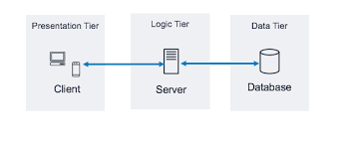
Fig 4.1.1 Architecture Overview

4.2 System Components
1. Web Application: The front-end of the application is designed to provide a seamless, intuitive, and high-performance user experience across various devices. The web interface ensures smooth navigation, interactive elements, and a visually appealing design, making the application both efficient and user-friendly.
- User Interface (UI): Designed for simplicity and ease of use, allowing users to upload plant images, view disease detection results, and receive treatment recommendations through an intuitive dashboard.
- Image Upload Module: Enables users to upload high-quality images of plant leaves for analysis.
- API Integration: Facilitates communication with the backend server via RESTful APIs, ensuring secure data exchange between the web application and cloud-based services.
2. Backend Server: The backend of the Plant Sage web app is designed to efficiently manage data, authenticate users securely, and process images with minimal latency. The backend handles the storage, retrieval, and analysis of plant disease data, ensuring a smooth user experience.
- Server-side Processing: The backend processes requests from the web application, handling image uploads, model inference, and disease detection. If additional processing is needed, it can integrate with external AI services.
- Database Management: A structured database is used to store plant disease information, historical scan data, and treatment suggestions. It ensures real-time syncing, allowing users to access updated disease records.
- Cloud Storage: A secure cloud storage solution is used for managing uploaded images. This allows the application to retain a history of scanned plant images for future reference while ensuring efficient storage management.
3. Machine Learning Models: Plant Sage utilizes a Convolutional Neural Network (CNN) to analyse leaf images and detect plant diseases with high accuracy. CNNs are widely used in image processing tasks due to their ability to automatically extract important features from images, such as patterns, textures, and color variations. The model is trained on a large dataset of plant images, allowing it to classify various plant diseases effectively. Once trained, the model is deployed on the cloud for inference.
4. Working Principle: The Plant Sage web application is designed to help farmers, gardeners, and plant enthusiasts quickly diagnose plant diseases using machine learning. It works by allowing users to upload an image of a plant leaf, analysing it with an AI model, and providing instant recommendations for treatment. Here’s how it all comes together:
- Uploading the Image: A user accesses the Plant Sage web application and uploads a picture of a plant leaf that looks unhealthy. The interface ensures the image is clear and well-lit, helping improve the accuracy of the diagnosis.
- Uploading and Storing the Image: Once the photo is uploaded, it’s sent securely to the application’s backend, where it gets stored in a cloud-based storage system. This step ensures that the image is safely managed and can be retrieved for further analysis.
- Preparing the Image for Analysis: Before the application can detect any diseases, the image undergoes preprocessing, where it is resized, normalized, and enhanced to make sure the AI model can read it properly. This ensures the application provides reliable and consistent results.
- Detecting Plant Diseases with CNN: The pre-processed image is fed to a Convolutional Neural Network (CNN) model. The model scans the leaf, compares it to a vast database of plant diseases, and determines whether the plant is healthy or infected. It also provides a confidence score, indicating how certain it is of the prediction.
- Getting Instant Results and Treatment Advice: After identifying the disease, the application displays a concise summary of possible treatments, preventive measures, and best practices. These guidelines are typically sourced from agricultural references and validated domain knowledge.
- Storing Data for Learning and Improvement: Every analysed image, diagnosis, and user interaction is stored in a structured database. This data helps improve the application’s accuracy and performance while ensuring users can access their past reports whenever needed.
- Constantly Learning and Improving: As more users engage with the application, the model can be retrained or updated with new images and feedback to improve its accuracy over time. The expanded dataset ensures robust, real-world adaptability.
Plant Sage brings together machine learning, cloud computing, and AI-driven insights to create a robust, user-friendly tool for spotting plant diseases. This application puts expert advice right at users' fingertips, whether they are farmers aiming to protect their crops or home gardeners looking to maintain healthy plants—offering a smarter way to care for them.

Working Principle
The Plant Sage app is designed to help farmers, gardeners, and plant lovers quickly diagnose plant diseases using ML. It works by capturing an image of a plant leaf, analyzing it with machine learning, and providing instant recommendations for treatment. Here’s how it all comes together:

The Plant Sage website is designed to help farmers, gardeners, and plant lovers quickly diagnose plant diseases using ML. It works by uploading an image of a plant leaf, analyzing it with machine learning, and providing instant recommendations for treatment. Here’s how it all comes together:

1. Uploading the Image: A user accesses the Plant Sage website and uploads a picture of a plant leaf that looks unhealthy. The interface ensures that users can easily select and submit high-quality images for accurate diagnosis.

2. Storing the Image: Once the photo is uploaded, it is sent securely to the website’s backend, where it gets stored in a cloud database. This step ensures that the image is safely managed and can be retrieved for further analysis.

3. Preparing the Image for Analysis: Before the system can detect any diseases, the image undergoes preprocessing. It is resized, normalized, and enhanced to ensure the AI model can read it properly, providing reliable and consistent results.

4. Detecting Plant Diseases with CNN: The preprocessed image is analyzed by a Convolutional Neural Network (CNN) model. The model scans the leaf, compares it to a vast database of plant diseases, and determines whether the plant is healthy or infected. It also provides a confidence score, indicating the accuracy of the prediction.

5. Getting Instant Results and Treatment Advice: After identifying the disease, the website displays a concise summary of possible treatments, preventive measures, and best practices. These guidelines are sourced from agricultural references and validated domain knowledge.

6. Storing Data for Learning and Improvement: Every analyzed image, diagnosis, and user interaction is stored in the database. This data helps improve the accuracy and performance of the system while allowing users to access their past reports whenever needed.

7. Constantly Learning and Improving: As more users engage with the website, the model can be retrained or updated with new images and feedback to improve its accuracy over time. The expanded dataset ensures robust, real-world adaptability.

Plant Sage combines machine learning, cloud computing, and AI-driven insights to create a user-friendly tool for identifying plant diseases. Whether you are a farmer aiming to protect your crops or a home gardener maintaining healthy plants, this website provides expert advice at your fingertips.

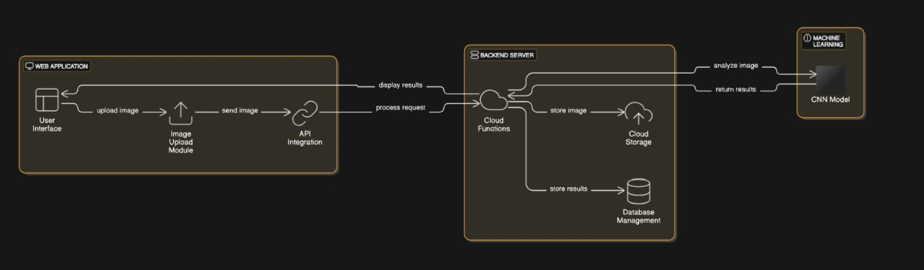

Fig. 4.3.1 Working Principle

CHAPTER 5: INDIVIDUAL CONTRIBUTIONS

Aditya Mahaur
Aditya played a pivotal role in the project by focusing on CNN model and its integration with the web application. His Core responsibilities included:

  - Model Selection: Aditya researched and evaluated various CNN models to determine which is the most effective for our application. He assessed their performance in terms of accuracy and efficiency, ensuring they met the specific needs of farmers.
  - Deployment Methods: He explored different deployment strategies to integrate the model into the web application, optimizing the overall user experience. His experimentation led to the selection of methods that balanced performance and usability, crucial for end-users who may not be tech-savvy.
  - Collaborative Input: Aditya collaborated closely with other team members, providing insights into how the output could be effectively tailored to meet user needs, enhancing the clarity and accessibility of the generated prediction.

Anushka Gupta

Anushka made significant contributions through her extensive review of research papers and participation in web application development. Her efforts included:

Literature Review: She analyzed academic papers and industry reports to identify potential models, informing the model selection process.

Identifying Challenges: She documented challenges faced in similar projects, helping the team anticipate and address potential issues.: Anushka collaborated with Ayush in developing the web application, assisting in workflows, , and improving the user experience.

Model Recommendations: Based on her research, she recommended models to pursue, facilitating informed decision-making

Ayush Thakur
Ayush focused on the backend integration of the web application, making vital contributions such as:
• Model Integration: He integrated the Convolutional Neural Network (CNN) into the web app. This involved ensuring that data flow between the models and the website was seamless, allowing for real-time processing of user input.
• Deployment Strategy: Ayush excels in developing a comprehensive deployment strategy that includes server management and monitoring. His approach ensures that the application remains stable and responsive, even under high usage conditions.
• Collaboration with Frontend: He has been working to ensure that the backend processes align smoothly with the user interface, enabling a cohesive user experience from image upload to diagnosis and prescription. He has also contributed to designing the user interface of the website.

Naman Roy
Naman has a critical role in the development of the CNN model, with contributions that included:

  - Data Curation: He undertook extensive research to compile a high-quality dataset for training CNN. This involved sourcing data from multiple reputable websites and ensuring it was well-labeled and relevant for plant disease detection.
  - Model Training and Optimization: Naman trained the CNN using TensorFlow, employing various techniques to optimize its performance, such as fine-tuning hyperparameters and experimenting with different architectures. His expertise significantly improves the model’s accuracy in identifying plant diseases.
  - Validation and Testing: He will be establishing a rigorous validation process to assess CNN’s performance, including testing against real-world scenarios to ensure reliability. His commitment to quality assurance ensures that the model produced is accurate and actionable results for farmers.

CHAPTER 6: PROGRESS SECTION

This section provides a detailed overview of the work completed, significant accomplishments achieved so far, and the remaining tasks required to bring the project to completion. It highlights the status of critical project components, and the next steps in the project timeline.

Progress Overview

The development and optimization of the web application have been successfully completed, integrating AI-powered disease detection and efficient processing with TensorFlow Lite. Each component has been fine-tuned for accuracy, speed, and accessibility. While the core system is fully functional, future enhancements are planned to further improve user experience and expand capabilities.

Optimized Processing with TensorFlow:

To enhance efficiency, TensorFlow is used to optimize the disease detection model. This lightweight framework enables fast inference, reducing latency and improving response times. The system is designed to process images efficiently, ensuring real-time disease detection with minimal computational load.

Smart Recommendations with Large Language Models (LLMs):

After detecting a disease, the web application utilizes Large Language Models (LLMs) to generate detailed treatment recommendations. These AI-driven insights include treatment options, preventive measures, and best farming practices tailored to the detected disease. This ensures that users receive not just a diagnosis but also actionable guidance for plant care.

The Web Application:

The Plant Sage platform has been successfully developed as a web-based application, providing a seamless and accessible experience across various devices. With an intuitive user interface, users can easily upload plant images, receive instant disease analysis, and access AI-generated recommendations. The web-based approach ensures accessibility without requiring platform-specific installations, making it available to a broader audience.

Intelligent Disease Detection and Scalable Integration

The web application utilizes a Convolutional Neural Network (CNN) to analyze leaf images and accurately detect plant diseases. Trained on a diverse dataset, the model classifies plants as healthy or infected while identifying specific diseases. Fully integrated into the platform, the CNN model works alongside cloud-based processing to deliver fast and reliable results. This scalable system ensures efficient performance, allowing for continuous improvements and updates.

User Interface Snapshots
This section showcases visual snippets of the Web app's User Interface (UI), highlighting its design, layout, and key features. These snapshots provide a glimpse into how users interact with the app, emphasizing the intuitive and accessible design that caters to a diverse audience, including farmers and agricultural experts.

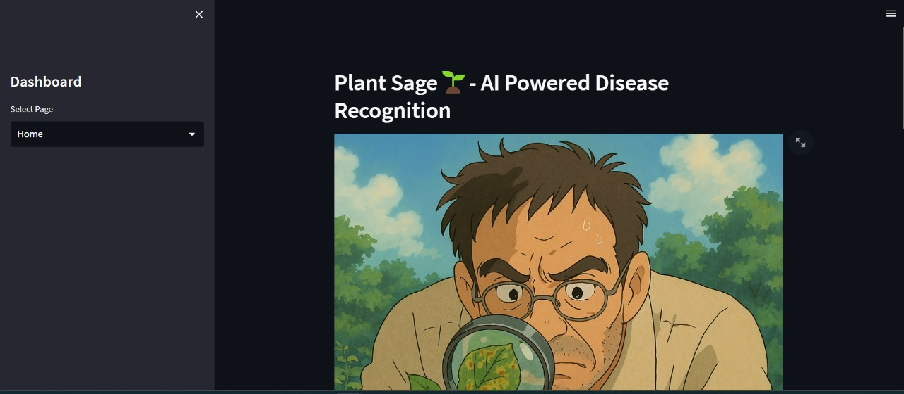
Fig 6.2.1 Home Page
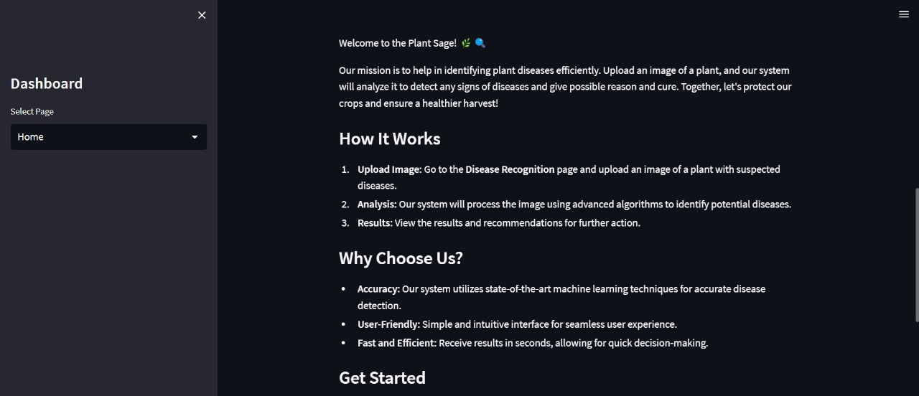
Fig 6.2.2 Home Page
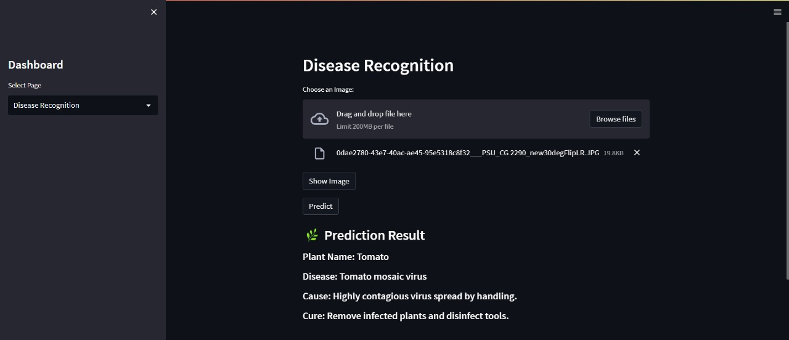
Fig 6.2.3 Output Page

ML Model Development:
The ML model for plant disease detection has been developed, trained, and fine-tuned using a robust dataset containing plant images. The model demonstrates high accuracy and reliability in identifying plant diseases, providing confidence in its practical application. It has been trained and tested using a comprehensive dataset of plant images to ensure high accuracy and reliability in disease detection. The model was trained covering a variety of plant species and diseases. This diverse dataset ensures that the model can accurately identify a wide range of plant diseases, even under different environmental conditions or slight variations in the appearance of the plants. The CNN model was trained to recognize patterns in the images, such as color changes, spots, lesions, and other visual signs of disease, to differentiate between healthy and diseased plants.

Image Capture via Camera:

The app allows users to take pictures of the plant using their device’s camera. This step is critical because the quality of the image directly impacts the model's accuracy. To assist the user, the app provides guidelines for taking clear, focused pictures of the plant’s leaves.

Image Processing and Disease Detection
Once the image is captured, the app processes the picture and feeds it into the CNN model for disease detection. The model analyzes the image for specific features associated with plant diseases, comparing it to patterns learned during training.

Output and Recommendations
The model then returns a prediction of whether the plant is healthy or affected by a particular disease. If a disease is detected, the app provides the name of the disease along with a confidence score, indicating the model's certainty in its diagnosis.

ML Model Output Snippets
This section presents snippets of the output generated by the Machine Learning model, showcasing its predictions and results when processing plant images. These outputs include disease detection labels, confidence scores, and relevant recommendations, providing insight into the model’s accuracy and how it aids in identifying plant diseases.

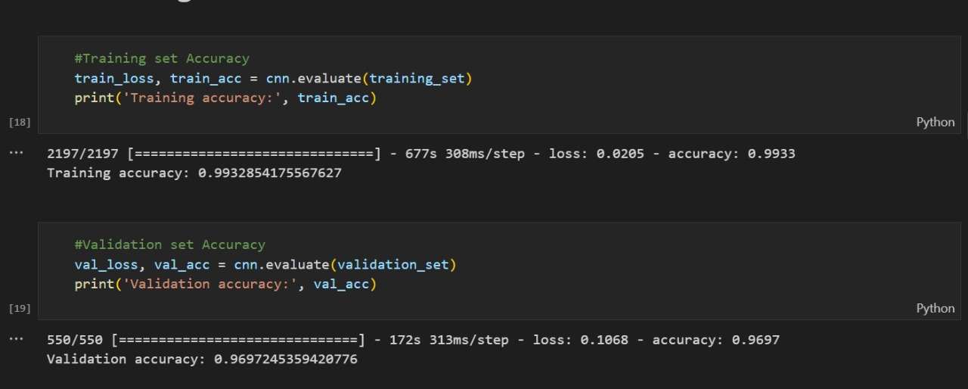 Fig. 6.3.1 Training

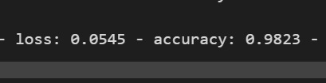

Fig. 6.3.2 Accuracy

Next Steps and Future Work
While the web application and the model are successfully developed and integrated, there are several enhancements planned for future updates. These improvements are essential for refining the system, optimizing its functionality, and ensuring a seamless user experience before deployment.

Multilingual Support for Farmers:
To make the application more accessible to farmers across diverse regions, we plan to introduce multilingual support. This will allow users to interact with the app in their native languages, making it easier to understand disease diagnoses and recommendations. The app will support major Indian languages, including Hindi, Punjabi, Tamil, Telugu, Marathi, Bengali, and Kannada, ensuring that farmers from different linguistic backgrounds can benefit from the technology.

Enhancing the Application with Advance Features:
We intend to roll out new features that will enhance usability and give users more in-depth information. This involves adding interactive features to make the app more interesting and educational, optimizing offline functionality for greater accessibility in remote locations, and improving the user interface for a more interactive user interface.

Expansion and Optimization of Dataset and Model:

To boost the performance of our application, we're focusing on optimizing the machine learning model for better accuracy and quicker processing times. This involves fine-tuning the Convolutional Neural Network (CNN) architecture, cutting down on latency, and enhancing the integration with TensorFlow Lite (TFLite) to guarantee smooth on-device inference, even on budget-friendly smartphones. On top of that, we’re looking to broaden the model’s capabilities by training it on a more varied dataset that includes a wider array of plant species and diseases. By consistently updating the dataset and retraining the model, we can make sure the application stays effective for farmers, gardeners, and agricultural experts, no matter their region or the types of crops they work with.

Bringing a Seamless Cross-Platform Experience:

While the web application has been successfully developed and integrated, we now aim to extend its features to a cross-platform mobile app. This enhancement will make the application more accessible and convenient, ensuring a seamless user experience across both mobile devices and laptops. The mobile app will include an adaptive interface that adjusts based on the device mode, offering an optimized experience for both touch and keyboard-based interactions. Additionally, it will leverage platform-specific features to enhance performance and engagement.

- Visual Insights of Future Enhancements:

Below are the screenshots showcasing the current features of Plant Sage, along with planned enhancements that will further improve functionality and user experience. These visuals provide a glimpse into the platform’s intuitive design, AI-powered disease detection, and real-time recommendations.

CHAPTER 7: CONCLUSION

Plant Sage represents a significant leap forward in the intersection of technology and agriculture, providing farmers with AI-driven tools to effectively combat plant diseases. By combining the power of Convolutional Neural Networks (CNNs) for disease detection and Large Language Models (LLMs) for tailored treatment recommendations, the platform ensures that users receive accurate diagnoses and actionable insights to improve plant health.

With its lightweight, optimized architecture, Plant Sage delivers real-time disease detection and reliable analysis, even in regions with limited internet connectivity. By leveraging cutting-edge AI advancements, the platform not only aids in early disease identification but also empowers farmers with research-backed solutions that enhance crop productivity and promote sustainable farming practices.

Looking ahead, we aim to further refine the model’s accuracy, expand the database to cover a wider range of plant diseases, and introduce multilingual support in languages such as Hindi, Tamil, and Punjabi. Additionally, future enhancements will focus on extending the platform to a cross-platform mobile application, making it even more accessible and convenient for farmers across diverse environments.

Our mission is to bridge the gap between AI and agriculture, making smart farming a reality for everyone. By equipping farmers with knowledge, advanced diagnostic tools, and sustainable solutions, Plant Sage is set to become an indispensable resource in modern agriculture—contributing to healthier crops, increased yields, and a more resilient farming community.

CHAPTER 8: REFERENCES
- Konstantinos P. Ferentinos, “Deep learning models for plant disease detection and diagnosis”, Elsevier , Volume 145, 02-02-2018
- Lili Li, Shujuan Zhang and Bin Wang “Plant Disease Detection and Classification by Deep Learning—A Review “ IEEE Access , Volume 9 , 08-04-2021
- Shima Ramesh , Ramachandra Hebbar , Niveditha M , Pooja R. and Prasad Bhat N
, ”Plant Disease Detection Using Machine Learning” IEEE Xplore , 2018 International Conference on Design Innovations for 3Cs Compute Communicate Control (ICDI3C) , 25-04-2018
- Rashmi Deshpande &Hemant Patidar, “Tomato plant leaf disease detection using generative adversarial network and deep convolutional neural network” The Imaging Science Journal , Volume 70 , 2022- Issue -1 , 06-01-2023
- J. Arun Pandian ,V. Dhilip Kumar and Oana Geman “Plant Disease Detection Using Deep Convolutional Neural Network” , MDPI , Volume 12 – Issue 14 , 10-07-2022

