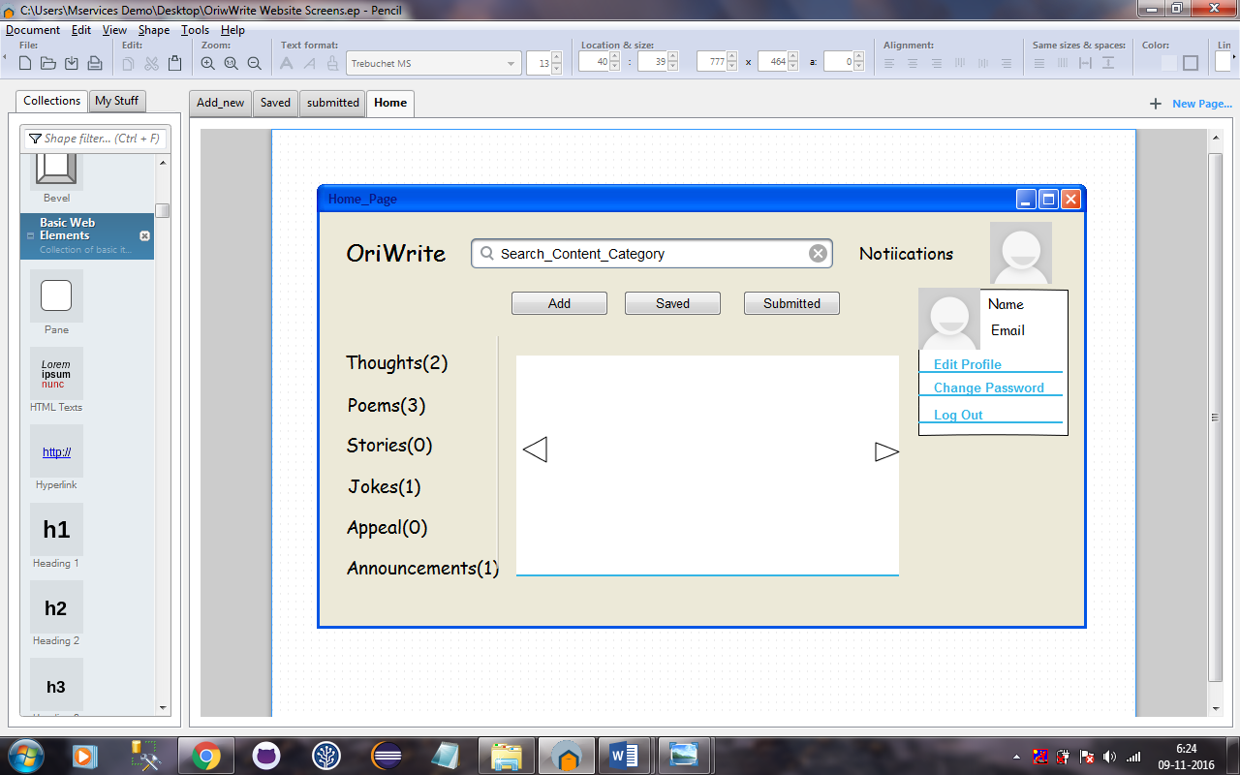

HomePage

* **OriWrite(Symbol)** :- Onclick on Oriwrite symbol it goes to home page.
* **Search text area** :-ontyping the content in serach textarea and on press enter it will display all data according to text enter in serach textarea in place of silder. It will search for Content Title, content code, author name and Content text
* **Notification :-**  on the click of notificaton symbol it gives all the notification according to its signin.
* **Silder :-** it sildes the latest category details in images form.
* **Click(Personal photo) :-** it shows the email address and name of the user.

**1.Edit profile :-** In edit profile user can change the their personal details and upload photos etc.

**2.LogOut :**- onclick logout It sign out from it’s account.

**3.Change PassWord :-** onclickchange password it gives three textfield

**1.Old password**

**2.New password**

**3.confirm password**

If the old password is correct and new password and confirm password is matches it gives the current password.

* **LeftPanel :-** In this panel different type of category like

**-**appeal,

**-**thought

**-**poem etc.

By default it show the all submitted with displaying it’s count(no of record)in each category.

Eg-

Appeal^2;

Poem^1;

Thought^0;

* **Add** :- onclick the Add menu this page is come

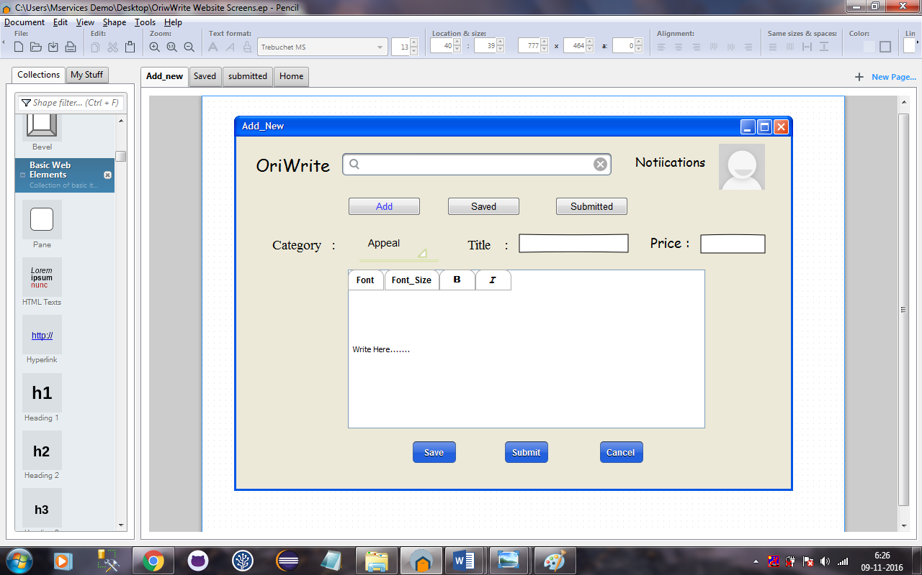

**Add**

* Category :- we can select the category from category dropdown list.
* Title :- in this textbox we can give the title of the content in which we are going to write in text-editor .
* Price :- in this textbox we can set the price of content.
* Save(button):-onclick on save button it will save record.
* Submit :- onclick on submit button it will submitted record.
* Cancel :- onclick on cancel button it will canceled record.
* Saved :-on click saved menu bar this page is come.

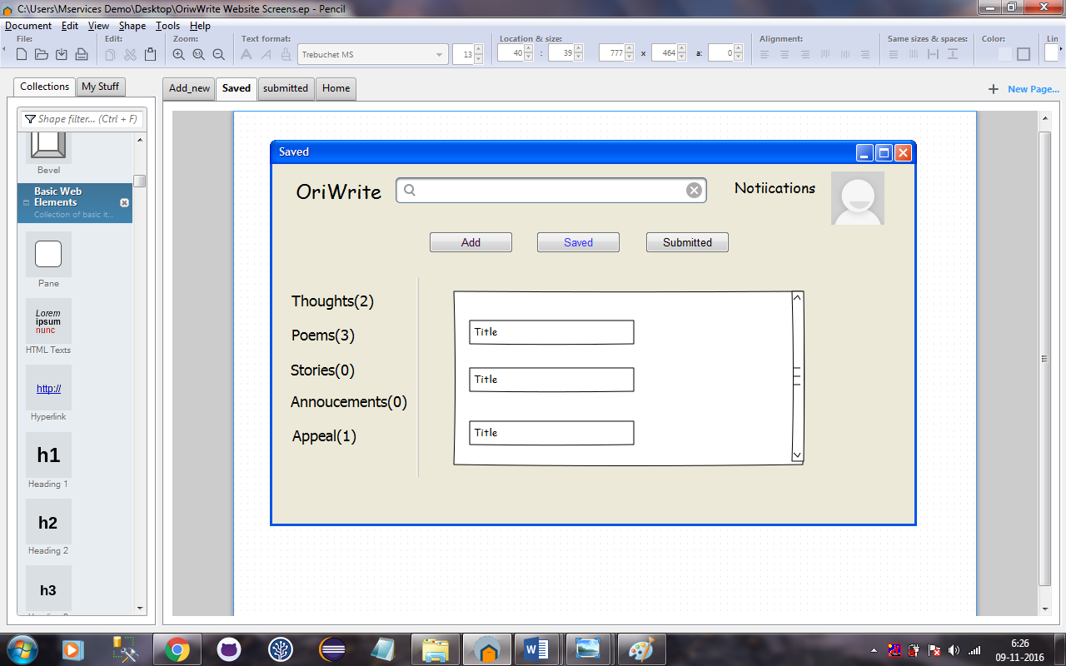

**Saved**

On click saved record it will display on left panel with its category wise and displaying count(no of record)in each category.

Eg-

Appeal^2;

Poem^1;

Thought^0;

On click of Particular category it will display its content with no. of count displaying on it, with it’s title or starting line or letter of content in a list format.

Eg: Poem^1;

Title1:

Onclick of the title My Mother, it will display its content.

* Submitted :-on click submitted menu bar this page is come.

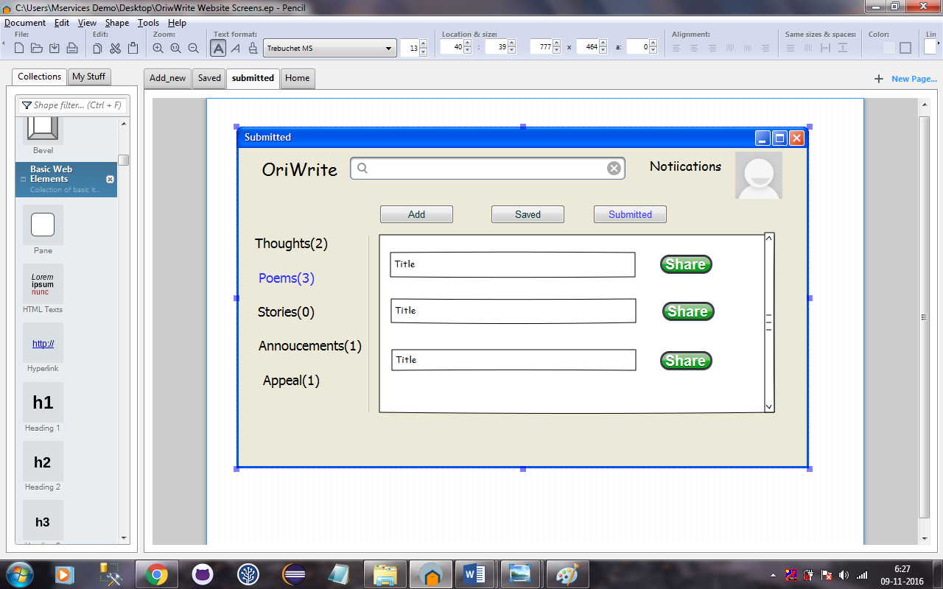

Submitted:

Onclick Of Submitted Button Which is on The Home Page:

All the Submitted record will display on the leftpanel with its Categories Wise And and displaying count(no. of records ) In Each Category.

Eg:

Jokes^2;

Pomes^2;

Thoughts^1;

On click of Particular category its will display its content with no. of count displaying on it, with its title or Staring letter of Content :

Eg :

Jokes^3;

On click on Jokes^3 it will show:

* Title1:
* Title2:

OnClick of Title funnyjoke: it will display its content With Share Symbol For Sharing the content

Onmouseover on Share symbol it will show the option through which we can share the content

Eg :whatsapp,FB…..