Customer Shopping Behavior Analysis

1. Project Overview
This project analyzes customer shopping behavior using transactional data from 3,900 purchases across various product categories. The goal is to uncover insights into spending patterns, customer segments, product preferences, and subscription behavior to guide strategic business decisions.

2. Dataset Summary
- Rows: 3,900
- Columns: 18
- Key Features:
  - Customer demographics (Age, Gender, Location, Subscription Status)
  - Purchase details (Item Purchased, Category, Purchase Amount, Season, Size, Color)
  - Shopping behavior (Discount Applied, Promo Code Used, Previous Purchases, Frequency of Purchases, Review Rating, Shipping Type)
- Missing Data: 37 values in Review Rating column

3. Exploratory Data Analysis using Python
We began with data preparation and cleaning in Python:
- Data Loading: Imported the dataset using pandas.
- Initial Exploration: Used df.info() to check structure and .describe() for summary statistics.
- Missing Data Handling: Checked for null values and imputed missing values in the Review Rating column using the median rating of each product category.
- Column Standardization: Renamed columns to snake case for better readability and documentation.
- Feature Engineering:
  - Created age_group column by binning customer ages.
  - Created purchase_frequency_days column from purchase data.
- Data Consistency Check: Verified if discount_applied and promo_code_used were redundant; dropped promo_code_used.
- Database Integration: Connected the Python script to MySQL (via MySQL Workbench for schema management) and loaded the cleaned DataFrame into the database for SQL analysis.
Connection was established using SQLAlchemy with the mysql-connector-python driver:
from sqlalchemy import create_engine
engine = create_engine(f"mysql+mysqlconnector://{username}:{password}@{host}:{port}/{database}")
df.to_sql("customer", engine, if_exists="replace", index=False)

4. Data Analysis using SQL (Business Transactions)
We performed structured analysis in MySQL (via MySQL Workbench) to answer key business questions:

1. Revenue by Gender
Compared total revenue generated by male vs. female customers.
gender | revenue
Female | 75191
Male | 157890

2. High-Spending Discount Users
Identified customers who used discounts but still spent above the average purchase amount.
customer_id | purchase_amount
2 | 64
3 | 73
4 | 90
7 | 85
9 | 97
12 | 68
13 | 72
16 | 81
20 | 90
22 | 62
Total rows returned: 839

3. Top 5 Products by Rating
Found products with the highest average review ratings.
item_purchased | average_product_rating
Gloves | 3.86
Sandals | 3.84
Boots | 3.82
Hat | 3.80
Skirt | 3.78

4. Shipping Type Comparison
Compared average purchase amounts between Standard and Express shipping.
shipping_type | avg_purchase_amount
Standard | 58.46
Express | 60.48

5. Subscribers vs. Non-Subscribers
Compared average spend and total revenue across subscription status.
subscription_status | total_customers | avg_spend | total_revenue
Yes | 1053 | 59.49 | 62645.00
No | 2847 | 59.87 | 170436.00

6. Discount-Dependent Products
Identified 5 products with the highest percentage of discounted purchases.
item_purchased | discount_rate
Hat | 50.00
Sneakers | 49.66
Coat | 49.07
Sweater | 48.17
Pants | 47.37

7. Customer Segmentation
Classified customers into New, Returning, and Loyal segments based on purchase history.
customer_segment | number_of_customers
Loyal | 3116
New | 83
Returning | 701

8. Top 3 Products per Category
Listed the most purchased products within each category.
item_rank | category | item_purchased | total_orders
1 | Accessories | Jewelry | 171
2 | Accessories | Sunglasses | 161
3 | Accessories | Belt | 161
1 | Clothing | Blouse | 171
2 | Clothing | Pants | 171
3 | Clothing | Shirt | 169
1 | Footwear | Sandals | 160
2 | Footwear | Shoes | 150
3 | Footwear | Sneakers | 145
1 | Outerwear | Jacket | 163
2 | Outerwear | Coat | 161

9. Repeat Buyers & Subscriptions
Checked whether customers with more than 5 purchases are more likely to subscribe.
subscription_status | repeat_buyers
No | 2518
Yes | 958

10. Revenue by Age Group
Calculated total revenue contribution of each age group.
age_group | total_revenue
Young Adult | 62143
Middle-aged | 59197
Adult | 55978
Senior | 55763

5. Dashboard in Power BI
Finally, we built an interactive dashboard in Power BI, connected directly to the MySQL database, to present insights visually.
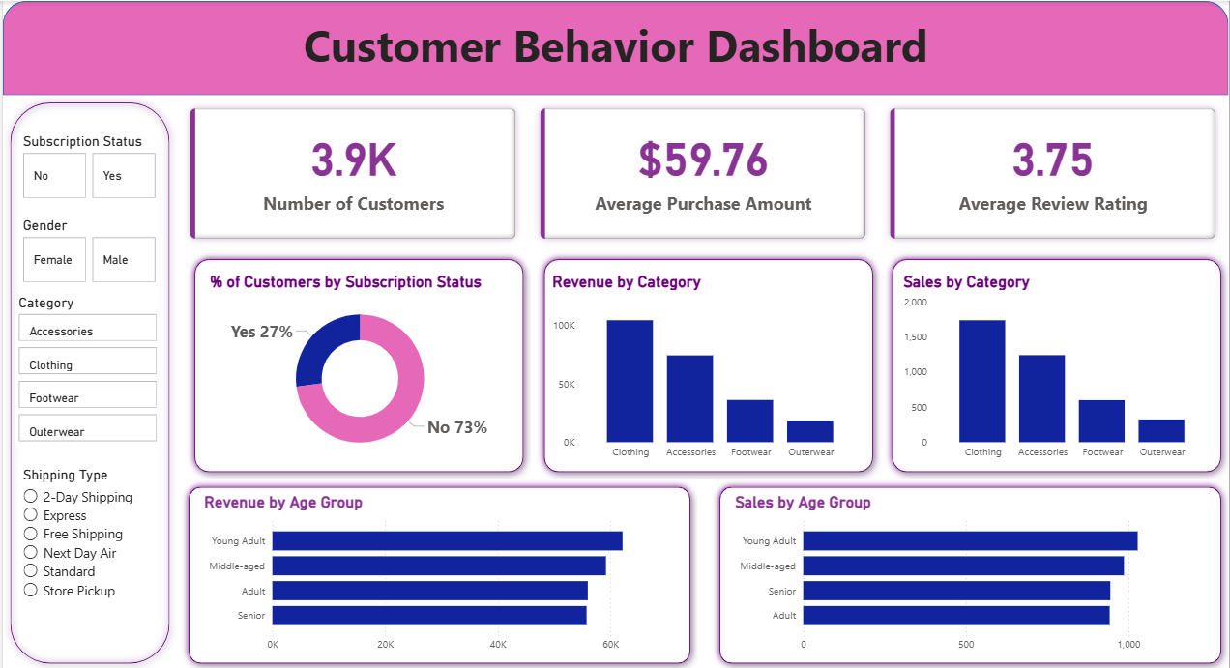

6. Business Recommendations
- Boost Subscriptions – Promote exclusive benefits for subscribers.
- Customer Loyalty Programs – Reward repeat buyers to move them into the "Loyal" segment.
- Review Discount Policy – Balance sales boosts with margin control.
- Product Positioning – Highlight top-rated and best-selling products in campaigns.
- Targeted Marketing – Focus efforts on high-revenue age groups and express-shipping users.

