DESIGN DOCUMENT
Battery Management System (BMS) ECU
Platform: STM32F407G Discovery Board | Final Merged Build

Table of Contents
Table of Contents 1
1. Project Overview 1
1.1 Project Summary 1
1.2 BMS ECU Scope 1
2. Hardware Platform — STM32F407G Discovery Board 1
2.1 On-Board LED Assignment 1
2.2 GPIO and Peripheral Pin Assignment 1
3. Sensors and Actuators 1
3.1 Temperature Sensor — MAX6675 (SPI) 1
3.1.1 MAX6675 Wiring 1
3.2 Battery Voltage Sensor — INA226 (I²C) 1
3.2.1 INA226 Wiring 1
3.3 Potentiometer — Motor RPM Input (ADC) 1
3.4 Motor, Relay and L298N Driver 1
3.4.1 PWM Configuration (TIM3) 1
3.4.2 Brake-Proportional PWM Logic 1
3.4.3 Relay and Motor Driver Wiring 1
4. Key Calculations and Mathematical Models 1
4.1 MAX6675 Temperature Data Conversion 1
4.2 State of Charge (SoC) — Voltage Lookup Table 1
4.3 Temperature Fault Thresholds 1
5. FreeRTOS Design 1
5.1 Overview 1
5.2 Task Inventory 1
5.3 Inter-Task Communication 1
5.4 Scheduler Configuration 1
6. BMS Control Algorithm Design 1
6.1 Main Loop / Task Execution Order 1
6.2 Immobiliser Logic 1
7. CAN Bus Communication Design 1
7.1 CAN Physical Layer Configuration 1
7.2 CAN Interrupt Configuration 1
7.3 CAN Message Map — BMS ECU Receives 1
7.4 CAN Message Map — BMS ECU Transmits 1
7.5 Status Byte Bit Definition (B0 of 0x105) 1
7.6 Gear-Based Motor Control via TCU (0x104) 1
7.7 Bus-Off Recovery 1
8. CAN Error Counters — TEC and REC 1
9. Bill of Materials (BOM) — BMS ECU Node 1
10. System Block Diagram 1
11. Control Loop Flowchart 1
12. UART Debug Dashboard 1
13. Known Fixes and Design Decisions 1
14. Revision History 1

1. Project Overview

1.1 Project Summary
This project implements a simulated multi-ECU vehicle system on a network of STM32 microcontrollers. Eight ECUs are integrated into a shared CAN bus architecture to replicate the behaviour of a real vehicle's electronic backbone. This document covers the BMS (Battery Management System) ECU implemented on the STM32F407G Discovery board — the Final Merged Build.

The BMS ECU performs the following core functions:
- Monitors battery voltage via an INA226 I²C sensor (5-sample averaged every 500 ms) and computes State of Charge (SoC) using a multi-threshold lookup table
- Reads temperature from two MAX6675 SPI thermocouple sensors (Temp1 on PE0, Temp2 on PE1)
- Controls a brushed DC motor through an L298N driver: direction (PC6/PC7), enable relay (PB1), and PWM speed (TIM3 CH1 on PB4)
- Receives CAN frames from Airbag ECU (0x100), ABS ECU (0x101), TCU (0x104), and Telematics (0x107)
- Transmits battery status, temperature, SoC, and RPM to Infotainment over CAN ID 0x105 every 1000 ms
- Implements vehicle immobilisation on crash detection (0x100) or remote command (0x107)
- Runs all tasks under FreeRTOS with priority-based scheduling

1.2 BMS ECU Scope
The BMS ECU is responsible for the following within the integrated system:
- Continuously reading battery temperature from two MAX6675 sensors (Temp1, Temp2)
- Reading battery voltage via the INA226 I²C power monitor
- Calculating battery State of Charge from measured battery voltage via a lookup table
- Controlling motor speed and direction based on TCU gear commands (0x104)
- Applying brake-proportional PWM reduction from ABS ECU commands (0x101)
- Immobilising the vehicle on crash signal (0x100) or telematics command 0x99 (0x107)
- Re-mobilising the vehicle on telematics command 0x11 (0x107) when gear permits
- Transmitting all key parameters over CAN ID 0x105 every 1000 ms

2. Hardware Platform — STM32F407G Discovery Board

2.1 On-Board LED Assignment
The STM32F407G Discovery board has four user-controllable LEDs. In the final build only PD15 (Blue) is actively used for TX indication and mobilisation confirmation.

LED | Pin | Colour | BMS System Function | Behaviour
LD1 | PD12 | Green | Reserved | Not used in final build
LD2 | PD13 | Orange | Reserved | Not used in final build
LD3 | PD14 | Red | Reserved | Not used in final build
LD4 | PD15 | Blue | CAN TX / Mobilise | Toggles on each TX; blinks 5x on mobilise command

2.2 GPIO and Peripheral Pin Assignment
All pin assignments match the final firmware exactly:

Signal | STM32 Pin | Direction | Peripheral | Notes
MAX6675 SCK | PB13 | OUTPUT | SPI2_SCK | Shared SPI2 clock
MAX6675 MISO | PB14 | INPUT | SPI2_MISO | Shared SPI2 data
Thermocouple 1 CS | PE0 | OUTPUT | GPIO | Active LOW chip select — Temp1
Thermocouple 2 CS | PE1 | OUTPUT | GPIO | Active LOW chip select — Temp2
INA226 SDA | PB7 | I/O | I2C1_SDA | Battery voltage sensing
INA226 SCL | PB6 | OUTPUT | I2C1_SCL | Battery voltage sensing
Motor RPM (ADC) | PB0 | INPUT | ADC1_CH8 | 10-sample averaged accelerator pot
Motor PWM Output | PB4 | OUTPUT | TIM3_CH1 | PWM to L298N ENA (ARR=999, PSC=83)
Motor FWD (IN1) | PC6 | OUTPUT | GPIO | HIGH=forward; boot default HIGH
Motor REV (IN2) | PC7 | OUTPUT | GPIO | HIGH=reverse; boot default LOW
Relay Control | PB1 | OUTPUT | GPIO | HIGH=relay ON, motor power enabled
CAN TX | PD1 | OUTPUT | CAN1_TX | 500 kbps, Prescaler=6 BS1=11 BS2=2
CAN RX | PD0 | INPUT | CAN1_RX | 500 kbps, AutoBusOff=ENABLE
USART2 TX | PA2 | OUTPUT | USART2 | 115200 8N1 debug output
USART2 RX | PA3 | INPUT | USART2 | 115200 8N1 (optional)
Status LED | PD15 | OUTPUT | GPIO | CAN TX blink + mobilise confirmation

3. Sensors and Actuators

3.1 Temperature Sensor — MAX6675 (SPI)
Two MAX6675 thermocouple-to-digital converters are used. Both share SPI2 (PB13 SCK, PB14 MISO) and are individually selected by chip-select pins PE0 and PE1 respectively.

Parameter | Specification
Sensor Type | K-Type Thermocouple Interface
Communication | SPI (Mode 0, MSB first, 8-bit, Prescaler=16)
STM32 Peripheral | SPI2 — SCK: PB13, MISO: PB14
CS Pins | PE0 (Temp1), PE1 (Temp2) — active LOW
Operating Voltage | 3.0 V – 5.5 V
Temperature Range | 0 °C to 1024 °C
Resolution | 0.25 °C
Data Output | 12-bit digital (16-bit frame, top 12 bits after >>3)
Conversion Formula | Raw = ((byte0 << 8) | byte1) >> 3; Temp (°C) = Raw × 0.25

3.1.1 MAX6675 Wiring
- Connect MAX6675 VCC to 3.3 V supply (or 5 V — check module)
- Connect MAX6675 GND to common ground shared with STM32
- Connect MAX6675 SCK to STM32 SPI2 clock pin PB13
- Connect MAX6675 SO (MISO) to STM32 SPI2 data pin PB14
- Connect Thermocouple 1 CS to PE0; connect Thermocouple 2 CS to PE1
- K-type thermocouple connects directly to MAX6675 T+ and T− terminals
- Place a 100 nF ceramic capacitor from VCC to GND near each MAX6675 module

3.2 Battery Voltage Sensor — INA226 (I²C)
The INA226 power monitor reads bus voltage over I²C at address 0x40. It replaces the old resistor-divider ADC approach. Battery voltage is sampled every 500 ms as a 5-sample average and converted to SoC via a multi-threshold lookup table.

Parameter | Value / Method
I²C Address | 0x40 (A0=GND, A1=GND)
STM32 Peripheral | I2C1 — SDA: PB7, SCL: PB6, 100 kHz
Configuration Reg | 0x00 → 0x4527 (after reset 0x8000)
Bus Voltage Reg | 0x02
Raw→Voltage | V_pin = raw × 1.25 mV; V_bat = (V_pin × 1.2) + 0.5
Sampling | 5 samples every 500 ms with 5 ms inter-sample delay
Scale / Offset | VOLTAGE_SCALE = 1.2, VOLTAGE_OFFSET = 0.5 V
SoC Method | Lookup table — 21 thresholds from 10.2 V (0%) to 12.7 V (100%)

3.2.1 INA226 Wiring
- Connect INA226 VCC to 3.3 V
- Connect INA226 GND to common ground
- Connect INA226 SDA to STM32 PB7 (I2C1_SDA) with 4.7 kΩ pull-up to 3.3 V
- Connect INA226 SCL to STM32 PB6 (I2C1_SCL) with 4.7 kΩ pull-up to 3.3 V
- Connect INA226 IN+ and IN− across the shunt resistor on the battery supply rail
- A0 and A1 address pins to GND for address 0x40

3.3 Potentiometer — Motor RPM Input (ADC)
A 10 kΩ potentiometer on PB0 (ADC1_CH8) provides the accelerator analog input. The ADC is read 10 times per loop iteration and averaged. The result is scaled to a PWM compare value (0–699) and an RPM value (0–5000).

Parameter | Value
ADC Channel | ADC1_CH8 — pin PB0
ADC Resolution | 12-bit (0–4095)
ADC Sampling | 10-sample average per loop iteration, 480-cycle sampling time
PWM Mapping | pwmValue = (adcValue × 699) / 4095
RPM Mapping | rpm = (adcValue × 5000) / 4095
Connections | Pin 1 → 3.3 V; Pin 3 → GND; Pin 2 (wiper) → PB0 + 100 nF cap

3.4 Motor, Relay and L298N Driver
The DC motor is driven through an L298N motor driver. Relay (PB1) controls the power path; TIM3 CH1 (PB4) generates the PWM speed signal; PC6 and PC7 set direction.

3.4.1 PWM Configuration (TIM3)
Parameter | Value
Timer | TIM3, Channel 1
Output Pin | PB4 (AF2)
Prescaler | 83 (APB1 84 MHz ÷ 84 = 1 MHz tick)
Auto-Reload | 999 (ARR) → 1 kHz PWM frequency
Max Compare | 699 (corresponds to 100% ADC → ~70% duty cycle maximum)
Direction FWD | PC6=HIGH, PC7=LOW
Direction REV | PC6=LOW, PC7=HIGH

3.4.2 Brake-Proportional PWM Logic
ABS ECU (0x101) sends brake percentage and handbrake status. The BMS maps these to PWM levels:

Condition | PWM Value | Relay (PB1) | Description
Handbrake ON | 0 | OFF | Full stop regardless of brake %
Brake ≥ 70% | 0 | OFF | Complete stop, relay cut
Brake 50–69% | ~104 (15% of 699) | ON | Very slow creep speed
Brake 30–49% | ~209 (30% of 699) | ON | Slow speed
Brake < 30% | ADC-derived (0–699) | ON (gear-dependent) | Full ADC speed control

3.4.3 Relay and Motor Driver Wiring
- Relay VCC → 5 V supply (L298N 5 V output or external)
- Relay GND → common ground
- Relay IN/S → STM32 PB1
- Relay COM → Battery +12 V
- Relay NO → L298N 12 V power input
- L298N ENA → STM32 PB4 (TIM3_CH1 PWM)
- L298N IN1 → STM32 PC6 (direction forward)
- L298N IN2 → STM32 PC7 (direction reverse)
- L298N OUT1/OUT2 → motor terminals

4. Key Calculations and Mathematical Models

4.1 MAX6675 Temperature Data Conversion
The STM32 reads 2 bytes (big-endian) from the MAX6675 over SPI. The temperature is extracted as follows:

raw_16bit = (spi_rx[0] << 8) | spi_rx[1]
spi_value = raw_16bit >> 3 // 12-bit integer degrees
temperature = spi_value * 0.25f // °C with 0.25°C resolution

4.2 State of Charge (SoC) — Voltage Lookup Table
SoC is derived from the calibrated INA226 battery voltage using a 21-entry lookup table. This replaces the older linear formula. The function Get_Battery_SOC() maps voltage to SoC:

Voltage ≥ (V) | SoC (%)
≥ 12.70 | 100
≥ 12.60 | 95
≥ 12.50 | 90
≥ 12.42 | 85
≥ 12.32 | 80
≥ 12.20 | 75
≥ 12.06 | 70
≥ 11.90 | 65
≥ 11.75 | 60
≥ 11.60 | 55
≥ 11.45 | 50
≥ 11.31 | 45
≥ 11.20 | 40
≥ 11.10 | 35
≥ 11.00 | 30
≥ 10.90 | 25
≥ 10.80 | 20
≥ 10.65 | 15
≥ 10.50 | 10
≥ 10.20 | 5
< 10.20 | 0

4.3 Temperature Fault Thresholds
The firmware uses a single TEMP_HIGH_THRESHOLD_C = 100.0°C for both sensors. Bit 2 (Temp1 fault) or Bit 3 (Temp2 fault) in the 0x105 status byte is set when the respective sensor exceeds this threshold.

Temperature | Status | BMS Action
< 100 °C | Normal | No fault bits set in CAN TX byte 0
≥ 100 °C (Temp1) | Fault | Bit 2 set in batt_status (txdata[0])
≥ 100 °C (Temp2) | Fault | Bit 3 set in batt_status (txdata[0])

5. FreeRTOS Design

5.1 Overview
The BMS firmware runs under FreeRTOS to provide deterministic, priority-driven scheduling of all subsystem tasks. Each major functional block is implemented as a separate FreeRTOS task. The HAL tick is redirected to TIM14 so that TIM3 can be used exclusively for PWM generation without conflict.

5.2 Task Inventory
Task Name | Priority | Stack (words) | Period / Trigger | Responsibility
CAN_RX_Task | High (3) | 256 | Event-driven (queue) | Dequeues CAN frames from ISR, dispatches to state variables
Motor_Task | Normal (2) | 256 | 10 ms periodic | Reads ADC, computes PWM, sets relay and motor direction
Sensor_Task | Normal (2) | 256 | 500 ms periodic | Reads both MAX6675 sensors and INA226 voltage/SoC
CAN_TX_Task | Normal (2) | 256 | 1000 ms periodic | Builds and transmits 0x105 frame to Infotainment
Print_Task | Low (1) | 512 | 1000 ms periodic | Outputs dashboard over UART2 (PuTTY)
Idle_Task | Idle (0) | 128 | Background | FreeRTOS idle hook; watchdog feed if enabled

5.3 Inter-Task Communication
CAN RX data is shared via volatile global variables protected by the ISR-to-task pattern (flag + data written in ISR, cleared in main loop / task). No explicit RTOS mutex is used for these small scalar values as they are written atomically on Cortex-M4.

Shared Variable | Written By | Read By | Protection Method
rx_brake_pct / rx_handbrake | CAN ISR (0x101) | Motor_Task | volatile + can_rx_abs_flag
rx_gear[5] | CAN ISR (0x104) | Motor_Task | volatile + can_rx_gear_flag
telematics_cmd | CAN ISR (0x107) | CAN_RX_Task | volatile + telematics_flag
crash_data | CAN ISR (0x100) | CAN_RX_Task | volatile + crash_flag
battery_voltage / battery_soc | Sensor_Task | CAN_TX_Task | Shared globals (500 ms update)
temperature1 / temperature2 | Sensor_Task | CAN_TX_Task | Shared globals (500 ms update)
immobilized | CAN_RX_Task | Motor_Task | volatile uint8_t

5.4 Scheduler Configuration
Parameter | Value
RTOS Kernel | FreeRTOS (CMSIS-RTOS v2 wrapper)
Tick Rate | 1000 Hz (configTICK_RATE_HZ = 1000)
HAL Tick Source | TIM14 (redirected from SysTick to free SysTick for RTOS)
Scheduler | Preemptive, priority-based
Total Tasks | 5 application + 1 idle
Stack Overflow Check | configCHECK_FOR_STACK_OVERFLOW = 2 (pattern fill)

6. BMS Control Algorithm Design

6.1 Main Loop / Task Execution Order
In the final build the main() function initialises peripherals and then delegates to FreeRTOS tasks. The logical execution order across tasks is:

Step | Action | Peripheral / Task
1 | Bus-off guard: check HAL_CAN_ERROR_BOF; restart CAN + notifications if flagged | main() loop guard
2 | CAN RX dispatch: crash (0x100), ABS (0x101), TCU (0x104), telematics (0x107) | CAN_RX_Task
3 | Airbag crash handler: if crash_data == 0x01 → immobilised=1, relay OFF | CAN_RX_Task
4 | Telematics handler: 0x99 → immobilise; 0x11 → mobilise + 5x LED blink | CAN_RX_Task
5 | TCU gear handler: set PC6/PC7 direction, set relay based on gear + immobilise | Motor_Task
6 | ABS brake handler: compute pwmValue from brake %; cut relay on ≥70% or HB | Motor_Task
7 | ADC read: 10-sample average on PB0; compute pwmValue and rpm | Motor_Task
8 | SPI read: PE0 (Temp1) then PE1 (Temp2); convert to °C | Sensor_Task
9 | INA226 read: 5-sample average every 500 ms; compute battery_voltage + SoC | Sensor_Task
10 | CAN TX: build 0x105 8-byte frame; transmit every 1000 ms | CAN_TX_Task
11 | UART dashboard: print status table every 1000 ms | Print_Task

6.2 Immobiliser Logic
Two independent sources can immobilise the vehicle. The immobilised flag persists until a mobilise command is received, and relay restoration is conditional on gear state:

Source | Trigger | Action | Recovery
Airbag ECU (0x100) | crash_data == 0x01 | immobilised=1, relay OFF, motor stopped | No automatic recovery — crash latched
Telematics (0x107) | cmd == 0x99 | immobilised=1, relay OFF | cmd == 0x11 re-enables if gear is DRIVE/SPORT/REVERSE
ABS Handbrake (0x101) | rx_handbrake == 1 | PWM=0, relay OFF | Cleared when rx_handbrake returns 0
ABS Brake ≥70% (0x101) | rx_brake_pct ≥ 70 | PWM=0, relay OFF | Cleared when rx_brake_pct drops below 70

7. CAN Bus Communication Design

7.1 CAN Physical Layer Configuration
Parameter | Value
Bit Rate | 500 kbps
APB1 Clock | 42 MHz
Prescaler | 6
Time Segment 1 (BS1) | 11 TQ
Time Segment 2 (BS2) | 2 TQ
Sync Jump Width | 1 TQ
Bit Time | (1+11+2) × (1/42 MHz × 6) = 2000 ns = 500 kbps
Auto Bus-Off | ENABLE (hardware recovery)
Auto Retransmission | DISABLE (matches ABS ECU)
Filter | Pass-all mask filter, FIFO0, 32-bit scale
TX Pins | PD1 (CAN1_TX), PD0 (CAN1_RX)
Termination | 120 Ω at each end of bus

7.2 CAN Interrupt Configuration
Both RX and TX notifications are activated simultaneously:

Notification Flag | Callback | Purpose
CAN_IT_RX_FIFO0_MSG_PENDING | HAL_CAN_RxFifo0MsgPendingCallback() | Fires on every received frame; dispatches to state variables
CAN_IT_TX_MAILBOX_EMPTY | HAL_CAN_TxMailbox0/1/2CompleteCallback() | Fires when 0x105 physically leaves TX mailbox onto bus

7.3 CAN Message Map — BMS ECU Receives
CAN ID | Source ECU | Byte Layout | BMS Action
0x100 | Airbag ECU | B0: crash byte (0x01 = crash detected) | Immobilise vehicle; cut relay; latch permanently
0x101 | ABS ECU | B0: brake % (0–100); B1: handbrake (0=OFF, 1=ON) | Scale PWM; cut relay if brake≥70% or handbrake ON
0x104 | TCU | B0:Drive B1:Sport B2:Park B3:Neutral B4:Reverse (0x01=active) | Set motor direction; enable/disable relay based on gear
0x107 | Telematics | B0: 0x99=immobilise, 0x11=mobilise, other=ignored | Toggle immobilised flag; control relay; blink LED on mobilise

7.4 CAN Message Map — BMS ECU Transmits
CAN ID 0x105 is transmitted every 1000 ms to the Infotainment ECU:

Byte | Signal | Encoding | Description
B0 | Status Flags | Bits[1:0]: 0x00=OK, 0x01=LOW, 0x02=CRITICAL; Bit2=Temp1 fault; Bit3=Temp2 fault | Battery charge status + temperature fault flags
B1 | Temp1 Low | uint16 = temperature1 × 100, little-endian — LSB | Temp sensor 1 (PE0) × 100, low byte
B2 | Temp1 High | uint16 = temperature1 × 100, little-endian — MSB | Temp sensor 1 (PE0) × 100, high byte
B3 | Temp2 Low | uint16 = temperature2 × 100, little-endian — LSB | Temp sensor 2 (PE1) × 100, low byte
B4 | Temp2 High | uint16 = temperature2 × 100, little-endian — MSB | Temp sensor 2 (PE1) × 100, high byte
B5 | SoC | uint8 (0–100) | Battery State of Charge percent
B6 | RPM Low | uint16 = rpm (capped 65535), little-endian — LSB | Motor RPM lower byte
B7 | RPM High | uint16 = rpm (capped 65535), little-endian — MSB | Motor RPM upper byte

7.5 Status Byte Bit Definition (B0 of 0x105)
Bits | Function | Values
[1:0] | Battery charge status | 0x00 = SoC ≥ 80% (OK); 0x01 = SoC ≥ 40% (LOW); 0x02 = SoC < 40% (CRITICAL)
[2] | Temp1 high fault | 1 = temperature1 ≥ 100 °C
[3] | Temp2 high fault | 1 = temperature2 ≥ 100 °C
[7:4] | Reserved | 0

7.6 Gear-Based Motor Control via TCU (0x104)
The TCU sends a 5-byte bitmask frame. Each byte corresponds to one gear; 0x01 = active:

Gear | rx_gear[] Index | CAN Byte | Motor Direction | Relay (PB1) | PWM
DRIVE | rx_gear[0] | B0 | Forward (PC6=H, PC7=L) | ON (if not immobilised and brake<30%) | ADC-derived
SPORT | rx_gear[1] | B1 | Forward (PC6=H, PC7=L) | ON (if not immobilised and brake<30%) | ADC-derived
PARK | rx_gear[2] | B2 | N/A | OFF | 0
NEUTRAL | rx_gear[3] | B3 | N/A | OFF | 0
REVERSE | rx_gear[4] | B4 | Reverse (PC6=L, PC7=H) | ON (if not immobilised and brake<30%) | ADC-derived

7.7 Bus-Off Recovery
If HAL_CAN_GetError() returns HAL_CAN_ERROR_BOF, the firmware performs software-level recovery in addition to the AutoBusOff hardware mechanism:
- HAL_CAN_Stop() halts the peripheral
- HAL_Delay(10) allows bus to settle
- HAL_CAN_Start() restarts CAN
- HAL_CAN_ActivateNotification() re-enables both RX and TX mailbox-empty interrupts

8. CAN Error Counters — TEC and REC
The STM32F4 CAN Error Status Register (ESR) contains transmit and receive error counters. The correct bit-field extraction per STM32F4 RM §32.9.4 is:

TEC = (CAN1->ESR >> 16) & 0xFF; // Transmit Error Counter — ESR[23:16]
REC = (CAN1->ESR >> 8) & 0xFF; // Receive Error Counter — ESR[15:8]

Both values are printed in the UART dashboard every 1000 ms alongside the full ESR hex value for diagnostics. A TEC above 127 indicates the node is in Error Passive state; TEC = 255 triggers Bus-Off.

9. Bill of Materials (BOM) — BMS ECU Node
Item | Component | Qty | Purpose | Notes
1 | STM32F407G-DISC1 Discovery Board | 1 | Main BMS ECU microcontroller | On-board ST-LINK, 4 LEDs, ADC, 168 MHz Cortex-M4
2 | MAX6675 Temperature Sensor Module | 2 | Thermocouple readout (Temp1, Temp2) | SPI2; CS on PE0 and PE1; K-type thermocouple
3 | INA226 Power Monitor Module | 1 | Battery voltage and SoC | I2C1 addr 0x40; SDA=PB7, SCL=PB6
4 | CAN Transceiver (e.g. SN65HVD230) | 1 | CAN physical layer | 3.3 V compatible; 500 kbps
5 | DC Motor (5 V or 12 V) | 1 | Motor drive simulation | Controlled via L298N + relay
6 | 5 V Relay Module (SPDT) | 1 | Motor power ON/OFF switch | Driven by PB1; 1N4007 flyback diode recommended
7 | L298N Motor Driver Module | 1 | PWM motor speed control | ENA→PB4 PWM; IN1→PC6; IN2→PC7
8 | 10 kΩ Potentiometer | 1 | Accelerator / RPM input | Wiper → PB0 (ADC1_CH8); 100 nF cap to GND
9 | 120 Ω resistors | 2 | CAN bus termination | One at each physical end of bus
10 | 100 nF ceramic capacitors | 4 | Decoupling | One near each MAX6675 VCC; one at PB0
11 | 4.7 kΩ resistors | 2 | I2C pull-ups | SDA (PB7) and SCL (PB6) to 3.3 V
12 | USB Mini-B Cable | 1 | Power + ST-LINK debug | Standard STM32F4 Discovery cable
13 | Breadboard + jumper wires | 1 set | Prototyping | Sensors, motor driver, transceiver wiring
14 | STM32CubeIDE + FreeRTOS | 1 | Development IDE + RTOS | FreeRTOS via CMSIS-RTOS v2 middleware
15 | CAN Bus Analyser (optional) | 1 | Bus verification | PEAK PCAN-USB or equivalent; verify 0x105 frames

10. System Block Diagram
The block diagram below shows all hardware components connected to the BMS ECU (STM32F407G Discovery Board), including sensor interfaces, CAN bus communication links, motor drive circuit, and power connections.
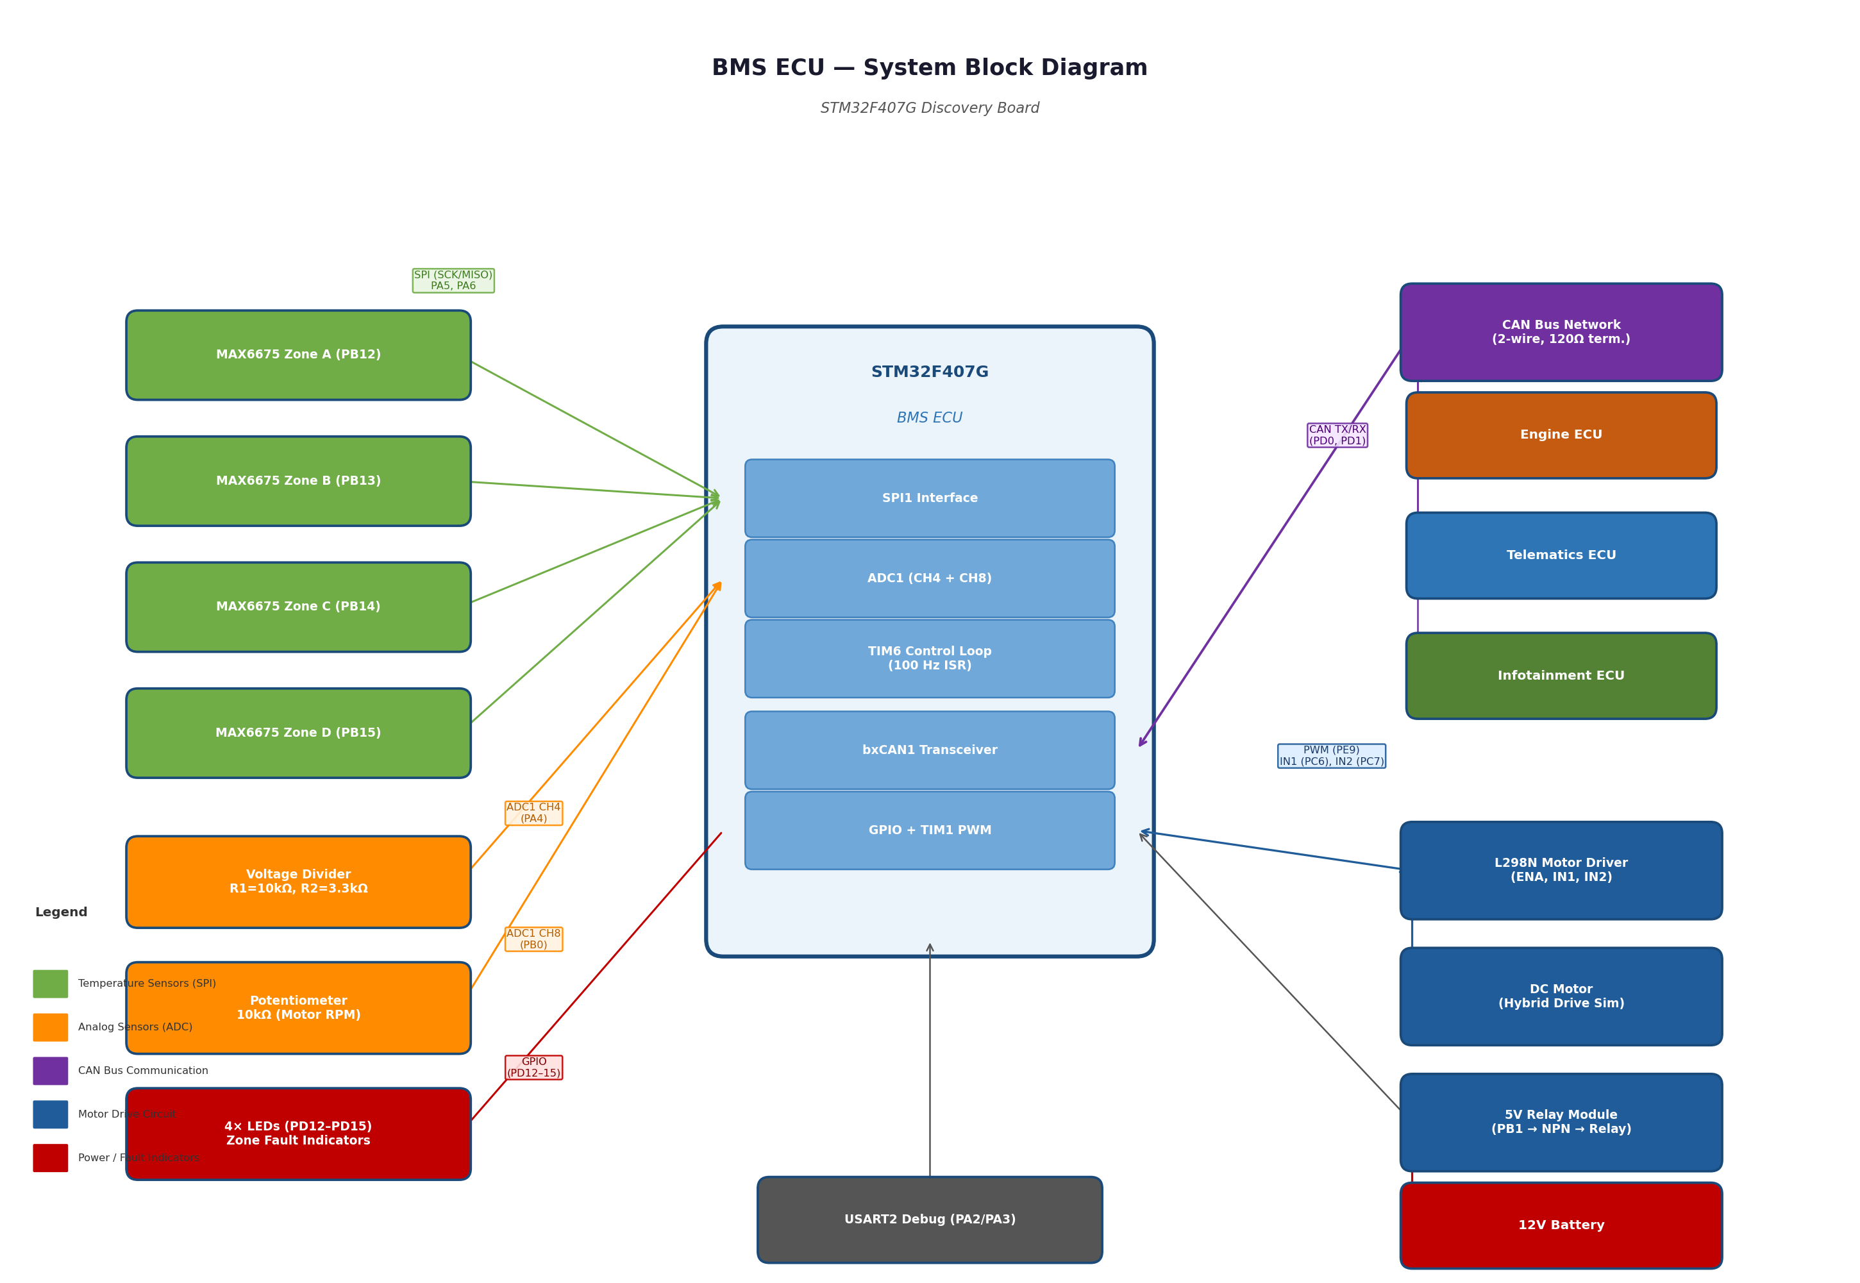
Figure 1: BMS ECU System Block Diagram

11. Control Loop Flowchart
The flowchart below describes the complete BMS ECU software control loop, including FreeRTOS task structure, CAN RX dispatch, immobiliser logic, gear-based motor control, ABS brake handling, sensor reads, and CAN TX.

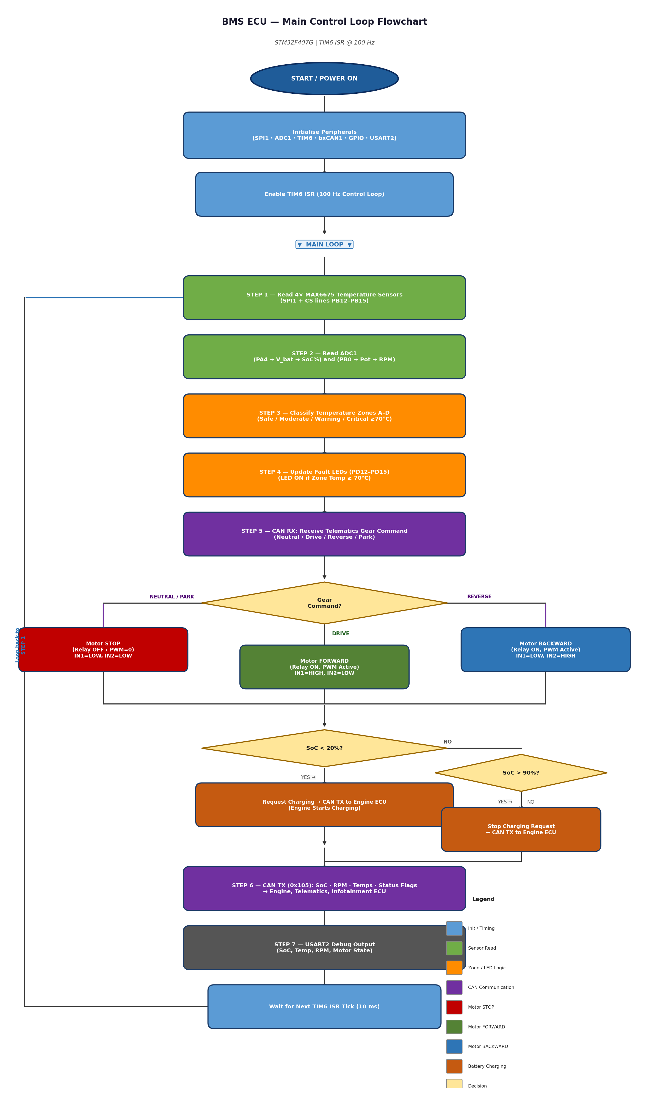
Figure 2: BMS ECU Main Control Loop Flowchart

12. UART Debug Dashboard
The BMS ECU prints a formatted dashboard over USART2 (PA2 TX, 115200 8N1) every 1000 ms via PuTTY or any terminal emulator. The dashboard uses ANSI colour codes and box-drawing characters:

Dashboard Section | Content Displayed
CAN STATE | HAL state: READY / LISTENING / ERROR
CAN ERR | HAL error: NO ERROR or ERROR DETECTED
TX frames | can_tx_total OK and can_tx_fail counts
RX frames | can_rx_total total received
RX from ABS (0x101) | Brake % value
RX from TCU (0x104) | Current gear string (DRIVE/SPORT/PARK/NEUTRAL/REVERSE/UNKNOWN)
RX Telematics (0x107) | Immobilised YES/NO
Battery (INA226) | Voltage (V) and SoC (%)
Temperature (SPI) | Temp1 and Temp2 in °C
Motor / ADC | RPM, PWM compare value, Relay ON/OFF
TX to Infotainment (0x105) | Confirmation: SENDING every 1000 ms
TEC / REC / ESR | CAN error counters and full ESR hex value

13. Known Fixes and Design Decisions
The following key fixes were applied during development to arrive at the Final Merged Build:

Fix ID | Issue | Resolution
FIX 1 | isr_log_flag/id/dlc/data were never assigned in ISR, so the per-frame print block never fired | Flags and data are now populated directly inside HAL_CAN_RxFifo0MsgPendingCallback() before the switch statement
FIX 2 | TEC read from wrong ESR nibble (previous code read [15:8] for TEC) | Corrected per STM32F4 RM §32.9.4: TEC = ESR[23:16], REC = ESR[15:8]
FIX 3 | TX mailbox callbacks not registered; no confirmation that 0x105 reached the bus | CAN_IT_TX_MAILBOX_EMPTY activated at init and re-activated after bus-off recovery; 3 callback stubs print confirmation
FIX 4 | Old code used SPI1 (PA5/PA6) with 4 CS pins (PB12–PB15); final code uses SPI2 (PB13/PB14) with 2 sensors (PE0/PE1) | SPI peripheral and CS pins updated throughout; BOM reduced from 4 to 2 MAX6675 modules
FIX 5 | Old SOC used resistor-divider ADC (PA4) with linear formula | Replaced with INA226 I²C power monitor and 21-entry voltage lookup table
FIX 6 | PWM was on TIM1/PE9; relay handling incomplete | PWM moved to TIM3 CH1 (PB4, ARR=999, PSC=83); full brake-proportional PWM logic implemented
FIX 7 | No FreeRTOS; single super-loop with blocking HAL_Delay() calls | FreeRTOS integrated; tasks split by function; HAL tick source moved to TIM14

14. Revision History
Version | Date | Author | Changes
v1.0 | Initial | Team | Original design document — 4× MAX6675 SPI1, ADC SoC, TIM1 PWM, no RTOS
v2.0 | Updated | Team | Added gear-based motor control (Section 10), updated CAN RX table, L298N wiring
v3.0 | Final | Team | Final Merged Build: SPI2, 2× MAX6675 (PE0/PE1), INA226 I²C, TIM3 PWM, FreeRTOS, FIX1-7, corrected TEC/REC, TX mailbox callbacks, brake-proportional PWM, full immobiliser logic

