**Restaurant table**

CREATE TABLE IF NOT EXISTS `restaurant` (

`Rest_id` int(32) NOT NULL AUTO_INCREMENT,

`Name` varchar(64) NOT NULL,

`Location_id` int(32) NOT NULL,

`Cuisine` varchar(64) NOT NULL,

`Cost` int(32) NOT NULL,

`Rating` int(32) NOT NULL,

PRIMARY KEY (`Rest_id`),

KEY `Location_id` (`Location_id`)

);

desc restaurant;

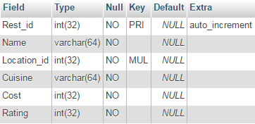

**Customer Table**

CREATE TABLE IF NOT EXISTS `customer` (

`C_id` int(32) NOT NULL AUTO_INCREMENT,

`C_name` varchar(64) NOT NULL,

`C_location` int(64) NOT NULL,

`C_phone` int(64) NOT NULL,

PRIMARY KEY (`C_id`)

);

desc customer;

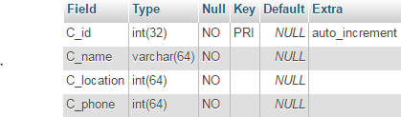

**Location Table**

CREATE TABLE IF NOT EXISTS `location` (

`Area` varchar(1024) NOT NULL,

`Pincode` int(64) NOT NULL,

`L_id` int(64) NOT NULL AUTO_INCREMENT,

PRIMARY KEY (`L_id`)

);

desc location;

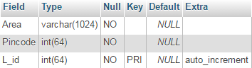

**Menu Table**

CREATE TABLE IF NOT EXISTS `menu` (

`Rest_id` int(32) NOT NULL,

`Food` varchar(64) NOT NULL,

`Cost` int(64) NOT NULL,

PRIMARY KEY (`Rest_id`),

KEY `Rest_id` (`Rest_id`)

);

desc menu;

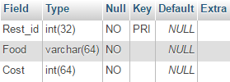

**Orders Table**

CREATE TABLE IF NOT EXISTS `orders` (

`O_id` int(32) NOT NULL AUTO_INCREMENT,

`Customer_id` int(32) NOT NULL,

`Restaurant_id` int(32) NOT NULL,

`Bill` int(32) NOT NULL,

PRIMARY KEY (`O_id`),

KEY `Customer_id` (`Customer_id`),

KEY `Restaurant_id` (`Restaurant_id`)

);

desc orders;

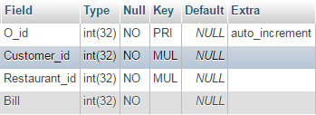

-- Constraints for table `menu`

ALTER TABLE `menu`

ADD CONSTRAINT `menu_ibfk_1` FOREIGN KEY (`Rest_id`) REFERENCES `restaurant` (`Rest_id`) ON DELETE CASCADE ON UPDATE CASCADE;

-- Constraints for table `orders`

ALTER TABLE `orders`

ADD CONSTRAINT `orders_ibfk_2` FOREIGN KEY (`Restaurant_id`) REFERENCES `restaurant` (`Rest_id`) ON DELETE CASCADE ON UPDATE CASCADE,

ADD CONSTRAINT `orders_ibfk_1` FOREIGN KEY (`Customer_id`) REFERENCES `customer` (`C_id`) ON DELETE CASCADE ON UPDATE CASCADE;

-- Constraints for table `restaurant`

ALTER TABLE `restaurant`

ADD CONSTRAINT `restaurant_ibfk_1` FOREIGN KEY (`Location_id`) REFERENCES `location` (`L_id`) ON DELETE CASCADE ON UPDATE CASCADE;

**Relationship Schema**

Restaurant

|  |  |  |  |  |  |
| --- | --- | --- | --- | --- | --- |
| Rest_id | Name | Location_id | Cuisine | Cost | Rating |

Location

|  |  |  |
| --- | --- | --- |
| Area | Pincode | L_id |

Customer

|  |  |  |  |
| --- | --- | --- | --- |
| C_id | C_name | C_location | C_phone |

Orders

|  |  |  |  |
| --- | --- | --- | --- |
| O_id | Customer_id | Restaurant_id | Bill |

Menu

|  |  |  |
| --- | --- | --- |
| Rest_id | Food | Cost |

Horizontal Partitioning

**Range Partitioning**

CREATE TABLE IF NOT EXISTS `restaurant2` (

`Rest_id` int(32) NOT NULL AUTO_INCREMENT,

`Name` varchar(64) NOT NULL,

`Location_id` int(32) NOT NULL,

`Cuisine` varchar(64) NOT NULL,

`Cost` int(32) NOT NULL,

`Rating` int(32) NOT NULL,

PRIMARY KEY (`Rest_id`,`Cost`),

KEY `Location_id` (`Location_id`)

)

PARTITION BY RANGE (Cost) (

PARTITION L5 VALUES LESS THAN (500),

PARTITION L10 VALUES LESS THAN (1000),

PARTITION G10 VALUES LESS THAN MAXVALUE

);

SELECT * FROM `restaurant2`;

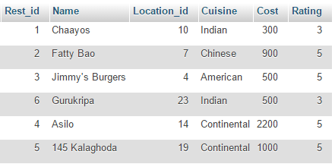

SELECT * FROM ‘restaurant2’ PARTITION (L5);

ddb1.GIF

SELECT * FROM ‘restaurant2’ PARTITION (L10);

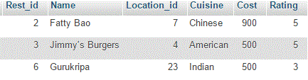

SELECT * FROM ‘restaurant2’ PARTITION (G10);

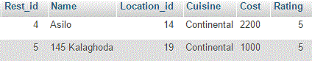

**List Partitioning**

CREATE TABLE IF NOT EXISTS `location` (

`Area` varchar(1024) NOT NULL,

`Pincode` int(64) NOT NULL,

`L_id` int(64) NOT NULL AUTO_INCREMENT,

PRIMARY KEY (`L_id`)

)

PARTITION BY LIST (L_id) (

PARTITION north VALUES IN (1,2,3,4,5,6),

PARTITION burbs VALUES IN (7,8,9,10,11),

PARTITION south VALUES IN (12,13,14,15,16,17,18,19,20),

PARTITION central VALUES IN (21,22,23,24,25)

);

SELECT * FROM `location`;

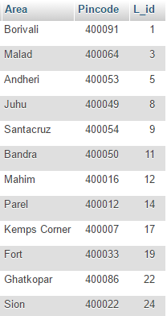

SELECT * FROM `location` PARTITION (north);

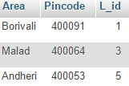

SELECT * FROM `location` PARTITION (burbs);

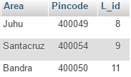

SELECT * FROM `location` PARTITION (south);

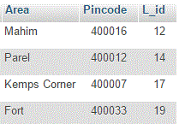

SELECT * FROM `location` PARTITION (central);

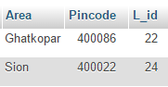

**Key Partitioning**

CREATE TABLE IF NOT EXISTS `location` (

`Area` varchar(1024) NOT NULL,

`Pincode` int(64) NOT NULL,

`L_id` int(64) NOT NULL AUTO_INCREMENT,

PRIMARY KEY (`L_id`)

)

PARTITION BY KEY()

PARTITIONS 2;

SELECT * FROM `location1` PARTITION (p0);

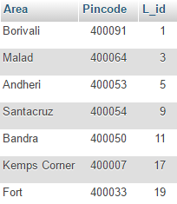

SELECT * FROM `location1` PARTITION (p1);

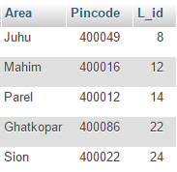

**Hash Partitioning**

CREATE TABLE IF NOT EXISTS `location3` (

`Area` varchar(1024) NOT NULL,

`Pincode` int(64) NOT NULL,

`L_id` int(64) NOT NULL AUTO_INCREMENT,

PRIMARY KEY (`L_id`)

)

PARTITION BY HASH(L_id)

PARTITIONS 4;

SELECT * FROM `location3` PARTITION (p0);

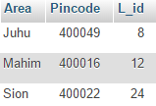

SELECT * FROM `location3` PARTITION (p1);

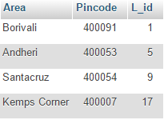

SELECT * FROM `location3` PARTITION (p2);

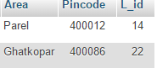

SELECT * FROM `location3` PARTITION (p3);

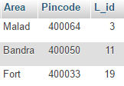

Vertical Fragmentation

**Vertical Partitioning**

CREATE VIEW v1 AS

SELECT L_id, Pincode FROM location;

CREATE VIEW v2 AS

SELECT L_id, Area FROM location

SELECT * FROM `v1`;

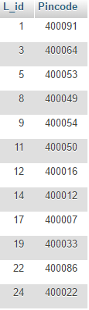

SELECT * FROM `v2`;

