PART- A
MILESTONE 1
Create a Postman Collection with this Name “Integration-WorkspaceYourName” which should contain all the below 3 milestone with request and response.
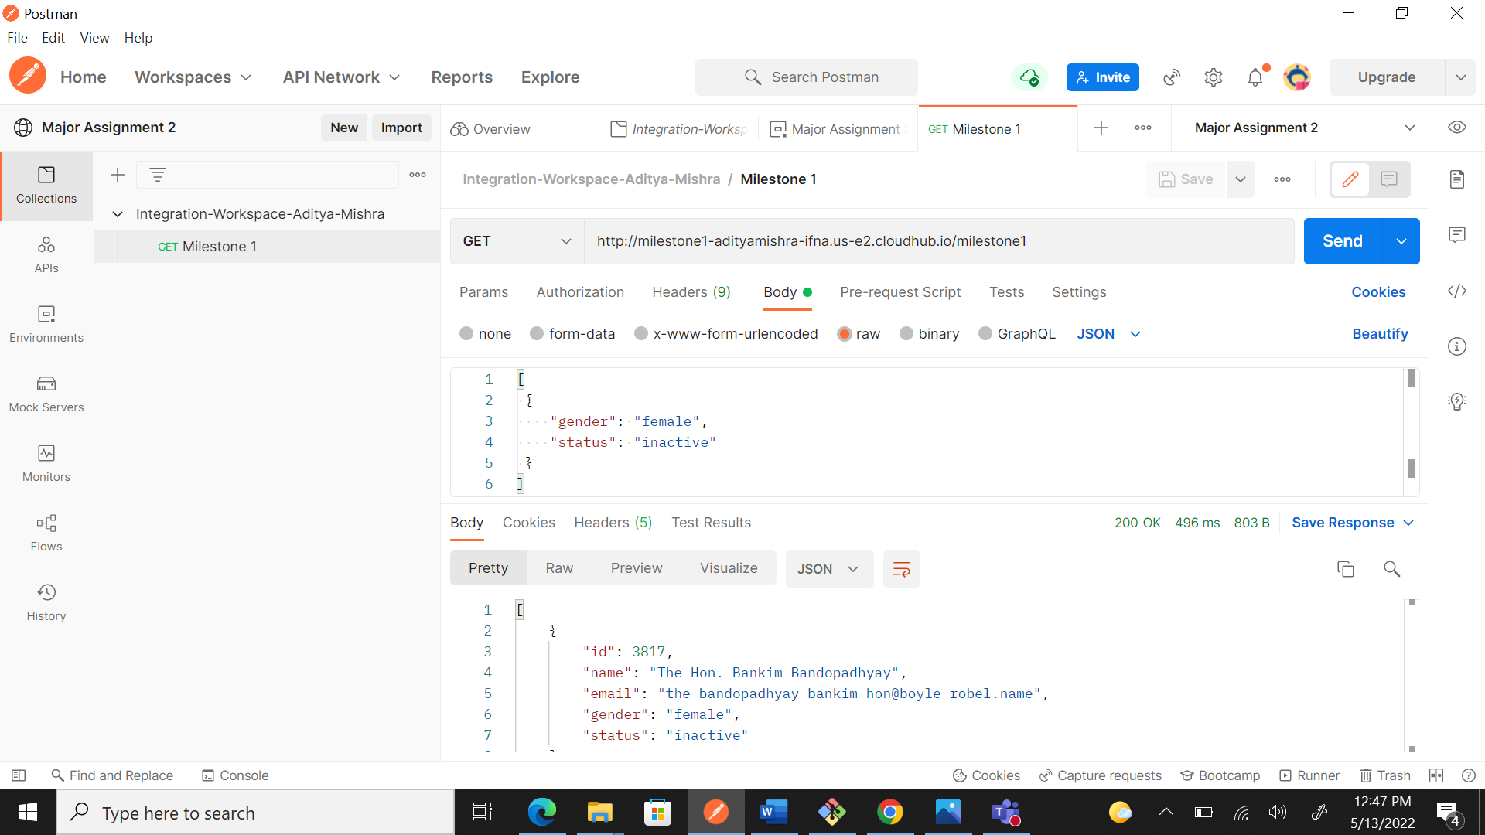

MILESTONE 2
Get the list of all the users whose gender is female, and status is inactive. Method: Get Endpoint: http://hu-major-assignment.us-e2.cloudhub.io/users Sample Response Body: [ { "id": 2482, "name": "Kartik Kocchar", "email": "kartik_kocchar@rutherford.io", "gender": "female", "status": "inactive" } ] Dataweave script : %dw 2.0 output application/json --- payload filter ((item, index) -> item.gender== "female" and item.status== "inactive" ) Part 1: Create a proper flow for the above-mentioned scenario in Flow designer with name Milestone1-” Your Name” Part 2: Create endpoint in RAML with endpoint path(resource name) as /milestone1 for the above mentioned scenario

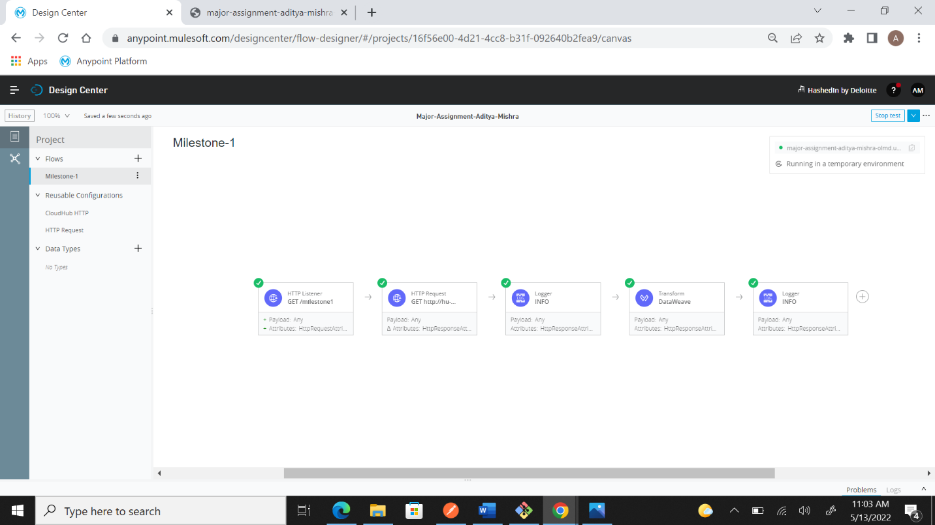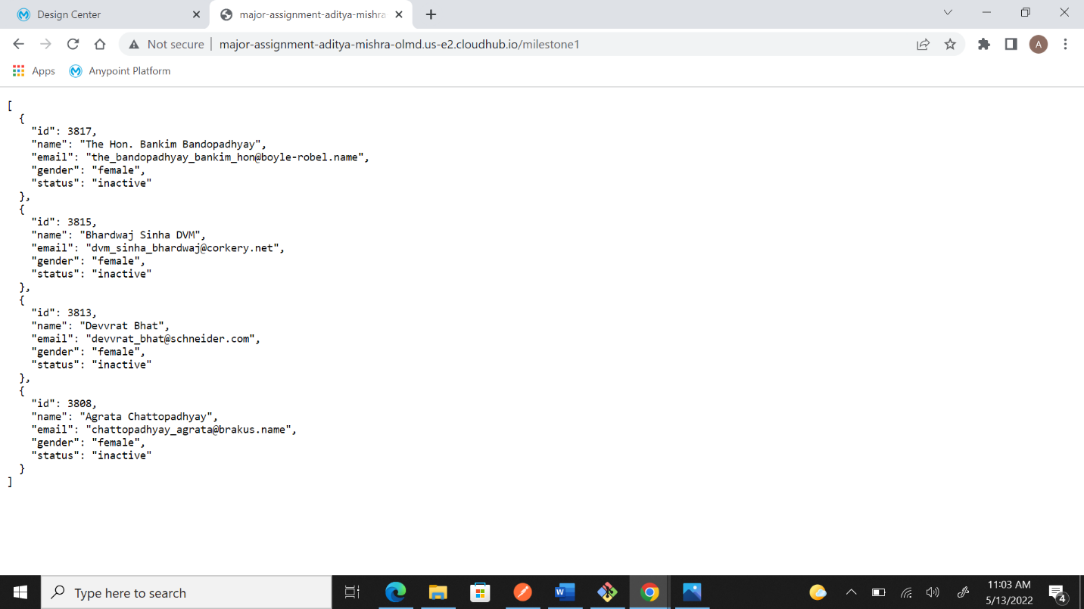

MILESTONE 3
Create an endpoint with a post method which will accept the post_id in the body and get the details of all the users who belong to that post_id.(post_id should be passed in the body from postman) Method: POST Endpoint: http://hu-major-assignment.us-e2.cloudhub.io/userdetails Request Body: { "post_id": 2003 } Sample Response Body: { "Userdetails": [ { "post_id": 2003, "id": 1978, "name": "Bhaaswar Pothuvaal III" } ] } Dataweave Script: %dw 2.0 output application/json var userdetails = payload filter ((item, index) -> item.post_id == vars.postId) --- { Userdetails: userdetails map (item, index) -> { post_id: item.post_id, id: item.id, name: item.name } } Note: You have to create a variable with the name “postId”. Part 1: Create a proper flow for the above mentioned scenario in Flow designer with name Milestone2-” Your Name” Part 2: Create endpoint in RAML with endpoint path(resource name) as /milestone2 for the above mentioned scenario
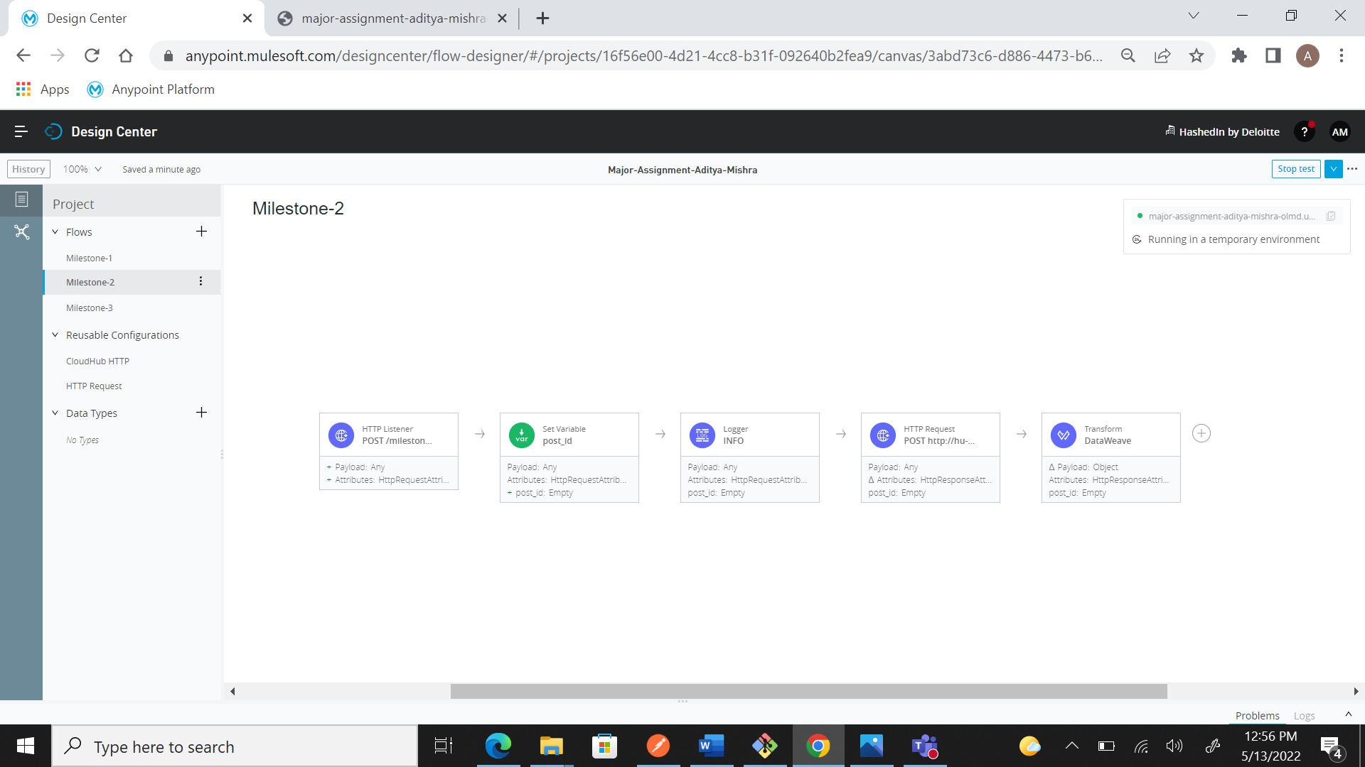
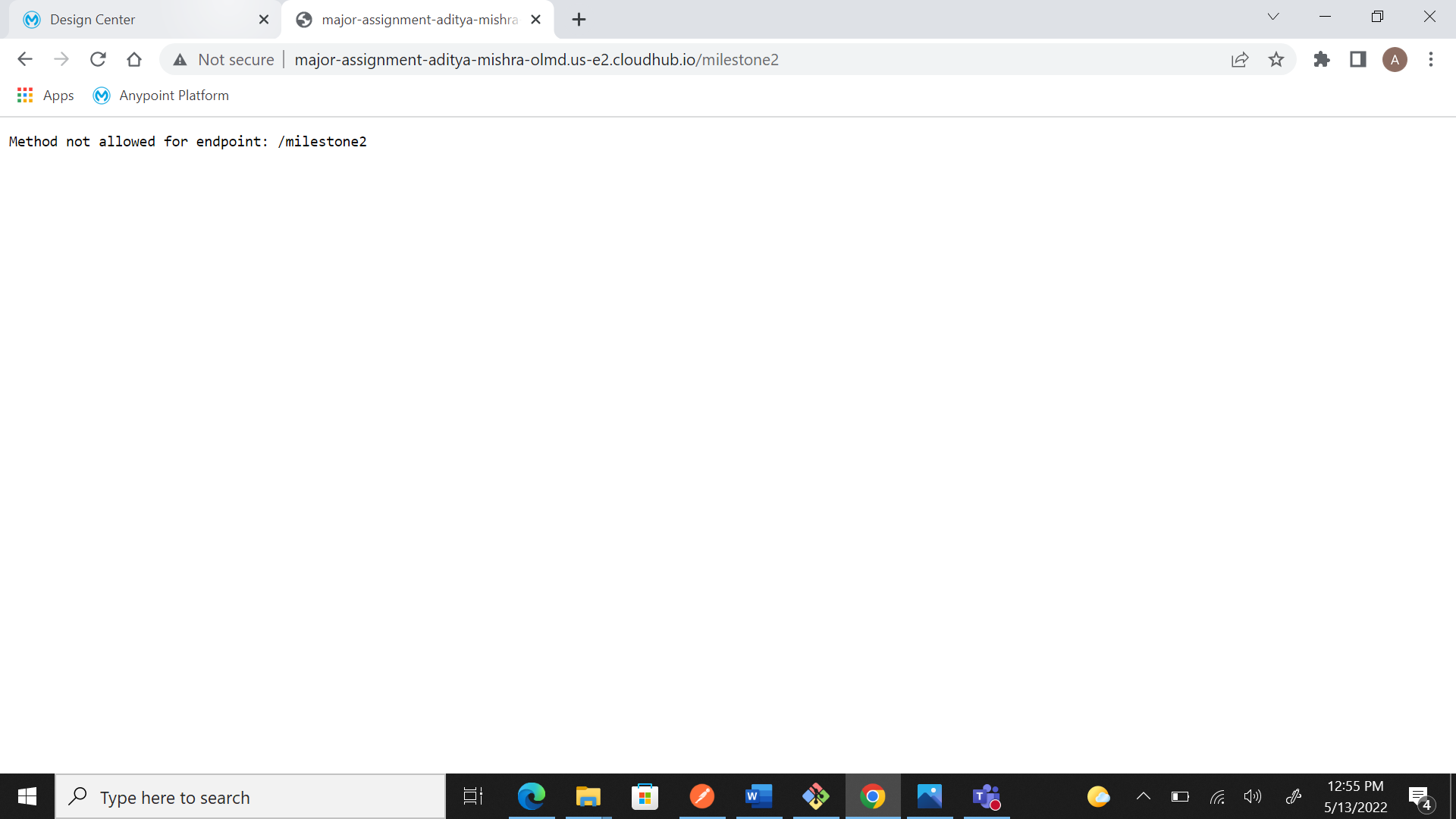

MILESTONE 4
Create an endpoint with a GET method. And write a Dataweave script to give the sample response as mentioned below: Method: GET Endpoint: http://hu-major-assignment.us-e2.cloudhub.io/userid Sample Response Body: { "Name": "Gorakhanatha Chaturvedi", "Status": "active", "Gender": "female" } Part 1: Create a proper flow for the above-mentioned scenario in Flow designer with name Milestone3-” Your Name” Part 2: Create endpoint in RAML with endpoint path (resource name) as /milestone3 for the above-mentioned scenario
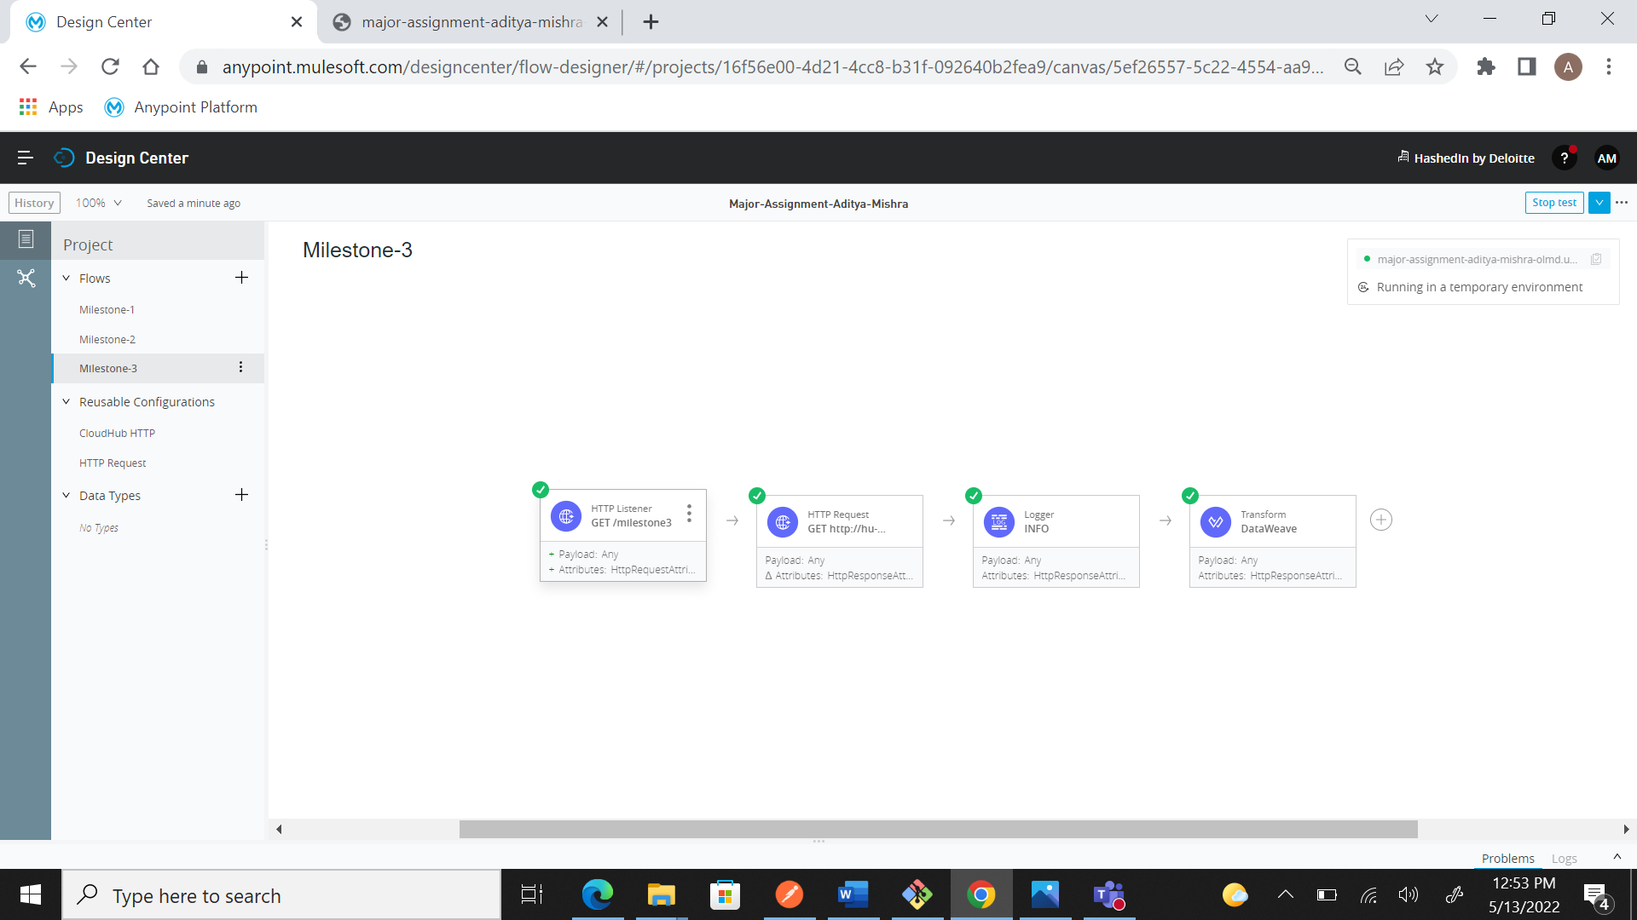
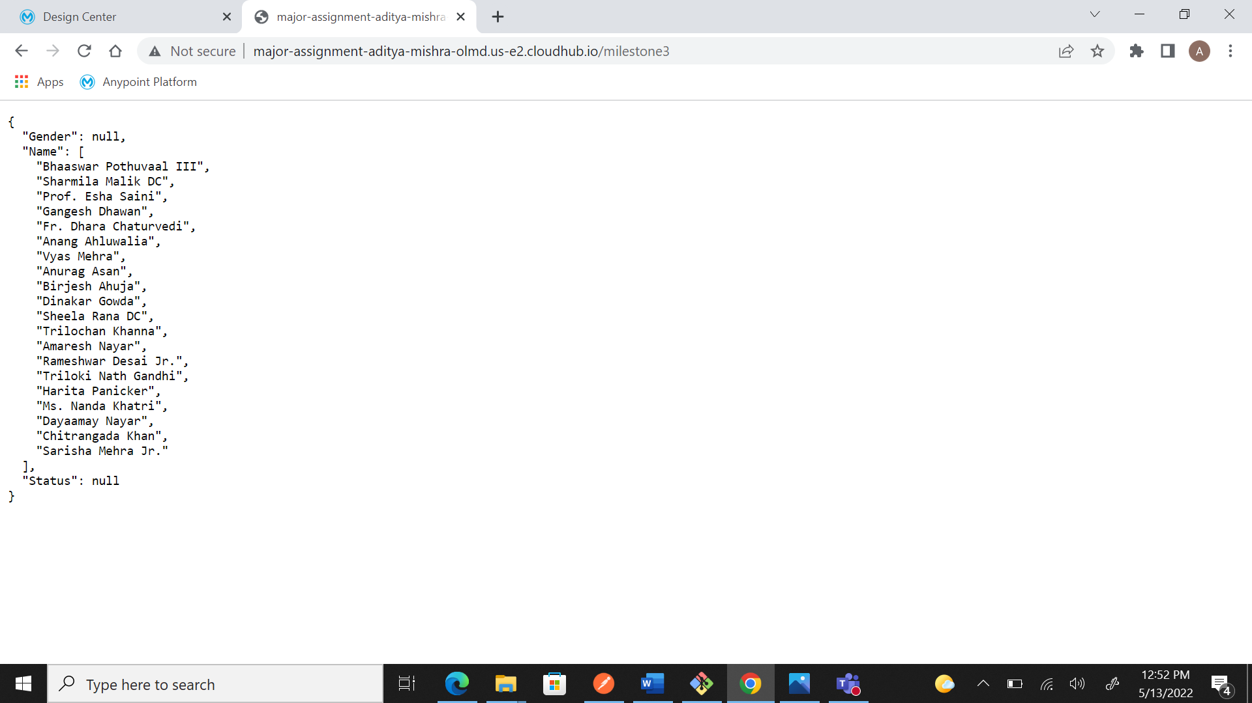

PART-B
MILESTONE 1
Create a collection “API-Collection-Your Name” in Postman. All the endpoints added to this collection should have proper name.
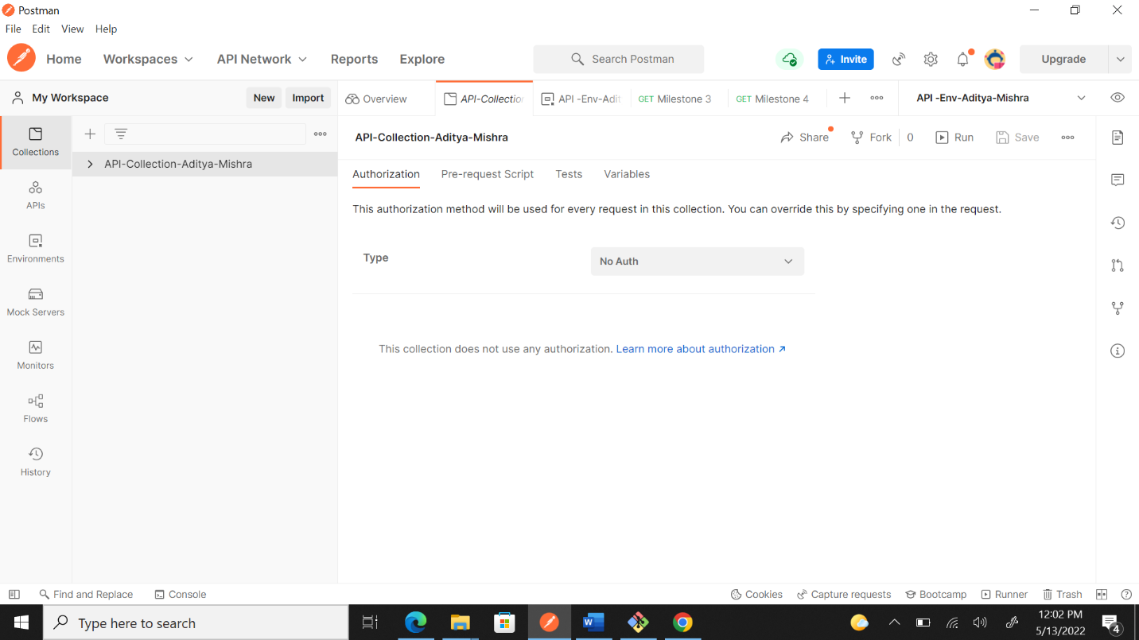

MILESTONE 2
Create an Environment “API -Env-Your Name” and load the commonly used values there.
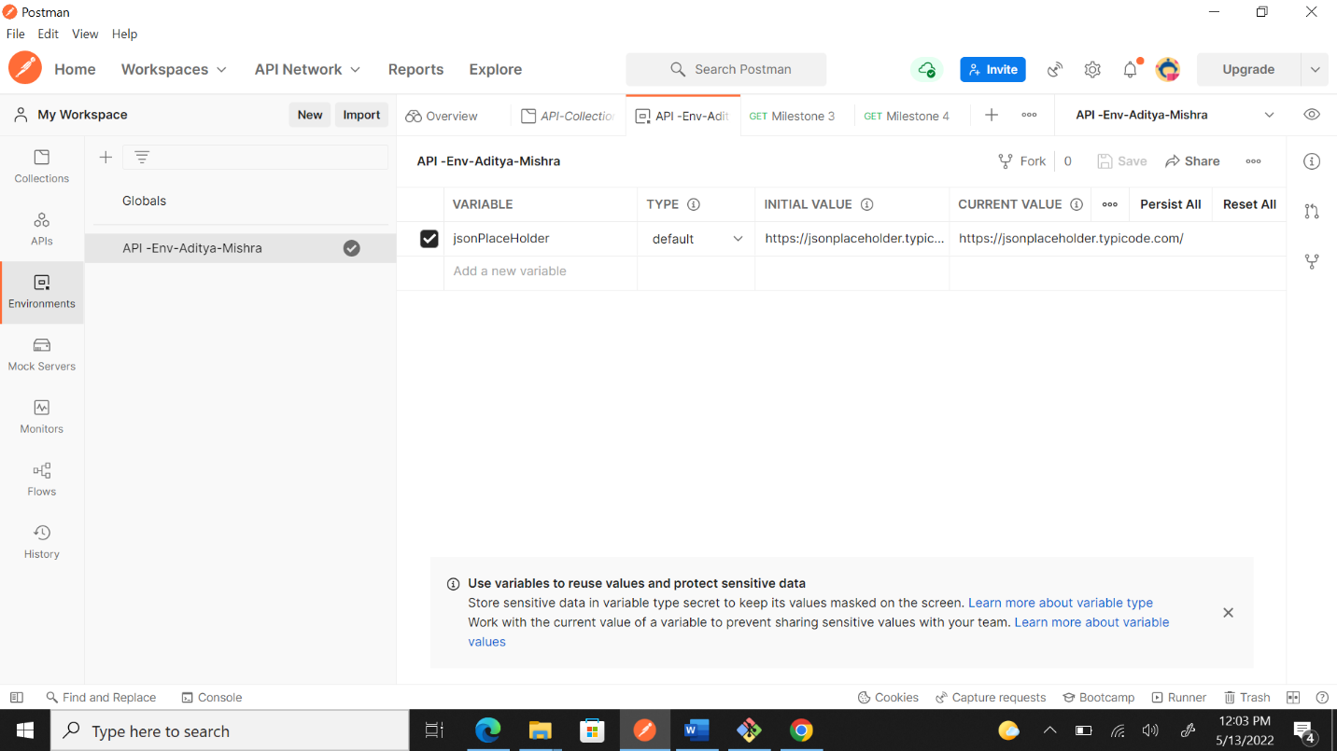

MILESTONE 3 with MILESTONE 6
GET : https://jsonplaceholder.typicode.com/posts • Response payload: (1 point) [ { "userId": 1, "id": 1, "title": "sunt aut facere repellat provident” "body": "quia et suscipit\nsuscipit” }, . . . ] • Verify the following(2 points): a. User with 'id' 40 has 'userId'=4 b. Every 'title' field in the response has the type is String.

Also perform the common validations listed , on each API response. (4 points each) • HTTP status code • Content type • Response time is less than 1000ms
Script:-
pm.test("Check_UserId_Id", function () {
var jsonData = pm.response.json();
var i=0;
while(i<jsonData.length){
if(jsonData[i].id == 40)
pm.expect(jsonData[i].userId).to.equal(4);
++i;
}
});

pm.test("Check_string", function () {
var jsonData = pm.response.json();
var i=0;
while(i<jsonData.length){
pm.expect(jsonData[i].title).to.be.a('String')
++i;
}
});

pm.test("Http_check", function(){
pm.response.to.have.status(200);
});

pm.test("Content-Type_check", function () {
pm.response.to.have.header("Content-Type");
});

pm.test("Response_time_less_than_1000ms", function () {
pm.expect(pm.response.responseTime).to.be.below(1000);
});

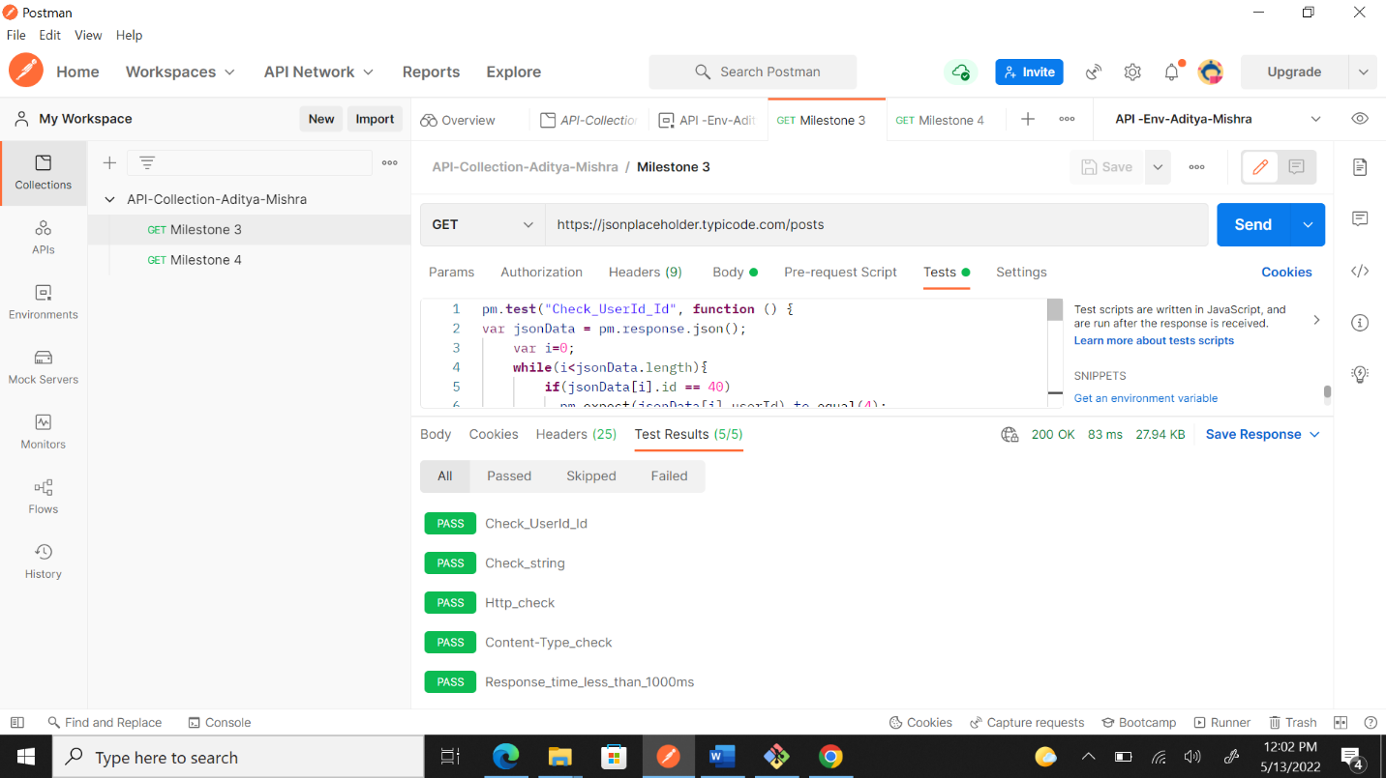
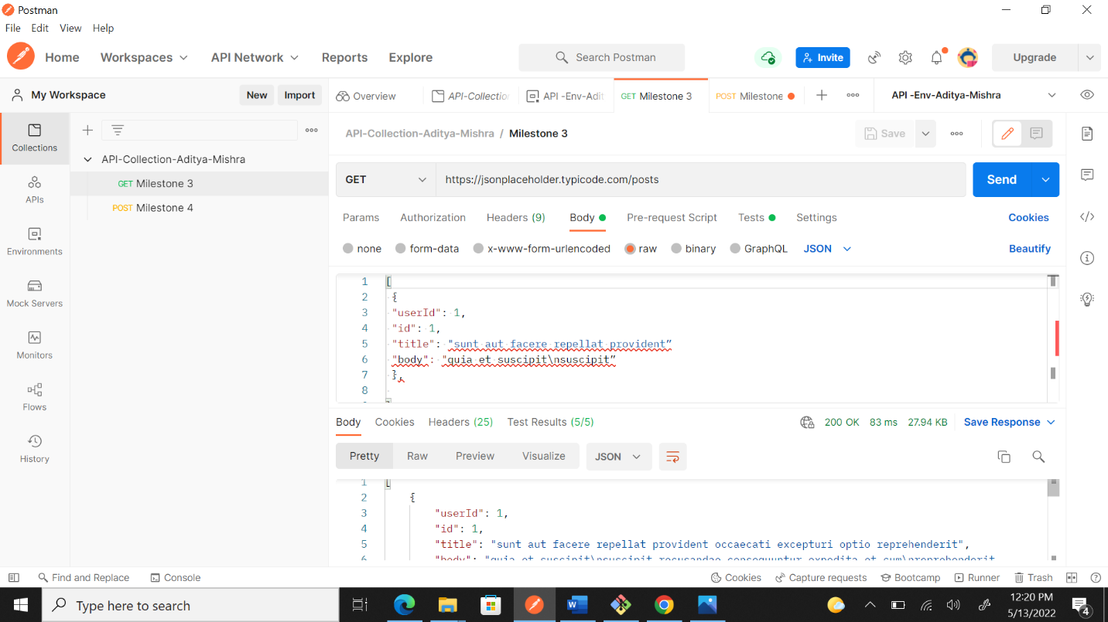

MILESTONE 4 and MILESTONE 6
POST: https://reqres.in/api/users • Request payload: (1 point) { "email": "amith.k@reqres.in", "first_name": "Amit", "last_name": "K", 5 "avatar": "" } • Set the 'email' and 'first_name’ values in Environment before sending the request. (2 points) • Verify the “email’ and ‘first_name’ values match with response.(2 point)
Also perform the common validations listed , on each API response. (4 points each) • HTTP status code • Content type • Response time is less than 1000ms
Script:
pm.test("Check String", function () {
var jsonData = pm.response.json();
pm.expect(jsonData.first_name).to.equal(pm.environment.get("first_name"));
pm.expect(jsonData.email).to.equal(pm.environment.get("email"));
});

pm.test("Http_check", function(){
pm.response.to.have.status(201);
});
pm.test("Content-Type_check", function () {
pm.response.to.have.header("Content-Type");
});

pm.test("Response_time_less_than_1000ms", function () {
pm.expect(pm.response.responseTime).to.be.below(1000);
});

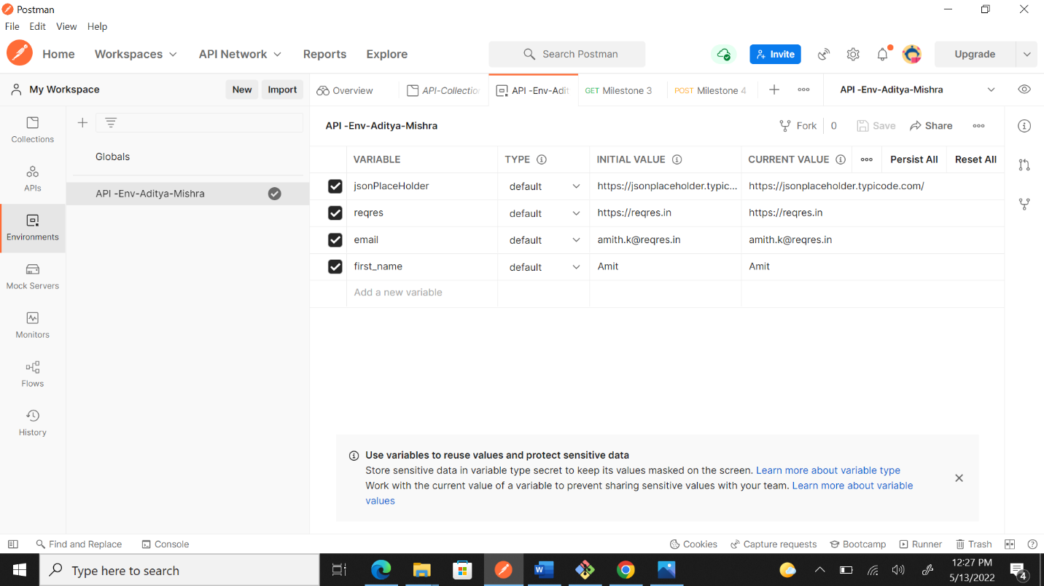
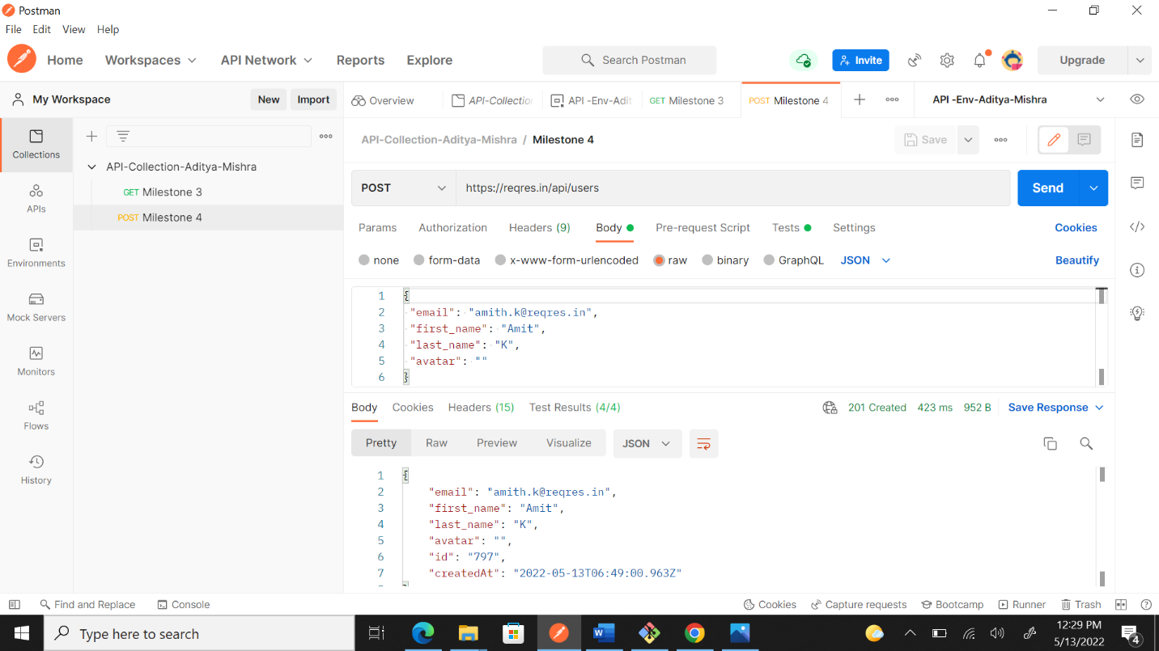
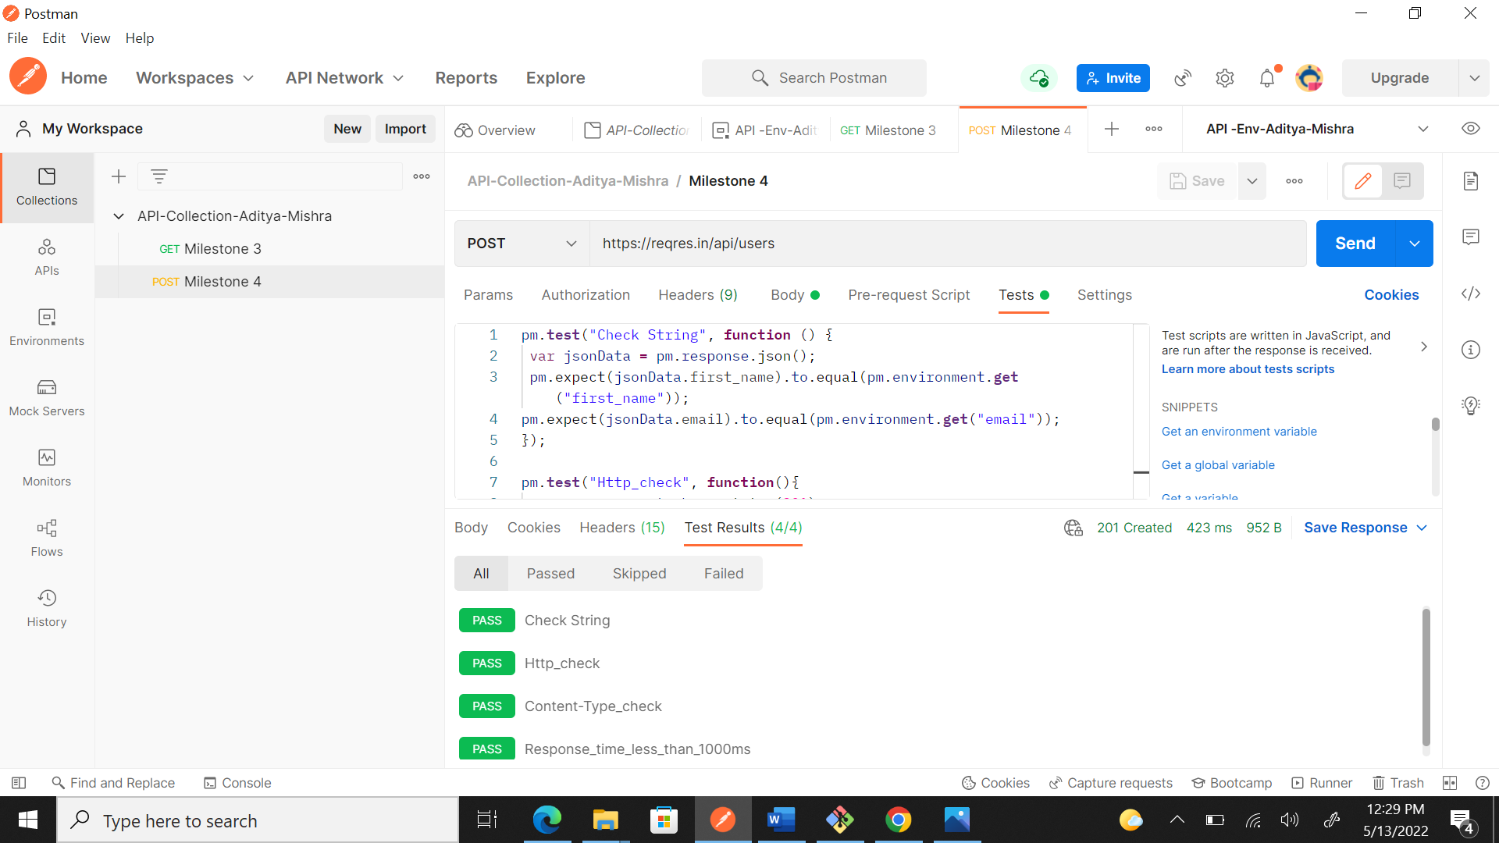

MILESTONE 5 with MILESTONE 6
PUT: https://reqres.in/api/users/ • Request payload: { "email": "amith.kumar@reqres.in", "first_name": "Amith", "last_name": "Kumar", "avatar": "", "id": "664", "createdAt": "2022-02-15T15:18:16.933Z" } • Response payload: { "email": "amith.kumar@reqres.in", "first_name": "Amith", "last_name": "Kumar", "avatar": "", "id": "664", "createdAt": "2022-02-15T15:18:16.933Z", "updatedAt": "2022-02-16T05:42:41.832Z" } • Verify “first_name”,‘last_name’ and ‘email’ are updated with correct values. These changed values should be reflected in the environment as well. (4 points) • Check whether the field “updatedAt” is present in the response body. (1 point)
Also perform the common validations listed , on each API response. (4 points each) • HTTP status code • Content type • Response time is less than 1000ms

Script:-
pm.test("Check_Response_Request", function () {
var reqbody = JSON.parse(pm.request.body.raw)
var jsonData = pm.response.json();
pm.expect(jsonData.first_name).to.equal(reqbody.first_name);
pm.expect(jsonData.last_name).to.equal(reqbody.last_name);
pm.expect(jsonData.email).to.equal(reqbody.email);

pm.environment.set('first_name', jsonData.first_name)
pm.environment.set('last_name',jsonData.last_name)
pm.environment.set('email', jsonData.email)
});

pm.test("API_Expected_Check", () => {
const response = pm.response.json();
pm.expect(response).to.have.property("updatedAt");
});

pm.test("Http_check", function(){
pm.response.to.have.status(200);
});
pm.test("Content-Type_check", function () {
pm.response.to.have.header("Content-Type");
});

pm.test("Response_time_less_than_1000ms", function () {
pm.expect(pm.response.responseTime).to.be.below(1000);
});

