**SnowSQL Approach**

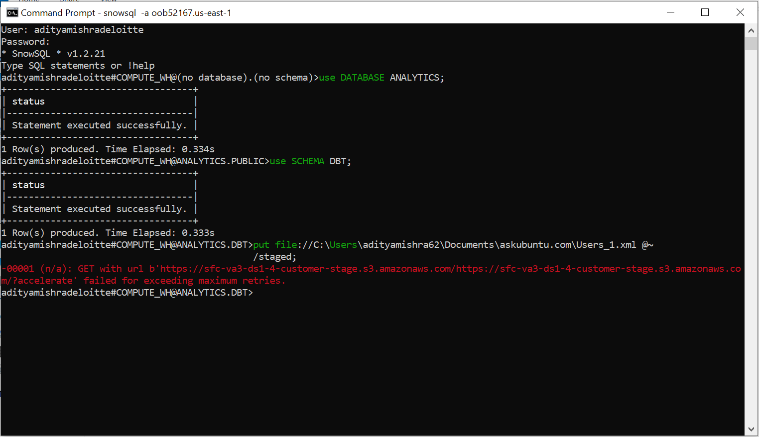

Initially I made the queries sql files inside the model folders and updated the schema.yml file accordingly, but I was facing issues with uploading whole dataset so I tried splitting them using snowsql, I got the aforementioned error.

Then I manually splitted the dataset into rows of 500, and then uploaded one of the users dataset into snowflake, is showed the data in different rows, but the value of the rows was still the same, so I tried using the below query I found on internet. It separated the header but didn’t parse the values of headers accordingly. So I couldn’t proceed further.

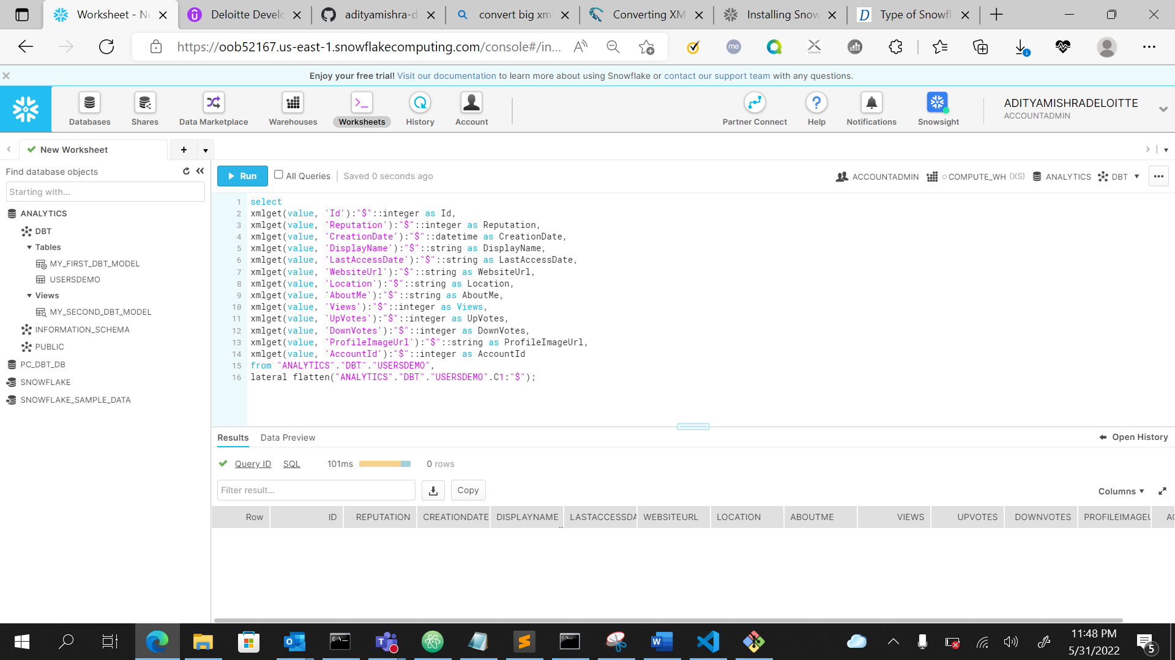

**Reference links:**

[Type of Snowflake Stages - How to Create and Use them? - DWgeek.com](https://dwgeek.com/type-of-snowflake-stages-how-to-create-and-use.html/)

[Converting XML to Snowflake, Redshift, BigQuery, Azure Synapse. A comparison - Sonra](https://sonra.io/xml/converting-xml-to-snowflake-redshift-bigquery-azure-synapse-a-comparison/)