**MILESTONE 1**

**Gather basic data insights from the given data**

For this, I uploaded the given csv files namely AMC, FundCategory and MutualFunds into snowflake. But I faced problem when uploading NavHistory so I used DBeaver Lite and connected the database with SnowFlake.

Then I created a new project folder and did the connections with the snowflake and dbt.

Then I created the models for first and second part of milestone 1.

**Part-i**

Calculate Monthly average NAV, Repurchase & Sale Price for each scheme.

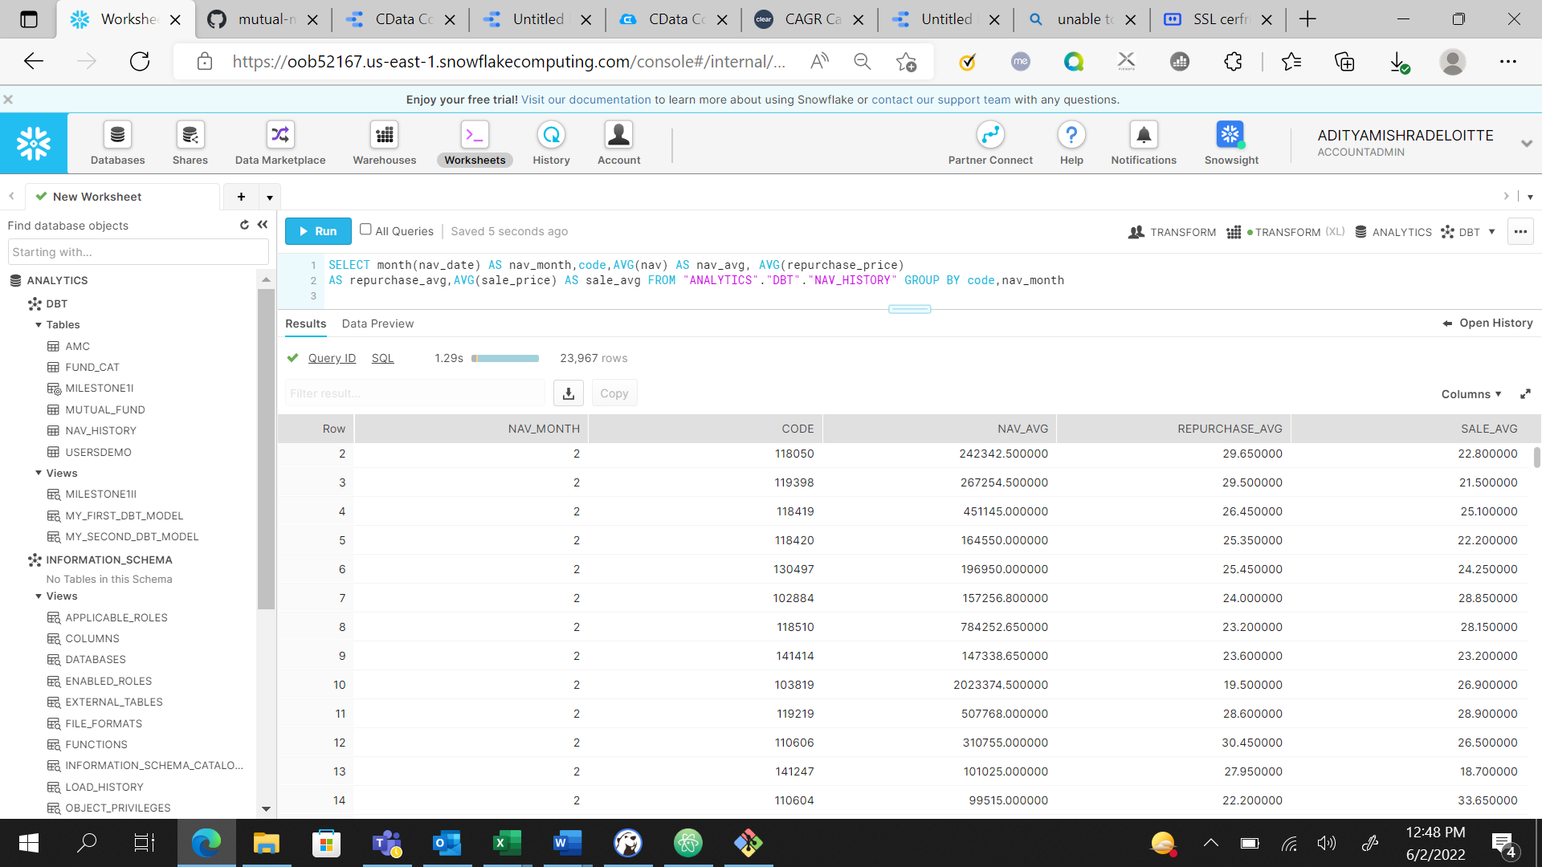

I used the aforementioned query and returned these values.

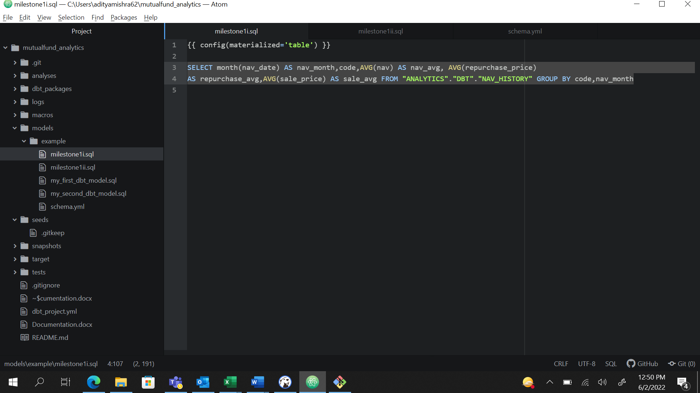

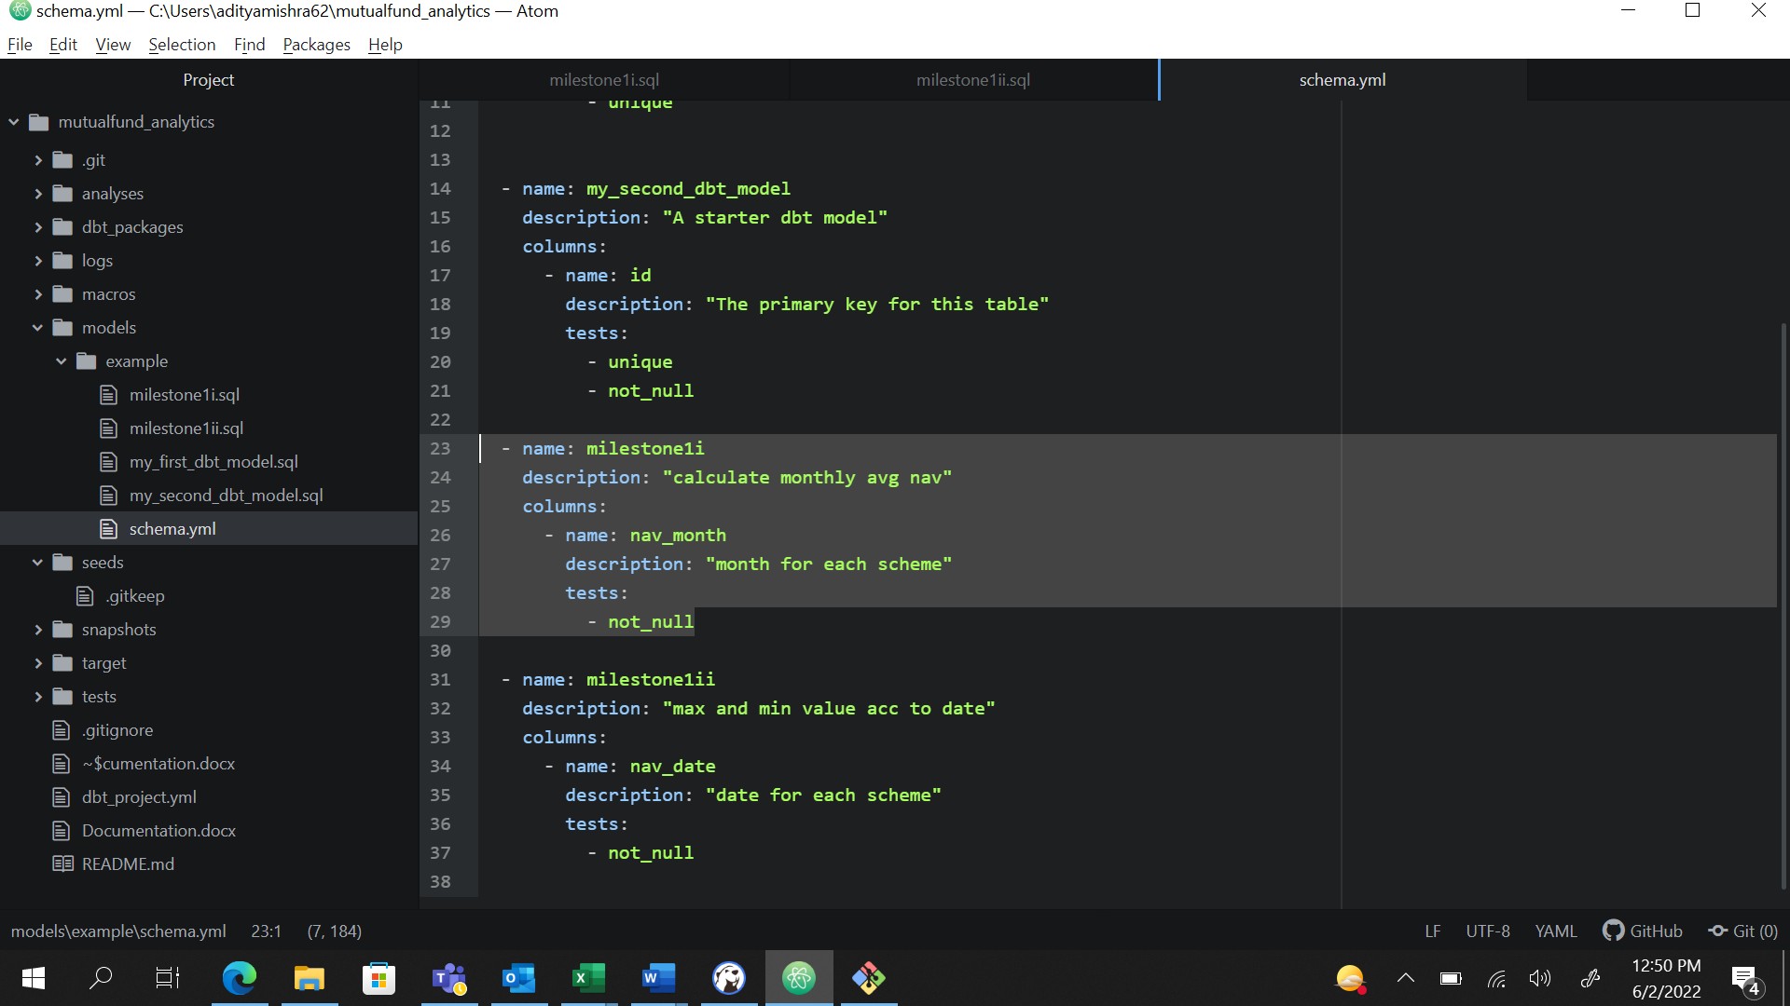

These are the changes I made into model and schema.

**Part-ii**

Find out each scheme’s Max and Min NAV value and Date it occurred

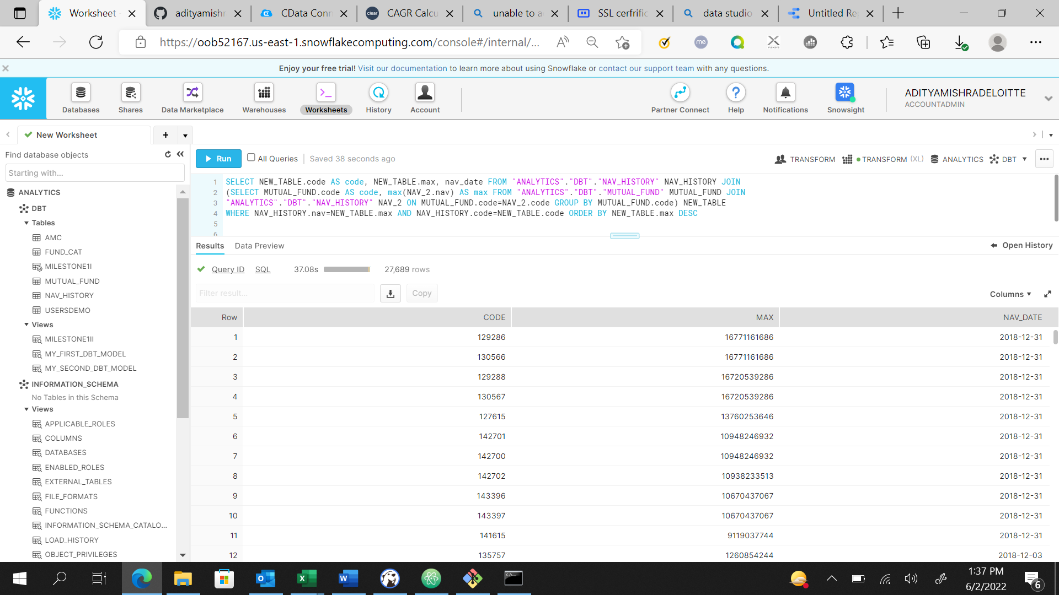

I used this query and used inner join two times, first on MutualFund and NavHistory using code as reference, then aliased this join as New Table and then used inner join on Nav History and New Table again to return the maximum nav value according to nav date in descending order. Now the minimum nav value will be at bottom of the table and maximum nav value will be at top.

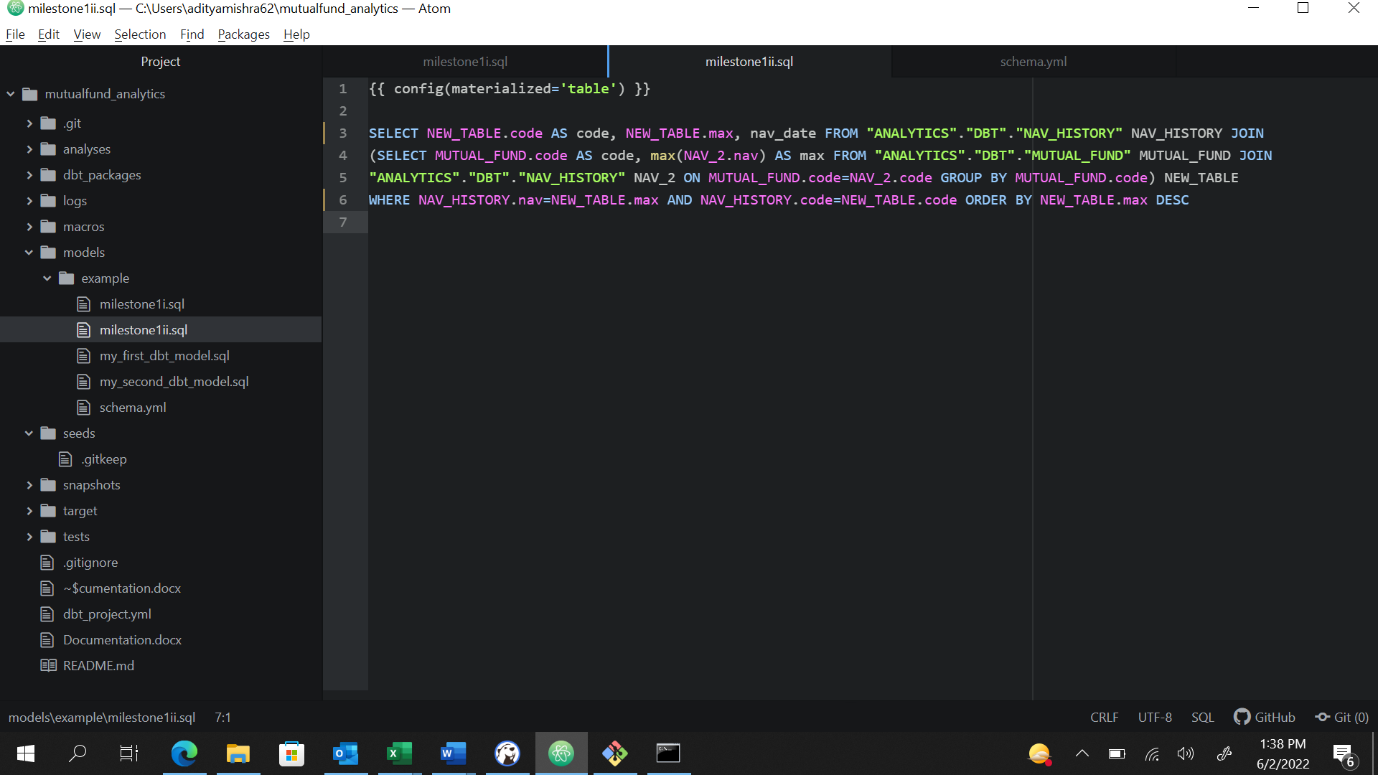

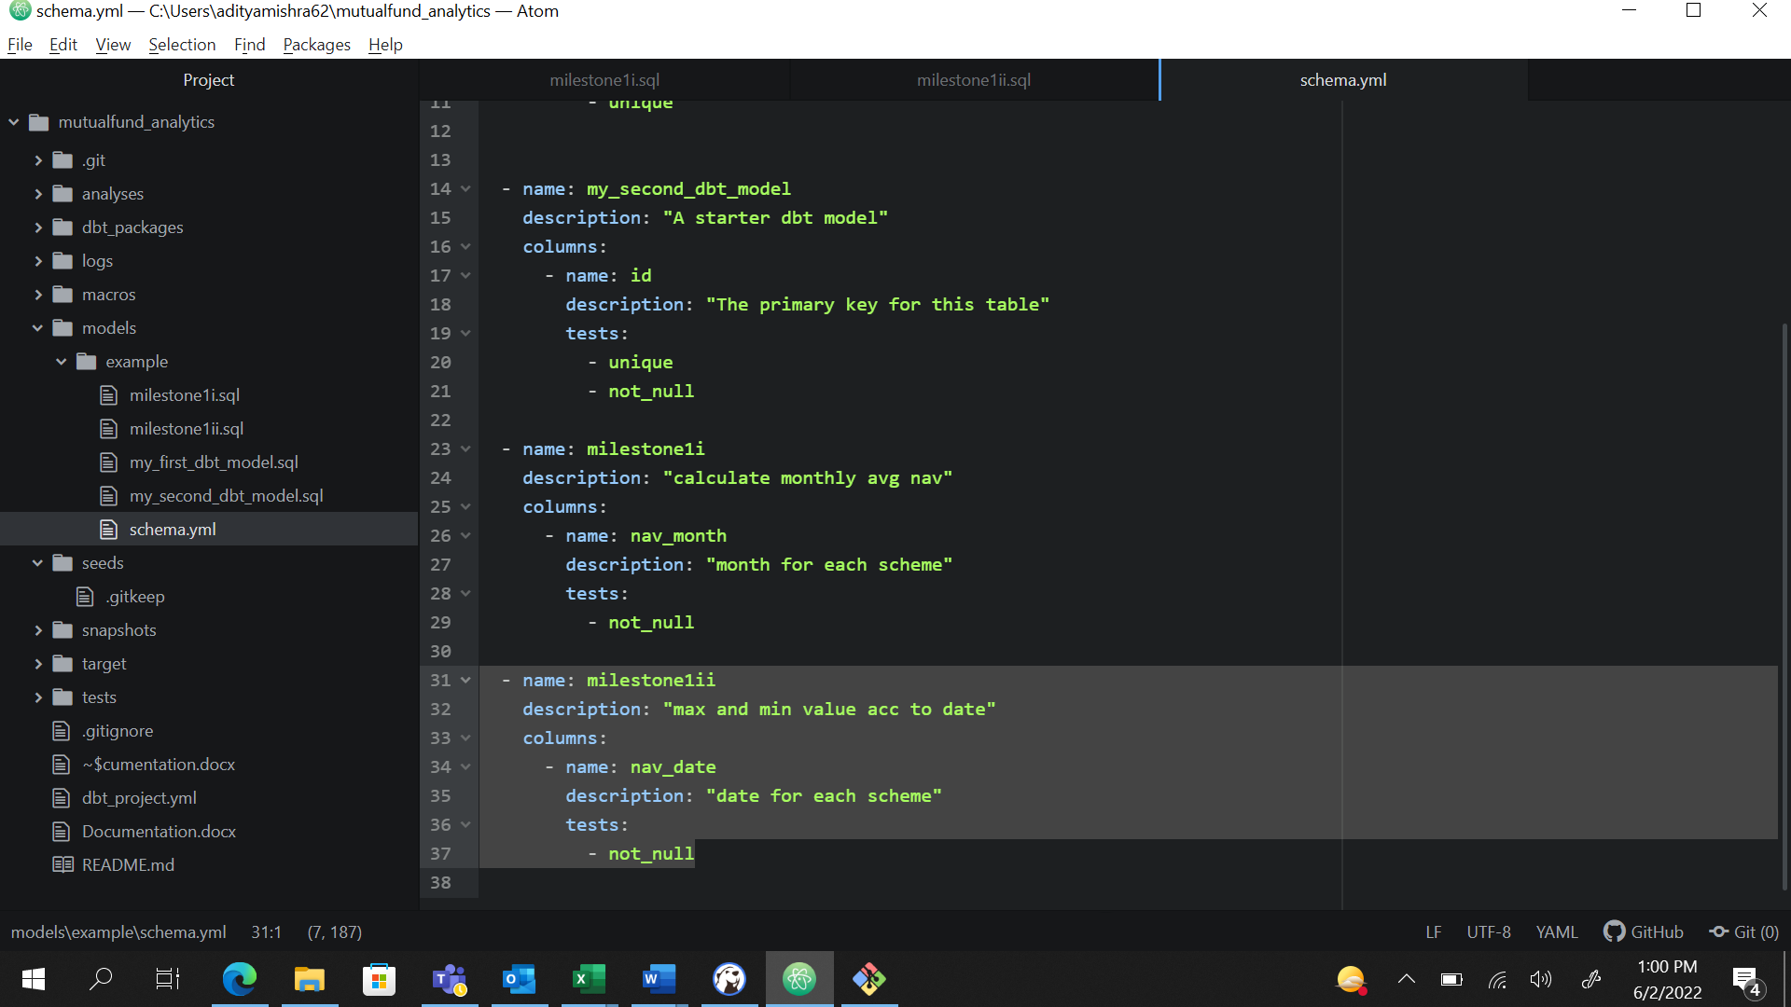

These are the changes I made in schema for this milestone.

DBT TEST

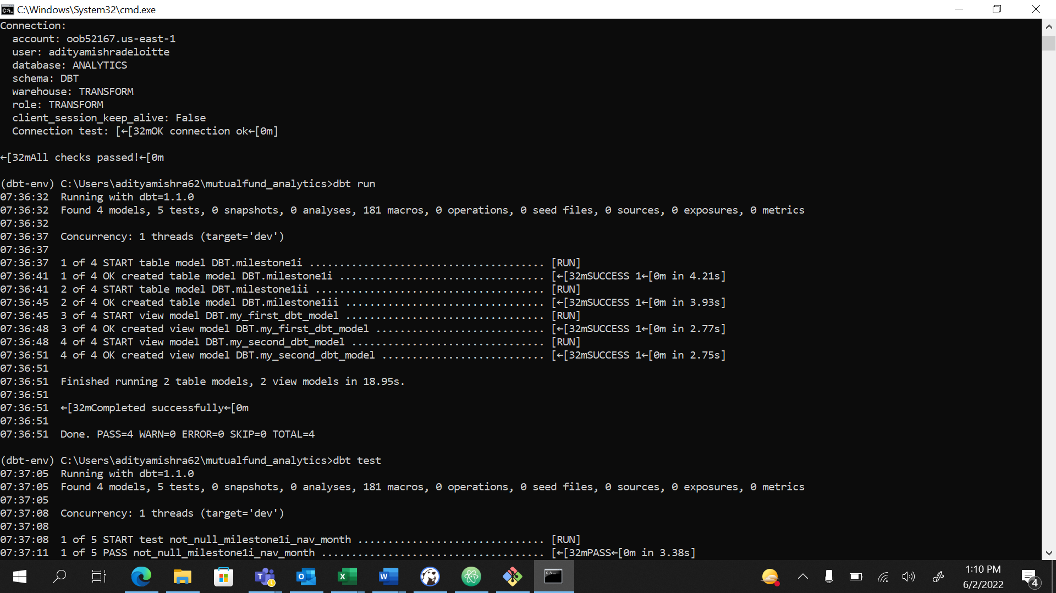

I used dbt run command and it returned success.

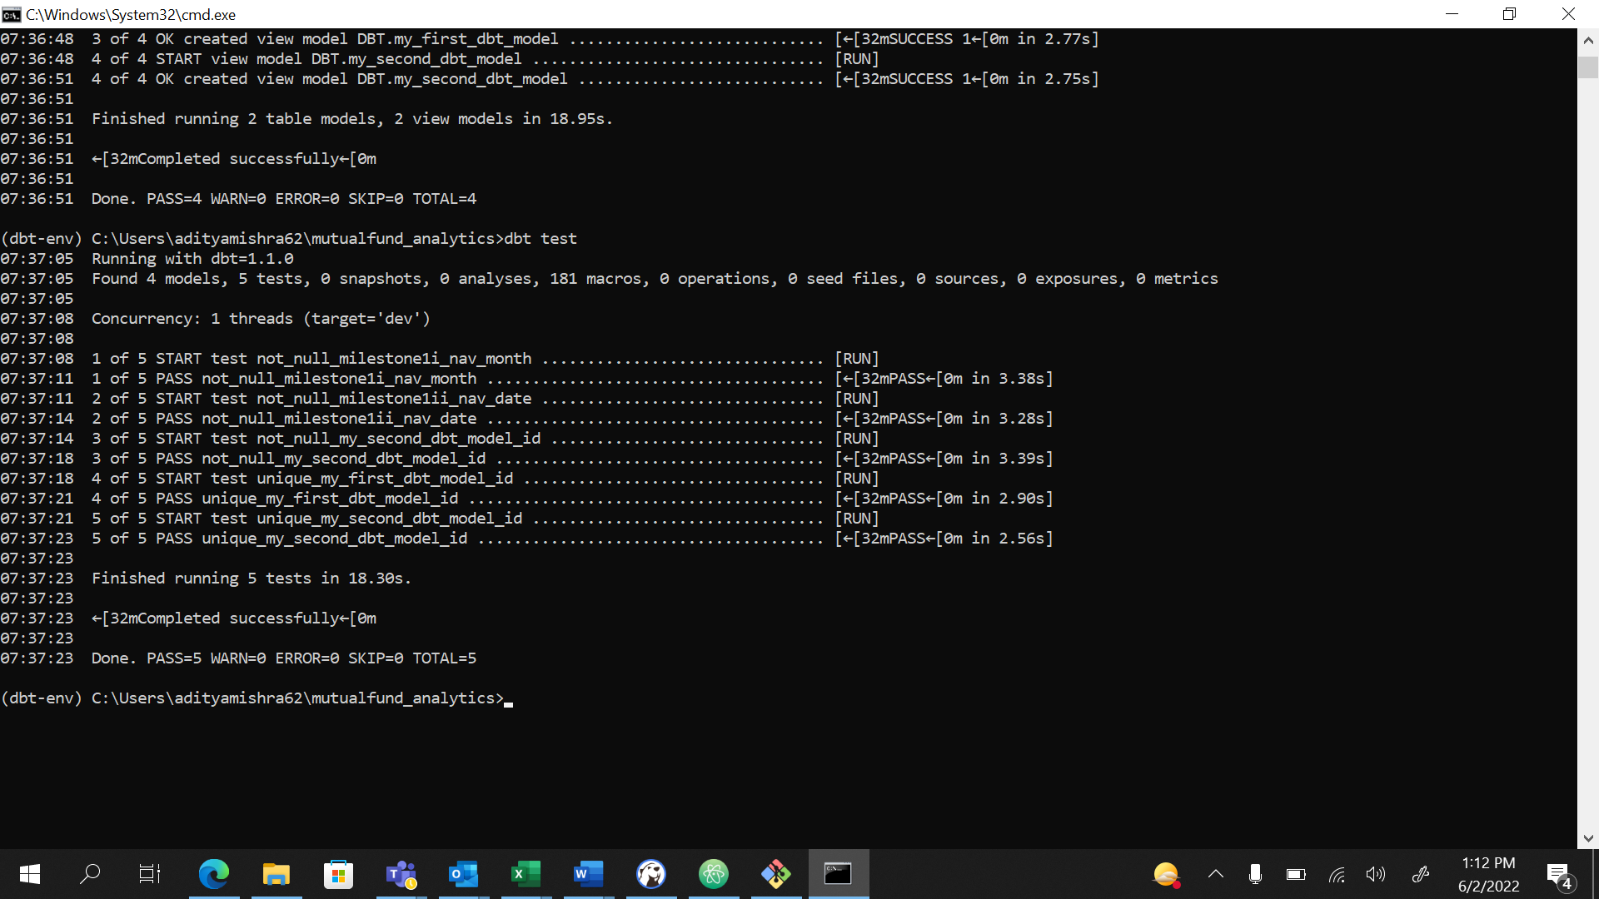

I used dbt test and it returned successfully.

**Milestone 3**

**Part 3**

For this I first connected the Snowflake with Data Studio using CData Cloud Connector as a third party connector.

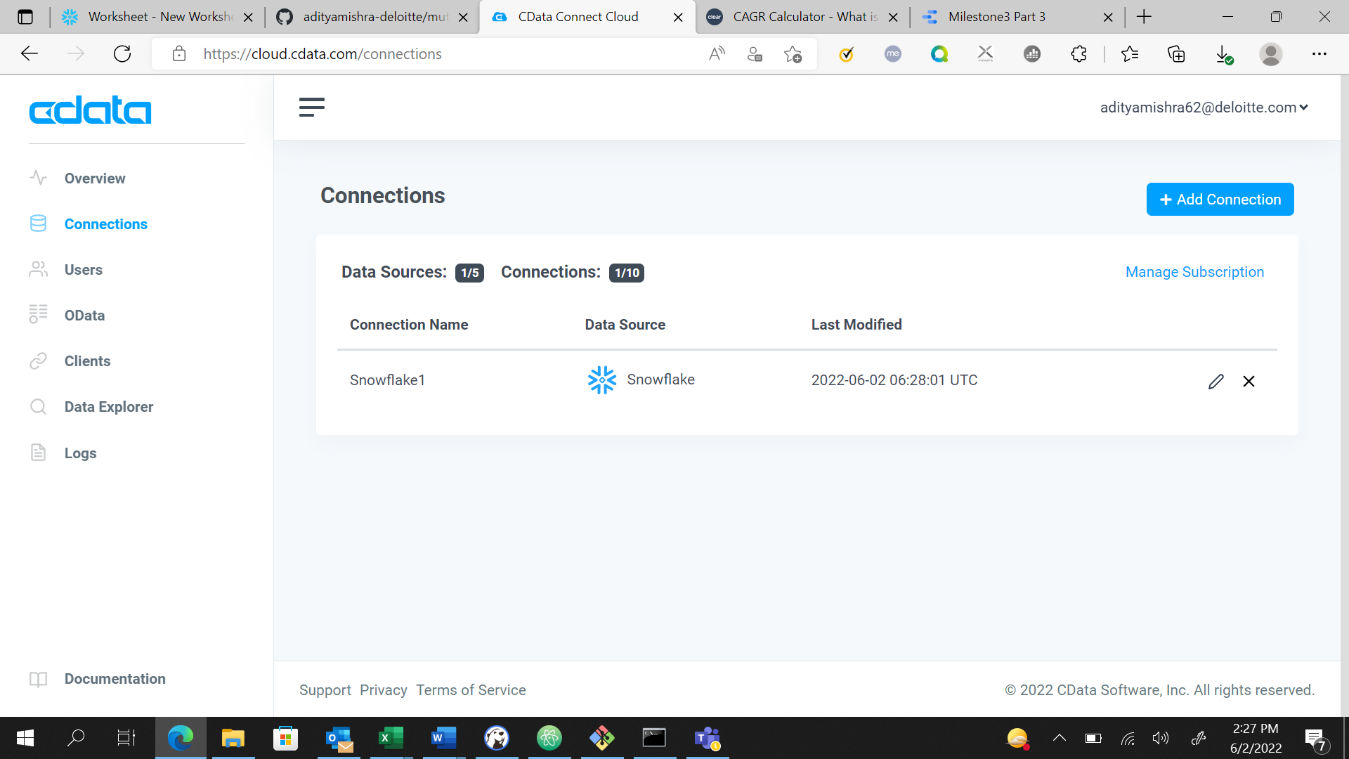

Then I run the below query to make a new model for this milestone which will return me the NAV according to each category id. For that I joined Mutual Fund and Fund Category using category id as reference, then using code as reference I joined this new_table and Nav History to create desired model.

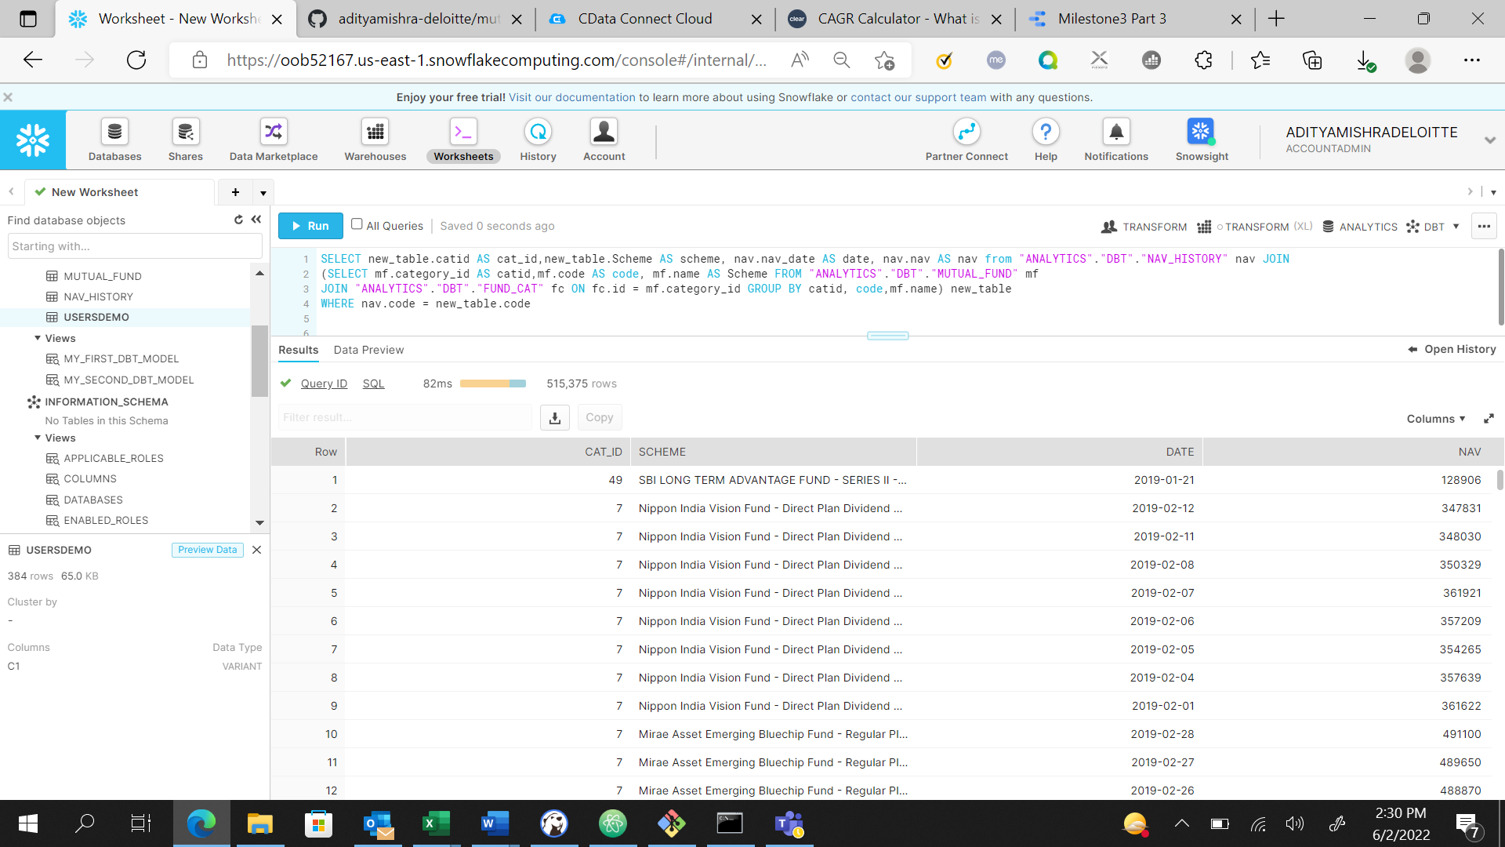

Then in Data Studio, I created a table and added data from this model. Then I used category id as dimension and NAV as metric and converted the table into a chart.

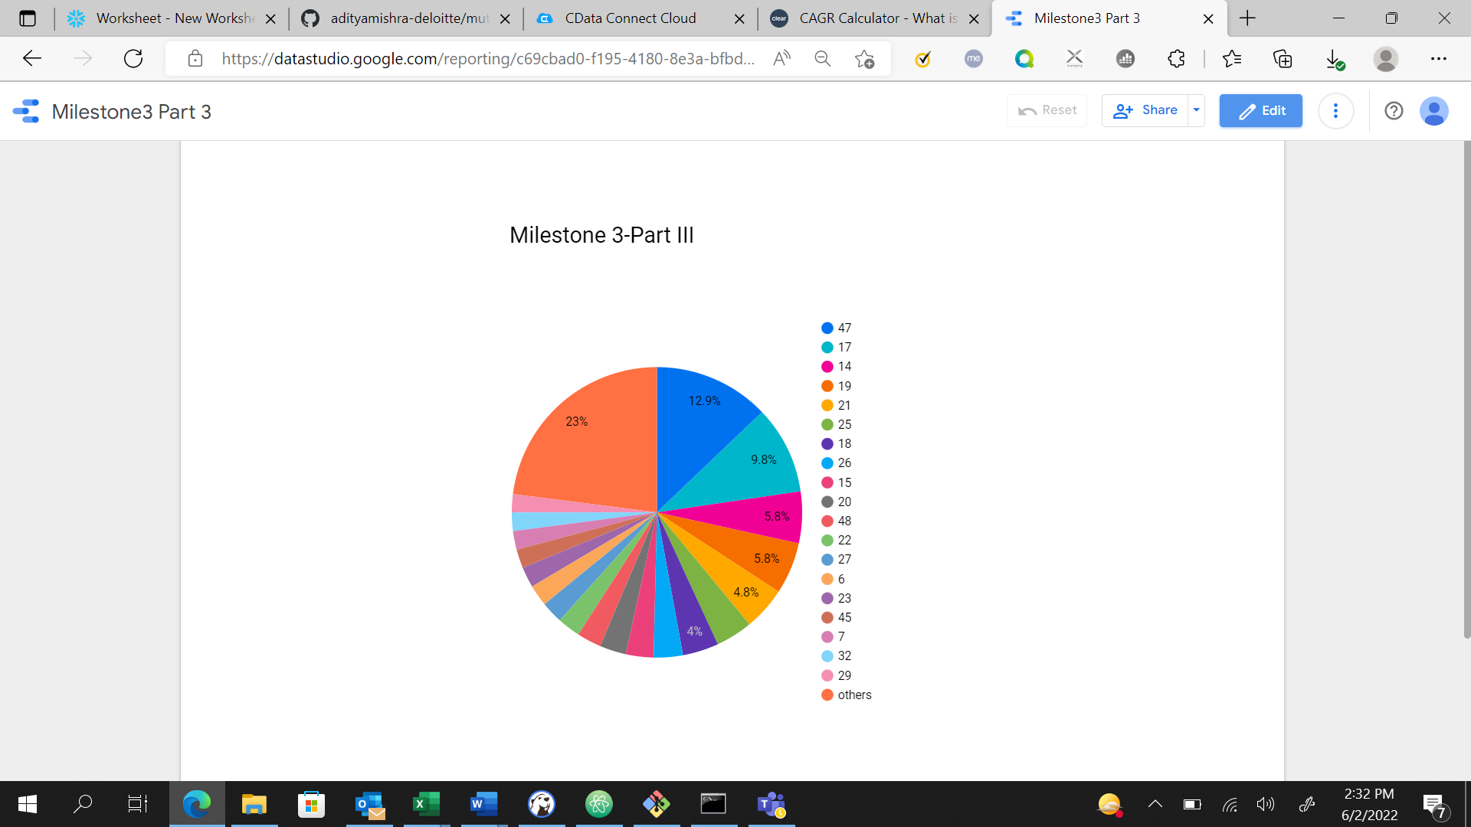

This was the returned values, since this pie can only have upto 20 slices, all 51 categories couldn’t get fit into this.